Supplemental Material

Comparative Efficacy and Safety of Echocardiography versus Radiation Guidance in Percutaneous Balloon Mitral Valvuloplasty: A Retrospective Study

Content of Supplemental Material

Supplemental Tables
- Supplementary Table 1. Definition of study variables.
- Supplementary Table 2. Missing rates of study variables.
- Supplementary Fig. 1. The absolute standardized differences of pre- and post-PSM.

Supplementary Table 1. Definition of study variables.
 | Definition | Continuous/Categorical/Binary
Age | Years after birth | Continuous
Sex | Female and Male | Binary, Female/Male
BMI | Calculated by BMI Equation | Continuous, kg/m²
AF | Atrial fibrillation | Binary, Yes/No
Left atrial diameter | Left atrial diameter measured by transthoracic echocardiography | Continuous, in mm
LVEDD | Left ventricle diastolic diameter measured by transthoracic echocardiography | Continuous, in mm
MVA | Mitral valve area measured by transthoracic echocardiography | Continuous, in cm²
Emax | Transmitral E peak velocity measured by transthoracic echocardiography | Continuous, in m/s
MTG | Mean transmitral gradient measured by transthoracic echocardiography | Continuous, in mmHg
TR | Tricuspid valve regurgitation measured by transthoracic echocardiography | Binary, Yes/No
Pregnancy | Admission pregnant status | Binary, Yes/No
CKD | Admission chronic kidney disease history | Binary, Yes/No
Abbreviations: BMI, body mass index; LVEDD, Left ventricle end-diastolic diameter; MVA, Mitral valve area; Emax, Transmitral E peak velocity; MTG, Mean transmitral gradient; TR, Tricuspid valve regurgitation; CKD, chronic kidney disease.

Supplementary Table 2 Missing rates of study variables.
Variables | Missing, N (%)
BMI | 17 (3.96)
Left atrial diameter | 14 (3.26)
LVEDD | 14 (3.26)
EF | 9 (2.10)
MVA | 4 (0.93)
Emax | 15 (3.50)
MTG | 24 (5.59)
Ballon size | 4 (0.93)
Abbreviations: BMI, body mass index; LVEDD, left ventricular end-diastolic diameter; EF, left ventricular ejection fraction; MVA, mitral valve area; Emax, transmitral E peak velocity; MTG, mean transmitral gradient.

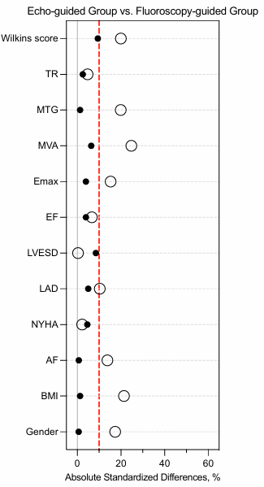
Supplementary Fig. 1 The standardized difference of pre-PSM. BMI, body mass index; LAD,left atrial diameter; LVEDD, left ventricular end-diastolic diameter; EF, left ventricular ejection fraction; MVA, mitral valve area; Emax, transmitral E peak velocity; MTG, mean transmitral gradient; TR, tricuspid regurgitation.

