Supplementary Materials

Auditory discrimination task of pure tones
Supplementary Fig. 1. A) The stimuli consisted of 50 ms pure tones at 900 Hz (low; condition 1) and 1050 Hz (high; condition 2). Tones were presented binaurally at a comfortable sound level of 60 dB through Sound Blaster speakers in a pseudo- random order with an interstimulus interval (ISI) varying between 1.5 and 2.5 seconds. There are 40 trials per condition. Responses are made by pressing an appropriate button (the right button for the low tone and the left one for the high tone), with immediate knowledge of the percent of the correct responses at the end of the task, which was displayed on a computer monitor; B) part of the tone sequence (four tones) in the time domain; C) frequency presentation of low and high tones vs. dB; D) amplitude spectrogram of the tone sequence (four tones), presented on (B).
Supplementary Table 1. Psychological scores of the groups in standardized scores (mean ±s.d.).
1. DDE-2 test | Controls  102 (4) months  Mean (S.D.) | DD  103 (3) months  Mean (S.D.)
1.1. Reading words
accuracy  time (s) | 107 (5.8)  131 (0.8) | 90.3 (4.9)  91.9 (4.7)
1.2.Reading pseudowords
accuracy  time (s) | 103 (4.71)  115 (0.78) | 88.1 (4.5)  96.5 (4.4)
1.3 Homonyms (accuracy) | 111 (4.7) | 98.3 (2.7)
1.4 Spelling (accuracy) | 111 (1.7) | 111 (4.51)
1.5 Writing words (accuracy) | 114 (4.4) | 84.9 (4.6)
1.6 Writing pseudowords (accuracy) | 105 (3.35) | 90.7 (4.1)
1.7 Dictation (accuracy) | 111 (4.9) | 88.7 (3.5)
2. Psychometric tests | Controls  mean (S.D.) | DD  mean (S.D.)
2.1. Reading text
correct answers | 129.3 (3.5) | 118.5 (6.8)
time (s) | 104.8 (29.5) | 191.7 (8.21)
2.2. Dictation
Correct sentences | 20.7 (5.4) | 11.2 (4.7)
2.3 Phological task
Without the first sound
accuracy | 9.7 (1.4) | 5.3 (1.94)
time (s) | 35 (10.9) | 63.4 (26.7)
2.4 Phological task
Without the last syllable
correct answers | 8.8 (2.5) | 6.5 ( 2.3)
time (s) | 36.6 (7.9) | 63.7 (27.7)
3. Girolami-Bulinier
correct answers | 51.4 (7.4) | 41 (2.4)
4. Raven's test | 107 (8) | 101 (5)

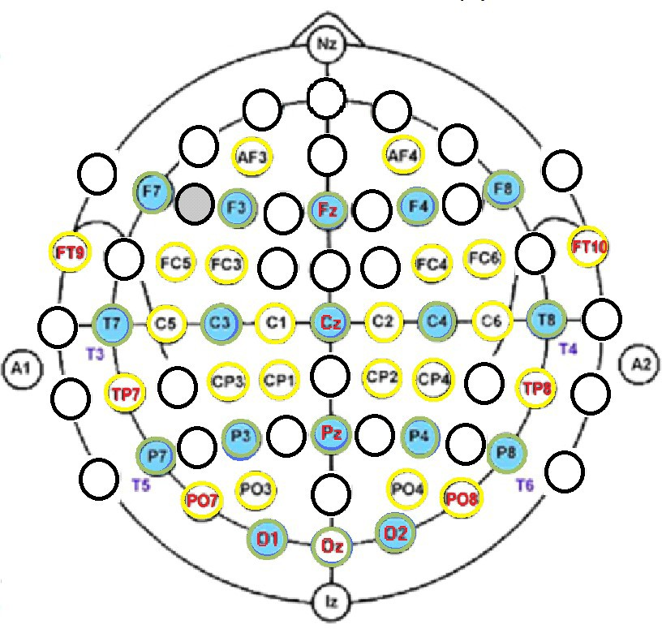
Electrode locations

Supplementary Fig. 2A. Positions of 40 EEG sensors are according to the international systems 10/20 (green circles) and 10/10 (yellow circles).
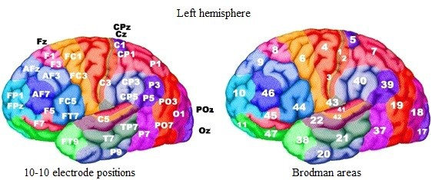 Supplementary Fig. 2B. Electrode positions and cytoarchitectural areas according to Brodmann.

Supplementary Table 2. Statistical comparison of global measures ɸ, ∆C, and ∆L (means ± s.e.; Kruskal-Wallis Test: χ² statistic, p-value, and a significance threshold of 0.0167) of frequency δ, θ, α, β1, β2, γ1, and γ2 networks for controls and children with DD for low-tone.

Frequebcy  /low tone |  | Control | Dyslexia | Kruskal- | Wallis  Test
 |  | Mean± S.E. | Mean± S.E. | p-values | χ² statistics
δ | ϕ | 0.653±0.01 | 0.687±0.02 | 0.486 | 0.484
 | ∆C | 0.276±0.02 | 0.316±0.016 | 0.179 | 1.797
 | ∆L | 0.336±0.015 | 0.326±0.026 | 0.200 | 1.639
θ | ϕ | 0.544±0.008 | 0.559±0.007 | 0.101 | 2.683
 | ∆C | 0.589±0.014 | 0.554±0.013 | 0.036 | 4.394
 | ∆L | 0.191±0.007 | 0.205±0.007 | 0.240 | 1.377
α | ϕ | 0.516±0.007 | 0.544±0.006 | 0.003 | 8.534
 | ∆C | 0.648±0.012 | 0.601±0.01 | 0.002 | 9.292
 | ∆L | 0.155±0.006 | 0.171±0.005 | 0.013 | 6.115
β1 | ϕ | 0.460±0.006 | 0.502±0.006 | <0.001 | 21.528
 | ∆C | 0.751±0.009 | 0.683±0.009 | <0.001 | 22.562
 | ∆L | 0.089±0.003 | 0.107±0.004 | 0.006 | 7.412
β2 | ϕ | 0.477±0.006 | 0.505±0.005 | 0.001 | 10.288
 | ∆C | 0.726±0.009 | 0.683±0.009 | 0.001 | 10.620
 | ∆L | 0.087±0.088 | 0.093±0.003 | 0.528 | 0.397
γ1 | ϕ | 0.513±0.007 | 0.541±0.006 | 0.001 | 10.414
 | ∆C | 0.650±0.012 | 0.612±0.01 | 0.001 | 10.006
 | ∆L | 0.141±0.006 | 0.148±0.005 | 0.140 | 2.1731
γ2 | ϕ | 0.516±0.008 | 0.518±0.017 | 0.463 | 0.536
 | ∆C | 0.407±0.015 | 0.457±0.014 | 0.015 | 5.842
 | ∆L | 0.426±0.015 | 0.403±0.027 | <0.001 | 18.599

Supplementary Table 3. Statistical comparison of global measures ϕ, ∆C, and ∆L (means ± s.e.; Kruskal-Wallis Test: χ² statistic, p-value, significance threshold 0.0167) of frequency δ, θ, α, β1, β2, γ1, and γ2 networks for Controls and children with DD for high tone.

Frequency  /high tone |  | Control | Dyslexia | Kruskal- | Wallis  Test
 |  | Mean± S.E. | Mean± S.E. | p-values | χ²-statistics
δ | ϕ | 0.630±0.015 | 0.655±0.009 | 0.299 | 1.076
 | ∆C | 0.304±0.021 | 0.288±0.015 | 0.634 | 0.226
 | ∆L | 0.346±0.021 | 0.317±0.013 | 0.617 | 0.249
θ | ϕ | 0.548±0.009 | 0.560±0.007 | 0.178 | 1.809
 | ∆C | 0.593±0.015 | 0.564±0.013 | 0.131 | 2.278
 | ∆L | 0.179±0.006 | 0.183±0.006 | 0.888 | 0.019
α | ϕ | 0.534±0.007 | 0.539±0.006 | 0.853 | 0.034
 | ∆C | 0.616±0.012 | 0.615±0.011 | 0.854 | 0.033
 | ∆L | 0.165 ±0.007 | 0.152±0.005 | 0.109 | 2.560
β1 | ϕ | 0.480±0.006 | 0.497±0.006 | 0.062 | 3.461
 | ∆C | 0.722±0.01 | 0.689±0.009 | 0.033 | 4.514
 | ∆L | 0.088±0.004 | 0.103±0.005 | 0.053 | 3.729
β2 | ϕ | 0.482±0.007 | 0.494±0.005 | 0.047 | 3.944
 | ∆C | 0.716±0.011 | 0.696±0.009 | 0.033 | 4.508
 | ∆L | 0.088±0.004 | 0.096±0.004 | 0.067 | 3.345
γ1 | ϕ | 0.510±0.006 | 0.533±0.006 | 0.003 | 8.730
 | ∆C | 0.661±0.011 | 0.619±0.019 | 0.001 | 10.352
 | ∆L | 0.142±0.005 | 0.157±0.006 | 0.065 | 3.384
γ2 | ϕ | 0.526±0.009 | 0.519±0.007 | 0.510 | 0.432
 | ∆C | 0.416±0.015 | 0.495±0.014 | <0.001 | 14.214
 | ∆L | 0.400±0.015 | 0.329±0.012 | <0.001 | 12.145

