Supplemental legends
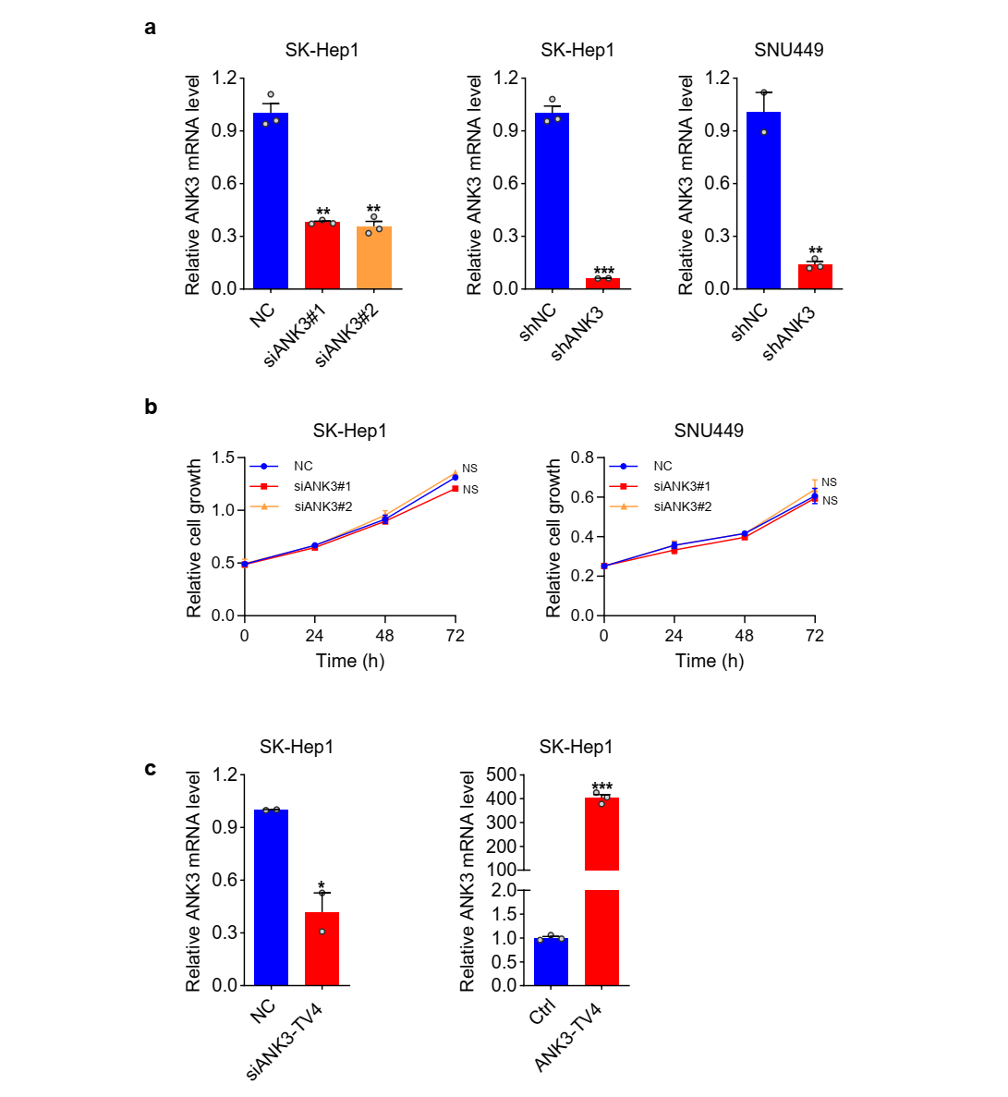
Supplementary Fig. 1. Knockdown of ANK3 has no effect on cell proliferation. (a) QRT-PCR analysis of ANK3 expression in SK-Hep1 cells transfected with NC or siANK3 (left) and shNC or shANK3 (middle), as well as SNU449 cells transfected with shNC or shANK3 (right). (b) MTS analysis of SK-Hep1 (left) and SNU449 (right) cells transfected with NC or siANK3. (c) QRT-PCR analysis of ANK3 expression in SK-Hep1 cells transfected with NC or siANK3-TV4 and ctrl (Empty Vector) or ANK3-TV4 overexpresssion vector. Data are shown as mean ± SEM, Student’s paired t test, *p<0.05, **p<0.01, ***p<0.001.
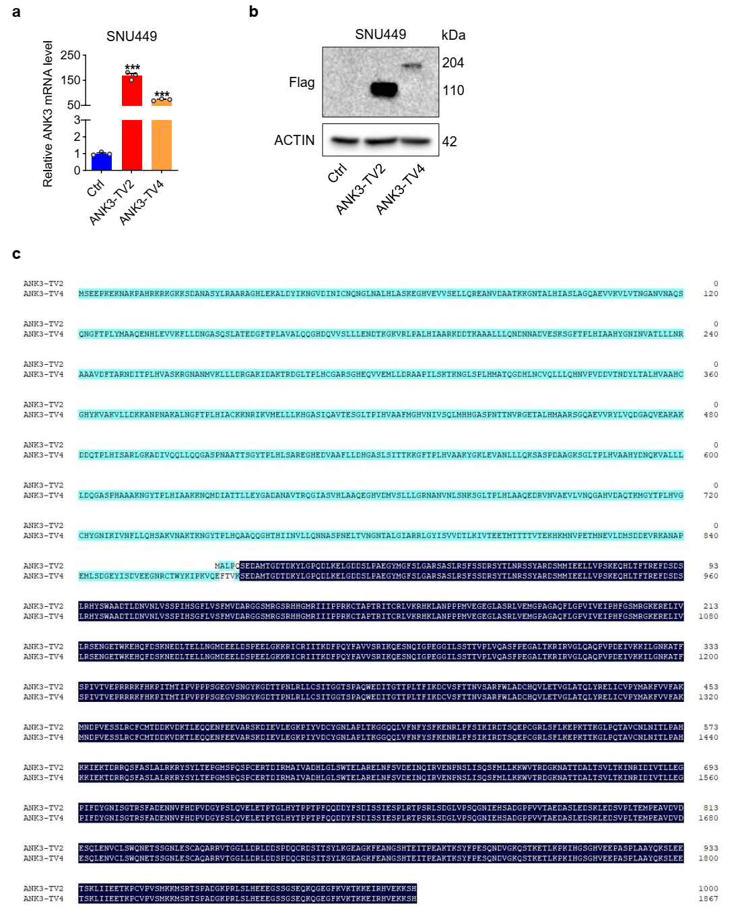
Supplementary Fig. 2. Validation of overexpression efficiency of ANK3-TV2 and ANK3-TV4. (a) mRNA levels of ANK3 in SNU449 cells transfected with ctrl (Empty Vector) or ANK3-TV2/ANK3-TV4 overexpresssion vectors. (b) Protein levels of ANK3 in SNU449 cells transfected with ctrl (Empty Vector) or ANK3-TV2/ANK3-TV4 overexpresssion vectors. (c) Amino acid sequence alignment diagram of TV2 with TV4. Data are shown as mean ± SEM, Student’s paired t test, ***p<0.001.
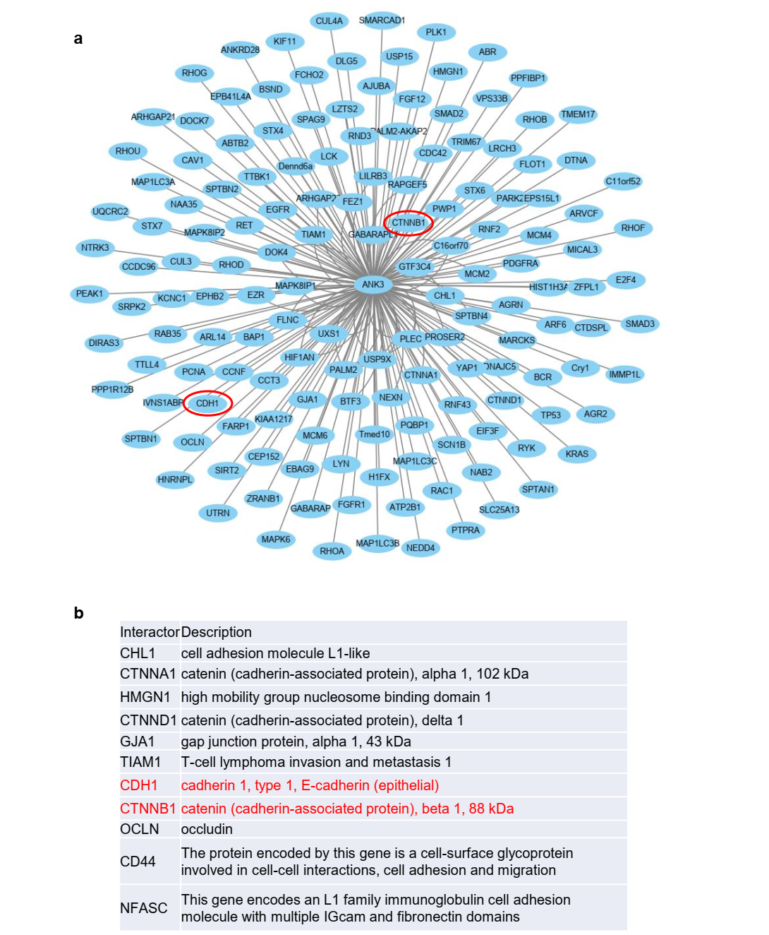
Supplementary Fig. 3. Potential interacting proteins of ANK3 were searched in the database. (a) Potential interacting protein profiles of ANK3 were searched in the BioGrid database. (b) Potential interacting proteins of ANK3 associated with metastasis were screened in the BioGrid database.

Supplementary Table 1. Sequences of siRNAs or shRNAs for ANK3 or RBM8A
Name | Sequence (5’ – 3’)
shANK3-top | CCGGACAACTCCTTTGACGTTTATACTCGAGTATAAACGTCAAAGGAGTTGTTTTTTG
shANK3-bottom | AATTCAAAAAACAACTCCTTTGACGTTTATACTCGAGTATAAACGTCAAAGGAGTTGT
shRBM8A-top | CCGGCGCTCTGTTGAAGGCTGGATTCTCGAGAATCCAGCCTTCAACAGAGCGTTTTTTG
shRBM8A-bottom | AATTCAAAAAACGCTCTGTTGAAGGCTGGATTCTCGAGAATCCAGCCTTCAACAGAGCG
shscramble-top | CCGGCAACAAGATGAAGAGCACCAACTCGAGTTGGTGCTCTTCATCTTGTTGTTTTT
shscramble-bottom | AATTAAAAACAACAAGATGAAGAGCACCAACTCGAGTTGGTGCTCTTCATCTTGTTGTTTTT
siANK3#1 | ACAACTCCTTTGACGTTTATA
siANK3#2 | GCCGTTTGGTAAAGAGACATA
siANK3-TV4 | GCTGAACAGGGCTACATTATT
siRBM8A#1 | CGCTCTGTTGAAGGCTGGATT
siRBM8A#2 | CATCAGCGTTGACTGGTGTTT

Supplementary Table 2. Sequences of RT-PCR primers
Name | Sequence (5’ – 3’)
A-F | ACCTGATTTAAAGGAAAGATGAGTG
A-R | AGGGCCTTTTCAAGGTGTCC
B-F | ACCTGATTTAAAGGAAAGATGAGTG
B-R | AGTAACTTGCATTGGCATCAGA
C-F | GTAAGTGAACTTGGCATTGGC
C-R | AGTAACTTGCATTGGCATCAGA
D-F | ACCTGATTTAAAGGAAAGATGAGTG
D-R | GCCAATGCCAAGTTCACTTAC
E-F | ACCTGATTTAAAGGAAAGATGAGTG
E-R | CTACAAAAGGAAAAGCAGAGGTT
Supplementary Table 3. Sequences of QRT-PCR primers of each ANK3 transcript
Name | Sequence (5’ – 3’)
Total-F | GGCTGGTAGAAATGGGTCCT
Total-R | GCTGTCAAACTGATGCTCCT
TV(1＋3＋4＋5)-F | AATGGGTTGAACGCTCTCCA
TV(1＋3＋4＋5)-R | TTTTACCACCTCTGCTTGCC
TV2-F | TAGAGGCTTGCCAGAGGAGTT
TV2-R | TTGACCACTTCGCAGACATCC
TV(1＋5)-F | CGTGTGTGCTTGAGAGGATC
TV(1＋5)-R | TGTAGTCGAGGGCCTTTTCA
TV3-F | GGAGGAGAGACTGGAGTTCC
TV3-R | TGTAGTCGAGGGCCTTTTCA
TV4 with RS-exon retention-F | GTAAGTGAACTTGGCATTGGC
TV4 with RS-exon retention-R | AGTAACTTGCATTGGCATCAGA
TV4 with RS-exon skipping-F | ACCCGTAAATGGACTTTGGTCTC
TV4 with RS-exon skipping-R | GCATTGGCATCAGACTTTCTTCCTT

Supplementary Table 4. Sequences of QRT-PCR primers
Name | Sequence (5’ – 3’)
β-Actin-F | CTACAATGAGCTGCGTGTGG
β-Actin-R | CCAGAGGCGTACAGGGATAG
PNN-F | ACGCTTTATTTGAAGGTAGACGC
PNN-R | CTCTAGCACATCCATAACTTCT
RNPS1-F | GGCTCCTTCACCTACCAAAC
RNPS1-R | CCGAGACCTGGTACTGCTG
MAGOH-F | GGAGCCATGGAGAGTGACTT
MAGOH-R | TCTTAACTTCCCGTCCGGTC
RBM8A-F | TCAGCCAGTCCACCTTTCTT
RBM8A-R | CCACCTCTCCTCTTGCCTT
eIF4A3-F | TGATGAATTGACTCTGGAAGGC
eIF4A3-R | TCAGCCAGTCCACCTTTCTT
β-catenin-F | GAAACGGCTTTCAGTTGAGC
β-catenin-R | CTGGCCATATCCACCAGAGT
TCF4-F | CACTGCCGACTACAATAGG
TCF4-R | GGACTGTGGAATATGAGAAGA
CCND1-F | CCTCGGTGTCCTACTTCA
CCND1-R | CTCCTCGCACTTCTGTTC
MYC-F | AGCCACAGCATACATCCT
MYC-R | CGCACAAGAGTTCCGTAG
VEGFC-F | TGTGTCCAGTGTAGATGAAC
VEGFC-R | TATGTTGCCAGCCTCCTT
BMP4-F | CCTCAACTCAACCAACCAT
BMP4-R | TACCACCTTATCATACTCATCC
MMP7-F | CAGGCTCAGGACTATCTCA
MMP7-R | ACATTCCAGTTATAGGTAGGC

