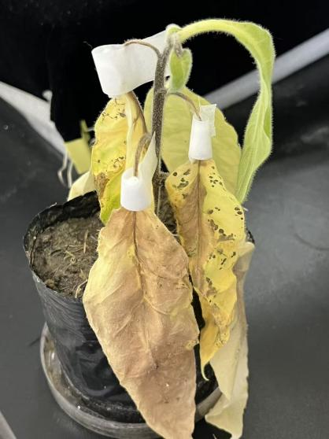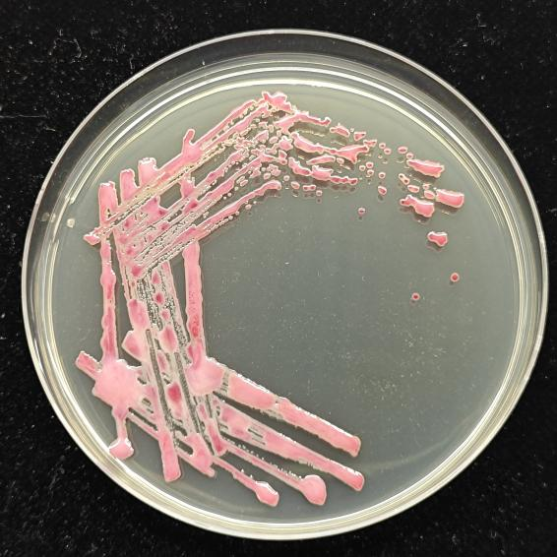
b

a

Supplementary Fig. 1. Bacterial Wilt Retransplantation Test Diagram. (a) Tobacco Wilt Diagram. (b) R. pseudosolanacearum plate diagram.
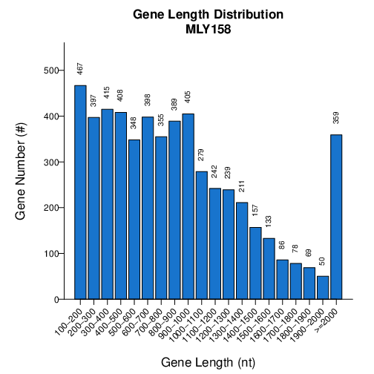
Supplementary Fig. 2. Gene Length Distribution.
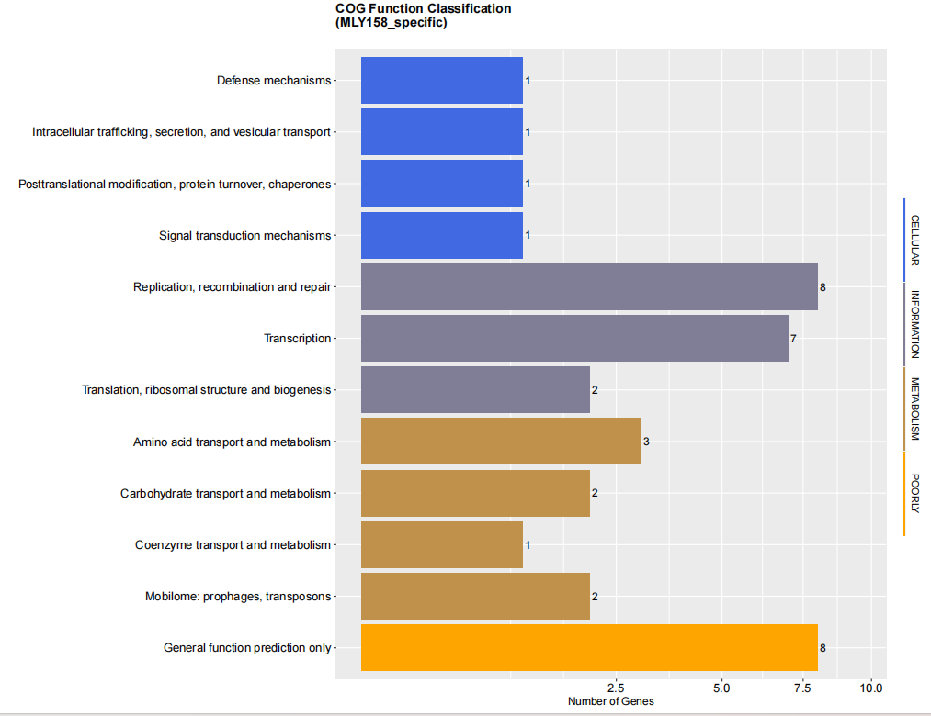
Supplementary Fig. 3. MLY158 COG specific genes.

Supplementary Table 1. Gene annotation rate.
Sample Name (#) | Total (#) | VFDB (#) | ARDB (#) | CAZY (#) | IPR (#) | SWISSPROT (#) | COG (#) | CARD (#) | GO (#) | KEGG (#) | NR (#) | T3SS (#) | OverAll (#)
MLY158 | 5,485 | 478 (8.71%) | 27 (0.49%) | 108 (1.96%) | 4,309 (78.55%) | 2,040 (37.19%) | 3,940 (71.83%) | 3 (0.05%) | 3,060 (55.78%) | 3,097 (56.46%) | 5,369 (97.88%) | 861 (15.69%) | 5,404 (98.52%)

Supplementary Table 2. Synteny rates at nucleic acid level.
 | RS-SL2064 | RS-Rs5 | RS-T95 | CFBP2957 | CMR15 | GMI1000 | PSI07 | Po82 | RS-UW251 | RS-CIAT078
MLY158 | 79.507 | 76.205 | 79.535 | 74.192 | 82.262 | 91.191 | 78.889 | 76.342 | 74.266 | 76.160
pMLY158 | 65.173 | 56.666 | 65.173 | 62.956 | 81.484 | 94.742 | 67.351 | 60.948 | 62.657 | 60.230

Supplementary Table 3. Synteny statistics at amino acid level between MLY158 and reference strains.
 | RS-SL2064 | RS-Rs5 | RS-T95 | CFBP2957 | CMR15 | GMI1000 | PSI07 | Po82 | RS-UW251 | RS-CIAT078
Aligned | 3905 | 3734 | 3913 | 3852 | 4053 | 4433 | 3909 | 3843 | 3838 | 3720
Target Genes | 5485 | 5485 | 5485 | 5485 | 5485 | 5485 | 5485 | 5485 | 5485 | 5485
Target Perc (%) | 71.19 | 68.08 | 71.34 | 70.23 | 73.89 | 80.82 | 71.27 | 70.06 | 69.97 | 67.82
Query Genes | 4719 | 4560 | 4729 | 5065 | 5123 | 5109 | 4967 | 4649 | 4758 | 4548
Query Perc (%) | 82.75 | 81.89 | 82.74 | 76.05 | 79.11 | 86.77 | 78.70 | 82.66 | 80.66 | 81.79
Identity Mean | 92.51 | 91.10 | 92.52 | 90.98 | 96.01 | 98.86 | 92.36 | 91.11 | 91.14 | 91.07
Identity Median | 94.59 | 93.40 | 94.59 | 93.47 | 97.74 | 99.66 | 94.59 | 93.52 | 93.48 | 93.48

