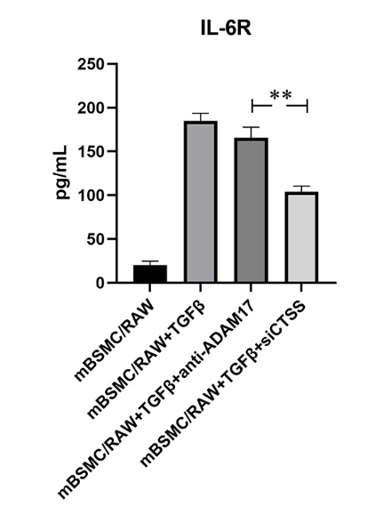
Supplementary Fig. 1. CTSS play a major role in activated CTSS/sIL-6R/IL-6 trans-signaling. CTSS played a greater effect on the secretion of sIL-6R induced by TGFβ in vitro. The data are expressed as the mean ± SEM, and n = 3 for each group. **P<0.01vs siCTSS group.

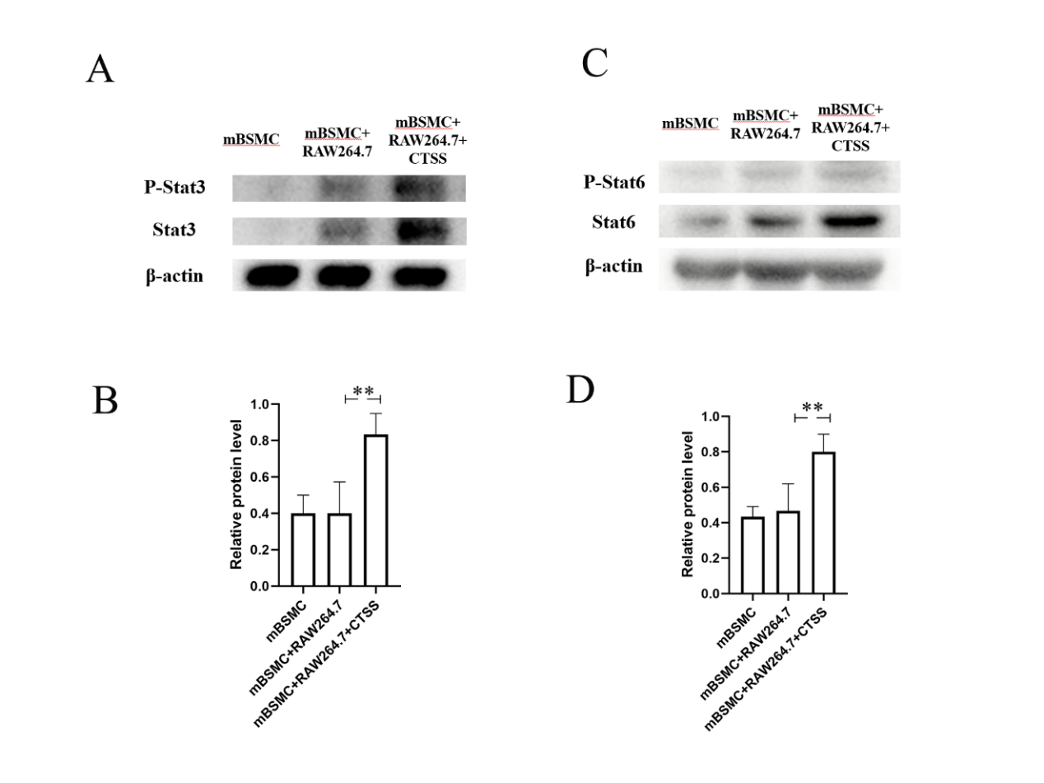
Supplementary Fig. 2. CTSS activated Stat pathway in smooth muscle cells/monocytes co-culture cell system. A-B. Stat3 phosphorylation level; C-D. Stat6 phosphorylation level. The data are expressed as the mean ± SEM, and n = 3 for each group. **P<0.01vs non-CTSS group.

