Supplementary Fig. 1
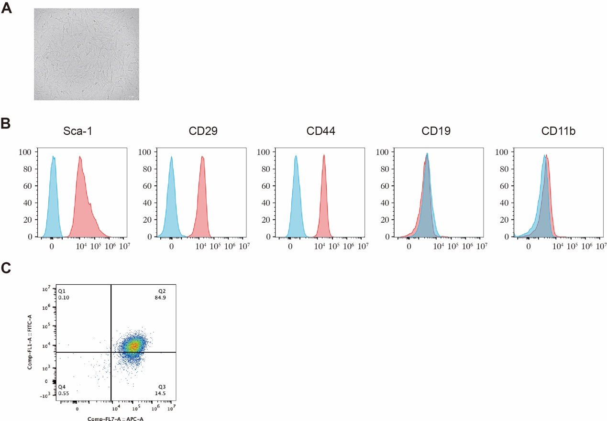
Supplementary Fig. 1. (A) Microscopy for morphology of MSCs. (B) Flow cytometric analysis of MSCs surface marker expression (Sca1 / CD29 / CD44 / CD19 / CD11b).

Supplementary Fig. 2
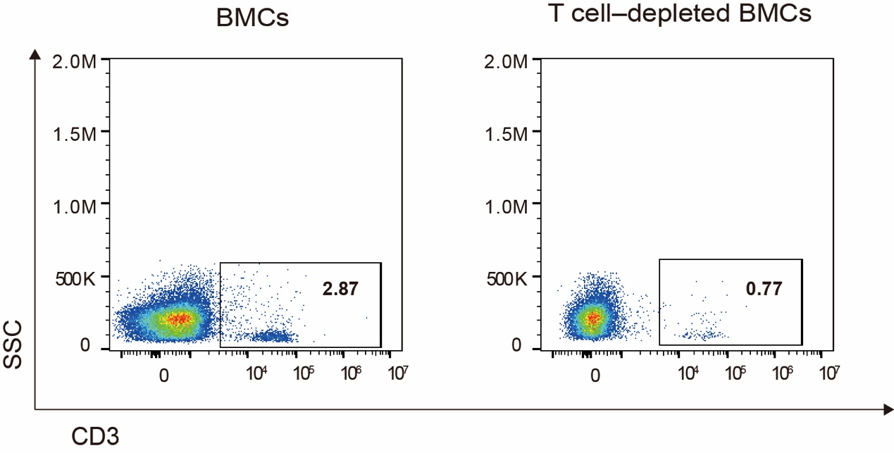
Supplementary Fig. 2. Flow cytometric analysis of CD3⁺ T cells proportion in BMCs or TCD-BMCs.

Supplementary Fig. 3
Supplementary Fig. 3. Flow cytometric analysis of CD11b+F4/80+ double-positive cells proportion within cells from peritoneal lavage fluid.

Supplementary Fig. 4
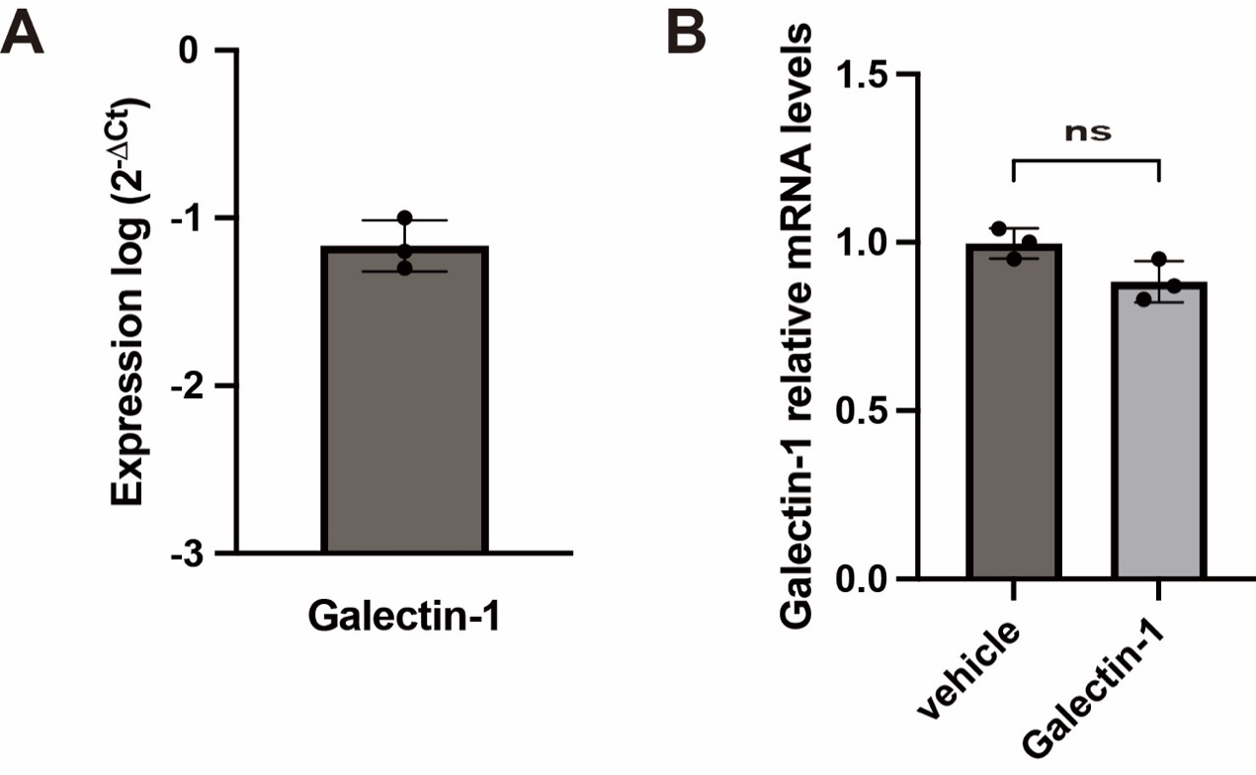
Supplementary Fig. 4. The mRNA expression of Galectin-1 in MSCs by qPCR. A. The relative expression level was normalized to expression of β-actin RNA. B. MSCs were treated with TD139 at a concentration of 100uM for 48h. Data were pooled from 3 independent experiments. Data are presented as the mean ± SD.

Supplementary Fig. 5
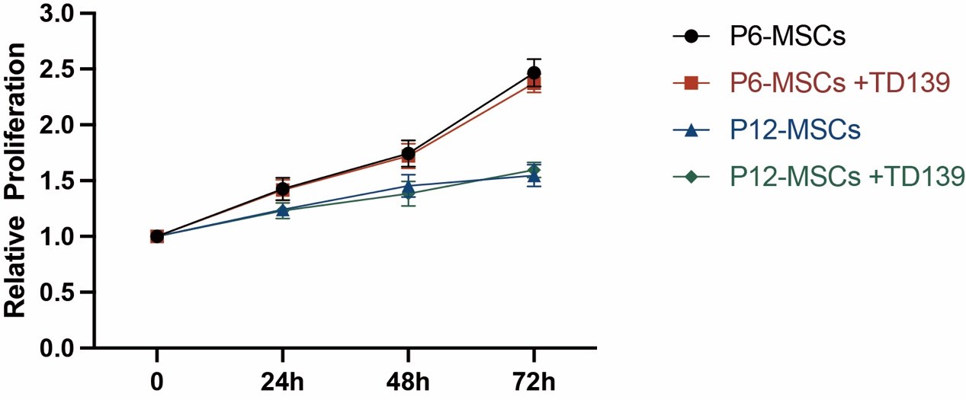
Supplementary Fig. 5. Effect of TD139 on proliferation and viability of MSCs. MSCs at different passages were treated with DMSO or TD139 (100 μM) for 72 h. Proliferation of MSCs was assessed at 24, 48, and 72 h by CCK-8 kit. Data were pooled from 3 independent experiments.

Supplementary Fig. 6
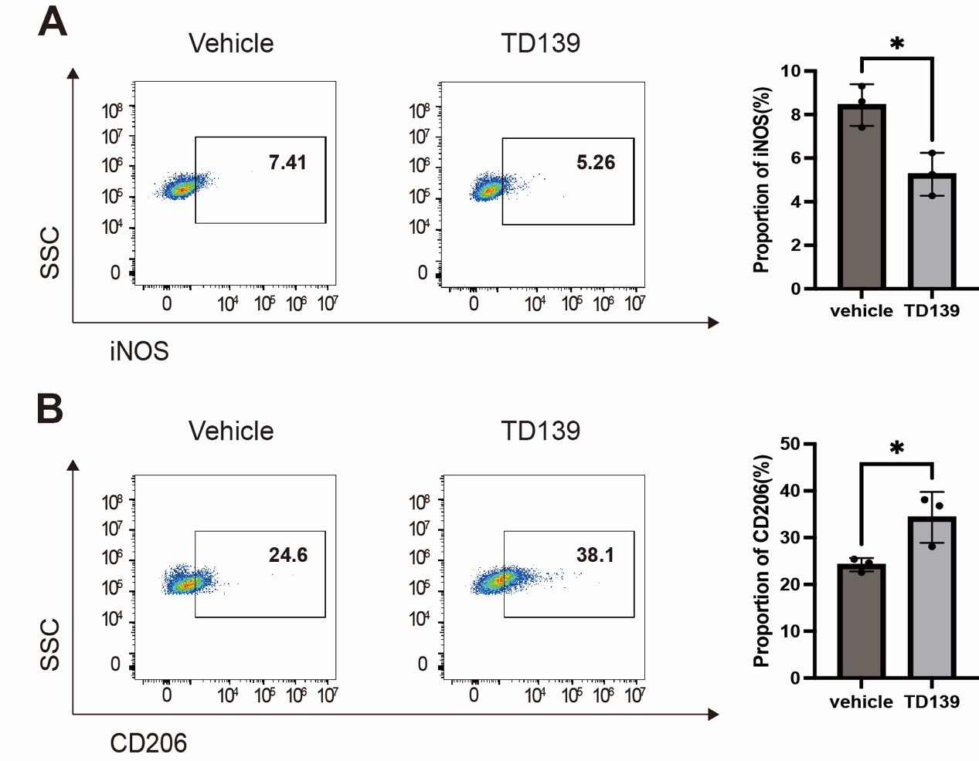
Supplementary Fig. 6. Effects of TD139 on macrophages polarization. Raw 264.7 macrophages were treated with vehicle or TD139 (100 μM) for 48 h. (A) Flow cytometry analysis of iNOS⁺ M1 macrophage proportion in Raw264.7 macrophages. (B) Flow cytometry analysis of CD206⁺ M2 macrophage proportion in Raw264.7 macrophages. Data were pooled from 3 independent experiments.

