Supplementary Figures

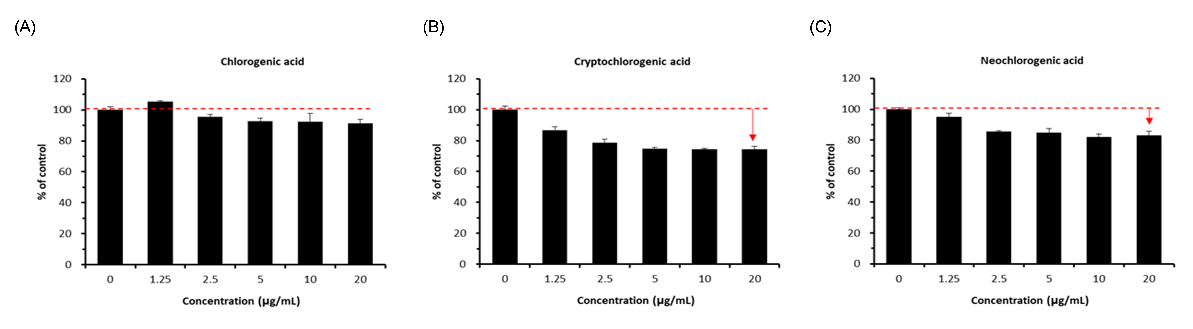
Supplementary Fig. 1. NADH dehydrogenase activity of chlorogenic acid and its isomers in corneal epithelial cells. NADH dehydrogenase activity was assessed after 24 h treatment with (A) chlorogenic acid, (B) cryptochlorogenic acid, or (C) neochlorogenic acid at the indicated concentrations (1.25–20 μg/mL). Chlorogenic acid demonstrated no significant mito-toxicity across the tested concentrations, whereas cryptochlorogenic acid and neochlorogenic acid induced dose-dependent reductions in NADH dehydrogenase activity. Data are presented as mean ± SD from three independent experiments.

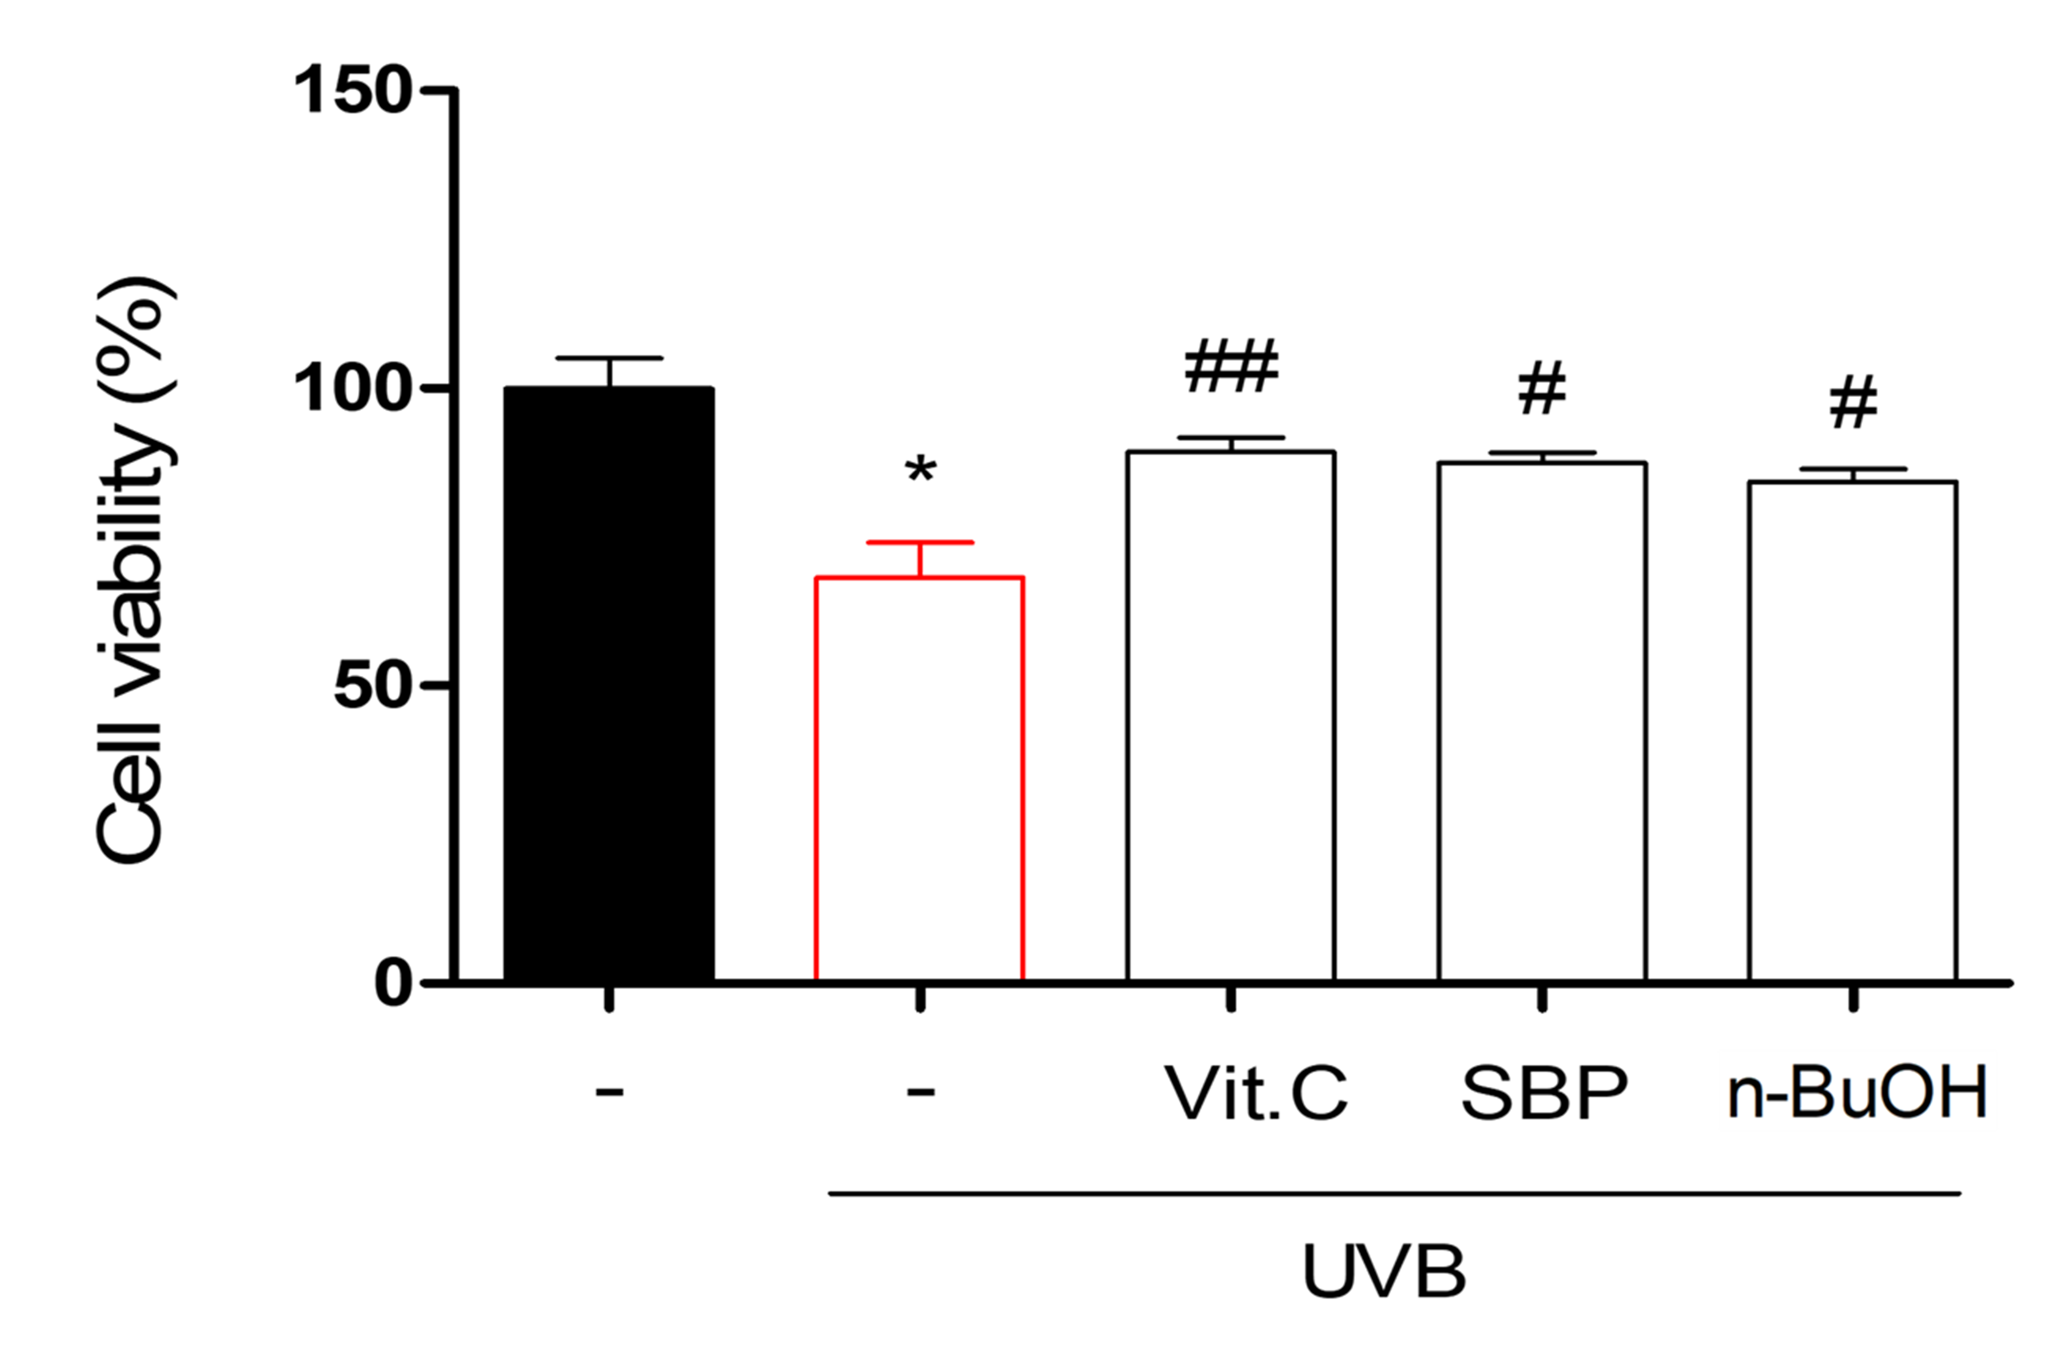
Supplementary Fig. 2. Comparative analysis of SBP and representative antioxidants on UVB-induced cytotoxicity in corneal epithelial cells. Cells were pretreated with vitamin C, SBP extract, or its n-BuOH fraction (20 μg/mL) for 24 h before UVB exposure, and cell viability was subsequently measured using the MTT assay. UVB irradiation significantly reduced cell viability (*p < 0.05 vs. control), while pretreatment with vitamin C, SBP, or n-BuOH fraction markedly restored cell survival (#p < 0.05, ##p < 0.01 vs. UVB group). SBP exhibited a comparable or slightly higher protective effect relative to vitamin C. Data represent mean ± SEM from three independent experiments.

Supplementary Method

Cell culture and treatments
Human corneal epithelial cells were cultured in Dulbecco’s modified Eagle medium (DMEM) supplemented with 10% heat-inactivated fetal bovine serum and 1% penicillin/streptomycin in a humidified atmosphere of 95% air and 5% CO₂ at 37 °C. Cells were seeded in 96-well plates at a density of 1 × 10⁴ cells/well and allowed to adhere overnight. Cells were then treated with SBP extract or its solvent fractions for 24 h; alternatively, cells were pretreated with the samples for 1 h and subsequently exposed to 150 mJ/cm² UVB irradiation using TL20W/12RS UVB lamps (Philips, Eindhoven, Netherlands) equipped with UV-C cut filters, followed by incubation for 23 h. The UVB intensity was measured and calibrated using a radiometer (E202850, Analytik Jena, USA). All human corneal epithelial cells used in this study were authenticated by tested negative for mycoplasma contamination.

Measurement of nicotinamide adenine dinucleotide dehydrogenase activity
Nicotinamide adenine dinucleotide (NADH) dehydrogenase activity, an indicator of mitochondrial metabolic function, was assessed using a Cell Counting Kit-8 (CCK-8; Dojindo, Kumamoto, Japan) according to the manufacturer’s instructions. Human corneal epithelial cells were seeded in 96-well plates and treated with SBP extract or its solvent fractions, with or without UVB irradiation (150 mJ/cm²). After treatment, 10 μL of the CCK-8 reagent was added to each well and incubated for 2 h at 37 °C. The absorbance was measured at 450 nm using a microplate reader (SpectraMax Gemini EM, Molecular Devices, CA, USA). The data were expressed as a percentage of the untreated control group.

Measurement of mitochondrial morphology and membrane potential (Δψm)
Corneal epithelial cells were seeded on coverslips in 24-well plates and treated with the indicated concentrations of SBP extract or its solvent fractions under UVB exposure for 24 h. For mitochondrial morphology analysis, cells were fixed with 4% paraformaldehyde at 25 °C for 30 min, rinsed with PBS, and incubated with MitoTracker dye (1:1000 dilution; Invitrogen, USA) for 15 min at room temperature. For the measurement of mitochondrial membrane potential (Δψm), cells were incubated with 5,5′,6,6′-tetraethylbenzimidazolyl-carbocyanine iodide (JC-1; Thermo Fisher Scientific, USA) at 37 °C for 30 min, washed twice with PBS, and mounted on slides using fluorescence mounting medium. Representative fluorescence images were acquired using a fluorescence microscope (Olympus Microscope System BX51, Olympus Corporation, Tokyo, Japan). The red (aggregated) and green (monomeric) fluorescence intensities were quantified at excitation/emission wavelengths of 485/535 nm using a fluorescence microplate reader (SpectraMax Gemini EM, Molecular Devices, Sunnyvale, CA, USA). Data were expressed as the ratio of red/green fluorescence relative to the untreated control. To ensure reproducibility, all experiments were independently performed in triplicate.

Corneal fluorescein staining, histology, and apoptosis analysis
Corneal damage was evaluated on day 2 after UVB exposure using fluorescein sodium staining. Briefly, 1 μL of 0.5% fluorescein sodium solution was instilled into the conjunctival sac of each mouse eye, and the corneal surface was gently rinsed with sterile saline after 1 min. The stained corneas were immediately imaged and analyzed using optical coherence tomography. Epithelial damage was graded on a standardized 0–4 scale (0 = no staining; 1 = slight punctate staining; 2 = moderate diffuse punctate staining; 3 = severe punctate staining with larger areas involved; 4 = confluent staining with severe epithelial loss). Two independent investigators, blinded to group allocation, performed the scoring. Representative images were archived with a digital imaging system. Following terminal assessments, animals were euthanized under deep anesthesia as described above (alfaxalone [Alfaxan] + xylazine [Rompun], 3:1 mixture; 30 mg/kg alfaxalone + 10 mg/kg xylazine, i.p.; terminal overdose followed by cervical dislocation). Whole globes were enucleated, fixed in 10% neutral-buffered formalin for 24 h, and processed for paraffin embedding. Serial sagittal sections (5 μm) were mounted on glass slides. For histology, sections were stained with hematoxylin and eosin (H&E) to assess overall corneal structure, epithelial thickness, stromal integrity, and inflammatory cell infiltration. Microscopy was performed using an Olympus BX51 (Olympus Corporation, Tokyo, Japan). Epithelial thickness was quantified at three randomly selected regions per cornea using ImageJ (NIH, USA). Apoptosis was detected by TUNEL using the In Situ Cell Death Detection Kit, POD (Roche, Mannheim, Germany) according to the manufacturer’s instructions. After deparaffinization, rehydration, and proteinase K permeabilization, sections were incubated with terminal deoxynucleotidyl transferase and labeled nucleotides, followed by peroxidase-conjugated anti-label antibody and development with a DAB chromogen for brown reaction product visualization. Slides were counterstained with hematoxylin, dehydrated, and a coverslip was added. TUNEL-positive nuclei were quantified in at least five randomly selected high-power fields per cornea using bright-field microscopy, and results were expressed as the percentage of TUNEL-positive cells relative to total nuclei.

