Supplementary materials
Supplementary Figure

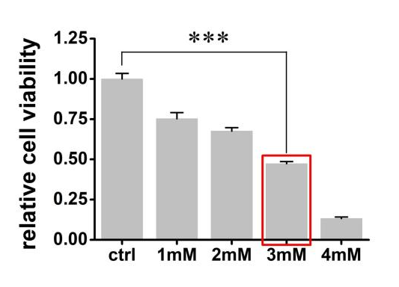
Supplementary Fig. 1. Dose-dependent impact of UA on HK-2 cell viability.
CCK-8 assay was used to assess the effect of different concentrations of UA (0, 1, 2, 3, 4 mM) on HK-2 cell viability after 24 hours of treatment. UA: Uric acid; HK-2: Human renal proximal tubular epithelial cells; CCK-8: Cell Counting Kit-8. The data are presented as the mean ± SD with a sample size of n = 3. Statistics were done using two-way ANOVA followed by Bonferroni's test. ***P < 0.001.

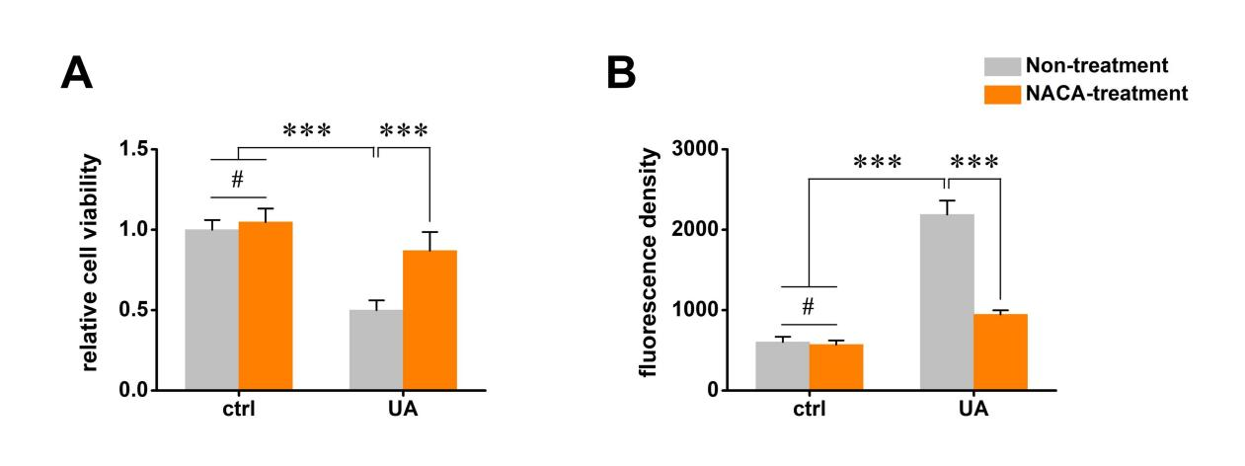
Supplementary Fig. 2. NACA alleviates UA-induced loss of cell viability and oxidative stress.
(A) Cell viability was measured by CCK-8 assay in HK-2 cells treated as follows: Control, NACA, UA, and UA+NACA. (B) Intracellular ROS levels were detected using the DCFH-DA fluorescence probe under the same treatment conditions. NACA: N-acetylcysteine; UA: Uric acid; CCK-8: Cell Counting Kit-8; HK-2: Human renal proximal tubular epithelial cells; ROS: Reactive oxygen species; DCFH-DA: 2',7'-Dichlorodihydrofluorescein diacetate. Data are presented as mean ± SD (n=3). Statistical analysis was performed using two-way ANOVA followed by Bonferroni's test. ***P < 0.001 and # not significant.

