Supplementary Table 1. The effect of mutation on waa H function and mutational sensitivity.
The 3D structure of mutated waa H gene |  | Expected biological function
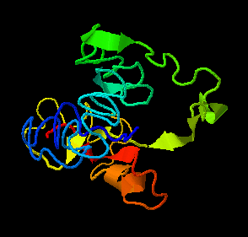  image colored by rainbow N → C terminus  Model dimensions (Å):X:42.358 Y:28.660 Z:76.673 |  | Putative membrane antigen.
The secondary structure of mutated waa H gene
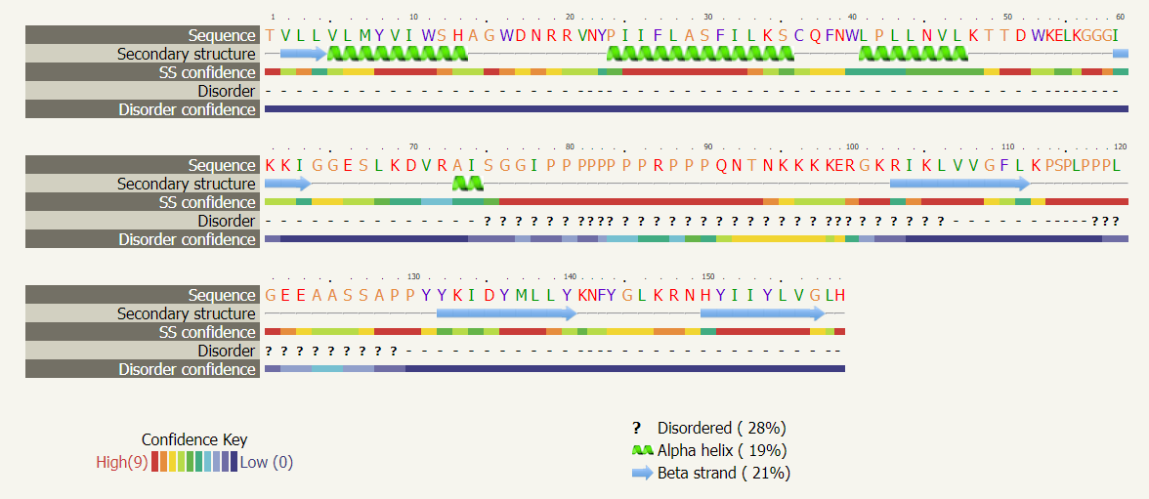
Function conservation of mutated waa H gene | Conserve amino acid residues in mutated protein |  | Position in the sequence
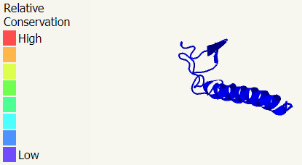 | Y, W, H, W, Y, P, C, W, P, W |  | 8, 11, 14, 16, 23, 24, 36, 40, 42, 52
Mutational sensitivity of mutated waa H gene | Highly sensitive amino acid residues in mutated protein |  | Position in the sequence
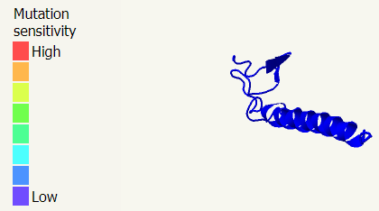 | W, H, W, Y, P, C, W, P, W, |  | 11, 14, 16, 23, 24, 36, 40, 42, 52
The 3D structure of wild type waa H gene |  | Expected biological function
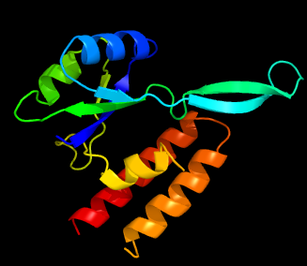  image colored by rainbow N → C terminus |  | transcriptional activator waa H
  Model dimensions (Å): | X:48.304 Y:39.098 Z:48.825
The secondary structure of mutated waa H gene
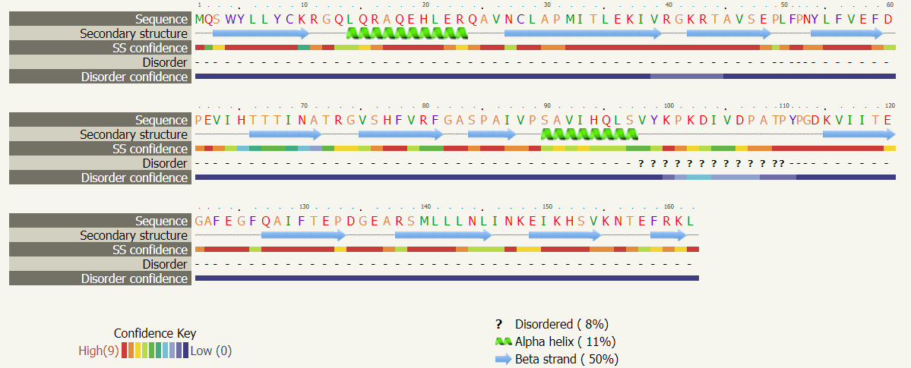
Function conservation of WILD type waa H gene | Conserve amino acid residues in wild type protein |  | Position in the sequence
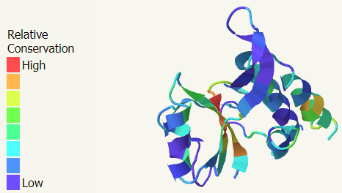 | M, W, Y, L, L, P, F, T, F, P |  | 1, 4, 5, 14, 29, 31, 36, 66, 78, 85
Mutational sensitivity of mutated waa H gene | Highly sensitive amino acid residues in mutated protein |  | Position in the sequence
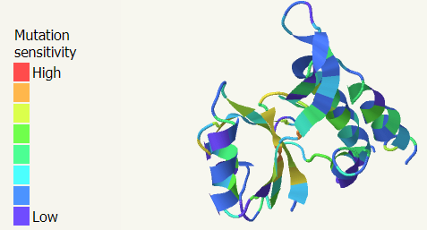 | M, W, Y, L, L, P, P, Y, F, T, F, P, A, F |  | 1, 4, 5, 14, 29, 31, 52, 64, 56, 66, 78, 85, 122, 123

Supplementary Table 2. The effect of mutation on waaK function and mutational sensitivity.
The 3D structure of mutated waa K gene |  | Expected biological function
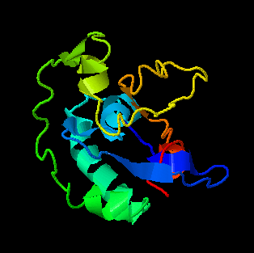  image colored by rainbow N → C terminus |  | Transcription factor mbp1.
  Model dimensions (Å): | X:40.215 Y:40.056 Z:35.489
The secondary structure of mutated waa K gene
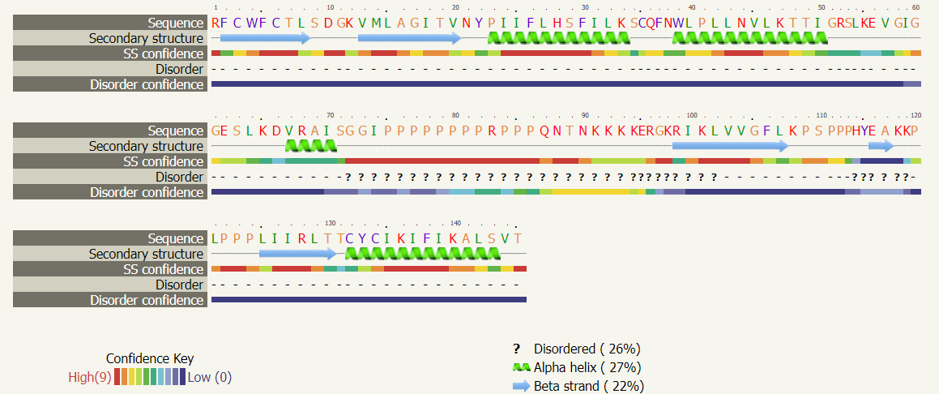
Function conservation of mutated waa K gene | Conserve amino acid residues in mutated protein |  | Position in the sequence
Non | Non |  | Non
Mutational sensitivity of mutated waa K gene | Highly sensitive amino acid residues in mutated protein |  | Position in the sequence
Non | Non |  | Non
The 3D structure of wild type waa K gene |  | Expected biological function
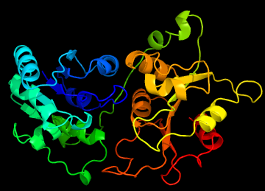  image colored by rainbow N → C terminus |  | UDP-Glycosyltransferase/glycogen phosphorylase
  Model dimensions (Å): | X:42.973 Y:60.945 Z:56.930
The secondary structure of wild type waaK gene
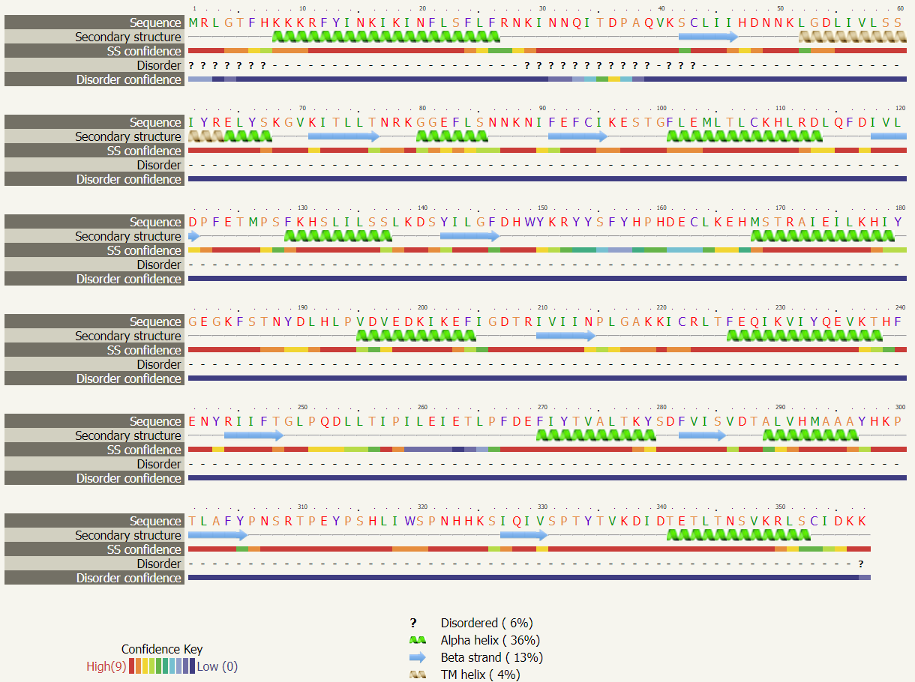
Function conservation of WILD type waa K gene | Conserve amino acid residues in wild type protein |  | Position in the sequence
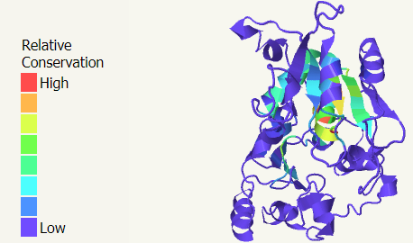 | M, C, H, G, D, S, K, I, L, K, F, D, L, |  | 1, 43, 47, 53, 54, 60, 78, 72, 74, 88, 101, 117, 120
Mutational sensitivity of mutated waa K gene | Highly sensitive amino acid residues in mutated protein |  | Position in the sequence
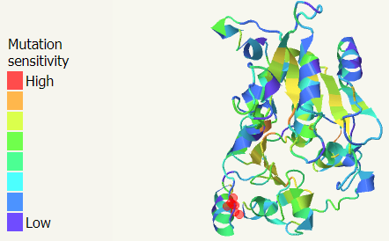 | M, C, H, G, D, S, K, I, L, K, F, F, D, L, |  | 1, 43, 47, 53, 54, 60, 68, 72, 74, 88, 101, 116, 117, 120

Supplementary Table 3. The effect of mutation on waa L function and mutational sensitivity.
The 3D structure of mutated waa L gene |  | Expected biological function
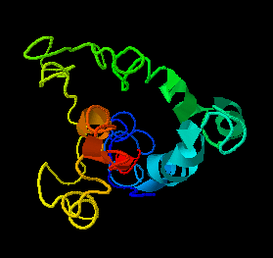  image colored by rainbow N → C terminus |  | beta-galactosidase.
  Model dimensions (Å): | X:40.215 Y:40.056 Z:35.489
The secondary structure of mutated waa L gene
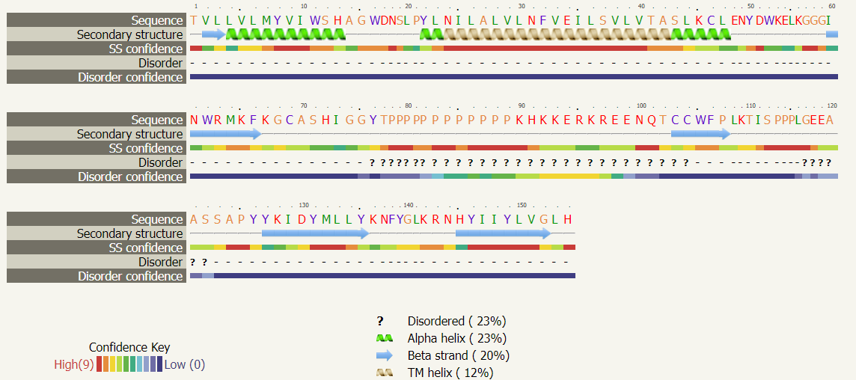
Function conservation of mutated waa L gene | Conserve amino acid residues in mutated protein |  | Position in the sequence
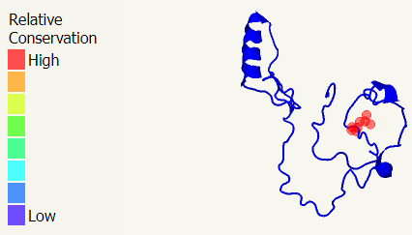 | Y, W, H, W, P, Y, C, W, W, C, H, Y, C, W |  | 8, 11, 13, 16, 21, 22, 46, 52, 62, 79, 72, 76, 103, 105,
Mutational sensitivity of mutated waa L gene | Highly sensitive amino acid residues in mutated protein |  | Position in the sequence
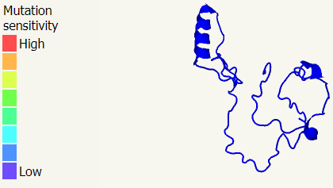 | Y, W, H, W, P, Y, C, W, W, C, I, C, W |  | 8, 11, 13, 16, 21, 22, 46, 52, 62, 69, 73, 104, 105
The 3D structure of wild type waa L gene |  | Expected biological function
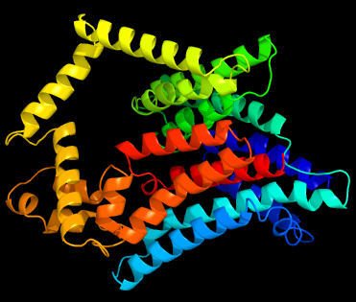  image colored by rainbow N → C terminus |  | putative cell suwaaIce polysaccharide polymerase/ligase; single-particle cryo-em structure of the waa l o-antigen ligase in its2 ligand bound state
  Model dimensions (Å): | X:65.307 Y:56.301 Z:60.449
The secondary structure of wild type waa L gene
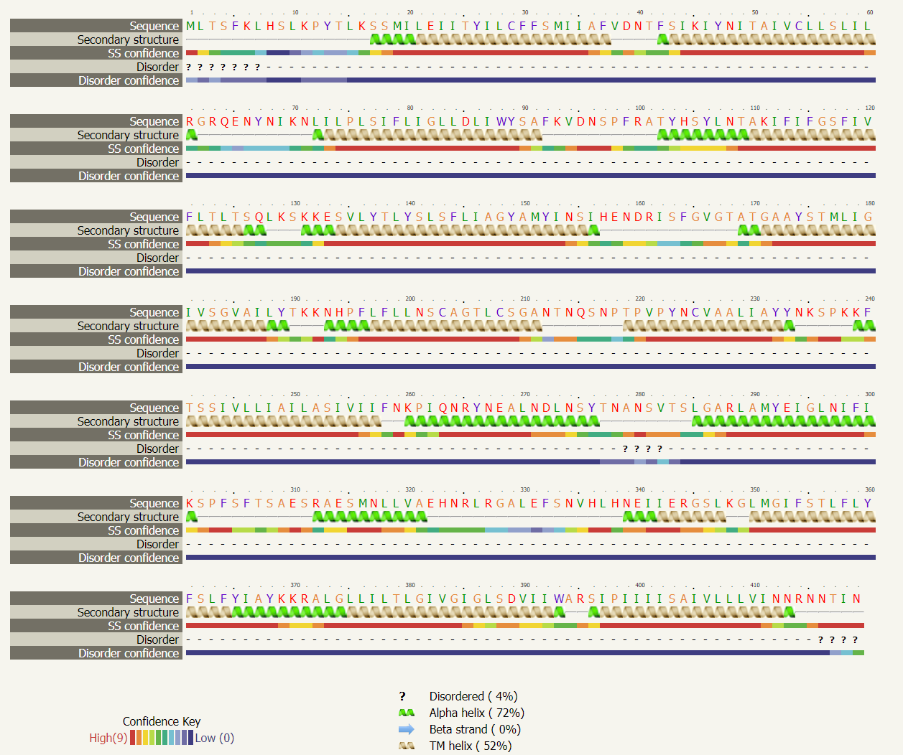
Function conservation of WILD type waa L gene | Conserve amino acid residues in wild type protein |  | Position in the sequence
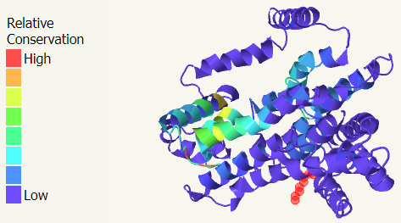 | M, H, Y, C, W |  | 1, 8, 26, 29, 88
Mutational sensitivity of mutated waa L gene | Highly sensitive amino acid residues in mutated protein |  | Position in the sequence
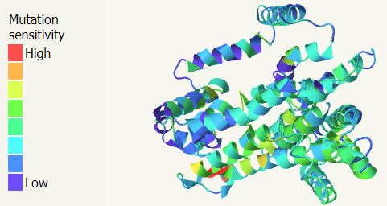 | M, H, Y, C, L, W, Y, R, Q, P, R |  | 1, 8, 26, 29, 88, 152, 161, 215, 218, 265

Supplementary Table 4. The effect of mutation on waa Z function and mutational sensitivity.
The 3D structure of mutated waa Z gene |  | Expected biological function
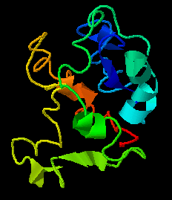  image colored by rainbow N → C terminus |  | conserved domain protein
  Model dimensions (Å): | X:24.922 Y:32.347 Z:29.648
The secondary structure of mutated waa Z gene
Function conservation of mutated waa Z gene | Conserve amino acid residues in mutated protein |  | Position in the sequence
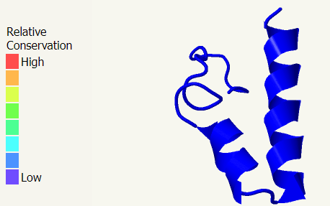 | Y, W, W, C, W, W, C, W |  | 8, 11, 16, 46, 52, 62, 104, 105
Mutational sensitivity of mutated waa Z gene | Highly sensitive amino acid residues in mutated protein |  | Position in the sequence
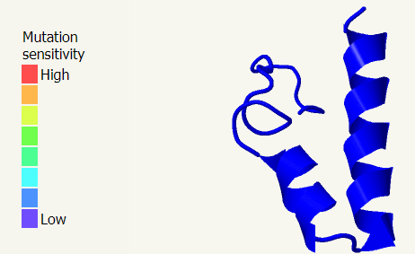 | W, W, C, W, W, C, C, W, |  | 11, 16, 46, 52, 62, 69, 104, 105
The 3D structure of wild type waa Z gene |  | Expected biological function
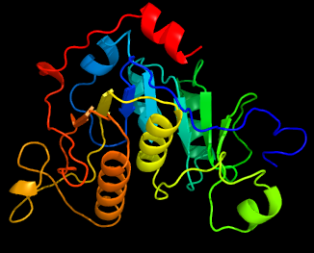  image colored by rainbow N → C terminus |  | glycosyltransferase
  Model dimensions (Å): | X:41.844 Y:56.301 Z:49.144
The secondary structure of wild type waa Z gene
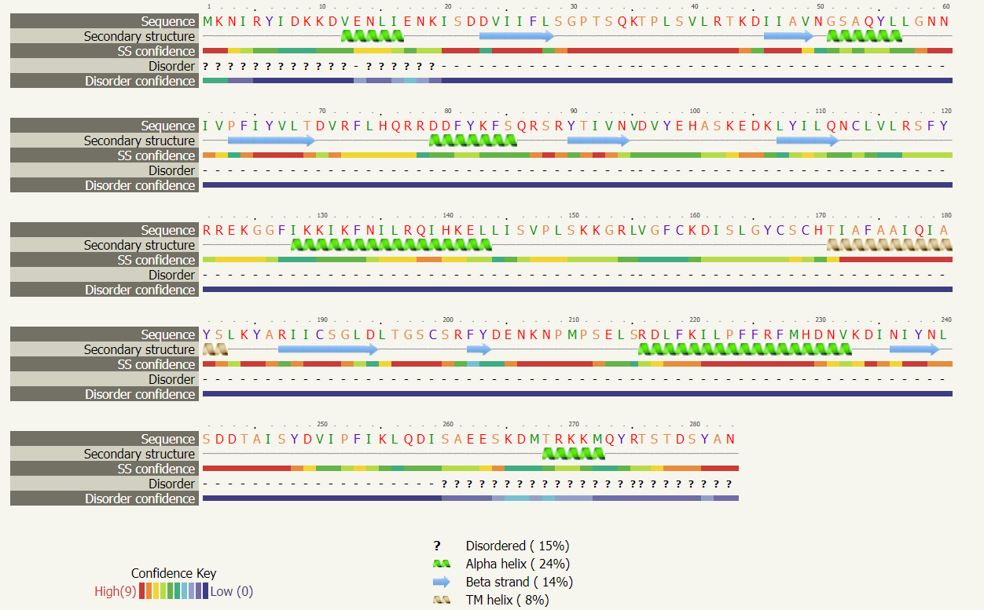
Function conservation of WILD type waa Z gene | Conserve amino acid residues in wild type protein |  | Position in the sequence
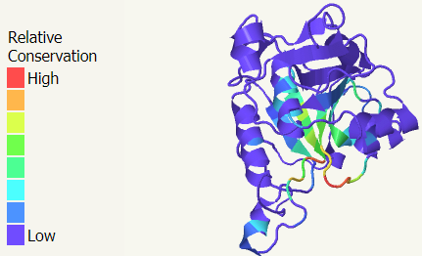 | I, P, Y, D, Q, L, I, G, D |  | 61, 63, 66, 178, 183, 188, 192, 194,
Mutational sensitivity of mutated waa Z gene | Highly sensitive amino acid residues in mutated protein |  | Position in the sequence
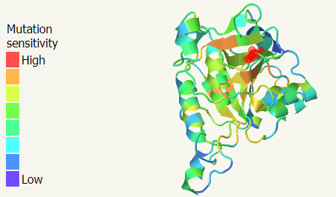 | G, P, N, P, G, D |  | 30, 31, 50, 62, 192,

Supplementary Table 5. The effect of mutation on waaY function and mutational sensitivity.
The 3D structure of mutated waa Y gene |  | Expected biological function
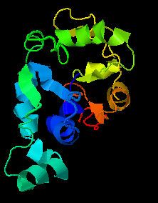  image colored by rainbow N → C terminus |  | Transferase protein
  Model dimensions (Å): | X:33.344 Y:52.031 Z:27.218
The secondary structure of mutated waa Y gene
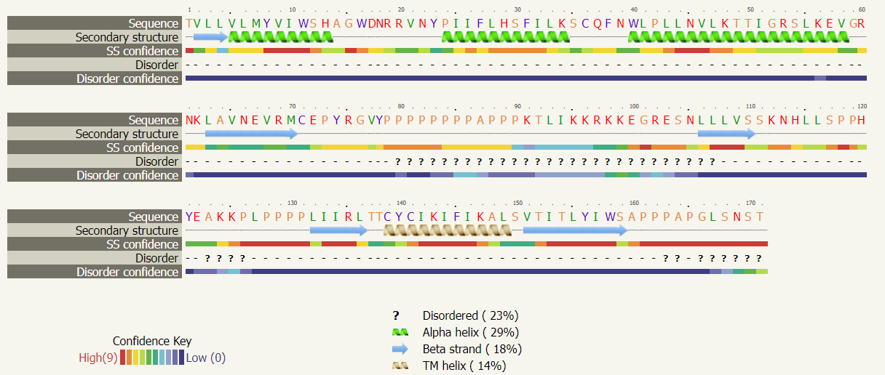
Function conservation of mutated waa Y gene | Conserve amino acid residues in mutated protein |  | Position in the sequence
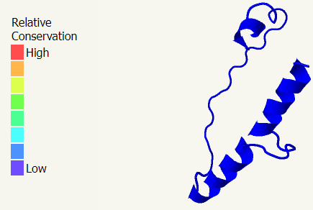 | W, W, C, W, C, W |  | 11, 16, 36, 40, 71, 159
Mutational sensitivity of mutated waa Y gene | Highly sensitive amino acid residues in mutated protein |  | Position in the sequence
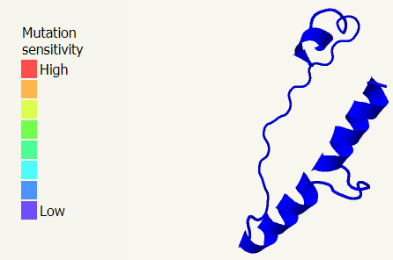 | W, W, C, W, C, C, W |  | 11, 16, 36, 40, 71, 141, 158
The 3D structure of wild type waa Y gene |  | Expected biological function
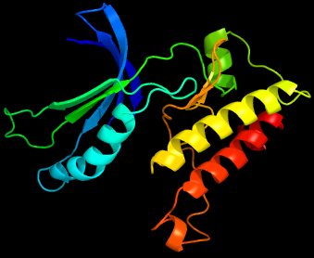  image colored by rainbow N → C terminus |  | LPS core heptose (II) kinase
  Model dimensions (Å): | X:47.053 Y:64.719 Z:48.441
The secondary structure of wild type waa Y gene
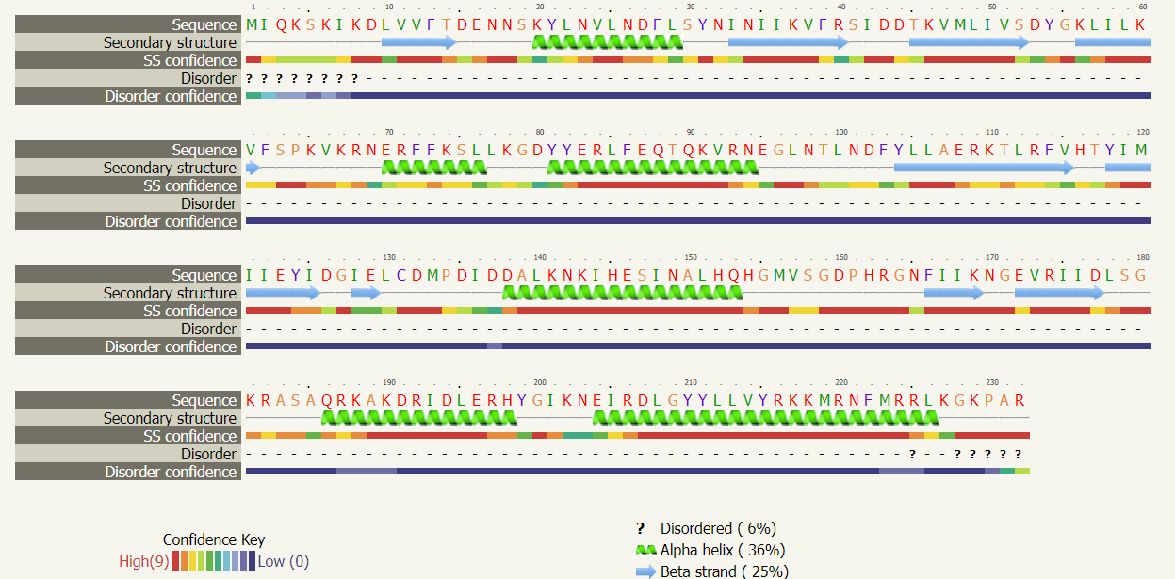
Function conservation of WILD type waa Y gene | Conserve amino acid residues in wild type protein |  | Position in the sequence
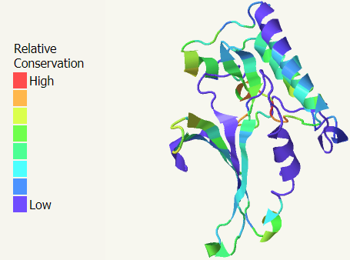 | K, Y, H, S, D, H, N |  | 60, 124, 192, 178, 160, 162, 165
Mutational sensitivity of mutated waa Y gene | Highly sensitive amino acid residues in mutated protein |  | Position in the sequence
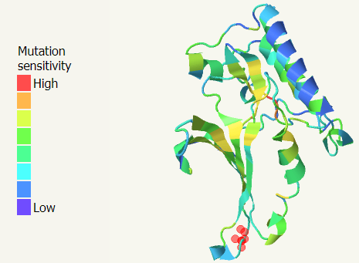 | G, F, H |  | 127, 178, 198

Supplementary Table 6. Topology and characteristics of mutated E. coli compared to the wild type.
The 3D structure of mutated waa gene |  | Expected biological function
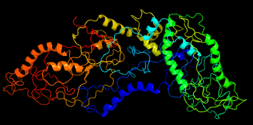  image colored by rainbow N → C terminus |  | Putative membrane antigen
  Model dimensions (Å): | X:111.214 Y:67.138 Z:102.658
The secondary structure of mutated waa gene
Function conservation of mutated waa gene | Conserve amino acid residues in mutated protein |  | Position in the sequence
 | Uncharacterized
Mutational sensitivity of mutated waa gene | Highly sensitive amino acid residues in mutated protein |  | Position in the sequence
 | Uncharacterized
The 3D structure of wild type cell wall |  | Expected biological function
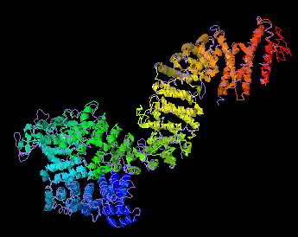  image colored by rainbow N → C terminus |  | Single-Particle Cryo-EM Structure of the waa L O-antigen ligase in its ligand bound state, lipopolysaccharide heptosyltransferase-1
  Model dimensions (Å): | X:47.053 Y:64.719 Z:48.441
The secondary structure of wild type waa gene
Function conservation of WILD type waa gene | Conserve amino acid residues in wild type protein |  | Position in the sequence
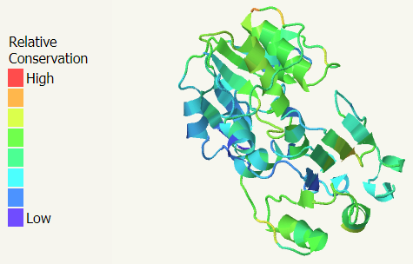 | W, Y, Y, Y, P, R, R, Y, P, H, N, Y, H, D, F, D, H, W, E, A, D, P, Y, N, E, Y, Y |  | 88, 106, 137, 152, 218, 265, 288, 292, 303, 380, 239, 368, 466, 529, 565, 706, 711, 737, 889, 951, 970, 999, 1013, 1015, 1039, 1050, 1057
Mutational sensitivity of mutated waa gene | Highly sensitive amino acid residues in mutated protein |  | Position in the sequence
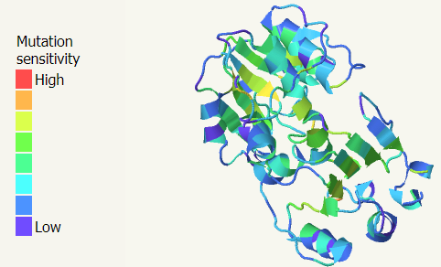 | H, W, Y, R, Q, P, R, G, R, Y, P, H, H, N, G, G, K, D, P, |  | 9, 88, 152, 161, 115, 118, 165, 186, 288, 292, 303, 336, 338, 339, 349, 352, 539, 634

