Supplementary Materials

Supplementary Fig. 1. Forest plot displaying odds ratios (ORs) and 95% confidence intervals (CIs) from a multivariate logistic regression predicting response based on depression scores (HAM-D). Predictors include age, sex, educational level, family history of psychiatric disorders, baseline HAM-D, and baseline HAM-A. The dashed vertical line represents the null effect (OR = 1).
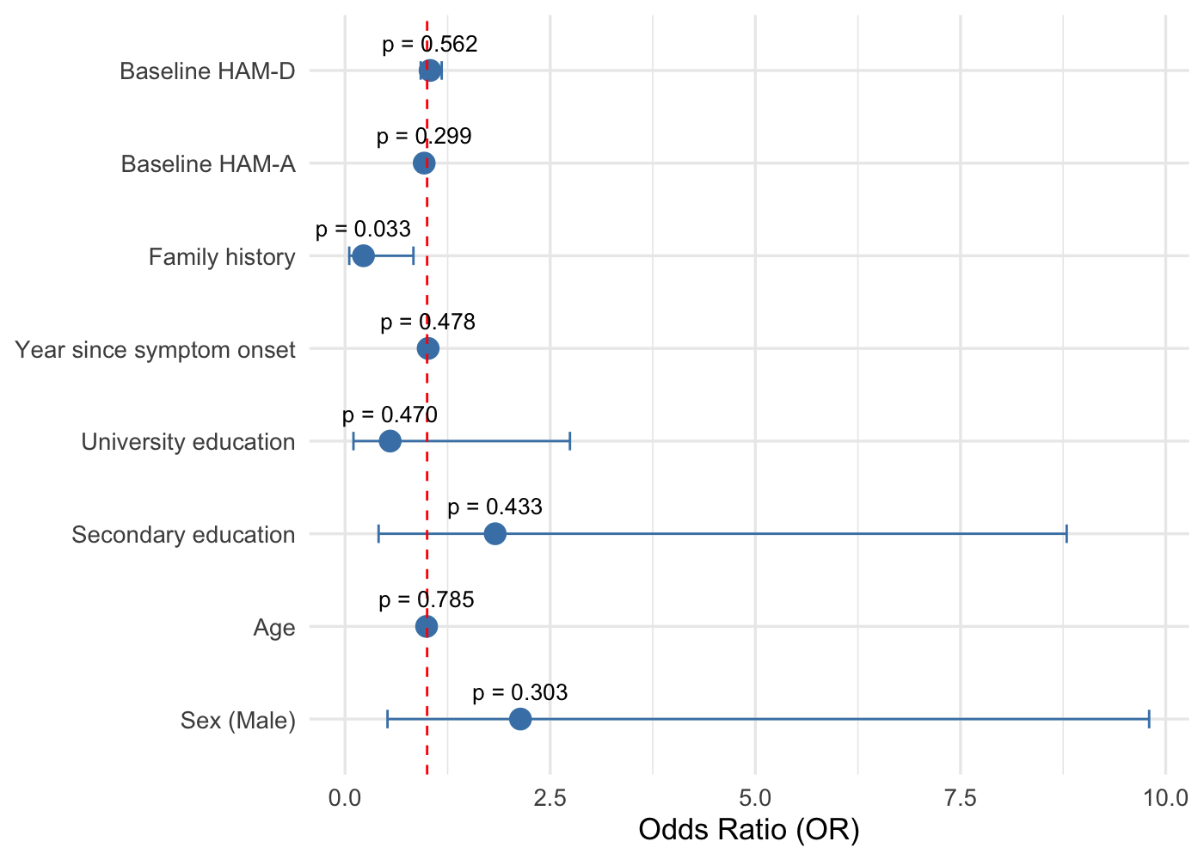

Supplementary Fig. 2. Forest plot summarizing ORs and 95% CIs for predictors of anxiety response (HAM-A). No significant associations were observed. Variables included match those in previous models. The dashed vertical line represents the null effect (OR = 1).
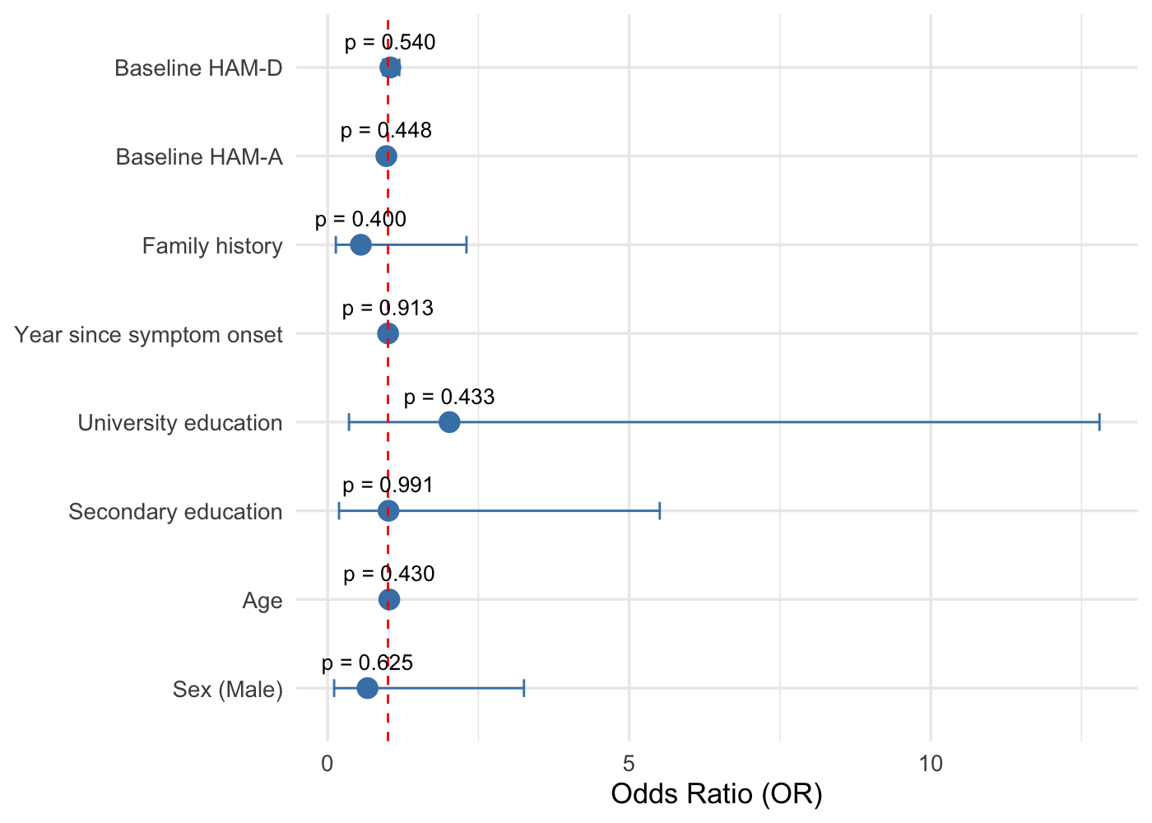

Supplementary Fig. 3. Multivariate regression model for depression remission (HAM-D), with forest plot showing ORs and 95% CIs. A trend-level association was observed for baseline HAM-D (p = 0.060); however, this did not remain significant after correction for multiple comparisons (FDR). The dashed vertical line represents the null effect (OR = 1).

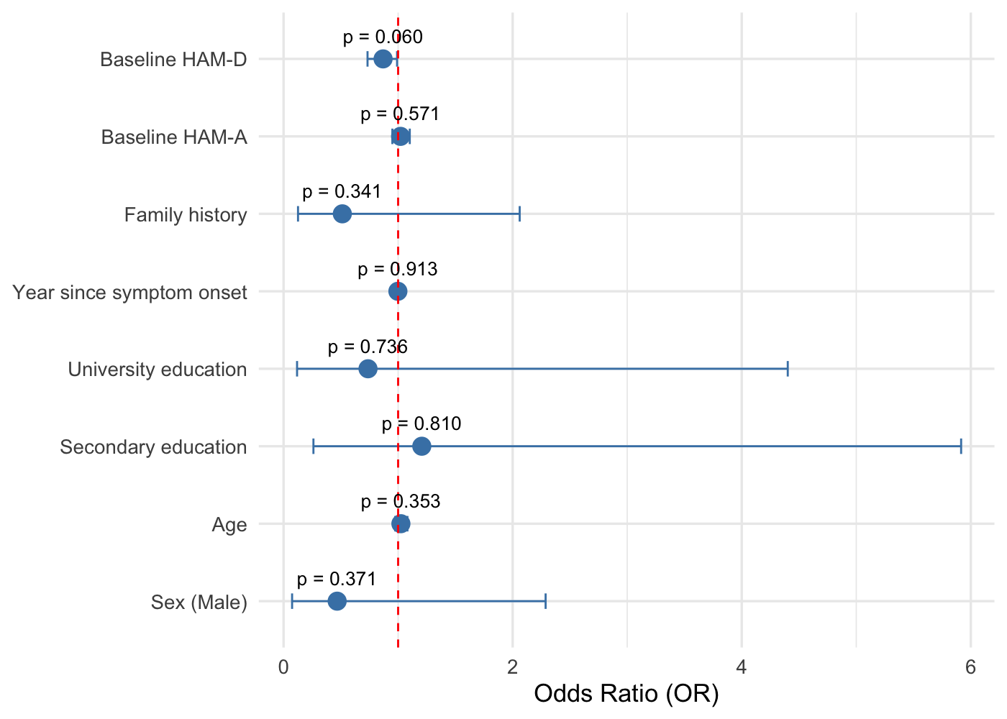

Supplementary Fig. 4. Forest plot of ORs and 95% CIs for predictors of anxiety remission (HAM-A). None of the predictors were statistically significant (p > 0.05). Covariates included are the same as in Supplementary Figure 1. The dashed vertical line represents the null effect (OR = 1).

