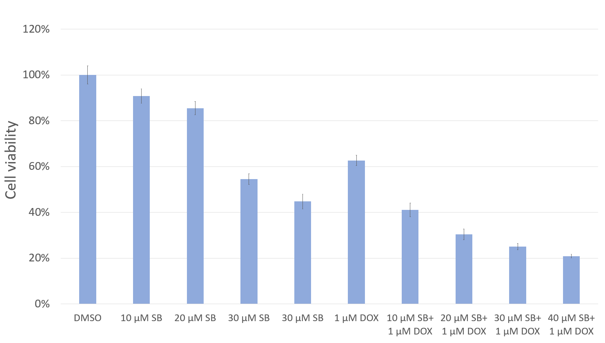

Supplementary Fig. 1. Dose–response evaluation of SB431542 in combination with doxorubicin in T47D cells. T47D cells were co-treated with increasing concentrations of SB431542 and a fixed dose of doxorubicin (1 µM). Cell viability was assessed after 48 h using the indicated cytotoxicity assay. The graph shows the percentage of viable cells relative to untreated controls, illustrating the combined cytotoxic effects across different SB431542 concentrations.

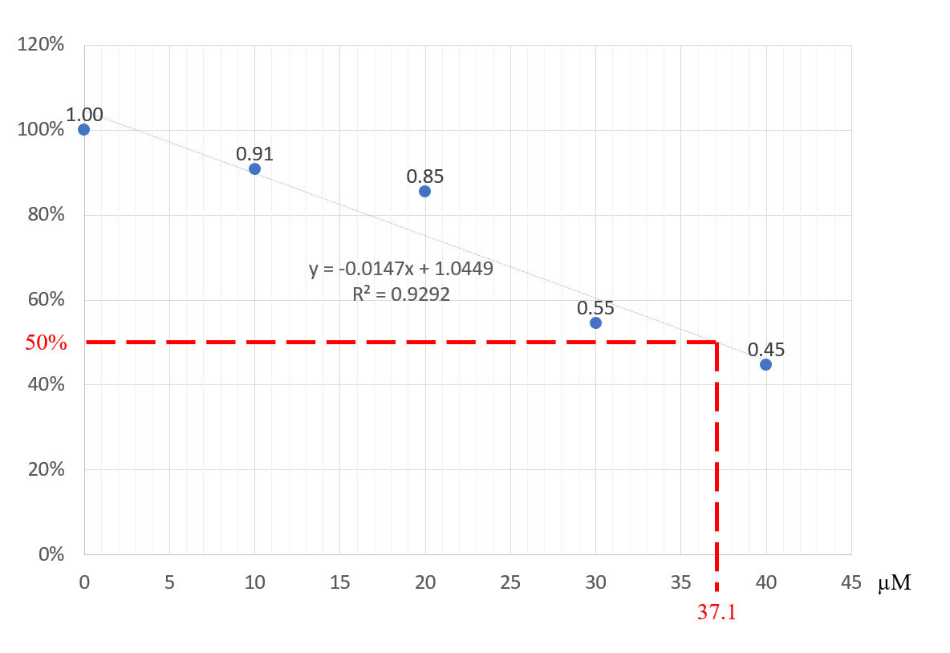
Supplementary Fig. 2. Determination of the IC₅₀ value of SB431542 in the presence of doxorubicin. The dose–response curve generated from treatments described in Figure S1 was used to calculate the IC₅₀ value of SB431542 under co-treatment with 1 µM doxorubicin. Linear regression analysis indicated an IC₅₀ of 37.1 µM.

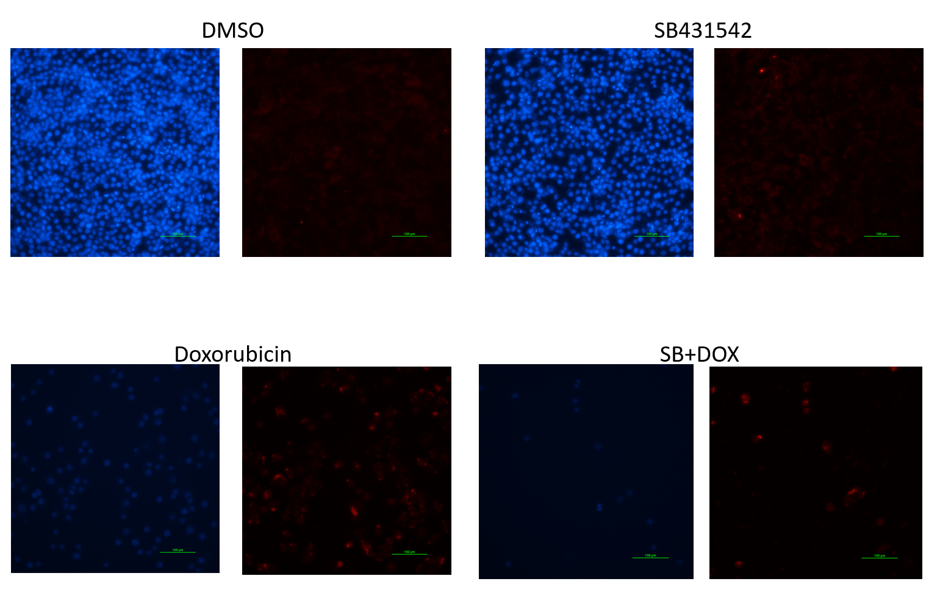
Supplementary Fig. 3. p63 Expression in MDA-MB-468 Cells Detected by Immunofluorescence. MDA-MB-468 cells were subjected to immunofluorescence staining for p63 (red). SB431542 treatment led to a notable increase in p63 expression. Doxorubicin also elevated p63 levels. Combined SB431542 and doxorubicin treatment, despite reducing the overall cell number, resulted in an approximately 1:1 ratio of p63-positive signals to nuclei, indicating increased p63 expression per cell. Nuclei were counterstained with Hoechst 33342 (blue). Scale bar: 100 µm (20×).

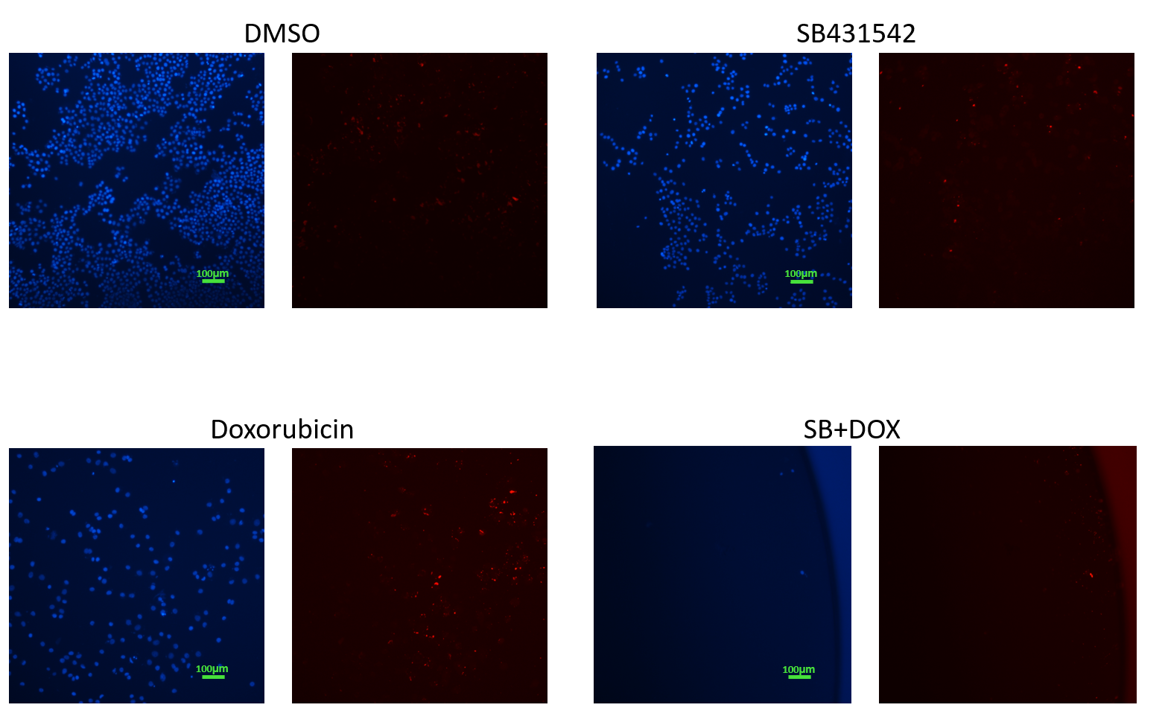
Supplementary Fig. 4. p63 Expression in BT-474 Cells Detected by Immunofluorescence. BT-474 cells were analyzed by immunofluorescence staining for p63 (red). SB431542 treatment did not markedly alter p63 expression, whereas doxorubicin increased p63 levels. Combined SB431542 and doxorubicin treatment reduced overall cell number but produced an approximately 1:1 ratio of p63 fluorescence to nuclei, indicating elevated p63 expression per cell. Nuclei were counterstained with Hoechst 33342 (blue). Scale bar: 100 µm (10×).

Supplementary Table 1. Synergistic effects of combined SB431542 and doxorubicin treatments on T47D cell viability.
DMSO | 10 μM SB | 20 μM SB | 30 μM SB | 40 μM SB | 1 μM DOX | 10 μM SB+ 1 μM DOX | 20 μM SB+ 1 μM DOX | 30 μM SB+ 1 μM DOX | 40 μM SB+ 1 μM DOX
100.00 (%) | 90.83 (%) | 85.48 (%) | 54.54 (%) | 44.70 (%) | 62.65 (%) | 41.03 (%) | 30.36 (%) | 25.05 (%) | 20.86 (%)
CDI = [survival% (Drug A + DrugB)] / [survival% (Drug A) × survival% (Drug B)] |  |  |  |  |  | CDI | CDI | CDI | CDI
 |  |  |  |  |  | 0.72 | 0.57 | 0.73 | 0.74
Cell viability percentages for all tested concentration combinations of SB431542 and doxorubicin are summarized. The combination of 20 µM SB431542 with 1 µM doxorubicin produced the strongest synergistic cytotoxic effect.

