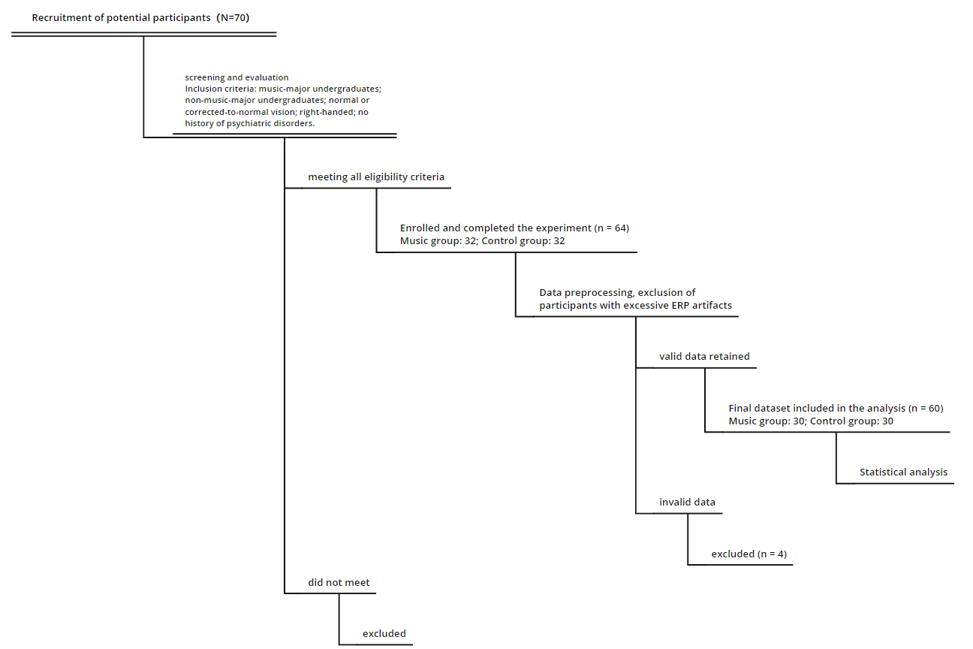
Supplementary Fig. 1. Flowchart of participant recruitment, screening, exclusions, and final inclusion.

Supplementary Table 1. Means and standard deviations of N450/Ninc and SP components under congruent and incongruent conditions in visual and auditory tasks for musician and control groups.
Modality | Group | ERP Component | Condition | Mean (μV) | SD (μV)
Visual | Musician Group | N450 | congruent | 4.123 | 4.823
 |  |  | incongruent | 3.315 | 5.124
 |  |  | difference wave | -0.807 | 2.857
 |  | SP | congruent | 0.751 | 2.996
 |  |  | incongruent | 0.763 | 2.940
 |  |  | difference wave | 0.011 | 2.577
 | Control Group | N450 | congruent | 5.286 | 5.289
 |  |  | incongruent | 4.348 | 6.530
 |  |  | difference wave | -0.938 | 2.370
 |  | SP | congruent | 0.341 | 3.695
 |  |  | incongruent | 2.090 | 3.849
 |  |  | difference wave | 1.749 | 2.539
Auditory | Musician Group | Ninc | congruent | 2.526 | 3.702
 |  |  | incongruent | 1.478 | 3.498
 |  |  | difference wave | -1.047 | 2.354
 |  | SP | congruent | 1.079 | 3.760
 |  |  | incongruent | 1.484 | 3.224
 |  |  | difference wave | 0.405 | 2.846
 | Control Group | Ninc | congruent | 2.364 | 3.511
 |  |  | incongruent | 1.594 | 4.832
 |  |  | difference wave | -0.770 | 2.519
 |  | SP | congruent | -0.025 | 3.046
 |  |  | incongruent | 1.100 | 3.796
 |  |  | difference wave | 1.125 | 2.581

Supplementary Table 2. Means and standard deviations of theta and beta power under congruent and incongruent conditions in visual and auditory tasks for musician and control groups.
Modality | Group | ERP Component | Condition | Mean (μV) | SD (μV)
Visual | Musician Group | theta | congruent | 0.054 | 0.621
 |  |  | incongruent | 0.039 | 0.05
 |  | beta | congruent | 0.001 | 0.003
 |  |  | incongruent | -0.0008 | 0.004
 | Control Group | theta | congruent | 0.040 | 0.058
 |  |  | incongruent | 0.048 | 0.067
 |  | beta | congruent | -0.0002 | 0.002
 |  |  | incongruent | -0.0003 | 0.002
Auditory | Musician Group | theta | congruent | 0.015 | 0.027
 |  |  | incongruent | 0.024 | 0.037
 |  | beta | congruent | -0.0007 | 0.003
 |  |  | incongruent | 0.023 | 0.062
 | Control Group | theta | congruent | 0.011 | 0.042
 |  |  | incongruent | 0.027 | 0.046
 |  | beta | congruent | 0.002 | 0.003
 |  |  | incongruent | -0.002 | 0.006
Note: All values are reported to three decimal places; 0.000 indicates a value rounded to zero.

Supplementary Table 3. Audit table of test statistics and p-values.
Modality | Component | Test type | Effect / Comparison | Statistic | df | Exact p value | Computational settings
Visual | N450 | Mixed ANOVA | Main effect of condition | F = 8.338 | 1, 58 | 0.005 | Repeated-measures factor: congruency (2), between-subject factor: group (2); two-tailed; sphericity assumed
Visual | N450 | Mixed ANOVA | Main effect of group | F = 0.001 | 1, 58 | 0.981 | same as above
Visual | N450 | Mixed ANOVA | Condition × group interaction | F = 0.194 | 1, 58 | 0.661 | same as above
Visual | N450 diff wave | Independent-samples t-test | Music vs control | t = -0.440 | 58 | 0.661 | two-tailed, equal variances assumed
Visual | SP | Mixed ANOVA | Main effect of condition | F = 4.764 | 1, 58 | 0.033 | same as above
Visual | SP | Mixed ANOVA | Main effect of group | F = 0.814 | 1, 58 | 0.371 | same as above
Visual | SP | Mixed ANOVA | Condition × group | F = 1.053 | 1, 58 | 0.309 | same as above
Visual | SP diff wave | Independent-samples t-test | Music vs control | t = -1.026 | 58 | 0.309 | two-tailed
Visual | Theta | Mixed ANOVA | Main effect of condition | F = 0.196 | 1, 58 | 0.66 | Time–frequency power (4–7 Hz); two-tailed
Visual | Theta | Mixed ANOVA | Main effect of group | F = 0.044 | 1, 58 | 0.835 | same as above
Visual | Theta | Mixed ANOVA | Condition × group | F = 2.599 | 1, 58 | 0.112 | same as above
Visual | Theta | Independent-samples t-test | Congruent vs incongruent | t = 0.944 | 58 | 0.349 | two-tailed
Visual | Theta | Independent-samples t-test | Incongruent vs congruent | t = -0.584 | 58 | 0.562 | two-tailed
Visual | Beta | Mixed ANOVA | Main effect of condition | F = 0.196 | 1, 58 | 0.66 | Time–frequency power (13–30 Hz); two-tailed
Visual | Beta | Mixed ANOVA | Main effect of group | F = 0.044 | 1, 58 | 0.835 | same as above
Visual | Beta | Mixed ANOVA | Condition × group | F = 2.599 | 1, 58 | 0.112 | same as above
Visual | Beta | Independent-samples t-test | Congruent vs incongruent | t = 0.944 | 58 | 0.349 | two-tailed
Visual | Beta | Independent-samples t-test | Incongruent vs congruent | t = -0.584 | 58 | 0.562 | two-tailed
Auditory | Ninc | Mixed ANOVA | Main effect of condition | F = 8.338 | 1, 58 | 0.005 | ERP mean amplitude; same structure as N450
Auditory | Ninc | Mixed ANOVA | Main effect of group | F = 0.001 | 1, 58 | 0.981 | same as above
Auditory | Ninc | Mixed ANOVA | Condition × group | F = 0.194 | 1, 58 | 0.661 | same as above
Auditory | Ninc diff wave | Independent-samples t-test | Music vs control | t = -0.440 | 58 | 0.661 | two-tailed
Auditory | SP | Mixed ANOVA | Main effect of condition | F = 4.764 | 1, 58 | 0.033 | same as above
Auditory | SP | Mixed ANOVA | Main effect of group | F = 0.814 | 1, 58 | 0.371 | same as above
Auditory | SP | Mixed ANOVA | Condition × group | F = 1.053 | 1, 58 | 0.309 | same as above
Auditory | SP diff wave | Independent-samples t-test | Music vs control | t = -1.026 | 58 | 0.309 | two-tailed
Auditory | Theta | Mixed ANOVA | Main effect of condition | F = 3.933 | 1, 58 | 0.052 | TF power (4–7 Hz)
Auditory | Theta | Mixed ANOVA | Main effect of group | F < 0.001 | 1, 58 | 0.984 | same as above
Auditory | Theta | Mixed ANOVA | Condition × group | F = 0.329 | 1, 58 | 0.568 | same as above
Auditory | Theta | Independent-samples t-test | Congruent vs incongruent | t = 0.418 | 58 | 0.677 | two-tailed
Auditory | Theta | Independent-samples t-test | Incongruent vs congruent | t = -0.326 | 58 | 0.745 | two-tailed
Auditory | Beta | Mixed ANOVA | Main effect of condition | F = 2.917 | 1, 58 | 0.093 | TF power (13–30 Hz)
Auditory | Beta | Mixed ANOVA | Main effect of group | F = 3.999 | 1, 58 | 0.05 | same as above
Auditory | Beta | Mixed ANOVA | Condition × group | F = 6.103 | 1, 58 | 0.016 | same as above
Auditory | Beta | Independent-samples t-test | Congruent vs incongruent | t = -3.240 | 58 | 0.002 | two-tailed
Auditory | Beta | Independent-samples t-test | Incongruent vs congruent | t = 2.242 | 58 | 0.029 | two-tailed

