Supplementary Fig. 1. Stability of TELNs within seven days (n=3).

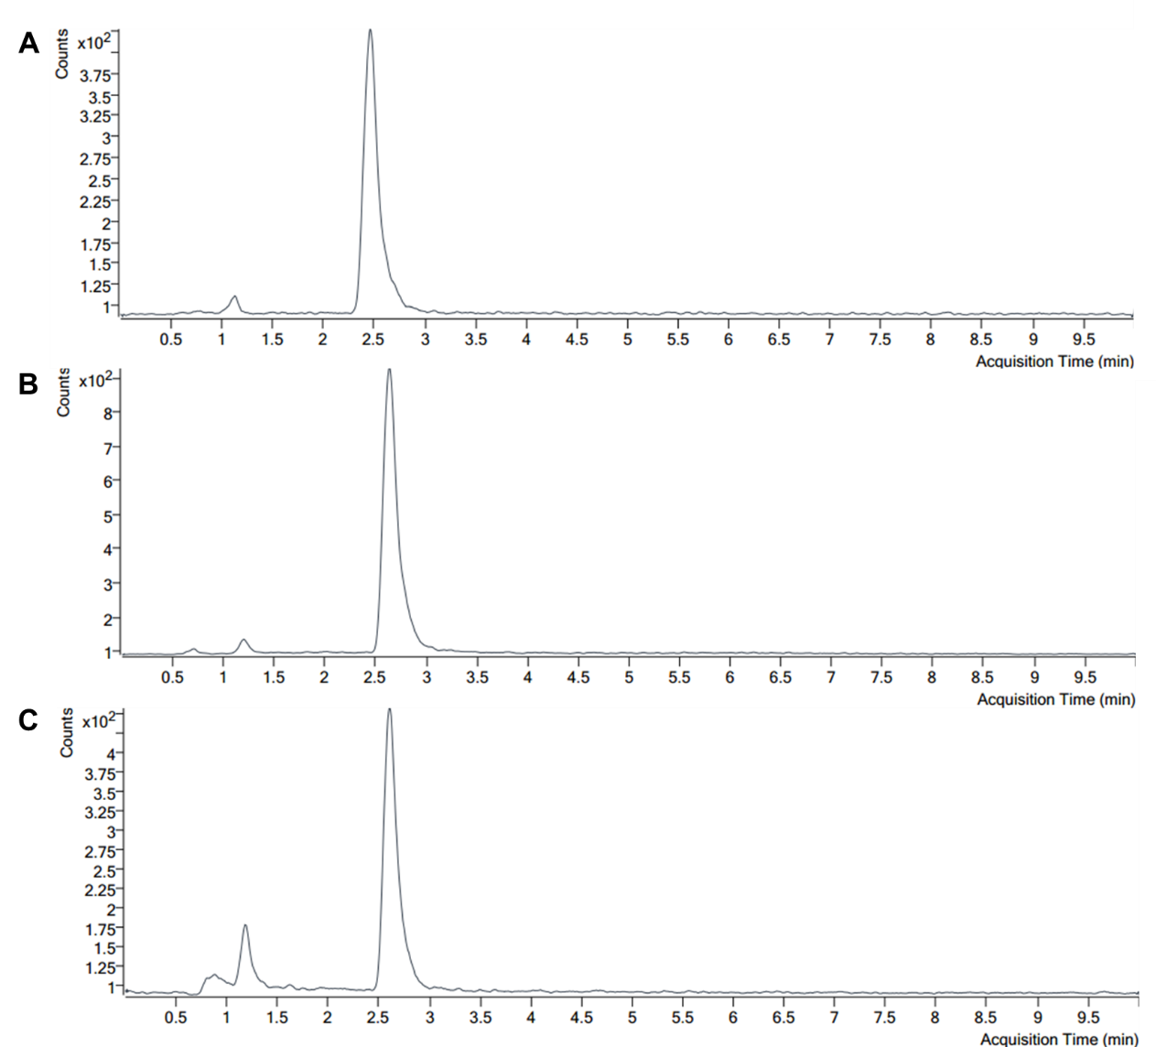
Supplementary Fig. 2 Curcumin quantified by Liquid Chromatography-Mass Spectrometry. (A) Curcumin standard. (B) Turmeric juice. (C) TELNs.

Supplementary Fig. 3. Curcumin release curve of TELNs within 24 hours (n=3).

Supplementary Fig. 4. Quantitative analysis of laser scanning confocal microscope images (n=3).

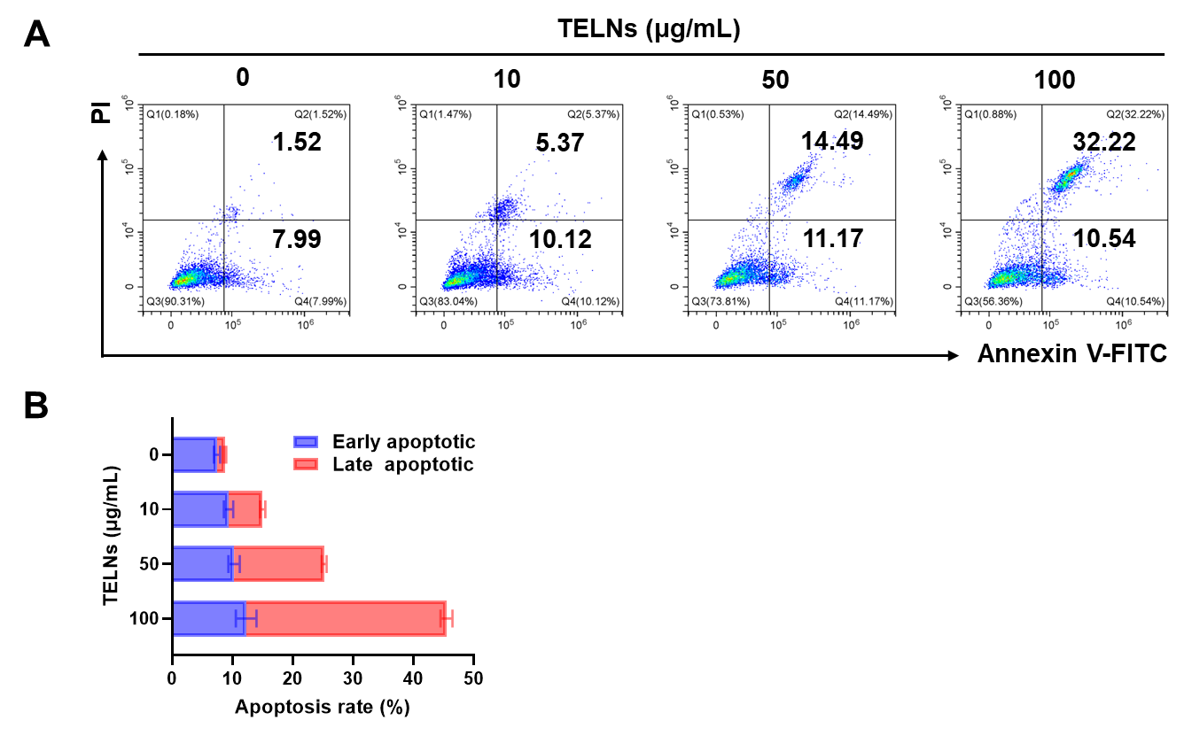
Supplementary Fig. 5. (A) Apoptosis of TELN-treated H1299 cells, as measured by flow cytometry. (B) Apoptosis rate of H1299 cells (n=3).

Supplementary Fig. 6. Cytotoxicity of TELNs against H1299 cells, as measured by CCK-8 assay (n=3).

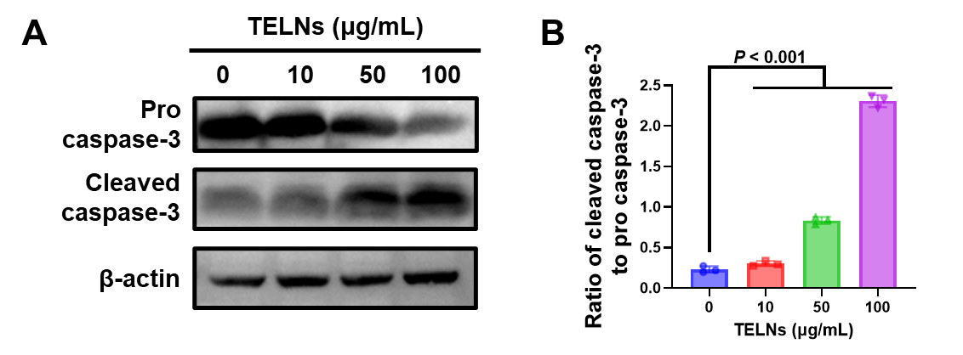
Supplementary Fig. 7. (A) Western blot analysis of pro and cleaved caspase-3 expression in H1299 cells after treatment. (B) The ratio of cleaved caspase-3 to pro caspase-3 (n=3).

Supplementary Fig. 8. hMOF mRNA levels in H1299 cells analyzed by real-time PCR (n=3).

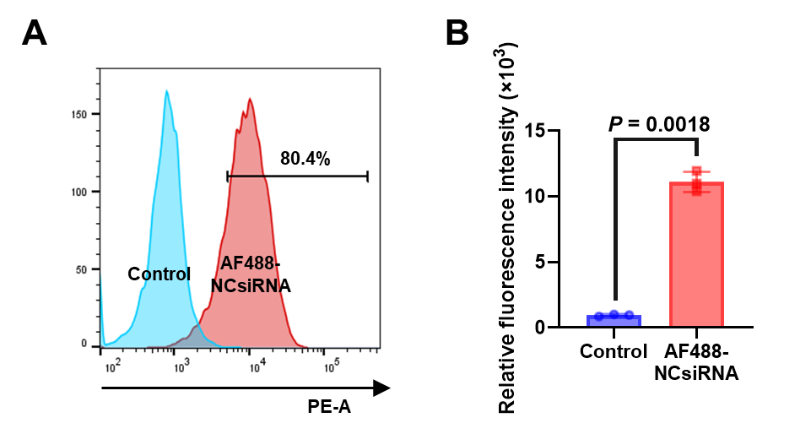
Supplementary Fig. 9. (A) siRNA transfection rate detected by flow cytometry. (B) Quantitative analysis of fluorescence intensity (n=3).

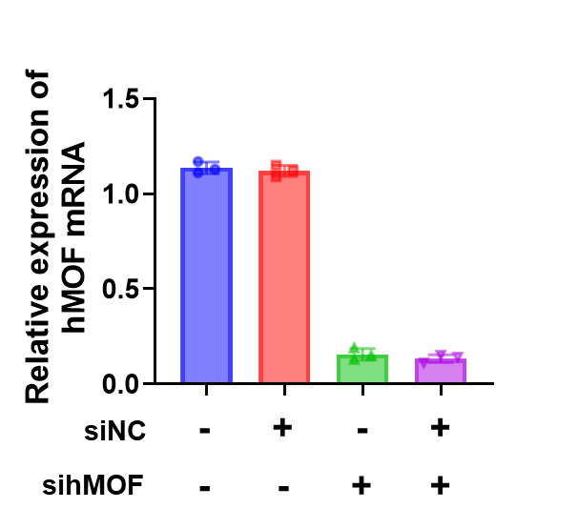
Supplementary Fig. 10. hMOF mRNA levels in A549 cells analyzed by real-time PCR (n=3).

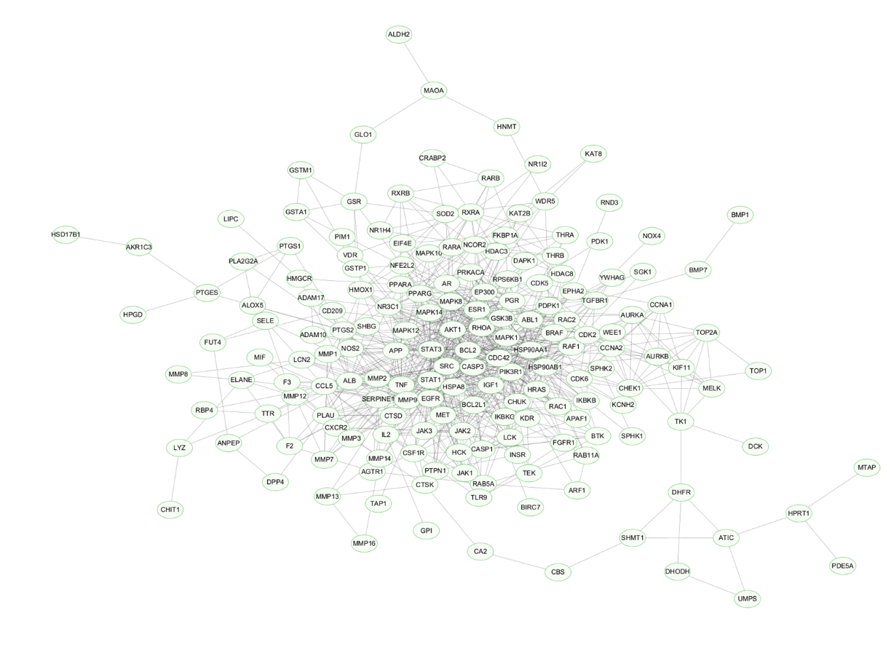
Supplementary Fig. 11. The protein-protein interaction (PPI) network of overlapping targets.

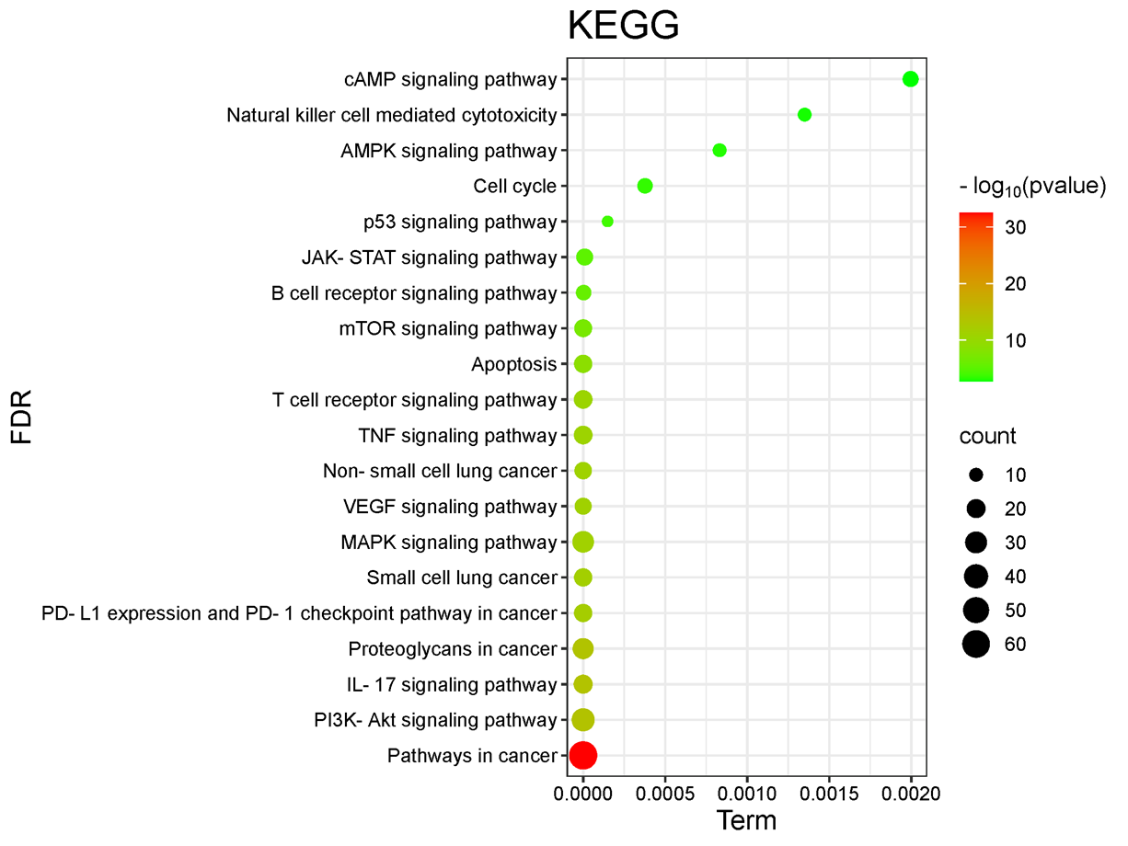
Supplementary Fig. 12. KEGG pathway enrichment analysis.

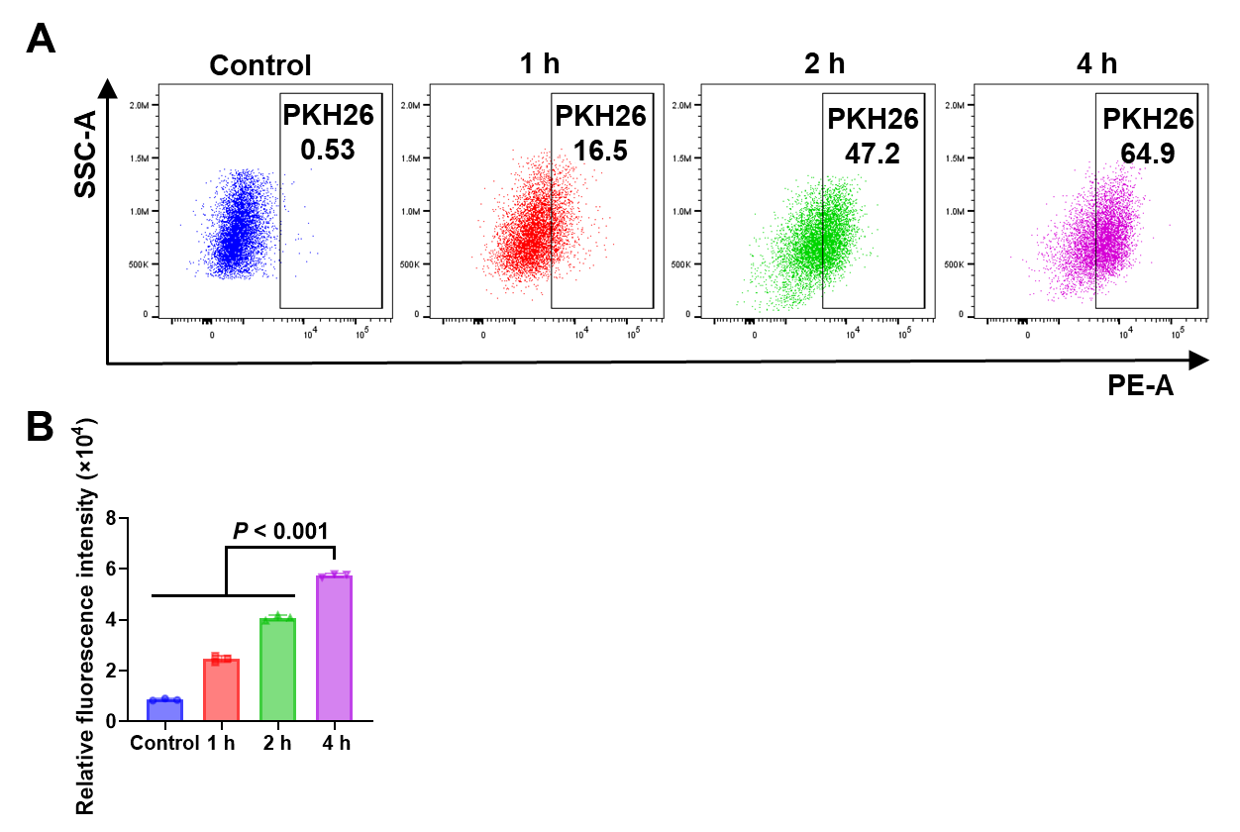
Supplementary Fig. 13. (A) Cellular uptake of CURLipo by A549 cells at 1, 2, and 4 h, as measured by flow cytometry. (B) Quantitative analysis by flow cytometry (n=3).

Supplementary Fig. 14. Stability of CURLipo within seven days (n=3).

Supplementary Fig. 15. Cytotoxicity of TELNs and CURLipo, as measured by CCK-8 assay (n=3).

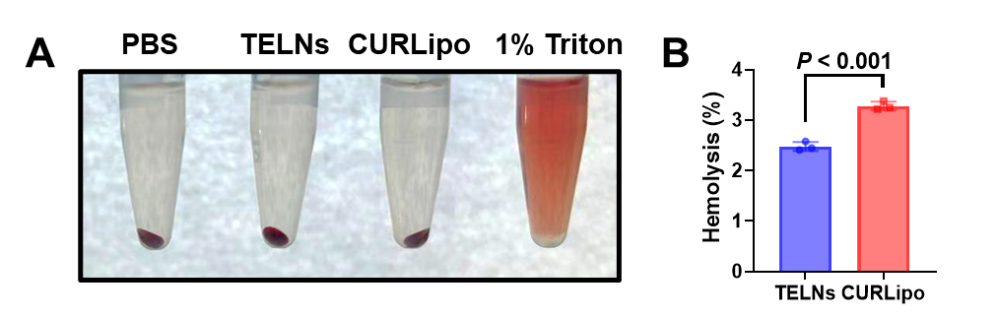
Supplementary Fig. 16. (A) Hemolysis assessment of TELNs and CURLipo. (B) The hemolysis rates (n=3).

