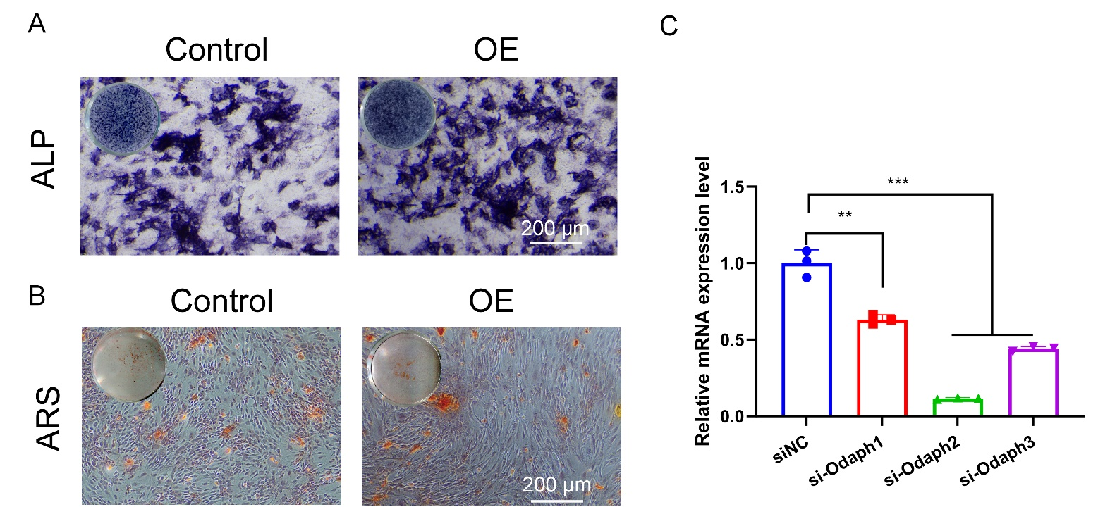

Supplementary Fig. 1. Validation of Odaph expression and additional osteogenic assays. (A) Day 14 alkaline phosphatase (ALP) staining in the indicated groups showing sustained ALP activity during osteogenic induction. Scale bar = 200 μm. (B) Day 14 Alizarin Red S (ARS) staining showing enhanced mineralized nodule formation after prolonged induction. Scale bar = 200 μm. (C) qPCR validation of three small interfering RNAs (siRNAs) targeting Odaph (si-Odaph-1, si-Odaph-2, si-Odaph-3). Among them, si-Odaph-2 achieved the highest knockdown efficiency and was used for subsequent experiments. Data represent three independent experiments. *p < 0.05, **p < 0.01, ***p < 0.001.

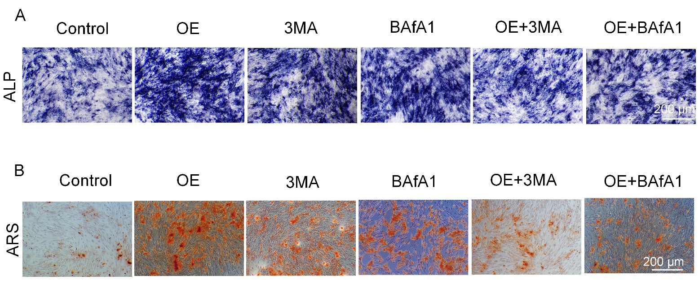
Supplementary Fig. 2. (A) ALP staining in the indicated groups. (B) Alizarin Red S (ARS) staining of mineralized nodules in the indicated groups. Scale bar = 200 μm

Supplementary Fig. 3. Quantitative analysis of immunohistochemical staining for Odaph, osteogenic, and autophagy markers in vivo. (A) Quantification of Odaph-positive cells in femoral bone sections from WT, OC-Cre KI^{+/-}, and OC-Odaph KI^{+/+} mice. Odaph expression is significantly increased in OC-Odaph KI^{+/+} mice. (B–C) Quantification of ALP (B) and RUNX2 (C) immunoreactivity, showing enhanced osteogenic marker expression in OC-Odaph KI^{+/+} mice relative to controls. (D–E) Quantification of LC3 (D) and p62 (E) immunostaining, indicating reduced LC3 and p62 levels in OC-Odaph KI^{+/+} mice, consistent with elevated autophagic activity. (F–G) Quantification of p-AMPK (F) and p-mTOR (G) immunoreactivity, demonstrating increased AMPK phosphorylation and decreased mTOR phosphorylation in OC-Odaph KI^{+/+} mice, supporting activation of the AMPK/mTOR pathway. Data are presented as mean ± SD. *p < 0.05, **p < 0.01, ***p < 0.001.

