Supporting Information

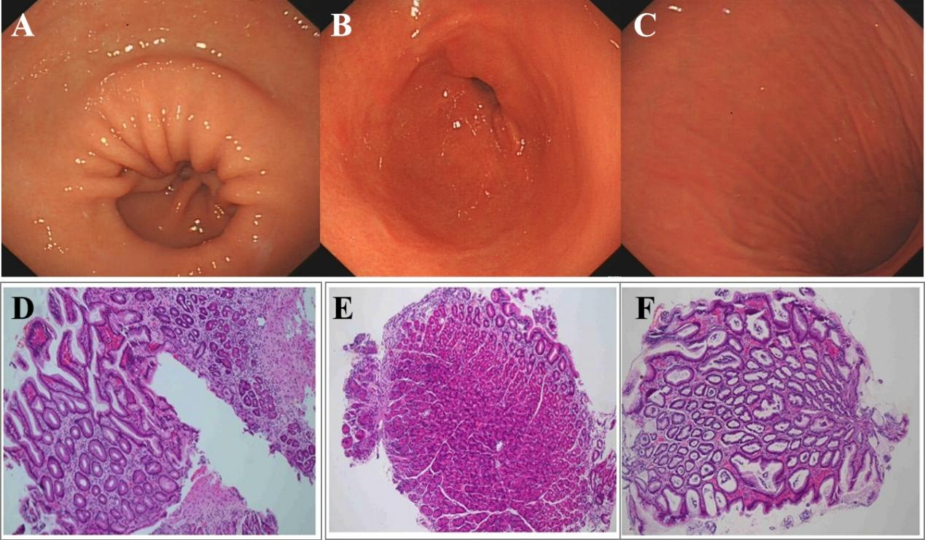
Supplementary Fig. 1. Representative clinical and histological images from the normal control group (G1). (A–C) Gastroscopic images. (D–F) Corresponding hematoxylin-eosin (HE)-stained histopathological sections (magnification: 100×).

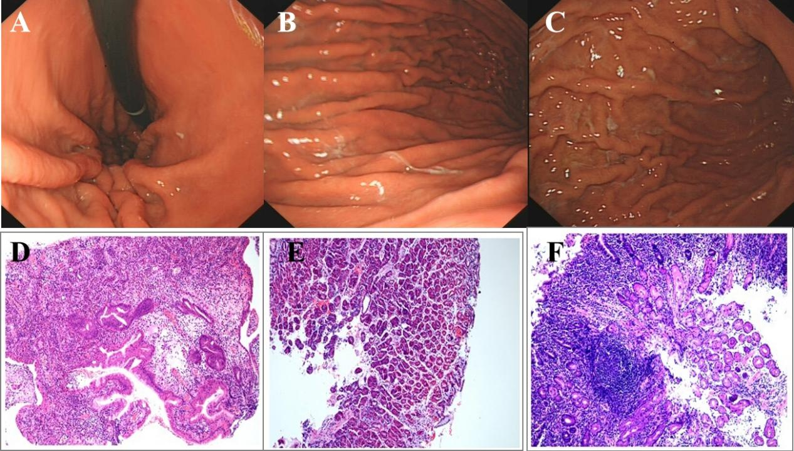
Supplementary Fig. 2. Representative clinical and histological images from the patients with gastritis group (G2). (A–C) Gastroscopic images. (D–F) Corresponding hematoxylin-eosin (HE)-stained histopathological sections (magnification: 100×).

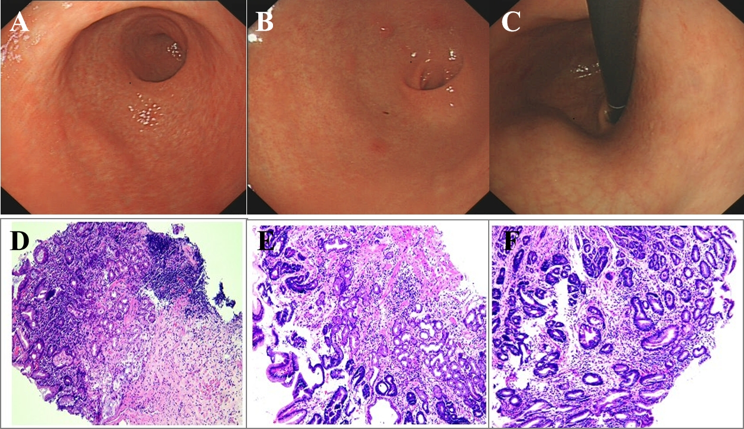
Supplementary Fig. 3. Representative clinical and histological images from the patients with gastric atrophy group (G3). (A–C) Gastroscopic images. (D–F) Corresponding hematoxylin-eosin (HE)-stained histopathological sections (magnification: 100×).

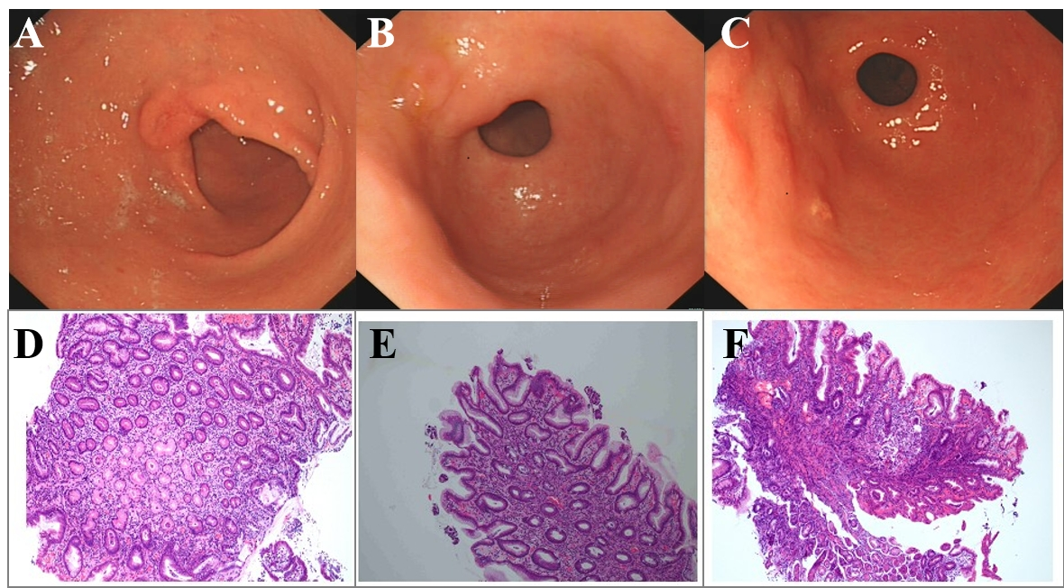
Supplementary Fig. 4. Representative clinical and histological images from the patients with gastric erosion group (G4). (A–C) Gastroscopic images. (D–F) Corresponding hematoxylin-eosin (HE)-stained histopathological sections (magnification: 100×).
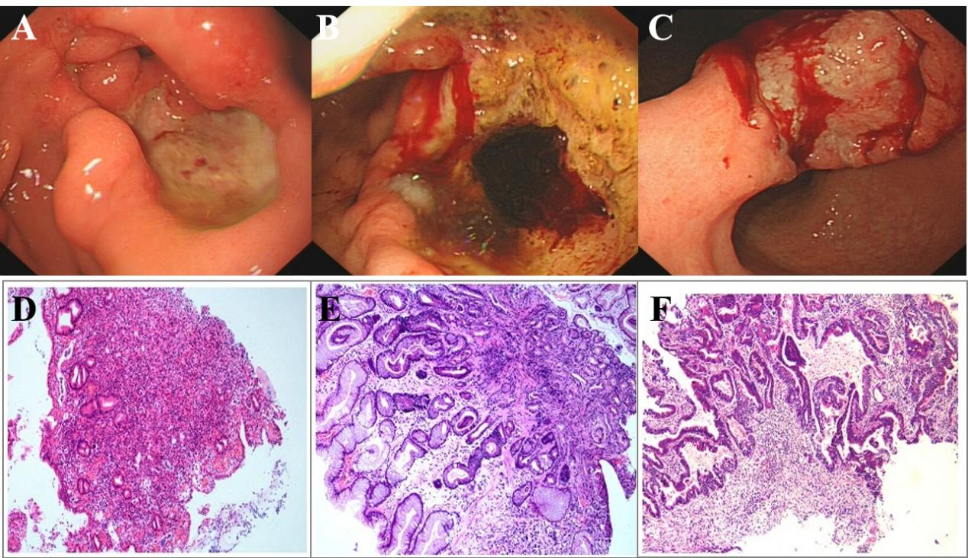
Supplementary Fig. 5. Representative clinical and histological images from the patients with gastric cancer group (G5). (A–C) Gastroscopic images. (D–F) Corresponding hematoxylin-eosin (HE)-stained histopathological sections (magnification: 100×).

