Supplementary Table 1. Reverse transcription reaction conditions.
Procedures | Condition
Step 1 | 37 ℃ 30 min
Step 2 | 85 ℃ 1 min
Step 3 | 4 ℃

Supplementary Table 2. Primer Sequences for Target Genes.
Gene | Prime | 5' to 3'
GAPDH* | F | TGGCCTTCCGTGTTCCTAC
GAPDH* | R | GAGTTGCTGTTGAAGTCGCA
ZO-1(TJP1) | F | GCTTTAGCGAACAGAAGGAGC
ZO-1(TJP1) | R | TTCATTTTTCCGAGACTTCACCA
Claudin-1  (Cldn1) | F | TGCCCCAGTGGAAGATTTACT
Claudin-1  (Cldn1) | R | CTTTGCGAAACGCAGGACAT
Occludin (Ocln) | F | TGAAAGTCCACCTCCTTACAGA
Occludin (Ocln) | R | CCGGATAAAAAGAGTACGCTGG
MUC2* | F | AGGGCTCGGAACTCCAGAAA
MUC2* | R | CCAGGGAATCGGTAGACATCG
Italics abbreviations denote genes encoding proteins.
*Proteins and genes with identical abbreviations are displayed as merged entries.

Supplementary Table 3. The mixture of RT-qPCR.
Reagent | Volume | Final concentration
TB Green Premix Ex Taq II (Tli RNaseH Plus) (2X Conc.) | 5μL | 1×
Forward Prime | 0.4μL | 0.4μM
Reverse Prime | 0.4μL | 0.4μM
RNase Free dH2O | 2.2μL
cDNA | 2μL

Supplementary Table 4. RT-qPCR Reaction Conditions.
 | Reaction Time and Temperature | Cycles
Stage 1: Initial Denaturation | 95 ℃ 30 s | 1
Stage 2: Amplification Cycles | 95 ℃ 5 s | 40
Stage 2: Amplification Cycles | 60 ℃ 34 s | 40
Stage 3: Melting Curve Analysis | 95 ℃ 15 s | 1
Stage 3: Melting Curve Analysis | 60 ℃ 1 min | 1
Stage 3: Melting Curve Analysis | 95 ℃ 15 s | 1

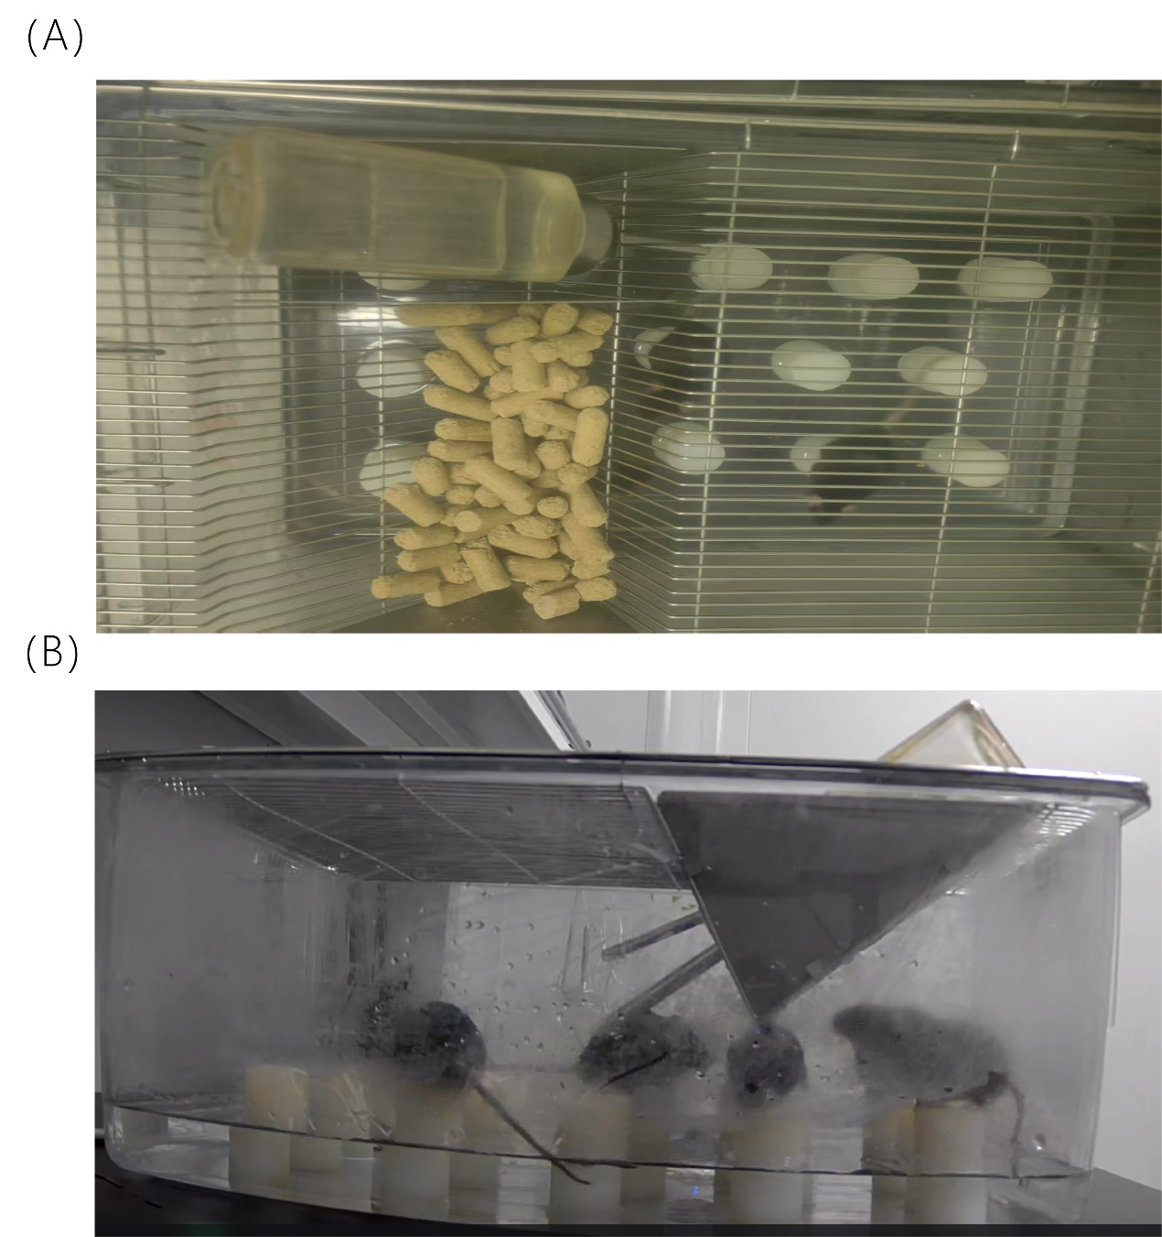
Supplementary Fig. 1. Schematic diagram of the modified multiple-platform water environment method. (A) Top view; (B) Side view.

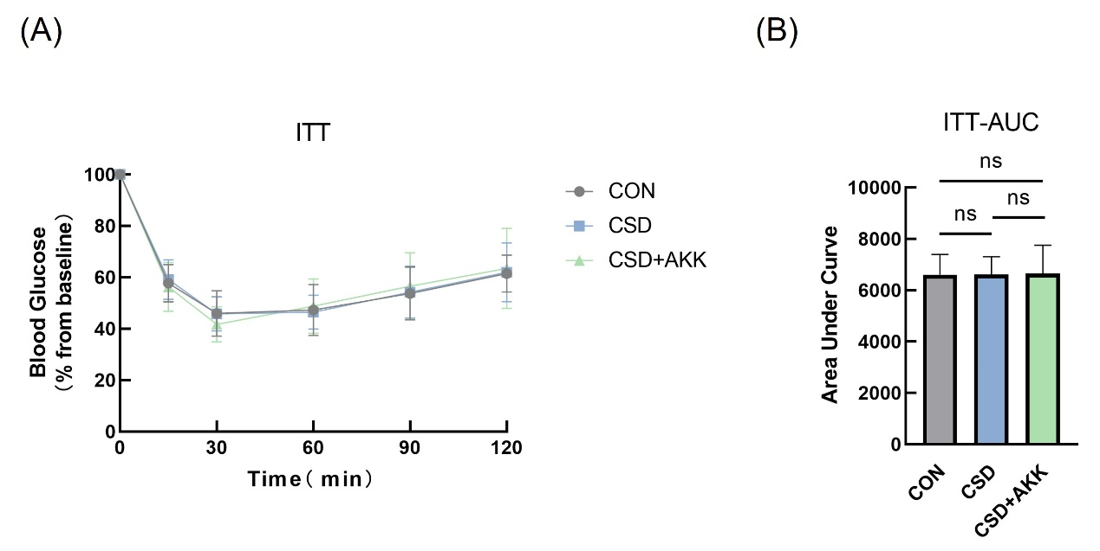
Supplementary Fig. 2. ITT line charts and AUC for CON, CSD, and CSD+AKK groups (n=10 per group). A: ITT glucose line chart; B: ITT glucose AUC; AUC: area under the curve; ITT: insulin tolerance test; CON: control; CSD: chronic sleep deprivation; CSD+AKK: chronic sleep deprivation + A. muciniphila intervention; data shown as mean ± SD, ns: not significant.

