A) Risk of Bias Summary
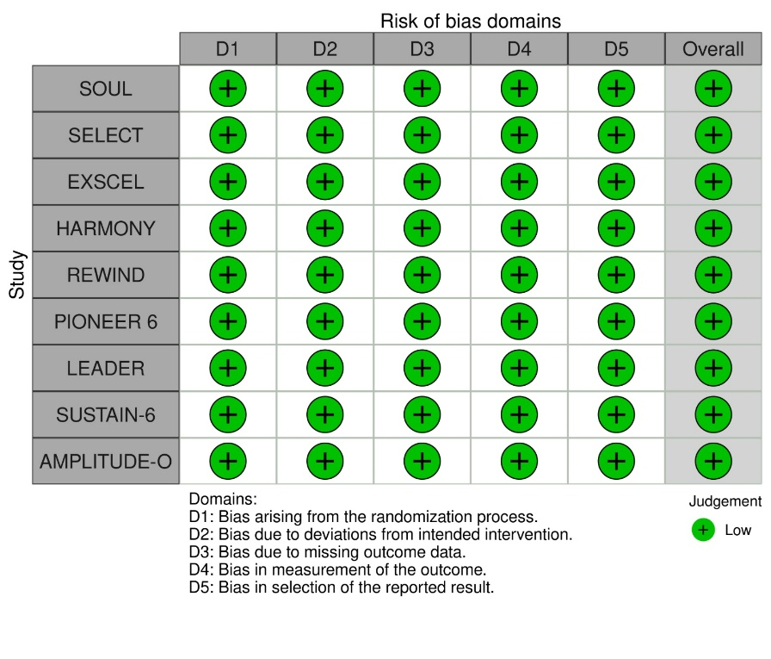
B) Risk of Bias Graph
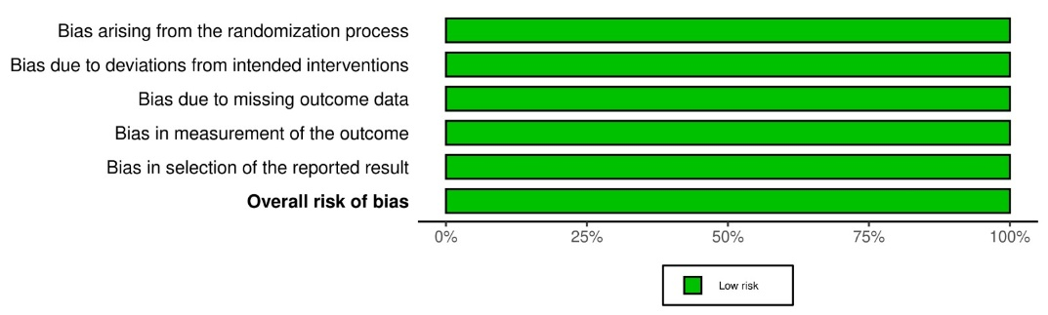

Supplementary Fig. 1 Cochrane risk of bias including A) Risk of Bias summary, B) Risk of Bias graph

