Impact of Sodium–Glucose Cotransporter 2 Inhibitors on Acute Kidney Injury Post Off-Pump Coronary Artery Bypass Grafting: A Retrospective Cohort Study and Meta-Analysis Supplementary Fig. 1 PRISMA diagram
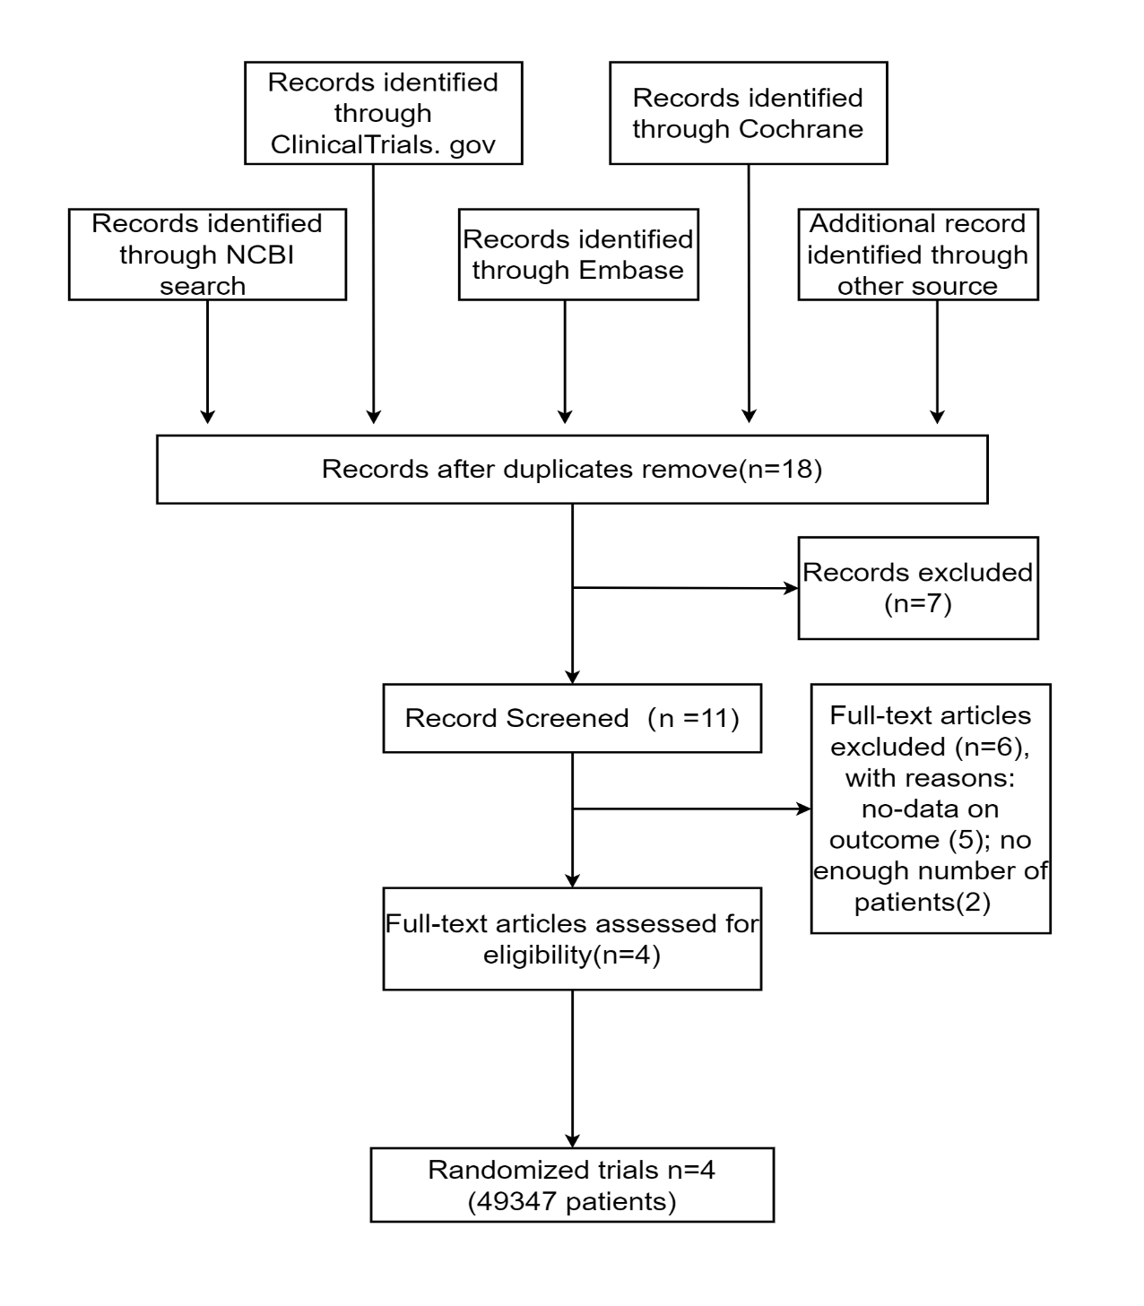

Supplementary Table 1 Search strategy
Search strategy
PubMed | (dapagliflozin) AND (acute kidney injury OR acute kidney damage OR acute kidney failure OR acute renal failure OR hypotension OR hypovolemia OR dehydration OR real world OR propensity OR observational OR randomized OR randomisation OR placebo OR Clinical Trialptyp)
ClinicalTrials.gov | dapagliflozin
EMBASE | (dapagliflozin) AND (acute kidney injury OR acute kidney damage OR acute kidney failure OR acute renal failure OR hypotension OR hypovolemia OR dehydration OR real world OR propensity OR observational OR randomized OR randomisation OR placebo OR Clinical Trial)
Cochrane Library | (dapagliflozin) AND (acute kidney injury OR acute kidney damage OR acute kidney failure OR acute renal failure OR hypotension OR hypovolemia OR dehydration OR real world OR propensity OR observational OR randomized OR randomisation OR placebo OR Clinical Trial)

Supplementary Table 2 Search strategy
The name of Study | First author | publication year | Study design | Country | Patient population | Type of SGLT2 inhibitor
DELIGHT | Dr. Amit X. Garg | 2023 | RCT | London Health Sciences Centre, LHSC | 293 | Dapagliflozin
DECLARE-TIM58 | Stephen D. Wiviott, MD；Itamar Raz, MD | 2015 | CVOT | North America (the United States and Canada), Europe (multiple countries), Latin America, the Middle East (especially Israel), Africa, and the Asia-Pacific region | 17143 | Dapagliflozin
DAPA-HF | John J.V. McMurray, MD；Scott D. Solomon, MD | 2017 | RCT | Europe, North America, South America and Asia | 4744 | Dapagliflozin
DAPA-MI(fourth) | Lars Køber, MD, DMSc  Anna Maria Langkilde, MD, PhD | 2020 | RCT | Sweden, Denmark,Norway, and the United Kingdom | 2,7167 | Dapagliflozin

Supplementary Table 3 Clinical outcome and postoperative complication
Variable | Dapagliflozin  (n=410) | No Dapagliflozin  (n=12442) | The all  (n=12825)
Death n(%) | 5 (1.2%) | 352 (2.8%) | 357 (2.9%)
AKI n(%) | 54 (13.2%) | 3651 (29.3%) | 427 (28.9%)
The duration in hospital (d) | 14.02±5.45 | 14.91±5.36 | 14.04±5.45
POAF n(%) | 117 (28.5%) | 3824 (30.7%) | 3941 (30.7%)
Second operation n(%) | 8 (2%) | 185 (1.5%) | 193 (1.5%)
The cost of treatment (RMB) | 135087.38±315.29 | 125094.16±373.9 | 125412.96±371.76
IABP n(%) | 12 (2.9%) | 492 (4%) | 504 (3.9%)
The duration of AKI (d) | 1.48±0.38 | 3.16±1.16 | 2.74±1.81
the success of treatment of AKI n(%) | 398 (98.8%) | 1171 (96.9%) | 1569 (97.3%)
ECMO n(%) | 51 (0.4%) | 0 (0%) | 51 (0.4%)
AKI indicates acute kidney injury; POAF, postoperative atrial fibrillation; CRRT, continuous renal replacement therapy; IABP, intraaortic balloon pump; ECMO, extra corporeal membrane oxygenation.

