SUPPORTING INFORMATION

The Icelandic mutation in the murine APP gene, mAPP^{A673T}, on amyloid-β plaque burden in the 5xFAD Alzheimer model

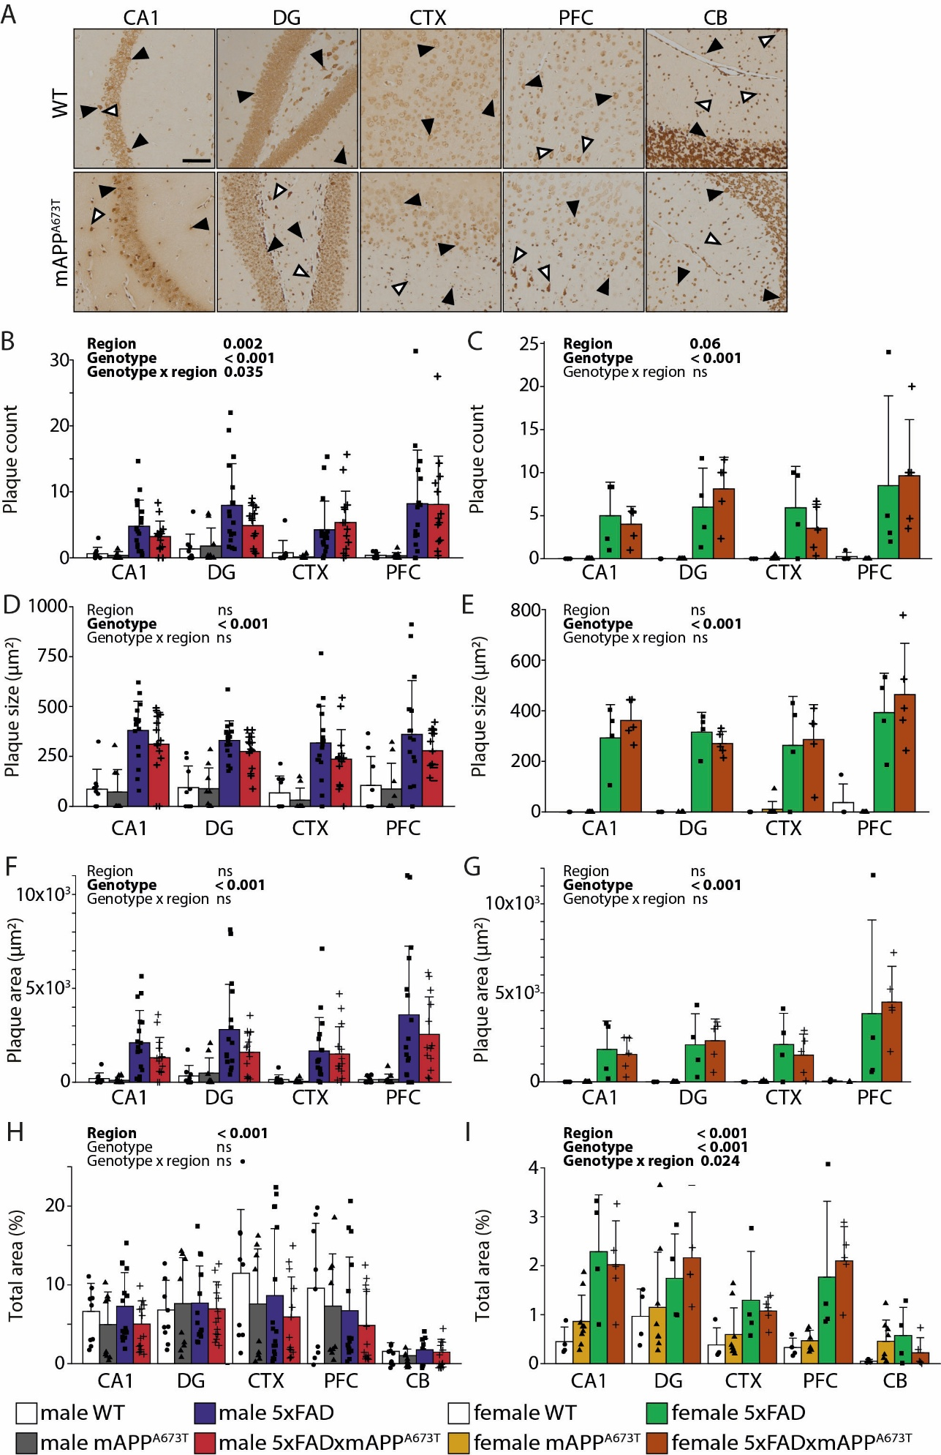
Supplementary Fig. 1. Aβ immunohistochemistry using the antibody 6E10. (A) Representative Aβ immunohistochemistry images in brains of male WT and mAPP^{A673T} mice stained with the antibody 6E10 (Biolegend # 803004, diluted 1:1,000). For the other two genotypes (5xFAD and 5xFADxAPP^{A673T}) see Fig. 1, main manuscript. Images from CA1, DG, CTX and PFC were taken using a light microscope at a 100x magnification. Black arrowheads, cytosolic staining; white arrowheads, axonal/dendritic staining; scale bars, 100µm. Aβ plaque levels were quantified using ilastik as plaque counts (B&C), plaque size (D&E), plaque area (F&G) and total area stained (H&I) in male (B, D, F and H) and female (C, E, G and I) WT, APP^{A673T}, 5xFAD and 5xFADxAPP^{A673T} mice in four pre-specified brain regions. Data is shown as individual values, group mean, and S.D. Data were analysed using Wald χ² test (B,C) or two-way ANOVA (D-I) with genotype and region as independent variables. Significance of each factor and their interaction is indicated above each graph. Count data did not need to be transformed (B,C) and remaining data were transformed using Yeo-Johnson (D-G) or square-root (H, I) transformation. Males: WT: n=9, mAPP^{A673T}: n=9, 5xFAD: n=17 (PFC n=16), 5xFADxmAPP^{A673T}: n=14 (PFC n=13). Females: WT: n=4 (CB n=3), mAPP^{A673T}: n=9 (PFC n=6, CB n=4), 5xFAD: n=4, 5xFADxmAPP^{A673T}: n=5. Abbreviations: CA1: hippocampal CA1, CTX: visual cortex, DG: dentate gyrus, ns: not significant, PFC: prefrontal cortex

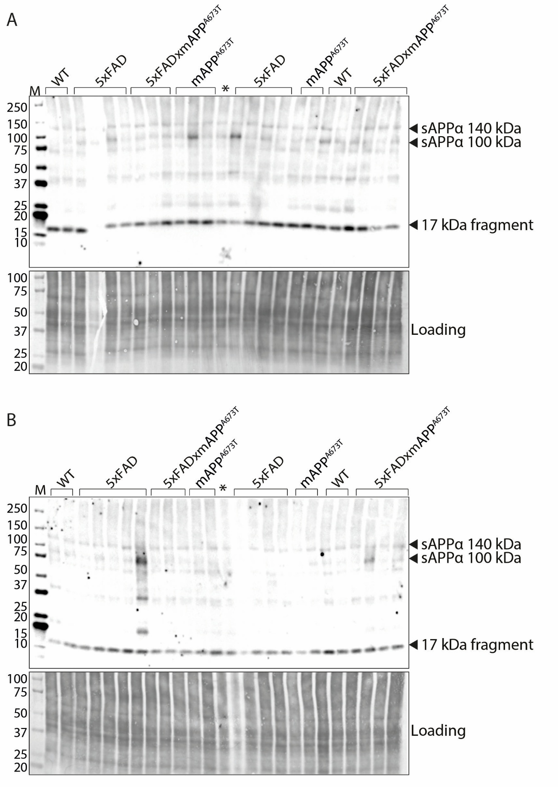
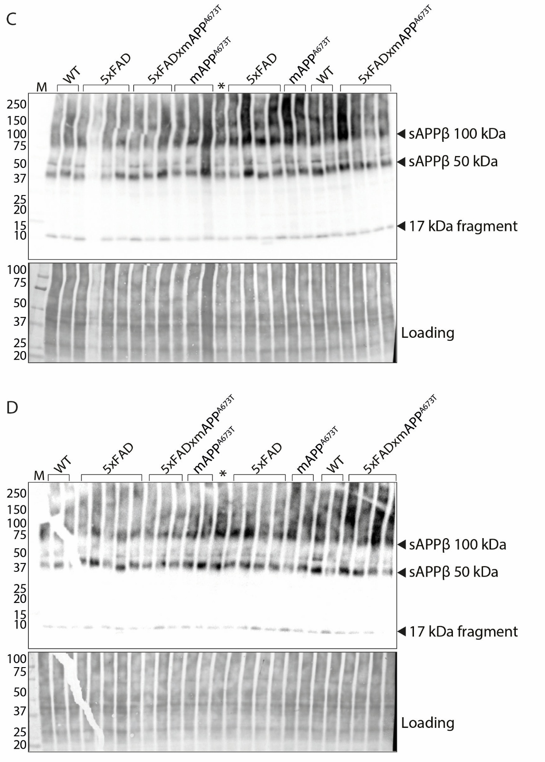
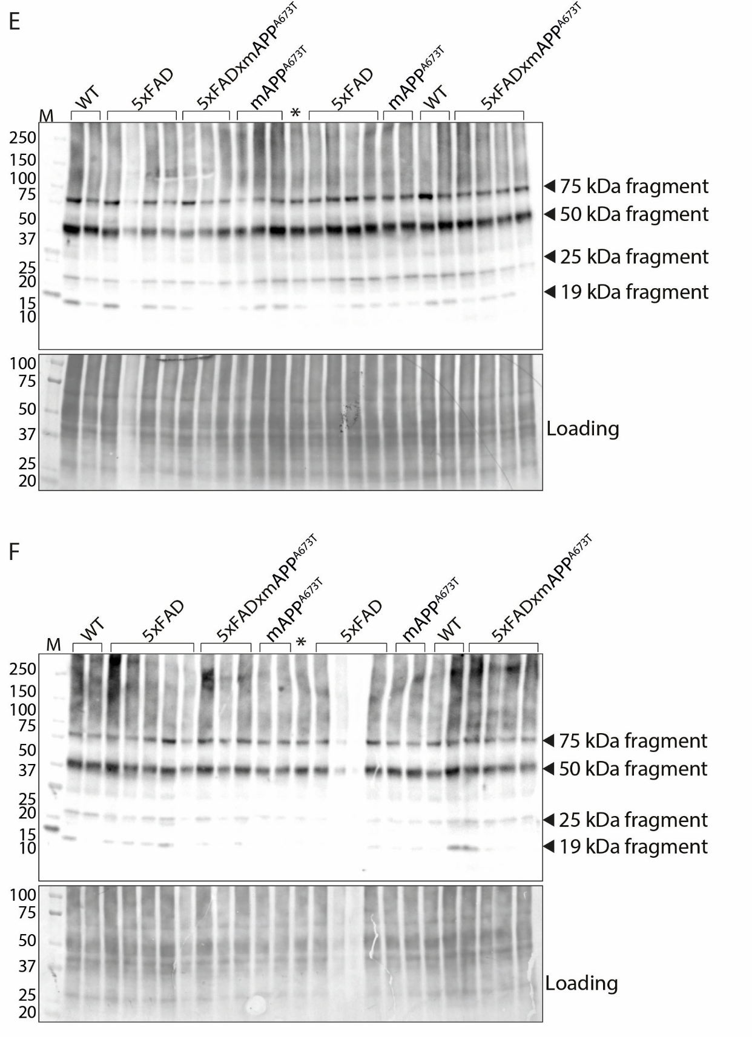
Supplementary Fig. 2. Quantification of APP/Aβ species using immunoblotting. Proteins from RIPA-soluble S1 fractions were separated by SDS-PAGE (20 µg per lane) and labelled with the antibodies 2B3 (IBL #11088, 1:500) against sAPPα (A&B), Poly8134 (Biolegend #Poly8134, 1:1,000) against sAPPβ (C&D), CT695 (Invitrogen #51-2700, 1:1,000) against CTFs of APP (E&F), and all blots for male WT, mAPP^{A673T}, 5xFAD and 5xFADxmAPP^{A673T} mice are displayed. For densitometric quantification see Fig. 3, main text. WT: n=8 (n=6 for Poly8134 antibody), mAPP^{A673T}: n=9, 5xFAD: n=17 (n=15 for Poly8134 antibody), 5xFADxmAPP^{A673T}: n=14.
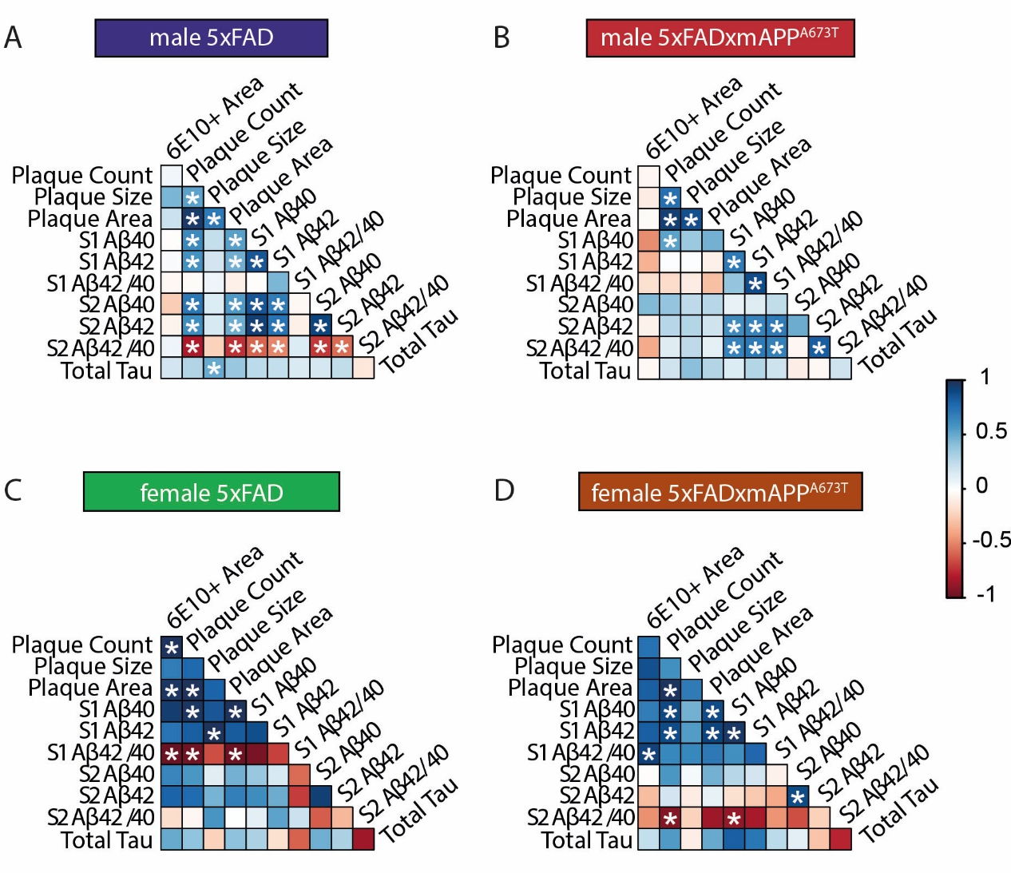
Supplementary Fig. 3. Correlation matrices for the different Aβ measurements and tau. (A-D) Pearson correlation matrix between Aβ plaque parameters (count, size, and area), Aβ40 and Aβ42 levels and their ratio (Aβ42/ Aβ40) in soluble and insoluble fractions S1 and S2, as well as tau ELISA are displayed for 5xFAD male (A), 5xFADxAPP^{A673T} male (B), 5xFAD female (C) and 5xFADxAPP^{A673T} female (D) mice with blue for positive correlations, red for negative correlations and white where no correlation was seen (* p < 0.05). Aβ and tau levels were quantified using ELISA and plaque counts, size and total area were quantified using immunohistochemistry (averaged across brain regions). Data were analysed using Jennrich test to detect differences between matrices. Abbreviations: mAPP^{A673T}: Icelandic mutation mice, 5xFAD: five familial Alzheimer's disease mice, 5xFADxmAPP^{A673T}: crosses carrying both the 5xFAD mutations and the A673T mutation in the APP gene.

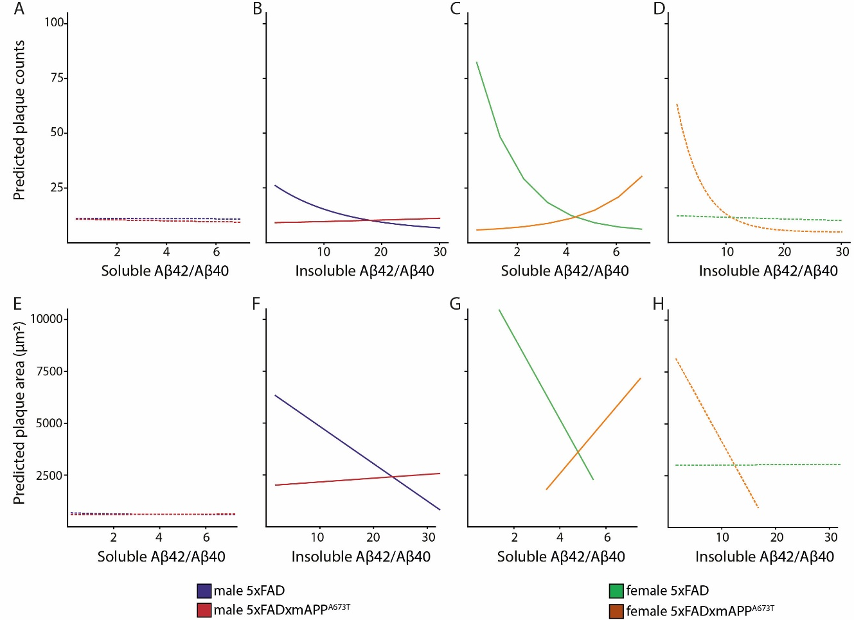
Supplementary Fig. 4. Prediction linear modelling for the different Aβ measurements. Generalized linear modelling was used to explore the effect of Aβ42/Aβ42 ratio in S1 and S2 on plaque counts (A-D) and plaque area (E-H)), and whether this differed across genotypes. Model-predicted plaque counts depending on Aβ42/Aβ40 ratio for 5xFAD and 5xFADxmAPP^{A673T} male in S1 (A) and S2 (B), as well as 5xFAD and 5xFADxmAPP^{A673T} female in S1 (C) and S2 (D) are presented. Further, model-predicted plaque area depending on Aβ42/Aβ40 ratio for 5xFAD and 5xFADxmAPP^{A673T} male in S1 (E) and S2 (F), as well as 5xFAD and 5xFADxmAPP^{A673T} female in S1 (G) and S2 (H) are presented. Dashed lines indicate non-significant effects.

