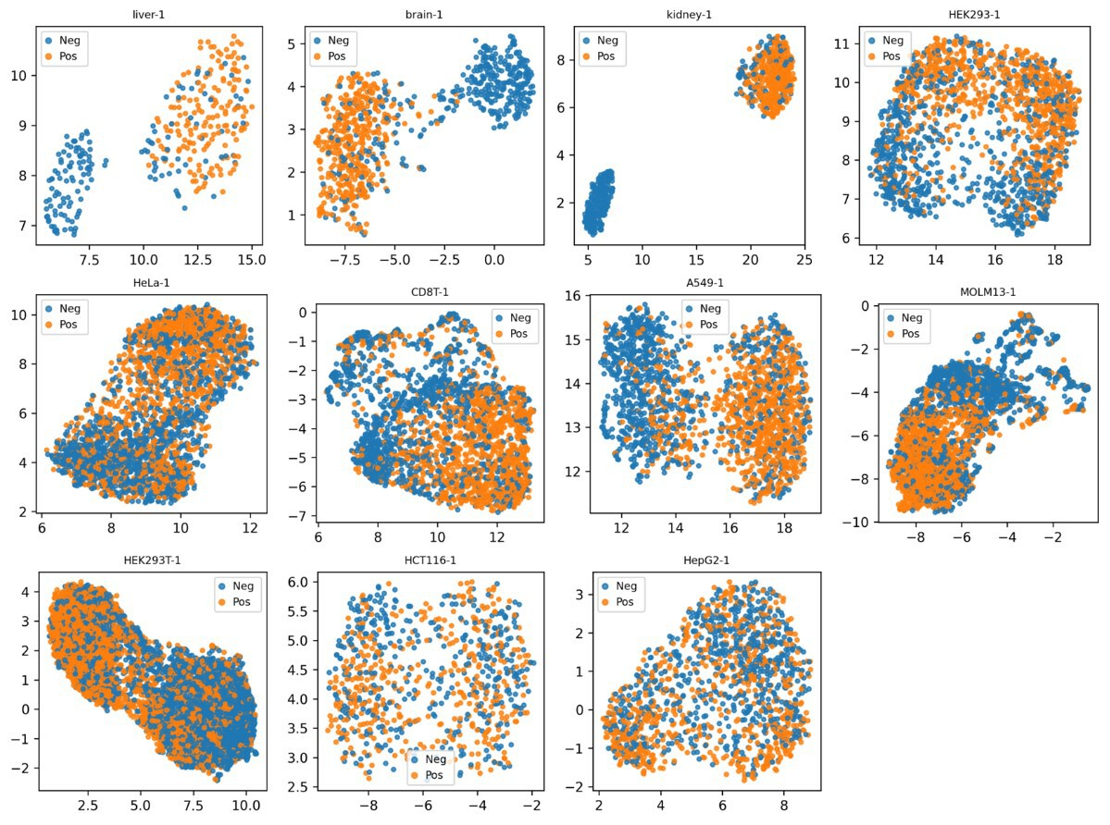
Supplementary Fig. 1. UMAP visualization of features representations extracted by the first-fold base learner across multiple independent test datasets. Each panel shows the feature representations learned by the model trained on the first fold for different cell lines and tissues, including liver, brain, kidney, HEK293, HeLa, CD8T, A549, MOLM13, HEK293T, HCT116, and HepG2. The high-dimensional features are projected into a low-dimensional space using UMAP for visualization. Generated using Python.
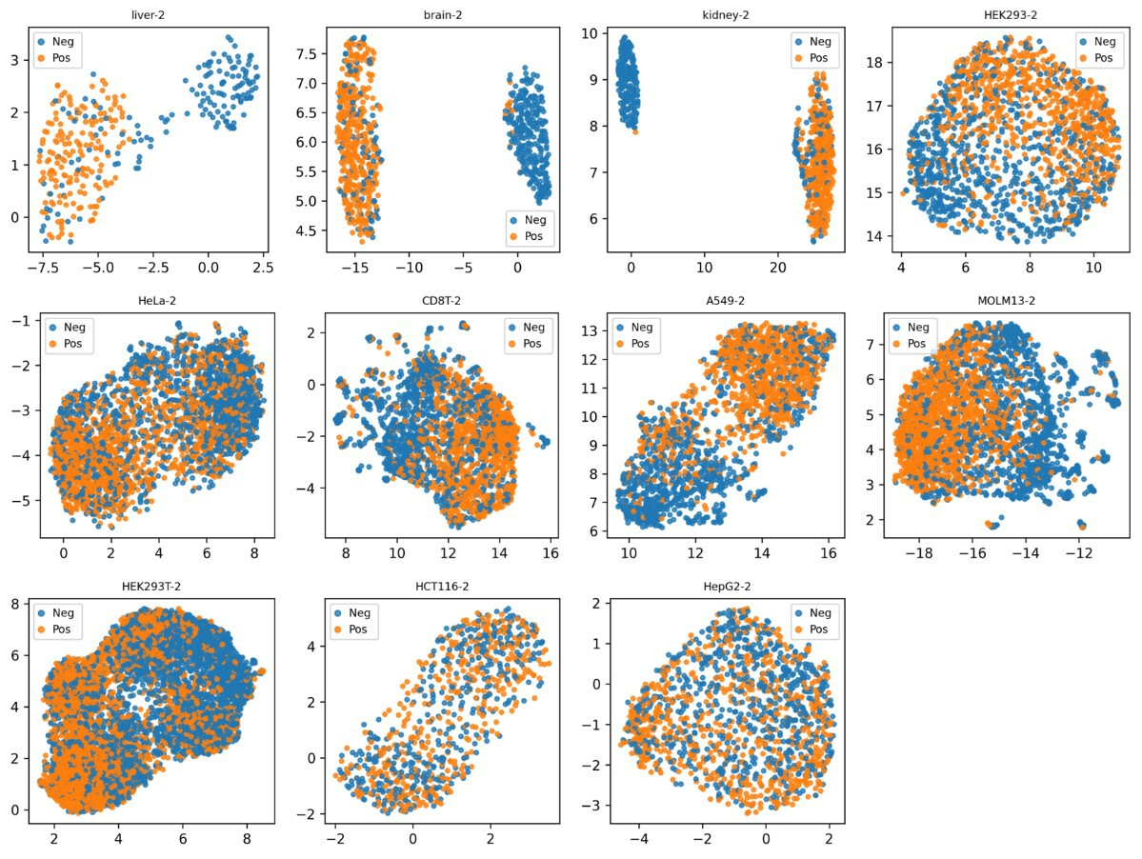
Supplementary Fig. 2. UMAP visualization of features representations extracted by the second-fold base learner across multiple independent test datasets. Each panel shows the feature representations learned by the model trained on the second fold for different cell lines and tissues, including liver, brain, kidney, HEK293, HeLa, CD8T, A549, MOLM13, HEK293T, HCT116, and HepG2. The high-dimensional features are projected into a low-dimensional space using UMAP for visualization. Generated using Python.
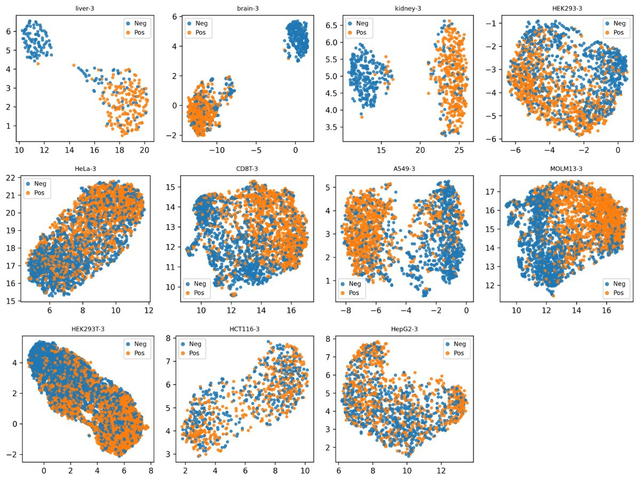
Supplementary Fig. 3. UMAP visualization of features representations extracted by the third-fold base learner across multiple independent test datasets. Each panel shows the feature representations learned by the model trained on the third fold for different cell lines and tissues, including liver, brain, kidney, HEK293, HeLa, CD8T, A549, MOLM13, HEK293T, HCT116, and HepG2. The high-dimensional features are projected into a low-dimensional space using UMAP for visualization. Generated using Python.
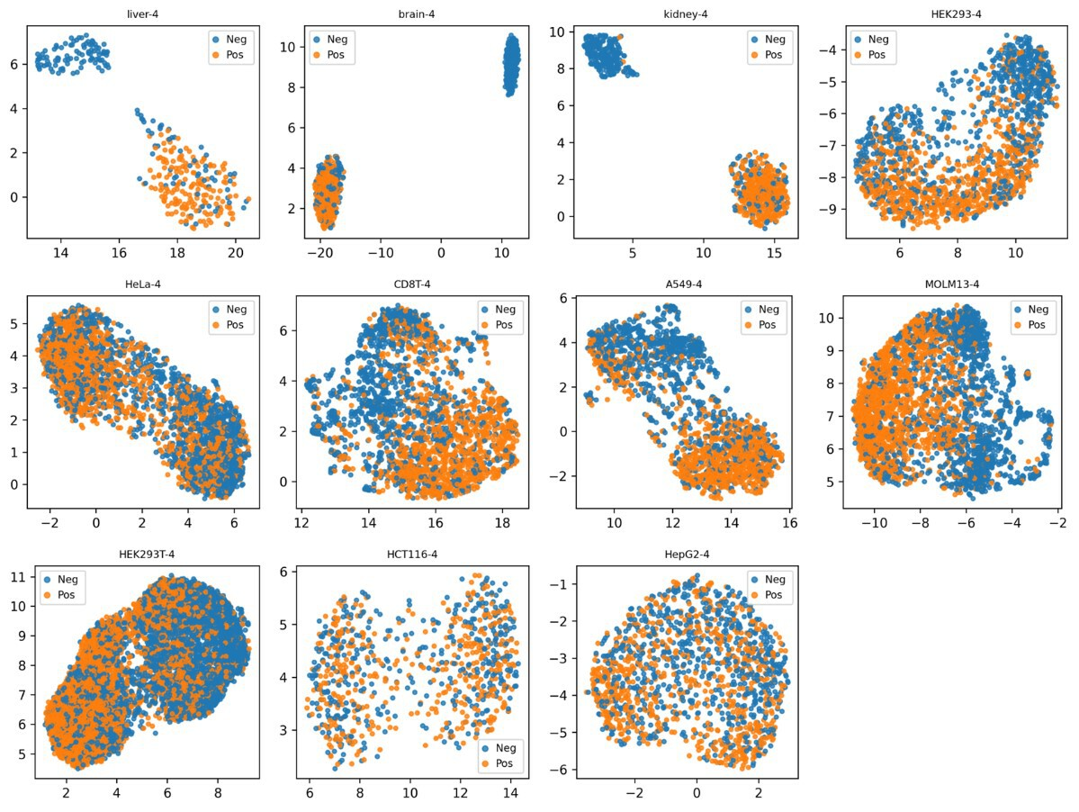
Supplementary Fig. 4. UMAP visualization of features representations extracted by the fourth-fold base learner across multiple independent test datasets. Each panel shows the feature representations learned by the model trained on the fourth fold for different cell lines and tissues, including liver, brain, kidney, HEK293, HeLa, CD8T, A549, MOLM13, HEK293T, HCT116, and HepG2. The high-dimensional features are projected into a low-dimensional space using UMAP for visualization. Generated using Python.
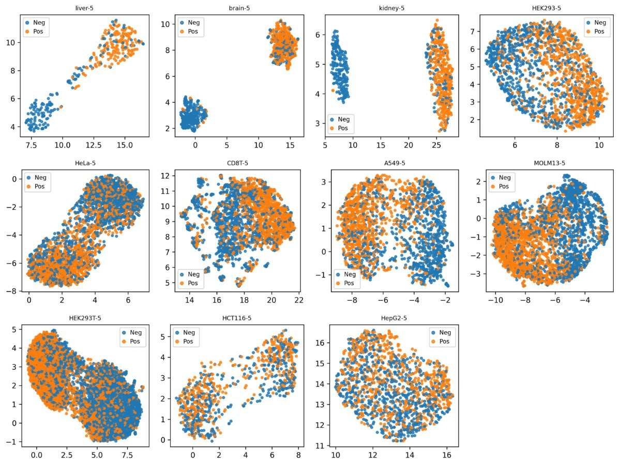
Supplementary Fig. 5. UMAP visualization of features representations extracted by the fifth-fold base learner across multiple independent test datasets. Each panel shows the feature representations learned by the model trained on the fifth fold for different cell lines and tissues, including liver, brain, kidney, HEK293, HeLa, CD8T, A549, MOLM13, HEK293T, HCT116, and HepG2. The high-dimensional features are projected into a low-dimensional space using UMAP for visualization. Generated using Python.

Supplementary Table 1 Silhouette coefficients of K-means clustering based on UMAP-reduced features from per-fold cross-validation models across datasets
 | Fold1 | Fold2 | Fold3 | Fold4 | Fold5
liver | 0.725 | 0.740 | 0.767 | 0.751 | 0.719
brain | 0.749 | 0.898 | 0.857 | 0.951 | 0.897
kidney | 0.902 | 0.938 | 0.840 | 0.883 | 0.911
HEK293 | 0.511 | 0.466 | 0.499 | 0.525 | 0.477
HeLa | 0.602 | 0.620 | 0.545 | 0.673 | 0.656
CD8T | 0.404 | 0.412 | 0.451 | 0.460 | 0.408
A549 | 0.622 | 0.607 | 0.633 | 0.638 | 0.556
MOLM13 | 0.524 | 0.441 | 0.464 | 0.435 | 0.467
HEK293T | 0.668 | 0.494 | 0.611 | 0.567 | 0.640
HCT116 | 0.607 | 0.620 | 0.668 | 0.676 | 0.713
HepG2 | 0.505 | 0.436 | 0.467 | 0.450 | 0.449
The table shows the Silhouette coefficients (measures of cluster tightness and separation) obtained by K-means clustering analysis for the features output by the per-fold cross-validation model (Fold1–Fold5) on each dataset after UMAP dimensionality reduction. The closer the Silhouette value is to 1, the better the clustering effect.

Supplementary Table 2 Performance comparison between DT-m6A and baseline models
Dataset | baseline models | ACC | MCC | PRE | REC | F1
liver | CNN-base-m6A | 0.8513 | 0.7163 | 0.7959 | 0.9571 | 0.8691
liver | CNN-Trans-m6A | 0.8576 | 0.7314 | 0.7980 | 0.9693 | 0.8753
liver | Dense-LSTM-m6A | 0.8544 | 0.7281 | 0.7910 | 0.9755 | 0.8736
liver | MST-m6A | 0.8608 | 0.7349 | 0.8051 | 0.9632 | 0.8771
liver | DT-m6A | 0.8766 | 0.7614 | 0.8298 | 0.9571 | 0.8889
brain | CNN-base-m6A | 0.8535 | 0.7195 | 0.7992 | 0.9497 | 0.8680
brain | CNN-Trans-m6A | 0.8573 | 0.7256 | 0.8056 | 0.9472 | 0.8707
brain | Dense-LSTM-m6A | 0.8624 | 0.7412 | 0.8008 | 0.9698 | 0.8773
brain | MST-m6A | 0.8637 | 0.7426 | 0.8038 | 0.9673 | 0.8780
brain | DT-m6A | 0.8752 | 0.7657 | 0.8138 | 0.9774 | 0.8881
kidney | CNN-base-m6A | 0.8708 | 0.7521 | 0.8199 | 0.9665 | 0.8872
kidney | CNN-Trans-m6A | 0.8546 | 0.7199 | 0.8047 | 0.9553 | 0.8736
kidney | Dense-LSTM-m6A | 0.8796 | 0.7640 | 0.8416 | 0.9497 | 0.8924
kidney | MST-m6A | 0.8664 | 0.7339 | 0.8432 | 0.9162 | 0.8782
kidney | DT-m6A | 0.8884 | 0.7845 | 0.8422 | 0.9693 | 0.9013
HEK293 | CNN-base-m6A | 0.7234 | 0.4469 | 0.7177 | 0.7326 | 0.7251
HEK293 | CNN-Trans-m6A | 0.7210 | 0.4426 | 0.7093 | 0.7448 | 0.7266
HEK293 | Dense-LSTM-m6A | 0.7325 | 0.4653 | 0.7243 | 0.7473 | 0.7356
HEK293 | MST-m6A | 0.7356 | 0.4728 | 0.7574 | 0.6899 | 0.7220
HEK293 | DT-m6A | 0.7562 | 0.5126 | 0.7500 | 0.7656 | 0.7577
HeLa | CNN-base-m6A | 0.6513 | 0.3026 | 0.6495 | 0.6482 | 0.6489
HeLa | CNN-Trans-m6A | 0.6426 | 0.2852 | 0.6468 | 0.6187 | 0.6324
HeLa | Dense-LSTM-m6A | 0.6702 | 0.3407 | 0.6615 | 0.6889 | 0.6749
HeLa | MST-m6A | 0.6611 | 0.3221 | 0.6589 | 0.6594 | 0.6592
HeLa | DT-m6A | 0.6848 | 0.3696 | 0.6823 | 0.6847 | 0.6835
CD8T | CNN-base-m6A | 0.7240 | 0.4487 | 0.7074 | 0.7402 | 0.7234
CD8T | CNN-Trans-m6A | 0.6936 | 0.3866 | 0.6915 | 0.6714 | 0.6813
CD8T | Dense-LSTM-m6A | 0.7503 | 0.5031 | 0.7248 | 0.7867 | 0.7545
CD8T | MST-m6A | 0.7705 | 0.5429 | 0.7469 | 0.8008 | 0.7729
CD8T | DT-m6A | 0.7750 | 0.5498 | 0.7666 | 0.7743 | 0.7704
A549 | CNN-base-m6A | 0.7428 | 0.4877 | 0.7214 | 0.7829 | 0.7509
A549 | CNN-Trans-m6A | 0.7289 | 0.4589 | 0.7131 | 0.7570 | 0.7344
A549 | Dense-LSTM-m6A | 0.7599 | 0.5223 | 0.7359 | 0.8035 | 0.7682
A549 | MST-m6A | 0.7754 | 0.5533 | 0.7510 | 0.8175 | 0.7828
A549 | DT-m6A | 0.7898 | 0.5817 | 0.7668 | 0.8272 | 0.7958
MOLM13 | CNN-base-m6A | 0.7609 | 0.5219 | 0.7544 | 0.7683 | 0.7613
MOLM13 | CNN-Trans-m6A | 0.7445 | 0.4890 | 0.7435 | 0.7406 | 0.7421
MOLM13 | Dense-LSTM-m6A | 0.7841 | 0.5685 | 0.7927 | 0.7650 | 0.7786
MOLM13 | MST-m6A | 0.8090 | 0.6195 | 0.7891 | 0.8396 | 0.8136
MOLM13 | DT-m6A | 0.8126 | 0.6270 | 0.7909 | 0.8462 | 0.8176
HEK293T | CNN-base-m6A | 0.7026 | 0.4078 | 0.6822 | 0.7686 | 0.7228
HEK293T | CNN-Trans-m6A | 0.6880 | 0.3768 | 0.6753 | 0.7348 | 0.7038
HEK293T | Dense-LSTM-m6A | 0.7123 | 0.4272 | 0.6917 | 0.7755 | 0.7312
HEK293T | MST-m6A | 0.7221 | 0.4444 | 0.7283 | 0.7165 | 0.7224
HEK293T | DT-m6A | 0.7248 | 0.4502 | 0.7138 | 0.7589 | 0.7357
HCT116 | CNN-base-m6A | 0.5730 | 0.1433 | 0.5741 | 0.6563 | 0.6125
HCT116 | CNN-Trans-m6A | 0.5755 | 0.1495 | 0.5843 | 0.6038 | 0.5939
HCT116 | Dense-LSTM-m6A | 0.5865 | 0.1720 | 0.5962 | 0.6062 | 0.6012
HCT116 | MST-m6A | 0.5767 | 0.1509 | 0.5746 | 0.6802 | 0.6230
HCT116 | DT-m6A | 0.6294 | 0.2585 | 0.6410 | 0.6348 | 0.6379
HepG2 | CNN-base-m6A | 0.6008 | 0.2036 | 0.6204 | 0.4885 | 0.5466
HepG2 | CNN-Trans-m6A | 0.5768 | 0.1545 | 0.5660 | 0.6034 | 0.5841
HepG2 | Dense-LSTM-m6A | 0.6150 | 0.2305 | 0.6275 | 0.5374 | 0.5789
HepG2 | MST-m6A | 0.6157 | 0.2337 | 0.5995 | 0.6624 | 0.6294
HepG2 | DT-m6A | 0.6539 | 0.3092 | 0.6728 | 0.5790 | 0.6224
Performance comparison between DT-m6A and baseline models evaluated on independent test datasets using the same five-fold cross-validation and ensemble strategy as DT-m6A. Performance is assessed using ACC, precision (PRE), recall (REC), F1 score (F1), and MCC. Bold values indicate the best performance for each metric across different cell lines and tissues.

