Supplementary Material

Supplementary Data
Supplementary Data 1. Description of cognitive domains assessed in vascular cognitive disorders
1 | Attention and processing speed (sustained attention, divided attention, selective attention, information processing speed)
2 | Frontal-executive function (planning, decision-making, working memory, responding to feedback/error correction, novel situations, over-riding habits, mental flexibility, judgment)
3 | Learning and memory (immediate memory, recent memory [including free recall, cued recall], and recognition memory)
4 | Language (naming, expressive, grammar and syntax, receptive)
5 | Visuoconstructional-perceptual ability (construction, visual perception and reasoning)
6 | Praxis-gnosis-body schema (Praxis, gnosis, right/left orientation, calculation ability, body schema, facial recognition)
7 | Social cognition (recognition of emotions and social cues, appropriate social inhibitions, theory of mind, empathy)

Supplementary Data 2. The abbreviations of Rich club regions
Abbreviation | AAL Regions
PreCG | Precentalgyrus
SFGdor | Superiorfrontalgyrus, dorsolateral
ORBsup | Superiorfrontalgyrus, orbitalpart
MFG | Middlefrontalgyrus
ORBmid | Middlefrontalgyrus, orbitalpart
ORBinf | Inferiorfrontalgyrus, orbitalpart
ROL | Rolandicoperculum
OLF | Olfactorycortex
SFGmed | Superiorfrontalgyrus, medial
REC | Gyrusrectus
INS | Insula
ACG | Anterior cingulate and paracingulate gyri
HIP | Hippocampus
PoCG | Postcentralgyrus
PUT | Lenticularnucleus, putamen

Supplementary Material-Method

rs-fMRI Data preprocessing steps

The first 10 volumes of each subject were removed to ensure magnetization equilibrium. Slice-timing adjustment and realignment for head-motion correction were then performed in the remaining volumes. Subsequently, confounding variables, including six head motion parameters, average white matter (WM), cerebrospinal fluid (CSF) and global signals were regressed out. For group average and group comparison purposes, the data were spatially normalized to the standard Montreal Neurological Institute (MNI) space and resampled with a resolution of 3 mm × 3 mm × 3 mm. Next, the normalized functional data were spatially smoothed with full width at half maxima (FWHM) Gaussian kernels of 4 mm. Finally, a band-pass (0.01-0.08 Hz) filter was applied to minimize the effects of low-frequency drift and high-frequency physiological noise.

DTI data preprocessing steps

First, the DICOM files of all subjects were converted into NIFTI format using the dcm2nii tool embedded in MRIcron. Second, the brain mask was estimated which is required for the subsequent processing steps. Third, the non-brain space in the raw images was cut off leading to a reduced image size, reducing the memory cost, and speeding up the processing in subsequent steps. Fourth, each diffusion-weighted image was coregistered to the b0 image using an affine transformation. Fifth, the eddy-current induced distortions and simple head-motion artifacts were corrected. Sixth, deterministic tractography was performed to reconstruct whole brain white matter tracts by using the Fiber Assignment by Continuous Tracking algorithm. A tract was terminated if the turn angle was greater than 45° or if the fiber entered a voxel with fractional anisotropy of less than 0.2. Seventh, the diffusion gradient directions were adjusted accordingly and the diffusion tensor matrices were yielded for each subject [1].

Functional network construction

Functional networks were constructed using the GRETNA (www.nitrc.org/projects/gretna/) [2]. A 90 × 90 temporal correlation matrix was assembled by computing Pearson’s correlation coefficient between the residual time series of each pair of the 90 nodes for each participant. For each region of interest (ROI), the mean time series were obtained by averaging the fMRI time courses over each ROI. The values of the interregional correlation coefficients were taken as the weights of the edges. Thus, we constructed a weighted functional connectivity matrix for each participant. Because of the multiple, non-independent comparisons entailed by thresholding each of inter-regional correlations, we built the functional connectivity matrix using a FDR 0.05-corrected threshold [3]. Based on this weighted functional connectivity matrix, the topological properties of the network were subsequently calculated by graph theoretical analyses.

Structural network construction

Structural networks were constructed by using deterministic tractography procedure proposed by Gong et al (1) in the PANDA (PANDA_1.3.1) toolbox [4]. The structured brain network was ultimately structured by 90 for each subject 90 × 90 fiber number (FN) weighted matrix construction. For each individual, we generated a symmetric 90 × 90 network matrix in which each row and column represents a brain node or region and each element represents the FN of the linking fibers between nodes. Each matrix represented the white matter network of the cerebral cortex. For each subject, the FN-weighted matrix was used for further graph theoretical analyses.

Definition of Resting State Network
Define DMN, FPCN, and DAN using seed based ROI method. According to the procedures of Grady et al.[5] and Spreng et al.[6], each node of the network is defined by a 5mm radius spherical ROI centered on the reported area coordinates. Consistent with previous studies [7], DMN consists of bilateral PCC, medial prefrontal cortex, inferior parietal lobule, lateral temporal lobe cortex, and hippocampus. FPCN consists of bilateral DLPFC, dorsomedial prefrontal cortex, and lateral parietal cortex, while DAN includes bilateral IPS, frontal eye field, and middle temporal lobe, which is consistent with previous studies [8, 9]. Then extract individual average time series for each ROI. Finally, calculate the Pearson correlation coefficient between each pair of ROIs for each subject. Ultimately, six network metrics were obtained from each individual: average DMN, FPCN, and DAN connectivity as intra network metrics, and DMN/FPCN, DMN/DAN, and FPCN/DAN connectivity as inter network metrics. Then associate these six indicators with the scores of the cognitive assessment scale.
For each ROI, extract a time series from the constituent voxels and take the average to create an average time series. Then use these time series for connectivity analysis. To check the intra network connectivity in DMN, FPCN, and DAN, correlation matrices were obtained from the time series of each ROI in each network. These correlation matrices represent the time series correlation of each ROI pair. Normalize each correlation coefficient using Fisher transform.
For each triangle half of the correlation matrix, the correlation coefficients of the Fisher transform are averaged to generate a measure of the average connectivity within each network. In this article, we refer to these indicators as "DMN connectivity", "FPCN connectivity", and "DAN connectivity".
For inter network connectivity, the time series containing all ROIs of each network is associated with the time series containing all ROIs of other networks. Normalize the correlation and average the correlation coefficients of Fisher transform to generate a measure of average connectivity between networks. In this article, we refer to these indicators as "DMN/FPCN connection", "DMN/DAN connection", and "FPCN/DAN connection".

Functional-structural coupling calculation steps
First, all non-zero connectivities of the structural network were selected. Next, these connectivity values were rescaled to a Gaussian distribution. Then, the corresponding connectivities of the functional network were also extracted and correlated with the structural counterparts selected forehead. And this resulted in a single functional-structural coupling value for each subject [10, 11].
References:
1.Gong G, He Y, Concha L et al (2009) Mapping anatomical connectivity patterns of human cerebral cortex using in vivo diffusion tensor imaging tractography. Cereb Cortex 19:524-536.
2.Wang J, Wang X, Xia M, Liao X, Evans A, He Y (2015) GRETNA: a graph theoretical network analysis toolbox for imaging connectomics. Front Hum Neurosci 9:386.
3.Genovese CR, Lazar NA, Nichols T (2002) Thresholding of statistical maps in functional neuroimaging using the false discovery rate. Neuroimage 15:870-888.
4.Cui Z, Zhong S, Xu P, He Y, Gong G (2013) PANDA: a pipeline toolbox for analyzing brain diffusion images. Front Hum Neurosci 7:42.
5.Grady C, Sarraf S, Saverino C, Campbell K. Age differences in the functional interactions among the default, frontoparietal control, and dorsal attention networks. Neurobiol Aging. 2016; 41: 159-172. https://doi.org/10.1016/j.neurobiolaging.2016.02.020
6.Spreng RN, Sepulcre J, Turner GR, Stevens WD, Schacter DL. Intrinsic architecture underlying the relations among the default, dorsal attention, and frontoparietal control networks of the human brain. J Cogn Neurosci. 2013; 25: 74-86. https://doi.org/10.1162/jocn_a_00281
7.Bai F, Watson DR, Shi Y, Wang Y, Yue C, YuhuanTeng, et al. Specifically progressive deficits of brain functional marker in amnestic type mild cognitive impairment. PLoS One. 2011; 6: e24271. https://doi.org/10.1371/journal.pone.0024271
8.Seeley WW, Menon V, Schatzberg AF, Keller J, Glover GH, Kenna H, et al. Dissociable intrinsic connectivity networks for salience processing and executive control. J Neurosci. 2007; 27: 2349-2356. https://doi.org/10.1523/jneurosci.5587-06.2007
9.Fox MD, Snyder AZ, Vincent JL, Corbetta M, Van Essen DC, Raichle ME. The human brain is intrinsically organized into dynamic, anticorrelated functional networks. Proc Natl Acad Sci U S A. 2005; 102: 9673-9678.
10.Honey CJ, Sporns O, Cammoun L et al (2009) Predicting human resting-state functional connectivity from structural connectivity. Proc Natl Acad Sci USA 106: 2035-2040.
11.Hagmann P, Sporns O, Madan N, Cammoun L, Pienaar R, Wedeen VJ, et al. White matter maturation reshapes structural connectivity in the late developing human brain. Proc Natl Acad Sci USA. 2010;107: 19067-19072.

Supplementary Figures and Tables

Supplementary Figure
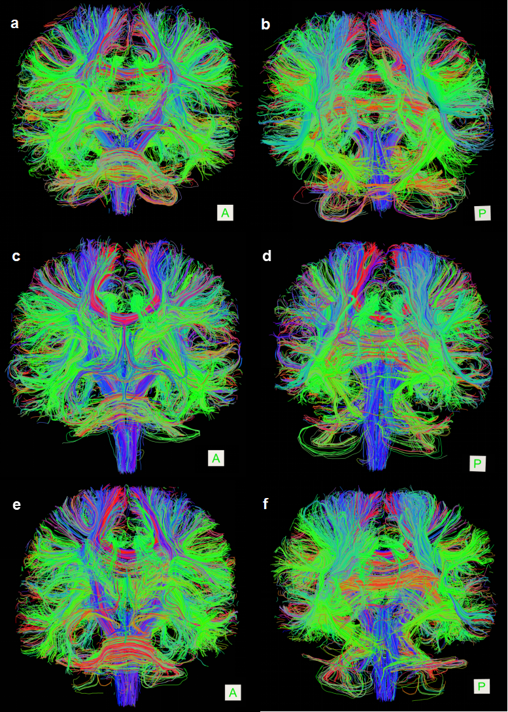
Supplementary Fig. 1. 3D maps of all white matter connections created using FA values from DTI images.
A: Positive view of the white matter junction 3D map in Con group patients; P: The posterior view of the white matter connection 3D map in Con group patients. The fibers from front to back are green, blue from top to bottom, and red from left to right. Fibers with linear combinations of these directions are colored with corresponding color combinations based on their degree of orientation in each standard direction.

Supplementary Table
Parameter | Description | Significance
Global property
Characteristic/shortest path length, Lp | The average shortest path between nodes in a network and other nodes. | The shorter the length of the feature path, the shorter the path through which the node transmits information, and the more efficient the system resources are.
Clustering coefficient, Cp | The ratio of the actual number of connected edges between neighboring nodes of a network node to its maximum possible number of connected edges. | To measure the degree of clustering in a network, a high clustering coefficient indicates a closer connection between local nodes.
Gamma | The ratio of clustering coefficients between real networks and random networks. | Quantify the local network connection function, i.e. "separation" function.
Lamda | The ratio of feature path lengths between real networks and 20 random networks. | Quantify the overall path efficiency of the network, i.e. the "integration" function.
Small-worldness, Sigma | σ= Cp/Lp, the ratio of standardized clustering coefficients to the length of standardized feature paths, a value greater than 1 indicates that the network has a small world attribute. | Measuring the ability of the network to balance "integration" and "separation"
Global efficiency, Eglob | The average global efficiency of all nodes in the network. | Measuring the information transmission capacity of the entire network.
Local efficiency, Elocal | The average global efficiency of neighboring subgraphs in a region is a measure of network fault tolerance. | Measuring how to efficiently disseminate information through directly adjacent nodes of a node.
Node property
Nodal betweenness | The number of shortest paths through a given node in a network, and the higher the node's betweenness. | Represents the degree of independence between nodes, the more important the node's position in the network becomes.
Nodal degree | All nodes directly adjacent to a node have more connections as the node degree increases. | The larger the node degree, the more connections it has and the more important its position in the network is.
Nodal efficiency | The average length of the shortest path between a node and other nodes. | Describe the transmission efficiency of information between this node and other nodes in the network.
Supplementary Table 1 Description and Significance of Topological Attributes in Brain Networks

Supplementary Table 2 Global brain network measures in participants of the three groups.
 | Con | CSVD-NMCI | CSVD-MCI | p value | p of Bonferroni Corrected
Graph measures | n = 60 | n = 93 | n = 111 | p value | Con vs. CSVD-NMCI | Con vs. CSVD-MCI | CSVD-NMCI vs. CSVD-MCI
Structural network
Eglob | 0.091  (0.089, 0.093) | 0.089  (0.085, 0.092) | 0.091  (0.086, 0.092) | 0.014 | 0.011 | 0.388 | 0.279
Elocal | 0.151  (0.149, 0.152) | 0.149  (0.148, 0.151) | 0.149  (0.148, 0.151) | 0.009 | 0.015 | 0.019 | > 0.999
Cp | 0.108  (0.106, 0.110) | 0.106  (0.104, 0.109) | 0.106  (0.103, 0.108) | 0.004 | 0.031 | 0.004 | > 0.999
Lp | 0.442  (0.432, 0.524) | 0.459  (0.442, 0.500) | 0.489  (0.453, 0.517) | 0.001 | 0.309 | 0.001 | 0.107
γ | 0.859  (0.772, 1.010) | 0.843  (0.748, 0.970) | 0.777  (0.729, 0.913) | 0.001 | > 0.999 | 0.004 | 0.015
λ | 0.231  (0.228, 0.233) | 0.232  (0.230, 0.235) | 0.233  (0.231, 0.238) | <0.001 | 0.017 | <0.001 | 0.517
σ | 0.697  (0.643, 0.859) | 0.714  (0.657, 0.835) | 0.665  (0.628, 0.749) | 0.006 | > 0.999 | 0.065 | 0.010
Functional network
Eglob | 0.150  (0.142, 0.158) | 0.155  (0.136, 0.161) | 0.142  (0.133, 0.155) | 0.017 | > 0.999 | 0.039 | 0.067
Elocal | 0.207  (0.184, 0.231) | 0.199  (0.177, 0.231) | 0.181  (0.163, 0.216) | 0.003 | > 0.999 | 0.016 | 0.013
Cp | 0.170  (0.140, 0.195) | 0.172  (0.152, 0.184) | 0.162  (0.139, 0.191) | 0.772 | > 0.999 | > 0.999 | > 0.999
Lp | 1.430  (1.400, 1.510) | 1.350  (1.320, 1.650) | 1.500  (1.410, 1.610) | 0.025 | > 0.999 | 0.048 | 0.103
γ | 0.862  (0.709, 0.973) | 0.844  (0.737, 0.937) | 0.768  (0.735, 0.803) | 0.005 | 0.906 | 0.007 | 0.075
λ | 0.512  (0.502, 0.543) | 0.524  (0.511, 0.536) | 0.533  (0.524, 0.542) | 0.002 | 0.969 | 0.004 | 0.037
σ | 0.730  (0.604, 0.792) | 0.717  (0.602, 0.791) | 0.658  (0.596, 0.701) | 0.011 | 0.608 | 0.011 | 0.204

Supplementary Table 3 Node brain network measurements of three groups of participants.
 | Con | CSVD-NMCI | CSVD-MCI | p value | p of Bonferroni Corrected
Graph measures | n = 60 | n = 93 | n = 111 |  | Con vs. CSVD-NMCI | Con vs. CSVD-MCI | CSVD-NMCI vs. CSVD-MCI
Structural network
Nodal betweenness
STG.L | 25.2689 (12.0246) | 22.8625 (12.9983) | 19.9431 (8.2729) | 0.0087 | 0.5633 | 0.0083 | 0.1807
Nodal degree
MFG.L | 2.3412 (0.4937) | 2.2261 (0.5006) | 2.1252 (0.6013) | 0.0451 | 0.6071 | 0.0415 | 0.5643
ACG.L | 2.7161 (0.5275) | 2.6968 (0.5474) | 2.5151 (0.5093) | 0.0165 | >0.999 | 0.0541 | 0.0446
PCG.R | 1.5842 (0.5245) | 1.4226 (0.5055) | 1.3355 (0.5501) | 0.0213 | 0.1985 | 0.0168 | 0.9403
PoCG.L | 2.5651 (0.5124) | 2.4635 (0.3551) | 2.3903 (0.3749) | 0.0267 | 0.3895 | 0.0221 | 0.5950
Nodal efficiency
MFG.L | 0.1459 (0.0144) | 0.1457 (0.0171) | 0.1395 (0.0167) | 0.0095 | >0.999 | 0.0458 | 0.0224
HIP.L | 0.1317 (0.0124) | 0.1296 (0.0158) | 0.1254 (0.0169) | 0.0268 | >0.999 | 0.0368 | 0.1693
HIP.R | 0.1282 (0.0114) | 0.1252 (0.0134) | 0.1221 (0.0155) | 0.0219 | 0.5832 | 0.0201 | 0.3435
Functional network
Nodal betweenness
ORBinf.L | 21.7672 (5.4174) | 20.7203 (5.0844) | 19.8281 (4.4145) | 0.0461 | 0.5929 | 0.0422 | 0.5877
PCG.L | 19.4892 (3.1168) | 18.1533 (1.9657) | 17.9491 (3.0630) | 0.0016 | 0.0106 | 0.0016 | >0.999
Nodal degree
AMYG.L | 2.2317 (0.4453) | 2.1505 (0.5389) | 2.0418 (0.4504) | 0.0405 | 0.9309 | 0.0440 | 0.3304
CAL.L | 2.1653 (0.4160) | 2.1028 (0.3224) | 2.0195 (0.3358) | 0.0284 | 0.8501 | 0.0303 | 0.2780
Nodal efficiency
SMA.R | 0.2101 (0.0459) | 0.2024 (0.0452) | 0.1863 (0.0428) | 0.0017 | 0.8867 | 0.0028 | 0.0312

