Topographic Mapping of Acupuncture Points
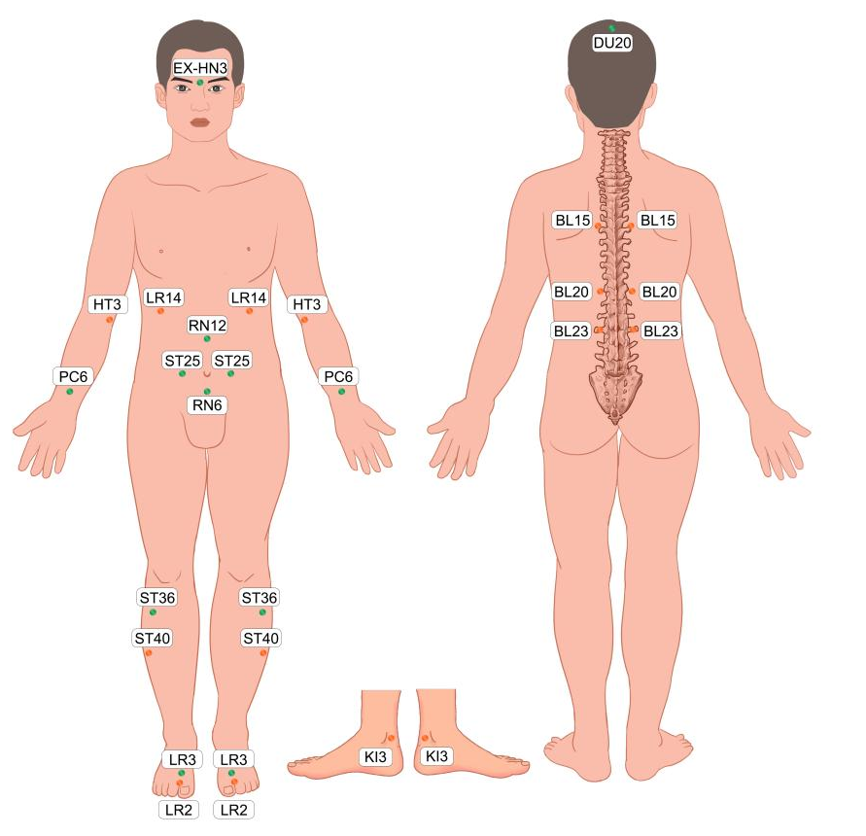
Supplementary Fig. 1. The acupoints we picked in this study.
Green acupoints: Obligatory points used for all patients in both groups. The obligatory points are Baihui (DU20), Yintang (EX-HN3), Zhongwan (RN12), Qihai (RN6), Tianshu (ST25 bilateral), Neiguan (PC6 bilateral), Zusanli (ST36 bilateral), and Taichong (LR3 bilateral).
Orange-yellow acupoints: Adjunct acupoints used for patients with different syndrome of traditional Chinese medicine. Adjunct acupoints will be chosen according to syndrome differentiation based on the theories of the traditional Chinese medicine (TCM). Qimen (LR14 bilateral) are used for the syndrome of liver qi stagnation. Xingjian (LR2 bilateral) are used for the syndrome of stagnated qi transforming into fire. Fenglong (ST40 bilateral) are used for the syndrome of qi stagnation causing phlegm retention. Shaohai (HT3 bilateral) and Xinshu (BL15 bilateral) are used for the syndrome of lack of heart spirit. Xinshu (BL15 bilateral) and pishu (BL20 bilateral) are used for the syndrome of heart-spleen deficiency. Shenshu (BL23 bilateral) and Taixi (KI3 bilateral) are used for the syndrome of yin-deficiency and fire-hyperactivity.

Supplementary Table 1. Key TCM syndrome differentiation criteria.
Syndrome Differentiation | Main Symptoms | Tongue Features | Pulse Characteristics | Adjunct acupoints
Syndrome of liver qi stagnation  (Gān Qì Yù Jié) | Emotional depression, frequent sighing, chest/hypochondriac distension, migrating pain, abdominal fullness, belching, irregular menstruation | Pale tongue with thin white coating | Wiry pulse | Qimen (LR14)
Syndrome of stagnated qi transforming into fire  (Qì Yù Huà Huǒ) | Irritability, chest oppression, hypochondriac distension, headache red eyes, tinnitus, dry and bitter mouth, dark yellow urine | Red tongue with yellow coating | Wiry and rapid pulse | Xingjian (LR2)
Syndrome of qi stagnation causing phlegm retention  (Qì Zhì Tán Zǔ) | Foreign body sensation in throat, difficulty swallowing or spitting, chest tightness, hypochondriac fullness | Pale tongue with white greasy coating | Wiry and slippery pulse | Fenglong (ST40)
Syndrome of lack of heart spirit  (Xīn Shén Shī Yǎng) | Restlessness, insomnia, suspicion, easy to startle, sadness and crying, mood swings | Pale tongue with thin coating | Wiry and thready pulse | Shaohai (HT3) Xinshu (BL15)
Syndrome of heart-spleen deficiency  (Xīn Pí Liǎng Xū) | Overthinking, palpitations, timidity, insomnia, forgetfulness, sallow complexion, dizziness, fatigu, poor appetite | Pale tongue | Thready and weak pulse | Xinshu (BL15)  pishu (BL20)
Syndrome of yin-deficiency and fire-hyperactivity  (Yīn Xū Huǒ Wàng) | Long course of illness, restlessness and insomnia, irritability, dry mouth/throat, nocturnal emission, lumbar pain, irregular menstruation | Red tongue | Thready and rapid pulse | Shenshu (BL23) Taixi (KI3)

Supplementary Table 2. Patient counts for each syndrome differentiation and antidepressant.
syndrome differentiation  or  antidepressants | MA (n = 50) | ADM (n = 50) | MA+ADM  (n = 50)
Syndrome of liver qi stagnation  (Gān Qì Yù Jié) | 19 | / | 19
Syndrome of heart-spleen deficiency (Xīn Pí Liǎng Xū) | 11 | / | 11
Syndrome of qi stagnation causing phlegm retention  (Qì Zhì Tán Zǔ) | 6 | / | 6
Syndrome of stagnated qi transforming into fire  (Qì Yù Huà Huǒ) | 7 | / | 6
Syndrome of lack of heart spirit  (Xīn Shén Shī Yǎng) | 4 | / | 4
Syndrome of yin-deficiency and fire-hyperactivity  (Yīn Xū Huǒ Wàng) | 3 | / | 4
Fluoxetine | / | 22 | 19
Escitalopram | / | 17 | 18
Sertraline | / | 11 | 13
MA, Manual acupuncture; ADM, Antidepressant Medication.

The processing parameters of Neurotransmitters analysis
Serum samples were collected and frozen immediately, and stored at -80 °C before analyses.
1 Reagents and instruments
Equipments
An ultra-high performance liquid chromatography coupled to tandem mass spectrometry (UHPLC-MS/MS) system (ExionLC™ AD UHPLC-QTRAP® 6500+, AB SCIEX Corp., Boston, MA, USA).
Materials and reagents
All of the neurotransmitters standards and stable isotope-labeled standards were obtained from ZZ Standards Co., LTD. (Shanghai, China). Ammonium acetate was of analytical grade and obtained from Sigma-Aldrich (A114-50, St. Louis, MO, USA). Acetonitrile (A955-4, Optima LC-MS) and formic acid (A117-50, Optima LC-MS) were purchased from Thermo-Fisher Scientific (FairLawn, NJ, USA). Ultrapure water was purchased from Millipore (W6-4, Billerica, MA, USA).
1.1 Standard solution preparation
The stock solution of individual neurotransmitter was mixed and prepared in neurotransmitter -free matrix to obtain a series of neurotransmitter calibrators. Certain concentrations of L-Tyrosine-d4 was mixed as Internal Standard (IS). The stock solution of all of these and working solution were stored in refrigerator of -20 °C.
2 Sample pre-processing
2.1 Metabolites extraction
The samples (100 μL) were taken respectively and homogenized with 200 μL of acetonitrile (80%) which contained mixed internal standards and centrifuged at 12,000 rpm for 10 min. Finally, the supernatant (2 μL) was injected into the LC-MS/MS system for analysis.
2.2 LC-MS method
An ultra-high performance liquid chromatography coupled to tandem mass spectrometry (UHPLC-MS/MS) system was used to quantitate neurotransmitter in Novogene Co., Ltd. (Beijing, China). Separation was performed on a Waters XSelect HSS T3 column (2.1 × 150mm, 2.5μm) which was maintained at 45 °C. The mobile phase, consisting of 0.1% formic acid in 5mM ammonium acetate (solvent A) and 0.1% formic acid in acetonitrile (solvent B), was delivered at a flow rate of 0.30 mL/min. The solvent gradient was set as follows: initial 5% B, 2min; 5–40% B, 4min; 40–70% B, 7 min; 70–100% B, 7.5min; 100% B, 9min; 100-5% B, 9.1min; 5% B, 11min.
The mass spectrometer was operated in negative multiple reaction mode (MRM) mode. Parameters were as follows: IonSpray Voltage (-4500 V), Curtain Gas (35 psi), Ion Source Temp (550 °C), Ion Source Gas of 1 and 2 (60 psi).

Supplementary Table 3. 23 Neurotransmitter Standards and 1 Stable Isotope-Labeled Internal Standard.
Number | Compound | Abbreviation | Catalog number | Manufacturer and its location
1 | 4-Aminobutyric acid | GABA | ZCS-N-14791-100MG | ZZ Standards Co., LTD. (Shanghai, China).
2 | Histamine | HisA | ZCH-14596.5-100-HCL | ZZ Standards Co., LTD. (Shanghai, China).
3 | Picolinic acid | PA | ZTR-P437220 | ZZ Standards Co., LTD. (Shanghai, China).
4 | Tyramine | TyrA | ZHC-676715 | ZZ Standards Co., LTD. (Shanghai, China).
5 | Acetylcholine chloride | Ach | ZTR-A172060 | ZZ Standards Co., LTD. (Shanghai, China).
6 | Hydroxytyramine hydrochloride | DA | ZCS-NG-15572-100MG | ZZ Standards Co., LTD. (Shanghai, China).
7 | Tryptamine | TrpA | ZTR-T894600 | ZZ Standards Co., LTD. (Shanghai, China).
8 | Noradrenaline hydrochloride | NE | ZB-240604 | ZZ Standards Co., LTD. (Shanghai, China).
9 | Serotonin hydrochloride | 5-HT | ZCP-111656 | ZZ Standards Co., LTD. (Shanghai, China).
10 | L-Tyrosine | Tyr | ZTR-T899975 | ZZ Standards Co., LTD. (Shanghai, China).
11 | Adrenaline hydrochloride | E | ZC-59098 | ZZ Standards Co., LTD. (Shanghai, China).
12 | Kynurenic acid | KynA | ZTR-K660500 | ZZ Standards Co., LTD. (Shanghai, China).
13 | 5-Hydroxyindole-3-acetic acid | 5-HIAA | ZWK-320-98003 | ZZ Standards Co., LTD. (Shanghai, China).
14 | Levodopa | DOPA | ZZ-13347 | ZZ Standards Co., LTD. (Shanghai, China).
15 | L-Tryptophan | Trp | ZZ-13373 | ZZ Standards Co., LTD. (Shanghai, China).
16 | Xanthurenic acid | XA | ZTR-X743500 | ZZ Standards Co., LTD. (Shanghai, China).
17 | DL-Kynurenine | Kyn | ZB-045851 | ZZ Standards Co., LTD. (Shanghai, China).
18 | 5-Hydroxytryptophan | 5-HTP | ZC-66437 | ZZ Standards Co., LTD. (Shanghai, China).
19 | Melatonine | MT | IR-19870 | ZZ Standards Co., LTD. (Shanghai, China).
20 | L-Glutamic acid | Glu | ZTR-G596960 | ZZ Standards Co., LTD. (Shanghai, China).
21 | L-Histidine | His | ZCS-N-16724-100MG | ZZ Standards Co., LTD. (Shanghai, China).
22 | L-Glutamine | Gln | ZCS-N-16655-100MG | ZZ Standards Co., LTD. (Shanghai, China).
23 | Vanillymandelic Acid | VMA | IR-18439 | ZZ Standards Co., LTD. (Shanghai, China).
24 | L-Tyrosine-d4 (Internal Standard) | d4-Tyr | ZCH-11819.9-K-HCL | ZZ Standards Co., LTD. (Shanghai, China).

The processing parameters of fMRI analysis
MRI images of 11 patients were scanned before and after treatment on a SIEMENS 1.5T MRI system (Avanto, SQ engine, Siemens, erlangen, Germany). Magnetization Prepared Rapid Gradient Echo (MPRAGE) sequence was used to obtain high-resolution 3D-T1WI anatomical images through the following parameters: Repetition time (TR) = 2200 ms, Echo Time (TE) = 2.63 ms, flip angle (FA) = 8°, field of view (FOV) = 250 × 250 mm², matrix = 256 × 246, slice thickness = 1.0 mm, slices = 192, gap = 0 mm. Resting-state-fMRI (rs-fMRI) data were obtained through the following parameters: Repetition Time (TR) = 2000 ms, Echo Time (TE) = 30 ms, flip angle (FA) = 90°, field of view (FOV) = 220 × 220 mm², matrix = 64 × 64, slice thickness = 4.0 mm, slices = 30, gap = 0 mm, volumes = 200. Both sequences lasted about 8 minutes. During the MRI scan, patients were instructed to close eyes, keep relax, and not move their heads while remaining awake without thinking.
RESTplus (v1.24) software package based on MATLAB R2017b (MathWorks, Natick, MA, USA) were used for data preprocessing which included the following procedures: (1) Convert file formats; (2) Remove first 10 time points; (3) Slice timing; (4) Realign: if the patient’ head rotation exceeded 3°, or translation exceeded 3 mm, his data would not be included in subsequent analysis; (5) Normalize by using T1 image unified segmentation with a resampling voxel size of 3 × 3 × 3 mm; (6) Smooth with a 6-mm full-width at half maximum Gaussian kernel to improve signal-to-noise ratio; (7) Detrend to remove the influence of thermal noise; (8) Perform regression of covariates including head motion parameters, white matter signal and cerebrospinal fluid signal; (9) use filter retain the BOLD signal in the 0.01–0.08 Hz frequency band. Amplitude of low-frequency fluctuations (ALFF) analysis does not require the ninth step, and the sixth step was not needed in regional homogeneity (ReHo) analysis. Moreover, all steps should be conducted before functional connectivity (FC) analysis.

Mendelian Randomization: Causality between rsfMRI and
Depression
These single nucleotide polymorphisms (SNPs) were further filtered by inkage disequilibrium (LD) pruning (r² = 0.001, window size = 10,000 kb). Additionally, we calculated the F-statistic for the instrumental variables (IVs), ensuring that all IVs had an F-statistic greater than 10 to guarantee independence and robustness. These datasets were standardized, including alignment of effect alleles and effect directions, as well as the removal of palindromic SNPs. The inverse-variance weighted (IVW) was used as the primary method to estimate causal effects. Sensitivity analysis, such as MR-Egger and weighted median, were also performed to assess the robustness of the results and to detect potential pleiotropy. Finally, a leave-one-out analysis was conducted to ensure that particular SNP did not have a significant impact on the results. Scatter plots, Funnel plots and Leave-one-out plots are shown in the following.
Supplementary Fig. 2. Scatter plots of the effect of functional connectivity between different brain regions on depression.
(a) (Temporal)&(Frontal_Inf); (b) (Frontal_Sup)&(Frontal_Inf); (c) (Temporal|Frontal|Supp_Motor_Area)&(Frontal); (d) (Precuneus|Angular|Cingulate)&(Temporal); (e) Global_measure, Triple_netwoks(Default_mode); (f) (Calcarine|Lingual|Cuneus)&(Postcentral|Precentral).
MR, Mendelian randomisation; SNP, single-nucleotide polymorphism.

Supplementary Fig. 3. Funnel plots of the effect of functional connectivity between different brain regions on depression.
(a) (Temporal)&(Frontal_Inf); (b) (Frontal_Sup)&(Frontal_Inf); (c) (Temporal|Frontal|Supp_Motor_Area)&(Frontal); (d) (Precuneus|Angular|Cingulate)&(Temporal); (e) Global_measure, Triple_netwoks(Default_mode); (f) (Calcarine|Lingual|Cuneus)&(Postcentral|Precentral).

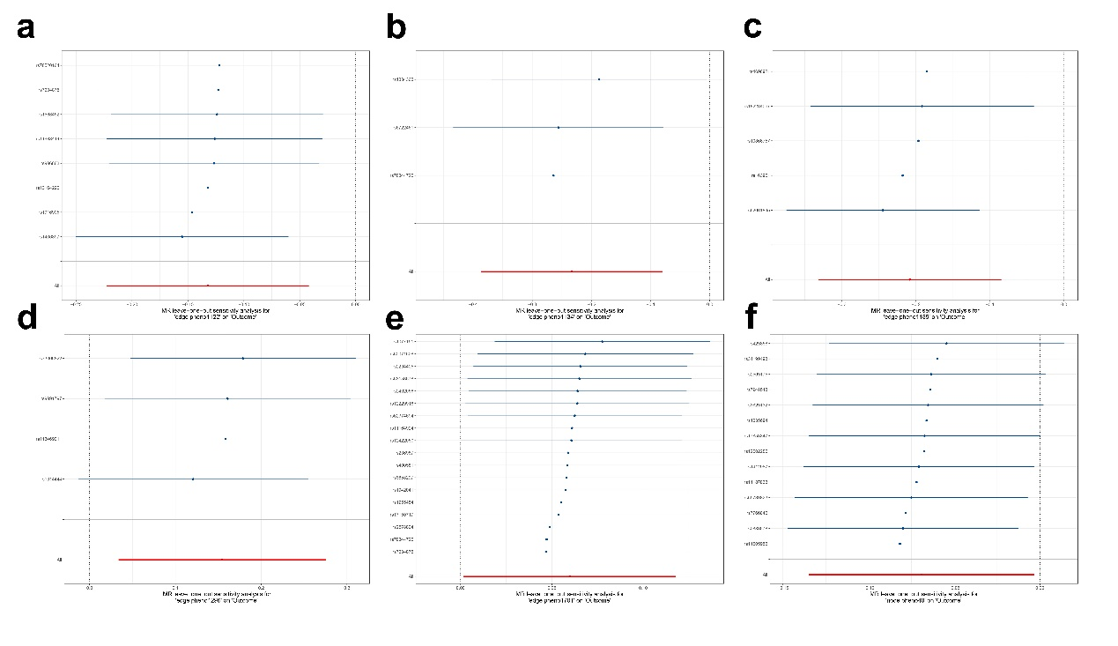
Supplementary Fig. 4. Leave-one-out plots of the effect of functional connectivity between different brain regions on depression.
- (Temporal)&(Frontal_Inf); (b) (Frontal_Sup)&(Frontal_Inf); (c) (Temporal|Frontal|Supp_Motor_Area)&(Frontal); (d) (Precuneus|Angular|Cingulate)&(Temporal); (e) Global_measure, Triple_netwoks(Default_mode); (f) (Calcarine|Lingual|Cuneus)&(Postcentral|Precentral).

