Supplementary Fig. 1. Flow chart of modeling.
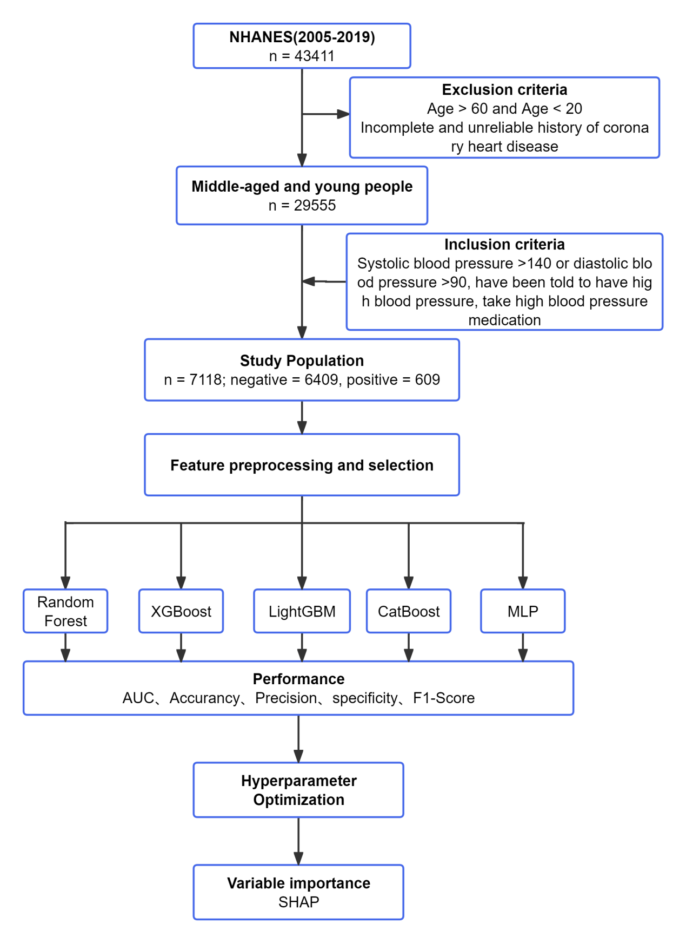
NHANES, the National Health and Nutrition Examination Survey; XGBoost, eetreme gradient boosting; LightGBM, light gradient-boosting machine; CatBoost,categorical boosting; MLP,Multilayer Perceptron; SHAP, Shapley additive explanations.

Supplementary Table 1. General characteristics of all model variables.
Variable | No coronary heart  disease(n=6409) | coronary heart disease(n=709) | p-Value
Average drink per day |  |  | <0.001
1 | 1203(18.8%) | 443(62.5%)
2 | 3763(58.7%) | 123(17.3%)
3 | 602(9.4%) | 56(7.9%)
4 | 324(5.1%) | 36(5.1%)
5 | 184(2.9%) | 18(2.5%)
6 | 242(3.8%) | 23(3.2%)
7 | 36(0.6%) | 3(0.4%)
8 | 55(0.9%) | 7(1.0%)
Type of work |  |  | <0.001
Working at a job or business | 4101.0 (64.0%) | 234.0(33.0%)
Not working at a job or business | 1908.0(29.8%) | 446.0(62.9%)
health of teeth and gums |  |  | <0.001
Very good | 876(13.7%) | 57(8.0%)
Good | 3206 (50.0%) | 146(20.6%)
Fair | 1244(19.4%) | 328(46.3%)
Poor | 684(10.7%) | 145(20.5%)
high cholesterol level |  |  | <0.001
Yes | 3650(57.0%) | 240(33.9%)
No | 2759(43.0%) | 469(66.1%)
arthritis |  |  | <0.001
Yes | 4509(70.4%) | 328(46.3%)
No | 1900 (29.6%) | 381(53.7%)
Tobacco Use |  |  | <0.001
Yes | 3434(53.6%) | 258(36.4%)
No | 2975(46.4%) | 451(63.6%)
Sleep Disorders |  |  | <0.001
Yes | 4065(63.4%) | 289(40.8%)
No | 2344(36.6%) | 420(59.2%)
How many times urinate in night |  |  | <0.001
1 | 1469(22.9%) | 108(15.2%)
2 | 2895(45.2%) | 272(38.4%)
3 | 548(8.6%) | 107(15.1%)
4 | 169(2.6%) | 39(5.5%)
5 | 182(2.8%) | 41(5.8%)
Close relative had asthma |  |  | <0.001
Yes | 4809(75.0%) | 458(64.6%)
No | 1600(25.0%) | 251(35.4%)
Depression |  |  | <0.001
0 | 4874(76.0%) | 460(64.9%)
1 | 1088(17.0%) | 150(21.2%)
2 | 447(7.0%) | 99(14.0%)
Moderate recreational activities |  |  | <0.01
Yes | 2632(41.1%) | 199(28.1%)
No | 3765(58.7%) | 499(70.4%)
Total cholesterol | 5.05±0.95 | 4.73±0.99 | <0.001
Mercury | 4.60±3.18 | 3.61±3.31 | <0.001
Lead | 0.06±0.03 | 0.06±0.03 | <0.001
Platelet count | 253.32±57.47 | 241.33±59.80 | <0.001
Cadmium | 3.33± 2.23 | 3.78 ± 2.44 | <0.001
Standing Height | 168.07±9.97 | 168.96±10.07 | <0.001
HDL | 49.16±12.46 | 45.65±12.47 | <0.001
Red cell distribution width | 13.30±0.94 | 13.54±0.93 | <0.001
Monocyte number | 0.55 ± 0.17 | 0.57 ± 0.17 | <0.05
Sleep hours | 6.83±1.48 | 6.70±1.73 | <0.001
Potassium | 3.94±0.32 | 3.99±0.33 | <0.001
ALT | 23.83±9.02 | 23.08±8.43 | <0.001
Uric acid | 336.73±79.36 | 345.22±80.89 | <0.001
Lymphocyte percent | 30.82±7.80 | 29.72±7.95 | <0.001
Age when heaviest weight | 40.51±11.32 | 42.78±10.98 | <0.001

For categorical variables,mean and percentages are given,Chi-square tests were used to assess inter-group differences in features.For continuous variables, mean and standard deviation are given,t tests were used to assess the inter-group differences in features.

Supplementary Fig. 2. Local model explanation by the SHAP method.

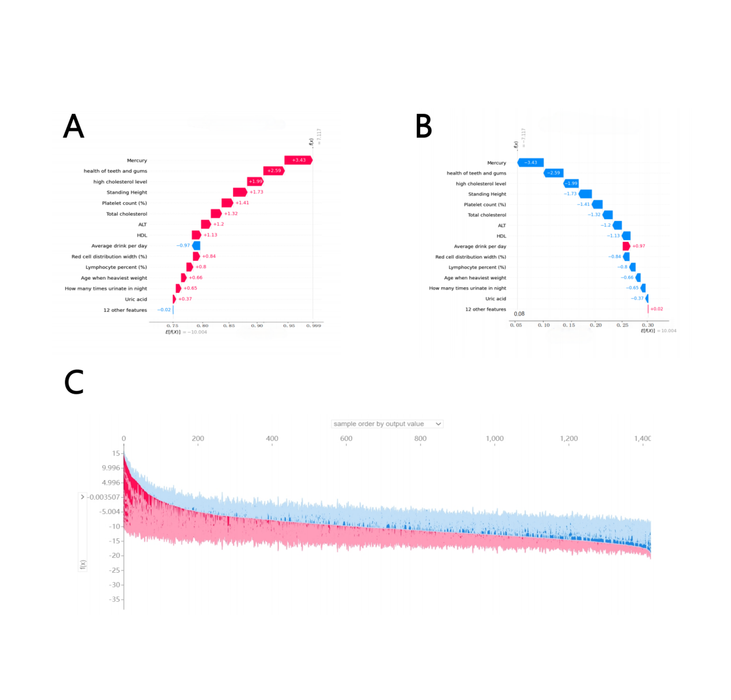
A Individual waterfall plot representing coronary heart disease. B Individual waterfall plot representing non-coronary heart disease.C Force plot for the internal validation set. Each patient was represented by the x-axis, while the features’ contributions were represented by the y-axis.

Supplementary Fig. 3. Convenient application for screening.

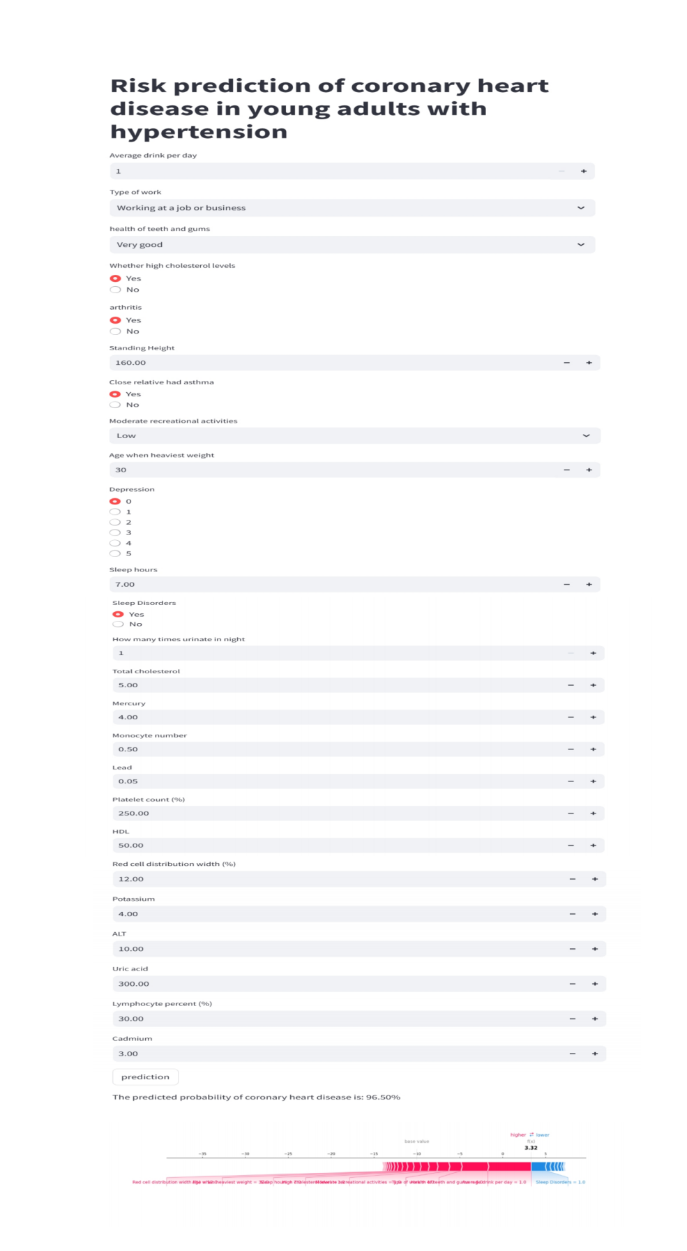
Enter the actual values of 26 features and the app automatically displays the probability of developing CAD. At the same time, the individual's force plot is shown at the bottom: the blue feature on the right is the feature that pushes the prediction into the "non-CAD" category, while the red feature on the left pushes the prediction into the "CAD" category.

