Research Article for Journal of Integrative Neuroscience

Title:
Time-dependent Potentiation of False Fear Memory through Glucocorticoid Receptor Activation and Mineralocorticoid Receptor Inactivation

Authors:
Haruka Asano^{1*}, Kotono Midorikawa^{1*}, Yayako Karino¹, Fuka Ohnuma¹, Emi Kasama¹, Miho Moriya¹, Tohru Matsuki^{2#}, Kenjiro Seki^{1#}

* These two authors contributed equally to this work.

Affiliations:
1: Department of Pharmacology, School of Pharmaceutical Science, Ohu University,
963-8041 Koriyama, Fukushima, Japan
2: Department of Cellular Pathology, Institute for Developmental Research, Aichi Developmental Disability Center, Kasugai, 480-0392 Kasugai, Aichi, Japan

# Corresponding authors:
Kenjiro Seki, Ph.D.: Address: 31-1 Misumido, Tomitamachi, Koriyama, Fukushima 963-8611, Japan, Phone: +81-24-932-9179, E-mail: k-seki@pha.ohu-u.ac.jp
Tohru Matsuki, Ph.D.: Kasugai, Aichi 480-0392, Japan, Phone: +81- 568-88-0811, E-mail: matsukit@inst.hsc.jp

Keywords:
False context fear memory; Glucocorticoid receptor; Mineralocorticoid receptor; Time-dependent false memory potentiation, Fear memories less precise

Data Availability:
Data are available from the Mendeley data (https://data.mendeley.com/drafts/3w6trnfpvn).

Methods
Apparatus for the contextual fear conditioning test
Our false context fear memory model was based on previous studies [1]. We modified the contextual fear conditioning methods in mice, as reported by Fujinaka et al. [2]. Context A, used for fear conditioning, was a communication box (CBX-303M, Muromachi Kikai Co., Ltd., Tokyo, Japan) with four light-gray polyvinyl chloride walls and a stainless-steel grid floor (24 bars, 3 mm diameter, and 11 mm apart) separated by a 55-mm gap from the paper-towel-covered bottom. The grid was illuminated at 270 lux. Context B, a similar box with dark-brown wood walls, had a grid floor (17 bars, 4 mm diameter, 17.8 mm apart) on a thin polypropylene board covered with a paper towel. The illuminance was 80 lux, and the grid was not connected to the electric shock generator, allowing mice to stand on the paper towel.

Producing the adeno-associated virus (AAV) for knockdown of CRF
We previously provided the detail method for producing the AAV for Crf KD. In brief, recombinant DNA experiments were conducted under the guidelines of Ohu University (No. 2019004) and Aichi Developmental Disability Center (No. 19-6) and in compliance with Japan's regulations on the use of living modified organisms. The AAV plasmid for shRNA expression was developed based on the AAV-shRNA-ctrl plasmid (#85741, Addgene) by substituting the region between two NotI sites with the synthesized fragment carrying U6 promoter, shRNA cloning site, CAG promoter, EGFP, WPRE, and human growth hormone (hGH) poly(A) signal. The shRNA sequences used to knockdown Crf were based on a previous report [3], the Sigma MISSION shRNA library by the RNAi Consortium (Boston, MA, USA): (#1) AGATTATCGGGAAATGAAA [3], TRCN0000414479 (#2) TTAGCTCAGCAAGCTCACAG, TRCN0000436997: and (#3): ATCTCTCTGGATCTCACCTTC. We validated each knockdown efficiency of Crf shRNA sequences by co-transfection of FLAG-tagged CRF expression plasmid and shRNA expression plasmid. AAV was produced following Challis et al. (2019) with minor modifications [4]. Cells were co-transfected with pUCmini-iCAP-PHP.eB, pAdDeltaF6, and the rAAV genome-carrying plasmid. AAV particles were collected, purified, and titrated using qPCR with primers targeting the WPRE sequence.

Adeno-associated Virus (AAV) Injection into the Hypothalamus
In accordance with the Animal Care Committee of Ohu University guidelines, as previously reported [1], we anesthetized the mice with a mixture of medetomidine hydrochloride, butorphanol tartrate (0.3 and 5.0 mg/kg, respectively), and midazolam (4.0 mg/kg) to ensure the loss of pain sensation and immobilization. After anesthetization, we placed the mice in a stereotactic frame (#68045, RWD Life Science, Guangdong, China). We then used a Hamilton neurosyringe (32-gauge, 7000.5 Neuros Syringe, #65457-02, Hamilton Co. Japan K.K., Tokyo, Japan) for a bilateral AAV microinjection into the bilateral hypothalamus. This involved a 0.1 μL AAV infusion into each side of the hypothalamus for 5 min. The AAV-control-GFP titers were 8.32 × 10¹² vg/mL, and the AAV-CRF-RFP (for overexpression of CRF) titers were 3.49 × 10¹² vg/mL. The stereotaxic coordinates (mm) for hypothalamic injection, according to the mouse brain in stereotaxic coordinates (Third Edition by Franklin and Paxinos) [5, 6], were anteroposterior (AP), −0.7 mm; lateral (L), 0.25 mm from bregma; and dorsoventral (DV), −4.6 mm. After the AAV injection, we left the neurosyringe in place for at least 5 min to minimize drug leakage along the injection track [25]. Next, we filled both holes with dental cement (GC Unifast II, GC Dental Products Corp., Tokyo, Japan) and fixed them with a stabilizing screw. After waking from anesthesia, we kept the mice in their cages for at least 14 days before the behavioral tests.

Verification of AAV infection and CRF expression
We performed the immunofluorescence staining using the standard protocol previously reported [1]. In brief, following the Animal Care Committee guidelines of Ohu University, we anesthetized mice with a mixture of medetomidine hydrochloride (0.3 mg/kg), butorphanol tartrate (5.0 mg/kg), and midazolam (4.0 mg/kg). We then placed the anesthetized mice in a stereotactic frame (#68045, RWD Life Science). We performed a bilateral AAV microinjection into the hypothalamus using a 32-gauge Hamilton Neurosyringe (#65457-02, Hamilton Co.), with 0.1 μL AAV infused per side, for over five minutes. The AAV-Control-GFP titer was 8.32 × 10¹² vg/mL, and the AAV-Crf-shRNA-EGFP (for CRF KD) titer was 3.49 × 10¹² vg/mL. The stereotaxic coordinates were AP: −0.7 mm, L: 0.25 mm from bregma, and DV: −4.6 mm [5]. After the injection, we left the syringe in place for 5 minutes to minimize virus spread. We then used dental cement (GC Unifast II) to seal the injection site. Mice recovered in their home cages for 14 days before behavioral tests.
Results

The original western blot (WB) figures for Fig. 3A are here.
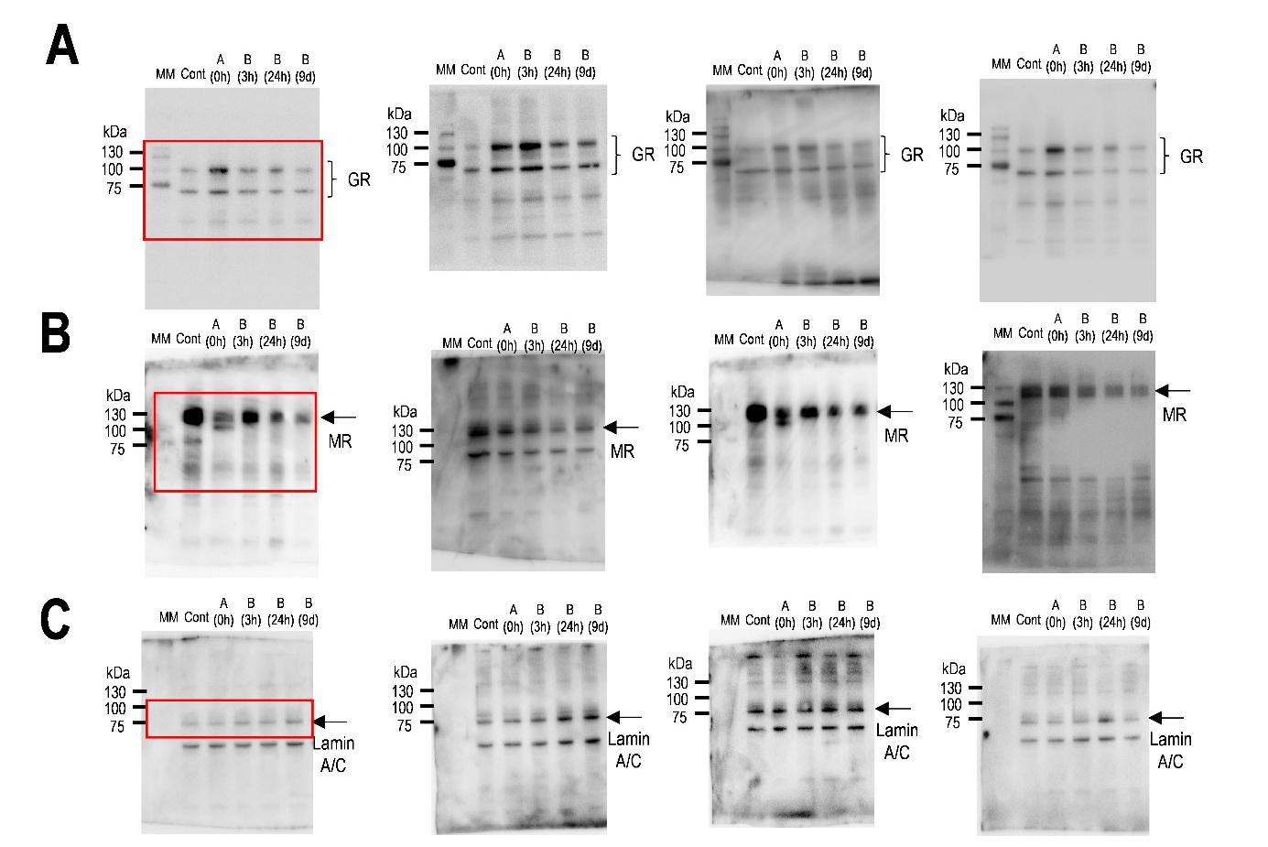

Supplementary Fig. 1. Original blots corresponding to the cropped images shown in Fig. 3A. (A) Full-length membrane images for the glucocorticoid receptor (GR), (B) mineralocorticoid receptor (MR), and (C) Lamin A/C, corresponding to the cropped blots presented in Fig. 3B. Samples were collected before exposure, at 0 h in Box A, and at 3 h, 24 h, and 9 days in Box B following the electric footshock during Context A. The cropped regions shown in Fig. 3A are indicated by red squares in the left panels of A–C.

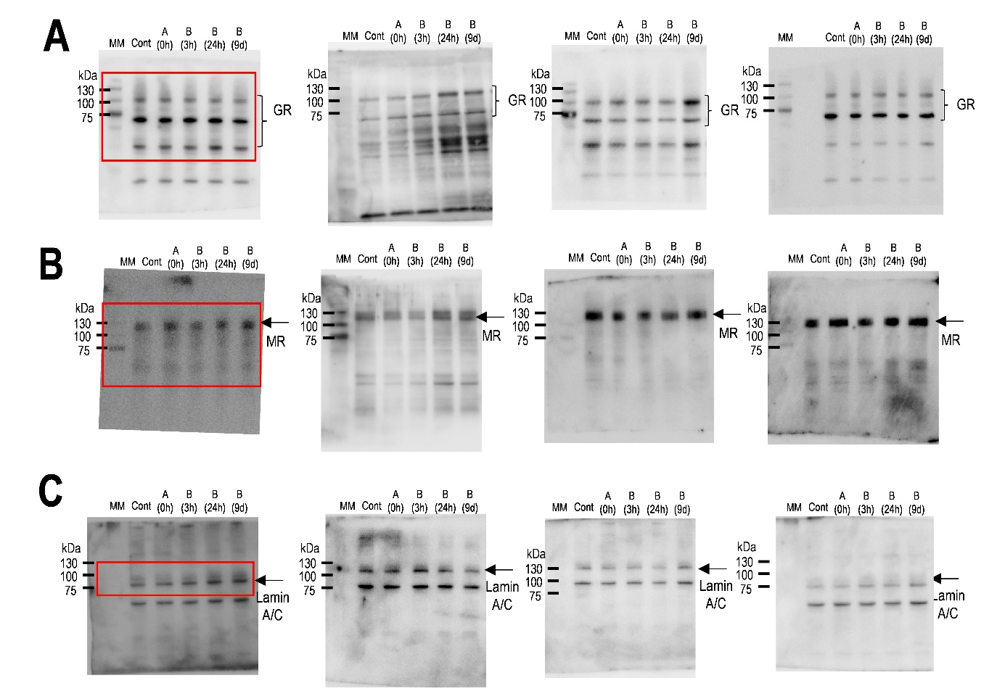
Supplementary Fig. 2. Original blots corresponding to the cropped images shown in Fig. 3D. (A) Full-length membrane images for the glucocorticoid receptor (GR), (B) mineralocorticoid receptor (MR), and (C) Lamin A/C, corresponding to the cropped blots presented in Fig. 3D. Samples were collected before exposure, at 0 h in Box A, and at 3 h, 24 h, and 9 days in Box B following Context A without electric footshock as controls. The cropped regions shown in Fig. 3E are indicated by red squares in the left panels of A–C.

Generation and characterization of hypothalamic CRF knockdown mice
We generated hypothalamic CRF KD mice to investigate the role of the corticoid receptors GR and MR using an agonist to form false context fear memories and potentiate a fear response due to these memories, (Fig. 3A). A hypothalamic CRF KD significantly decreased plasma corticosterone compared to the control AAV injected into the hypothalamus (t-test: KD: t₍₈₎ = 5.00, p < 0.01, Fig. 3B), suggesting that the hypothalamic CRF were knocked down by AAV (Fig. 3D). However, a hypothalamic CRF KD did not affect locomotor activity (t-test: t₍₁₈₎ = 0.594, p = 0.559, Fig. 3C). In addition, a freezing response during ES in context A of KD was similar to control AAV injected mice (two-way repeated measures ANOVA: F_{(7, 168)} = 1.584, p = 0.143, Fig. 3F). The potentiation of the fear response at 24 hours in KD mice compared to that at 3 hours was similar to that of control mice (Two-way repeated measures ANOVA: F_{(1, 18)} = 1.586, p = 0.224, Fig. 3G; Student t-test: t₍₁₈₎ = 1.186, p = 0.256, Fig. 3H).
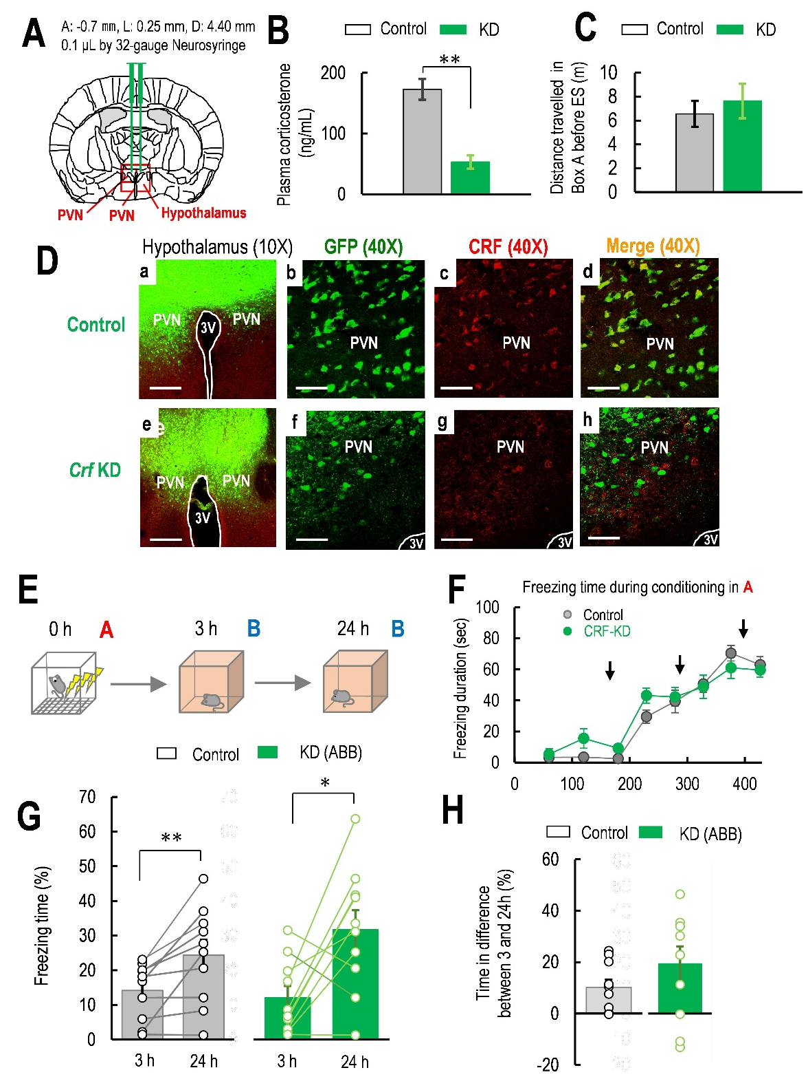

Supplementary Fig. 3. (A) Brain atlas for the AAV-PHP.eB virus injection according to the Paxinos mouse brain atlas (anterior: −0.7 mm, lateral: 0.25 mm, and depth: 4.40 mm). Green bars around the center of the brain map indicate virus injection needles and the location of virus injections into the hypothalamus, including the PVN (0.1 μL of virus injected by 32-gauge neurosyringe). In the images, “3V” represents the third ventricle, and “PVN” represents the paraventricular nucleus of the hypothalamus in the red square. (B) The concentration of plasma corticosterone in control (n = 5) and hypothalamic Crf-KD (n = 5) mice during 12:00–14:00 h in the light phase (n = 10). (C) Effect of hypothalamic Crf knockdown (KD) on locomotor activity. Distance (m) traveled in context A before electrical footshock (ES) in ABB ES (+) mice with control AAV (n = 10) and hypothalamic Crf-control (n = 10). (D) Transduction of mouse hypothalamus with AAV-PHP.eB control or Crf shRNA expressing vectors carrying GFP as a marker and detection of mouse CRF by immunofluorescence in control ((a–d); upper panels) and KD mice ((e–h); lower panel; hypothalamic Crf-KD). In the images, “3V” represents the third ventricle, and “PVN” represents the paraventricular nucleus of the hypothalamus. Scale bar = 200 μm (×10 magnification) for (a and e) and 50 μm for (b–d and f–h) (×40 magnification). (E) The schematic representation of context A for delivering the electrical footshock (ES) and context B for Context B. (F) Freezing level during Context A in control (n = 16) and hypothalamic Crf KD mice (n = 10) during the ES. Arrows represent the electric shocks delivered at 180, 280, and 380 s after the mouse was placed in the center bottom of Box A. (G) Percentage of freezing level in Context B at 3 and 24 hours after ES for ABB ES (+) mice in control AAV (n = 10) and hypothalamic Crf KD (n = 10) mice. (H) Percentage of freezing level differences between 3 and 24 hours in ABB ES (+) with control AAV (n = 10) and hypothalamic Crf KD mice (n = 10). Data are represented by mean ± SEM. * p < 0.05; ** p < 0.01.

References:
[1] Kasama E, Moriya M, Kamimura R, Matsuki T, Seki K. Formation of False Context Fear Memory Is Regulated by Hypothalamic Corticotropin-Releasing Factor in Mice. Int J Mol Sci. 2022; 23.
[2] Fujinaka A, Li R, Hayashi M, Kumar D, Changarathil G, Naito K, et al. Effect of context exposure after fear learning on memory generalization in mice. Mol Brain. 2016; 9: 2.
[3] Elliott E, Ezra-Nevo G, Regev L, Neufeld-Cohen A, Chen A. Resilience to social stress coincides with functional DNA methylation of the Crf gene in adult mice. Nat Neurosci. 2010; 13: 1351-1353.
[4] Challis RC, Ravindra Kumar S, Chan KY, Challis C, Beadle K, Jang MJ, et al. Systemic AAV vectors for widespread and targeted gene delivery in rodents. Nat Protoc. 2019; 14: 379-414.
[5] Williams RW. Mapping genes that modulate mouse brain development: a quantitative genetic approach. Results Probl Cell Differ. 2000; 30: 21-49.
[6] Franklin K. PG. Mouse Brain Stereotaxic Coordinates. 3rd ed. Academic Press; Cambridge, MA, USA. 2008; The Coronal Plates and Diagrams, Compact: 256.

