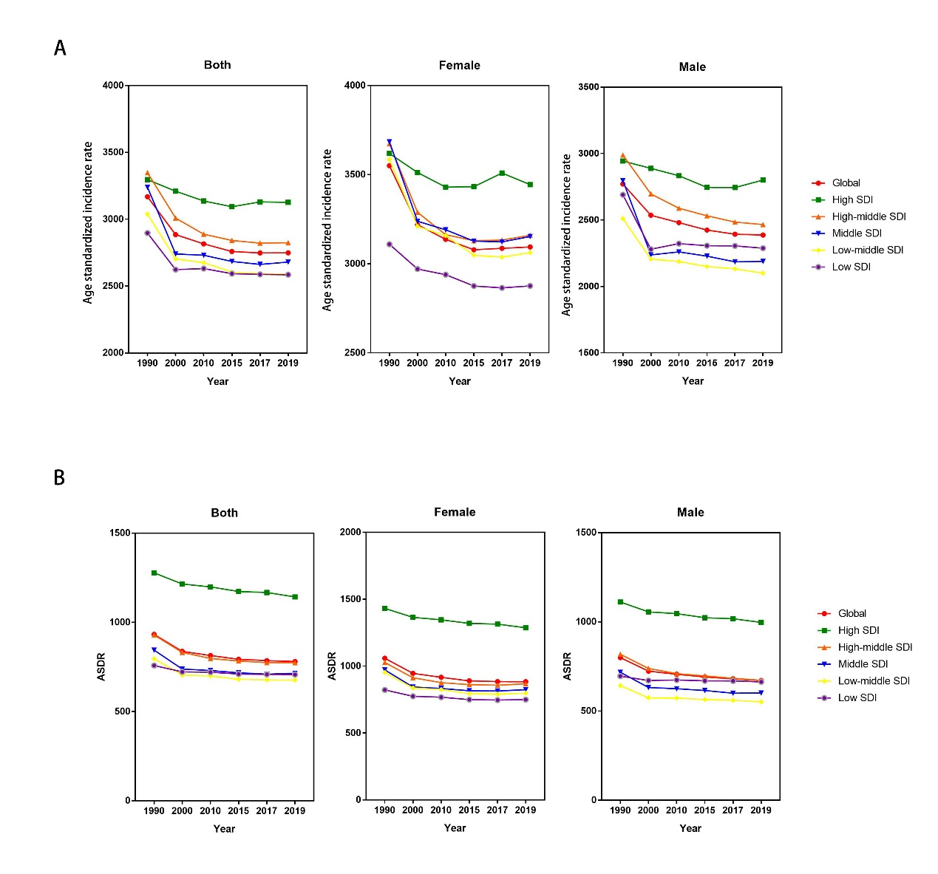
Supplementary Fig. 1. The change trends of age-standardized endometriosis incidence, and DALY rate among different SDI quintiles and gender from 1990 to 2019. (A) ASIR, age standardized incidence rate. (B) age-standardized DALY rate. DALY = disability adjusted life-year.

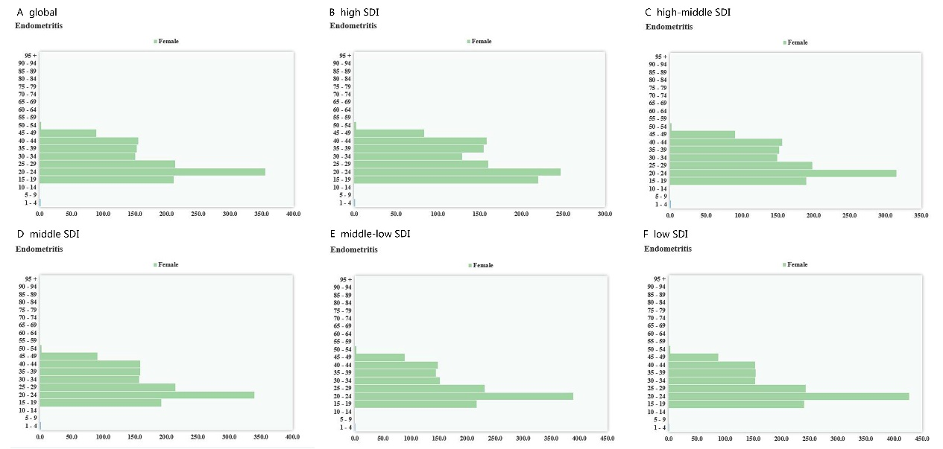
Supplementary Fig. 2. The age standardized incidence rate of endometriosis among age.

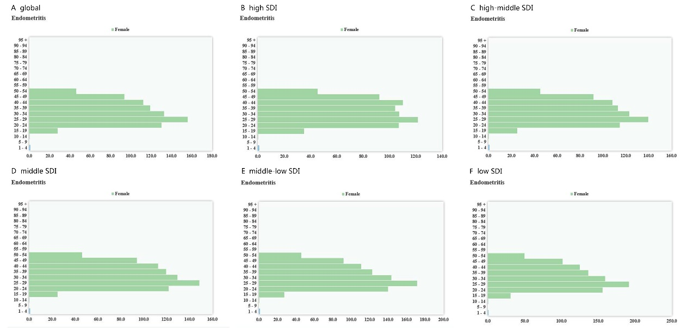
Supplementary Fig. 3. The age-standardized DALY rate of endometriosis among age.

