Supplementary Materials

Table 1. NEWCASTLE-OTTAWA quality assessment scale for cohort studies

 |  |  |  | Jeng et al (2020) [1] | Cheung et al (2019) [2] | Zhang et al  (2014) [3] | Cho et al  (2013) [4] | Feng et al (2017) [5] | Lee et al (2019) [6] | Cheng et al (2015) [7] | Flyckt et al (2016) [8] | Nash et al (2012) [9] | Mansour et al (2012) [10] | Huberlant et al (2019) [11] | Kramer et al (2016) [12] | Liu et al (2017) [13]
Selection | 1 | Representativeness of the  exposed cohort | Truly representative of the average _ (describe) in the community* | * | * | * | * | * | * | * | * | * | * | * | * | *
Selection | 1 | Representativeness of the  exposed cohort | Somewhat representative of the average _in the community* | * | * | * | * | * | * | * | * | * | * | * | * | *
Selection | 1 | Representativeness of the  exposed cohort | Selected group of users eg nurses, volunteers
Selection | 1 | Representativeness of the  exposed cohort | No description of the derivation of the cohort
Selection | 2 | Selection of the non exposed cohort | Drawn from the same community as the exposed cohort* | * | * | * | * | * | * | * | * | * | * | * | * | *
Selection | 2 | Selection of the non exposed cohort | Drawn from a different source
Selection | 2 | Selection of the non exposed cohort | No description of the derivation
Selection | 3 | Ascertainment of exposure | Secure record (surgical record)* | * | * | * | * | * | * | * | * | * | * | * | * | *
Selection | 3 | Ascertainment of exposure | Structured interview* | * | * |  | * |  | * |  | * |  |  |  |  | *
Selection | 3 | Ascertainment of exposure | Written self report
Selection | 3 | Ascertainment of exposure | No description
Selection | 4 | Demonstration that outcomes of interest was not present at start of study | Yes
Selection | 4 |  | No
Comparability | 1 | Comparability of cohorts on the basis of the design or analysis | Study controls for _(select the most important factor)* | * | * | * | * | * | * | * | * | * | * | * | * | *
Comparability | 1 |  | Study controls for any additional factor*(This criteria could be modified to indicate specific control for a second important factor.) | * | * | * | * | * | * | * | * | * | * | * | * | *
Outcome | 1 | Assessment of outcome | Independent blind assessment*
Outcome | 1 | Assessment of outcome | Record linkage* | * | * | * | * | * | * | * | * | * | * | * | * | *
Outcome | 1 | Assessment of outcome | Self report
Outcome |  | Assessment of outcome | No description
Outcome | 2 | Was follow-up long enough for outcomes to occur | Yes (select an abequate follow up period for outcome of interest )* |  |  |  |  |  |  |  | *
Outcome | 2 | Was follow-up long enough for outcomes to occur | NO
Outcome | 3 | Adequacy of follow up of cohorts | Complete follow up-all subjects accounted for* | * | * | * | * |  | * |  |  |  |  | * | * | *
Outcome |  | Adequacy of follow up of cohorts | Follow up rate <_% ( select adequate %) and no description of those lost
Outcome |  | Adequacy of follow up of cohorts | No statement
Total |  |  |  | 9  Very Good | 9  Very Good | 8  Good | 9  Very Good | 8  Good | 9  Very Good | 8  Good | 9  Good | 8  Good | 8  Good | 8  Good | 8  Good | 9  Very Good

Continue Table 1. NEWCASTLE-OTTAWA quality assessment for cohort studies.

 |  |  |  | ^{Gunnala et al (2016) [14]} | ^{Seracchioli et al}  ⁽²⁰⁰³⁾  ^{[15]} | ^{Prapas et al (2009) [16]} | ^{Metter et al (2004) [17]} | ^{Zhang et al (2011) [18]} | ^{Sasson et al (2018) [19]} | ^{Huff et al (2018) [20]} | ^{Zou et al (2017) [21]} | ^{Liu et al (2017) [22]} | ^{Wu et al (2020) [23]} | ^{Chen et al (2016) [24]} | ^{Xu et al (2015) [25]} | ^{Wang et al (2006) [26]}
^{Selection} | ¹ | Representativeness of the exposed cohort | Truly representative of the average _ (describe) in the community* | * | * | * | * | * | * | * | * | * | * | * | * | *
^{Selection} | ¹ | Representativeness of the exposed cohort | Somewhat representative of the average _in the community* | * | * | * | * | * | * | * | * | * | * | * | * | *
^{Selection} | ¹ | Representativeness of the exposed cohort | Selected group of users eg nurses, volunteers
^{Selection} | ¹ | Representativeness of the exposed cohort | No description of the derivation of the cohort
^{Selection} | ² | Selection of the non exposed cohort | Drawn from the same community as the exposed cohort* | * | * | * | * | * | * | * | * | * | * | * | * | *
^{Selection} | ² | Selection of the non exposed cohort | ^{Drawn from a different source}
^{Selection} | ² | Selection of the non exposed cohort | No description of the derivation
^{Selection} | ³ | ^{Ascertainment of exposure} | Secure record (surgical record)* | * | * | * | * | * | * | * | * | * | * | * | * | *
^{Selection} | ³ | ^{Ascertainment of exposure} | ^{Structured interview*} |  |  |  |  |  | * | * |  |  |  | *
^{Selection} | ³ | ^{Ascertainment of exposure} | ^{Written self report}
^{Selection} | ³ | ^{Ascertainment of exposure} | ^{No description}
^{Selection} | ⁴ | Demonstration that outcomes of interest was not present at start of study | ^{Yes}
^{Selection} | ⁴ |  | ^{No}
^{Comparability} | ¹ | Comparability of cohorts on the basis of the design or analysis | Study controls for _(select the most important factor)* | * | * | * | * | * | * | * | * | * | * | * | * | *
^{Comparability} | ¹ |  | Study controls for any additional factor*(This criteria could be modified to indicate specific control for a second important factor.) | * | * | * | * | * | * | * | * | * | * | * |  | *
^{Outcome} | ¹ | ^{Assessment of outcome} | ^{Independent blind assessment*}
^{Outcome} | ¹ | ^{Assessment of outcome} | ^{Record linkage*} | * | * | * | * | * | * | * | * | * |  | * | *
^{Outcome} | ¹ | ^{Assessment of outcome} | ^{Self report}
^{Outcome} |  | ^{Assessment of outcome} | ^{No description}
^{Outcome} | ² | Was follow-up long enough for outcomes to occur | Yes (select an abequate follow up period for outcome of interest )*
^{Outcome} | ² | Was follow-up long enough for outcomes to occur | ^{NO}
^{Outcome} | ³ | Adequacy of follow up of cohorts | Complete follow up-all subjects accounted for* |  |  |  |  |  | * | * | * | * | * | * | *
^{Outcome} | ³ | Adequacy of follow up of cohorts | Subjects lost to follow up unlikely to introduce bias- small number lost - >_% (select an adequate %) follow up, or description provided of those lost)*
^{Outcome} |  | Adequacy of follow up of cohorts | Follow up rate <_% ( select adequate %) and no description of those lost
^{Outcome} |  | Adequacy of follow up of cohorts | ^{No statement}
^{Total} |  |  |  | ⁷  ^{Good} | ⁷  ^{Good} | ⁸  ^{Good} | ⁷  ^{Good} | ⁷  ^{Good} | ⁹  ^{Very Good} | ⁹  ^{Very Good} | ⁸  ^{Good} | ⁸  ^{Good} | ⁷  ^{Good} | ⁹  ^{Very Good} | ⁸  ^{Good} | ⁷  ^{Good}

Table 2. CASP Randomized Controlled Trail- Quality assessment

 |  |  | Palomba et al (2007) [27] | Alessandri et al (2006) [28] | Kramer et al (2016) [12]
1 | Did the trial address a clearly focused issue? | Yes | * | * | *
1 | Did the trial address a clearly focused issue? | Can’t tell
1 | Did the trial address a clearly focused issue? | No
2 | Was the assignment of patients to treatments randomised | Yes | * | * | *
2 | Was the assignment of patients to treatments randomised | Can’t tell
2 | Was the assignment of patients to treatments randomised | No
3 | Were all of the patients who entered the trial properly accounted for at its conclusion | Yes | * | * | *
3 |  | Can’t tell
3 |  | No
4 | Were patients, health workers and study personnel ‘blind’ to treatment | Yes
4 |  | Can’t tell | * | * | *
4 |  | No
5 | Were the groups similar at the start of the trial | Yes | * | * | *
5 | Were the groups similar at the start of the trial | Can’t tell
5 | Were the groups similar at the start of the trial | No
6 | Aside from the experimental intervention, were the groups treated equally? | Yes | * | * | *
6 |  | Can’t tell
6 |  | No
7 | How large was the treatment effect? | Yes | * | * | *
7 | How large was the treatment effect? | Can’t tell
7 | How large was the treatment effect? | No
8 | How precise was the estimate of the treatment effect? | Yes | *
8 | How precise was the estimate of the treatment effect? | Can’t tell |  | * | *
8 | How precise was the estimate of the treatment effect? | No
9 | Can the results be applied to the local population, or in your context? | Yes | * | * | *
9 |  | Can’t tell
9 |  | No
10 | Were all clinically important outcomes considered? | Yes | * | * | *
10 | Were all clinically important outcomes considered? | Can’t tell
10 | Were all clinically important outcomes considered? | No
11 | Are the benefits worth the harms and costs? | Yes
11 | Are the benefits worth the harms and costs? | Can’t tell
11 | Are the benefits worth the harms and costs? | No | * | * | *
 | Total |  | 9 | 8 | 8

Figure 1. Funnel plot of age and body mass index in HIFU, robotic surgery and laparoscopic surgery.

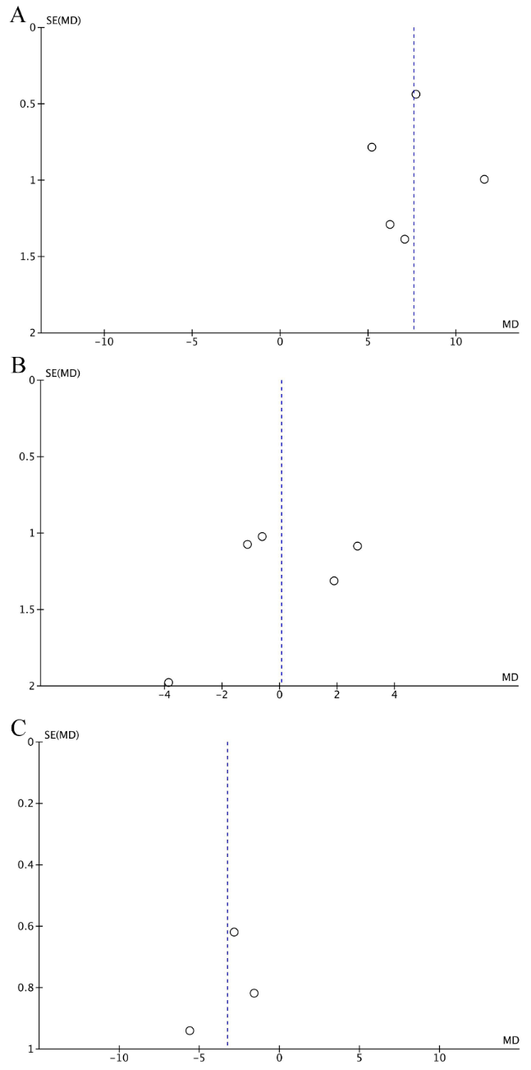

ªNote: A. Funnel plot of age in HIFU, robotic surgery.
B. Funnel plot of age in robotic surgery and laparoscopic surgery.
C. Funnel plot of body mass index in HIFU and robotic surgery.

Figure 2. Funnel plot of HIFU, robotic surgery and laparoscopic surgery in between operation time and fibroid size.
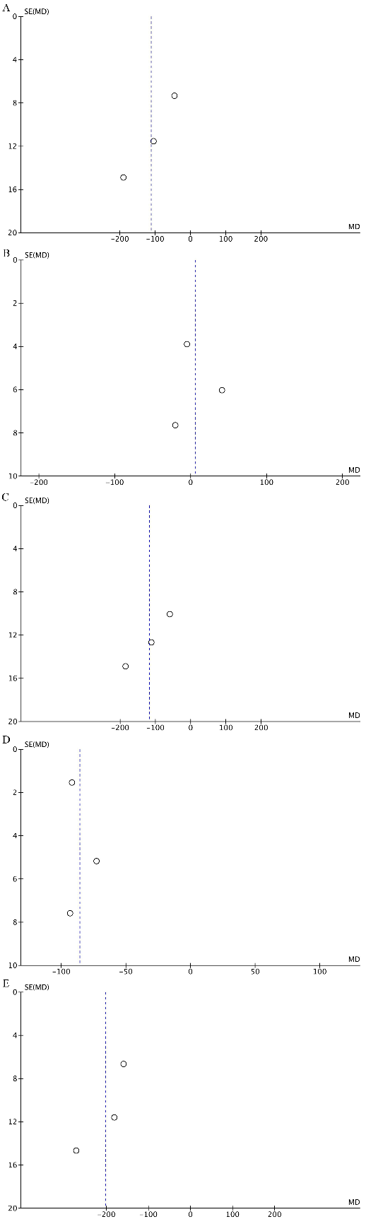
^{b}Note: A. Funnel plot of operation time in HIFU and robotic surgery.
B. Funnel plot of operation time in HIFU and laparoscopic surgery.
C. Funnel plot of operation time laparoscopic surgery and robotic.
D. Funnel plot of fibroids size and operation time in laparoscopic surgery.
E. Funnel plot of fibroids size and operation time in robotic surgery.

Figure 3. Funnel plot of blood loss, fibroids size, and hospital stay in robotic surgery and laparoscopic surgery.
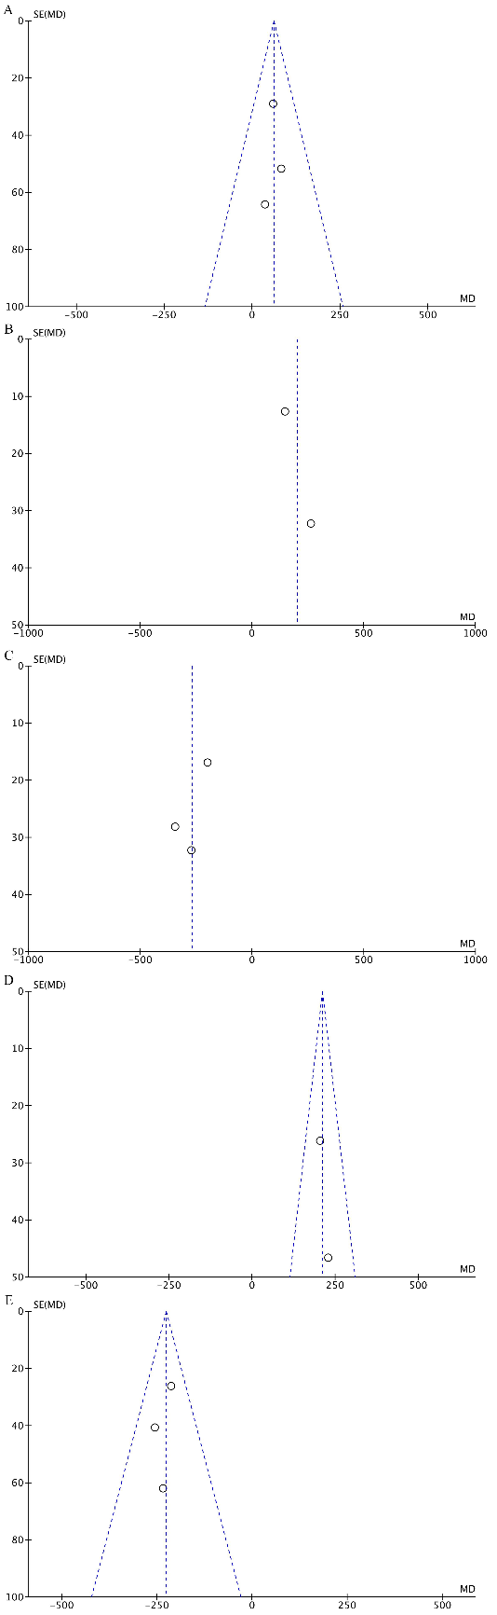

^{c} Note: A. Funnel plot of blood loss in robotic surgery and laparoscopic surgery.
B. Funnel plot of blood loss and fibroid size in laparoscopic surgery.
C. Funnel plot of hospital stay and blood loss in laparoscopic surgery.
D. Funnel plot of blood loss and fibroids size in robotic surgery.
E. Funnel plot of hospital stay and blood loss in robotic surgery.

Figure 4. Funnel plot of UF-QOL score for uterine fibroids and adenomyosis after 3 months in HIFU. SSS score for uterine fibroids after 3 months in HIFU.
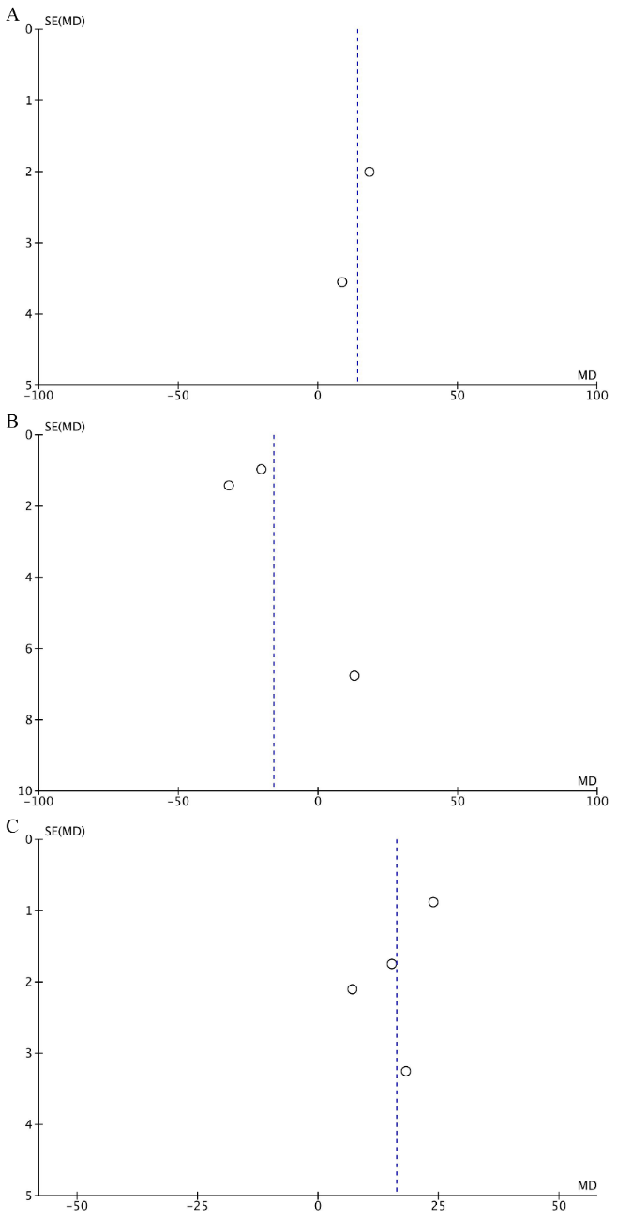

^{d} Note: A. Funnel plot of UF-QOL score for uterine fibroids in HIFU.
B. Funnel plot of UF-QOL score for adenomyosis after 3 months in HIFU.
C. Funnel plot of SSS score for uterine fibroids after 3 months in HIFU.

Figure 5. Funnel plot of delivery outcome in HIFU and laparoscopic surgery.
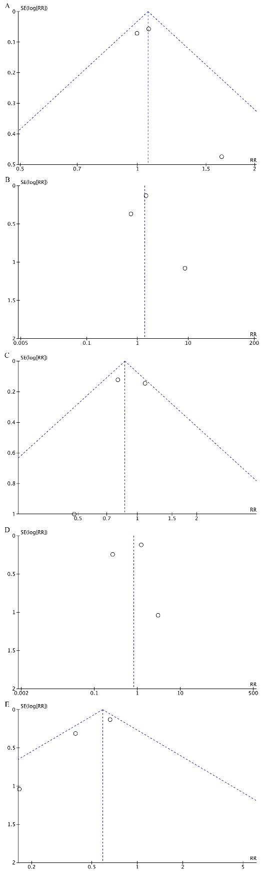

^{e}Note: A. Funnel plot of live birth in HIFU and laparoscopic surgery.
B. Funnel plot of NSD in HIFU and laparoscopic surgery.
C. Funnel plot of c-section in HIFU and laparoscopic surgery.
D. Funnel plot of NSD and c-section in HIFU.
E. Funnel plot of NSD and c-section in laparoscopic surgery.

References
[1] Jeng CJ, Ou KY, Long CY, Chuang L, Ker CR. 500 Cases of High-intensity Focused Ultrasound (HIFU) Ablated Uterine Fibroids and Adenomyosis. Taiwanese Journal of Obstetrics & Gynecology. 2020; 59: 865–871.
[2] Cheung VYT, Lam TPW, Jenkins CR, Lam SW, Cheung GKI, Chan SSY, et al. Efficacy and safety of ultrasound-guided high-intensity focused ultrasound for uterine fibroids: a preliminary experience. Journal of Obstetrics and Gynaecology. 2019; 39: 833–839.
[3] Zhang X, Li K, Xie B, He M, He J, Zhang L. Effective ablation therapy of adenomyosis with ultrasound-guided high-intensity focused ultrasound. International Journal of Gynecology & Obstetrics. 2014; 124: 207–211.
[4] Cho JY, Kim SH, Kim SY, Moon SK, Li J. Efficacy and Safety of Daily Repeated Sonographically Guided High-Intensity Focused Ultrasound Treatment of Uterine Fibroids. Journal of Ultrasound in Medicine. 2013; 32: 397–406.
[5] Feng Y, Hu L, Chen W, Zhang R, Wang X, Chen J. Safety of ultrasound-guided high-intensity focused ultrasound ablation for diffuse adenomyosis: a retrospective cohort study. Ultrasonics Sonochemistry. 2017; 36: 139–145.
[6] Lee JS, Hong GY, Lee KH, Song JH, Kim TE. Safety and Efficacy of Ultrasound-Guided High-Intensity Focused Ultrasound Treatment for Uterine Fibroids and Adenomyosis. Ultrasound in Medicine and Biology. 2019; 45: 3214–3221.
[7] Cheng H, Chen Y, Wang P, Tsai H, Chang Y, Twu N, et al. Robotic-assisted laparoscopic complex myomectomy: a single medical center's experience. Taiwanese Journal of Obstetrics and Gynecology. 2015; 54: 39–42.
[8] Flyckt R, Soto E, Nutter B, Falcone T. Comparison of Long-Term Fertility and Bleeding Outcomes after Robotic-Assisted, Laparoscopic, and Abdominal Myomectomy. International Journal of Gynecology & Obstetrics. 2016; 2016: 2789201.
[9] Nash K, Feinglass J, Zei C, Lu G, Mengesha B, Lewicky-Gaupp C, et al. Robotic-assisted laparoscopic myomectomy versus abdominal myomectomy: a comparative analysis of surgical outcomes and costs. Archives of Gynecology and Obstetrics. 2012; 285: 435–440.
[10] Mansour FW, Kives S, Urbach DR, Lefebvre G. Robotically Assisted Laparoscopic Myomectomy: a Canadian Experience. Journal of Obstetrics and Gynaecology Canada. 2012; 34: 353–358.
[11] Huberlant S, Lenot J, Neron M, Ranisavljevic N, Letouzey V, De Tayrac R, et al. Fertility and obstetrical outcomes after robot‐assisted laparoscopic myomectomy. The International Journal of Medical Robotics and Computer Assisted Surgery. 2020; 16: e2059.
[12] Krämer B, Hahn M, Taran FA, Kraemer D, Isaacson KB, Brucker SY. Interim analysis of a randomized controlled trial comparing laparoscopic radiofrequency volumetric thermal ablation of uterine fibroids with laparoscopic myomectomy. International Journal of Gynecology & Obstetrics. 2016; 133: 206–211.
[13] Liu Y, Ran W, Shen Y, Feng W, Yi J. High-intensity focused ultrasound and laparoscopic myomectomy in the treatment of uterine fibroids: a comparative study. BJOG: an International Journal of Obstetrics & Gynaecology. 2017; 124: 36–39.
[14] Gunnala V, Setton R, Pereira N, Huang JQ. Robotic-Assisted Myomectomy for Large Uterine Myomas: A Singe Center Experience. Minimally Invasive Surgery. 2016; 2016: 1–5.
[15] Seracchioli R, Colombo FM, Bagnoli A, Govoni F, Missiroli S, Venturoli S. Laparoscopic myomectomy for fibroids penetrating the uterine cavity: is it a safe procedure? BJOG: an International Journal of Obstetrics and Gynaecology. 2003; 110: 236–240.
[16] Prapas Y, Kalogiannidis I, Prapas N. Laparoscopy vs laparoscopically assisted myomectomy in the management of uterine myomas: a prospective study. American Journal of Obstetrics and Gynecology. 2009; 200: 144.e1–144.e6.
[17] Mettler L, Schollmeyer T, Lehmann‐Willenbrock E, Dowaji J, Zavala A. Treatment of myomas by laparoscopic and laparotomic myomectomy and laparoscopic hysterectomy. Minimally Invasive Therapy & Allied Technologies. 2004; 13: 58–64.
[18] Zhang P, Song K, Li L, Yukuwa K, Kong B. Application of Simultaneous Morcellation in situ in Laparoscopic Myomectomy of Larger Uterine Leiomyomas. Medical Principles and Practice. 2011; 20: 455–458.
[19] Mohr-Sasson A, Machtinger R, Mashiach R, Nir O, Inbar Y, Maliyanker N, et al. Long-term outcome of MR-guided focused ultrasound treatment and laparoscopic myomectomy for symptomatic uterine fibroid tumors. American Journal of Obstetrics and Gynecology. 2018; 219: 375.e1–375.e7.
[20] Huff KO, Aref-Adib M, Magama Z, Vlachodimitropoulou EK, Oliver R, Odejinmi F. Returning to work after laparoscopic myomectomy: a prospective observational study. Acta Obstetricia Et Gynecologica Scandinavica. 2018; 97: 68–73.
[21] Zou M, Chen L, Wu C, Hu C, Xiong Y. Pregnancy outcomes in patients with uterine fibroids treated with ultrasound-guided high-intensity focused ultrasound. BJOG: An International Journal of Obstetrics & Gynaecology. 2017; 124: 30–35.
[22] Liu X, Huang L, Zhang C, Huang G, Yan L, He J. A comparison of the cost-utility of ultrasound-guided high-intensity focused ultrasound and hysterectomy for adenomyosis: a retrospective study. BJOG: an International Journal of Obstetrics & Gynaecology. 2017; 124: 40–45.
[23] Wu G, Li R, He M, Pu Y, Wang J, Chen J, et al. A comparison of the pregnancy outcomes between ultrasound-guided high-intensity focused ultrasound ablation and laparoscopic myomectomy for uterine fibroids: a comparative study. International Journal of Hyperthermia. 2020; 37: 617–623.
[24] Chen R, Keserci B, Bi H, Han X, Wang X, Bai W, et al. The safety and effectiveness of volumetric magnetic resonance-guided high-intensity focused ultrasound treatment of symptomatic uterine fibroids: early clinical experience in China. Journal of Therapeutic Ultrasound. 2016; 4: 27.
[25] Xu Y, Fu Z, Yang L, Huang Z, Chen WZ, Wang Z. Feasibility, Safety, and Efficacy of Accurate Uterine Fibroid Ablation Using Magnetic Resonance Imaging-Guided High-Intensity Focused Ultrasound With Shot Sonication. Journal of Ultrasound in Medicine. 2015; 34: 2293–2303.
[26] Wang CJ, Yuen LT, Lee CL, Kay N, Soong YK. Laparoscopic myomectomy for large uterine fibroids. Surgical Endoscopy. 2006; 20: 1427–1430.
[27] Palomba S, Zupi E, Falbo A, Russo T, Marconi D, Tolino A, Manguso F, Mattei A, Zullo F. A multicenter randomized, controlled study comparing laparoscopic versus minilaparotomic myomectomy: reproductive outcomes. Fertility and Sterility. 2007; 88: 933–941.
[28] Alessandri F, Lijoi D, Mistrangelo E, Ferrero S, Ragni N. Randomized study of laparoscopic versus minilaparotomic myomectomy for uterine myomas. Journal of Minimally Invasive Gynecology. 2006; 13: 92–97.

