Supplementary Materials

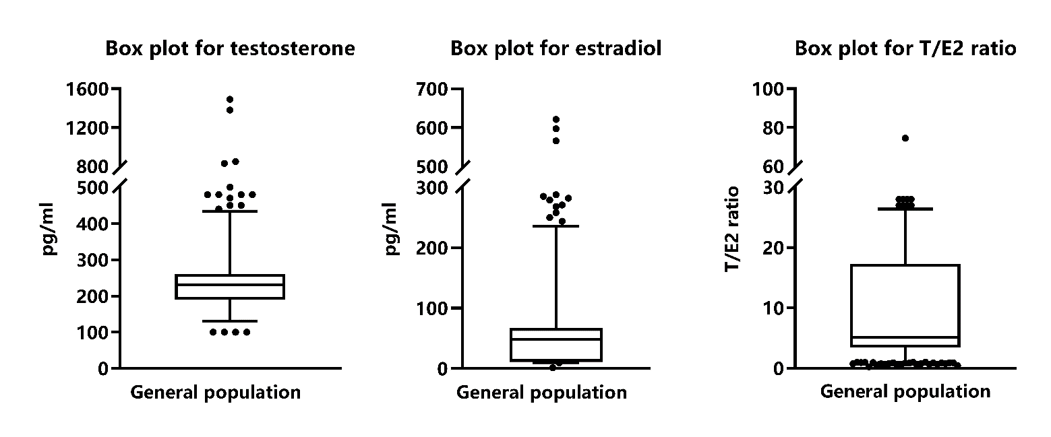
Supplementary Fig. 1. The distribution of T, E2 and T/E2 ratio among the study population.

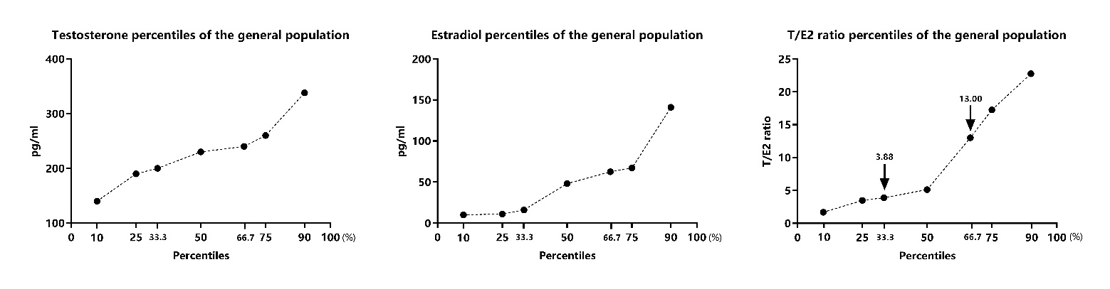
Supplementary Fig. 2. The distribution of T, E2 and T/E2 ratio percentiles among the study population.

Supplementary Table 1. Prevalence ratio between T/E2 ratio with CMD and its components.
Disease | Group | PR (95%CI) | p | p _{for trend}
Obesity | T1 | Reference |  | 0.002
Obesity | T2 | 2.16 (0.93–5.03) | 0.075 | 0.002
Obesity | T3 | 4.01 (1.59–10.11) | 0.003 | 0.002
Hypertension | T1 | Reference |  | 0.010
Hypertension | T2 | 1.86 (1.30–2.66) | 0.001 | 0.010
Hypertension | T3 | 1.67 (1.10–2.53) | 0.016 | 0.010
T2DM | T1 | Reference |  | 0.418
T2DM | T2 | 1.60 (0.69–3.74) | 0.275 | 0.418
T2DM | T3 | 1.50 (0.59–3.81) | 0.397 | 0.418
Hyperlipidemia | T1 | Reference |  | 0.032
Hyperlipidemia | T2 | 0.34 (0.13–0.93) | 0.035 | 0.032
Hyperlipidemia | T3 | 0.23 (0.06–0.89) | 0.034 | 0.032
MetS | T1 | Reference |  | 0.911
MetS | T2 | 1.03 (0.57–1.88) | 0.92 | 0.911
MetS | T3 | 1.04 (0.54–2.00) | 0.91 | 0.911
CVD | T1 | Reference |  | 0.860
CVD | T2 | 0.84 (0.39–1.81) | 0.653 | 0.860
CVD | T3 | 1.03 (0.45–2.35) | 0.939 | 0.860
CMD | T1 | Reference |  | 0.001
CMD | T2 | 1.64 (1.26–2.15) | <0.001 | 0.001
CMD | T3 | 1.65 (1.21–2.23) | 0.001 | 0.001
Groups were the tertiles of T/E2 ratio, and were set with T1 <3.9, T2 = 3.9–13.0, T3 >13.0.
Poissoon loglinear model was performed, and was adjusted by age (continuous variable), Han ethnicity, married, never smoke, never alcohol, never OCT, never HRT, number of live births (continuous variable), menopause status, CAD family history.
T2DM, type 2 diabetes mellitus; CVD, cardiovascular diseases; MetS, metabolic syndrome; CMD, cardiometabolic diseases; PR, prevalence ratio; CI, confidence interval.

Supplementary Table 2. Odds ratio between T/E2 ratio with CMD and its components.
T/E2 ratio | Crude | p | Model 1 | p | Model 2 | p | Model 3 | p
T/E2 ratio | OR (95%) | p | OR (95%) | p | OR (95%) | p | OR (95%) | p
Obesity
T1 | Reference |  | Reference |  | Reference |  | Reference
T2 | 2.187 (0.927–5.161) | 0.074 | 2.357 (0.988–5.626) | 0.053 | 2.388 (0.989–5.765) | 0.053 | 2.323 (0.956–5.644) | 0.063
T3 | 3.252 (1.406–7.519) | 0.006 | 4.149 (1.596–10.790) | 0.004 | 4.299 (1.630–11.340) | 0.003 | 4.701 (1.745–12.666) | 0.002
p _{for trend} | 1.745 (1.182–2.577) | 0.005 | 2.002 (1.262–3.175) | 0.003 | 2.043 (1.276–3.269) | 0.003 | 2.154 (1.324–3.503) | 0.002
Hypertension
T1 | Reference |  | Reference |  | Reference |  | Reference
T2 | 2.312 (1.446–3.699) | <0.001 | 2.187 (1.355–3.531) | 0.001 | 2.205 (1.360–3.574) | 0.001 | 2.369 (1.454–3.860) | 0.001
T3 | 2.248 (1.384–3.651) | 0.001 | 1.876 (1.059–3.322) | 0.031 | 1.895 (1.065–3.372) | 0.030 | 2.015 (1.120–3.624) | 0.019
p _{for trend} | 1.466 (1.162–1.849) | 0.001 | 1.374 (1.042–1.812) | 0.024 | 1.383 (1.046–1.829) | 0.023 | 1.434 (1.079–1.906) | 0.013
T2DM
T1 | Reference |  | Reference |  | Reference |  | Reference
T2 | 1.923 (0.803–4.607) | 0.142 | 1.539 (0.627–3.778) | 0.346 | 1.598 (0.648–3.940) | 0.308 | 1.671 (0.670–4.171) | 0.271
T3 | 2.917 (1.249–6.813) | 0.013 | 1.493 (0.544–4.095) | 0.437 | 1.568 (0.568–4.325) | 0.385 | 1.556 (0.553–4.379) | 0.403
p _{for trend} | 1.677 (1.121–2.509) | 0.012 | 1.195 (0.735–1.943) | 0.473 | 1.226 (0.752–2.001) | 0.414 | 1.216 (0.739–2.002) | 0.441
Hyperlipidemia
T1 | Reference |  | Reference |  | Reference |  | Reference
T2 | 0.604 (0.211–1.732) | 0.348 | 0.458 (0.152–1.382) | 0.166 | 0.444 (0.146–1.348) | 0.152 | 0.296 (0.088–1.000) | 0.050
T3 | 0.707 (0.246–2.031) | 0.520 | 0.317 (0.082–1.222) | 0.095 | 0.349 (0.090–1.354) | 0.128 | 0.187 (0.044–0.796) | 0.023
p _{for trend} | 0.823 (0.474–1.427) | 0.487 | 0.551 (0.279–1.085) | 0.085 | 0.571 (0.288–1.128) | 0.107 | 0.425 (0.204–0.884) | 0.022
CVD
T1 | Reference |  | Reference |  | Reference |  | Reference
T2 | 1.190 (0.526–2.692) | 0.677 | 0.839 (0.358–1.965) | 0.687 | 0.824 (0.348–1.955) | 0.661 | 0.810 (0.335–1.957) | 0.639
T3 | 3.083 (1.483–6.411) | 0.003 | 1.157 (0.469–2.853) | 0.752 | 1.159 (0.460–2.921) | 0.755 | 1.054 (0.398–2.793) | 0.915
p _{for trend} | 1.857 (1.274–2.708) | 0.001 | 1.101 (0.696–1.741) | 0.680 | 1.105 (0.692–1.766) | 0.676 | 1.049 (0.642–1.715) | 0.847
MetS
T1 | Reference |  | Reference |  | Reference |  | Reference
T2 | 1.264 (0.662–2.415) | 0.477 | 0.984 (0.503–1.926) | 0.963 | 1.010 (0.514–1.983) | 0.997 | 1.025 (0.518–2.031) | 0.943
T3 | 2.126 (1.143–3.952) | 0.017 | 1.008 (0.470–2.163) | 0.984 | 1.061 (0.492–2.288) | 0.880 | 1.038 (0.472–2.279) | 0.927
p _{for trend} | 1.476 (1.079–2.018) | 0.015 | 1.005 (0.685–1.472) | 0.981 | 1.030 (0.701–1.514) | 0.879 | 1.018 (0.687–1.509) | 0.927
CMD
T1 | Reference |  | Reference |  | Reference |  | Reference
T2 | 2.389 (1.566–3.645) | <0.001 | 2.187 (1.421–3.366) | <0.001 | 2.166 (1.403–3.343) | <0.001 | 2.290 (1.474–3.556) | <0.001
T3 | 2.885 (1.861–4.472) | <0.001 | 2.156 (1.284–3.619) | 0.004 | 2.206 (1.309–3.720) | 0.003 | 2.335 (1.366–3.992) | 0.002
p _{for trend} | 1.691 (1.361–2.101) | <0.001 | 1.495 (1.158–1.932) | 0.002 | 1.514 (1.169–1.960) | 0.002 | 1.563 (1.199–2.038) | 0.001
Groups were the tertiles of T/E2 ratio, and were set with T1 <3.9, T2 = 3.9–13.0, T3 >13.0.
Binary logistics regression was performed in these models.
Model 1: adjusted by age.
Model 2: adjusted by model 1 + Han ethnicity, married, never smoke, never alcohol, never OCT, never HRT.
Model 3: adjusted by model 2 + number of live births, menopause status, CAD family history.
Age and number of live births served as continuous variables in those models.
T2DM, type 2 diabetes mellitus; CVD, cardiovascular diseases; MetS, metabolic syndrome; CMD, cardiometabolic diseases; OR, odds ratio; T/E2 ratio, testosterone/estradiol ratio.

