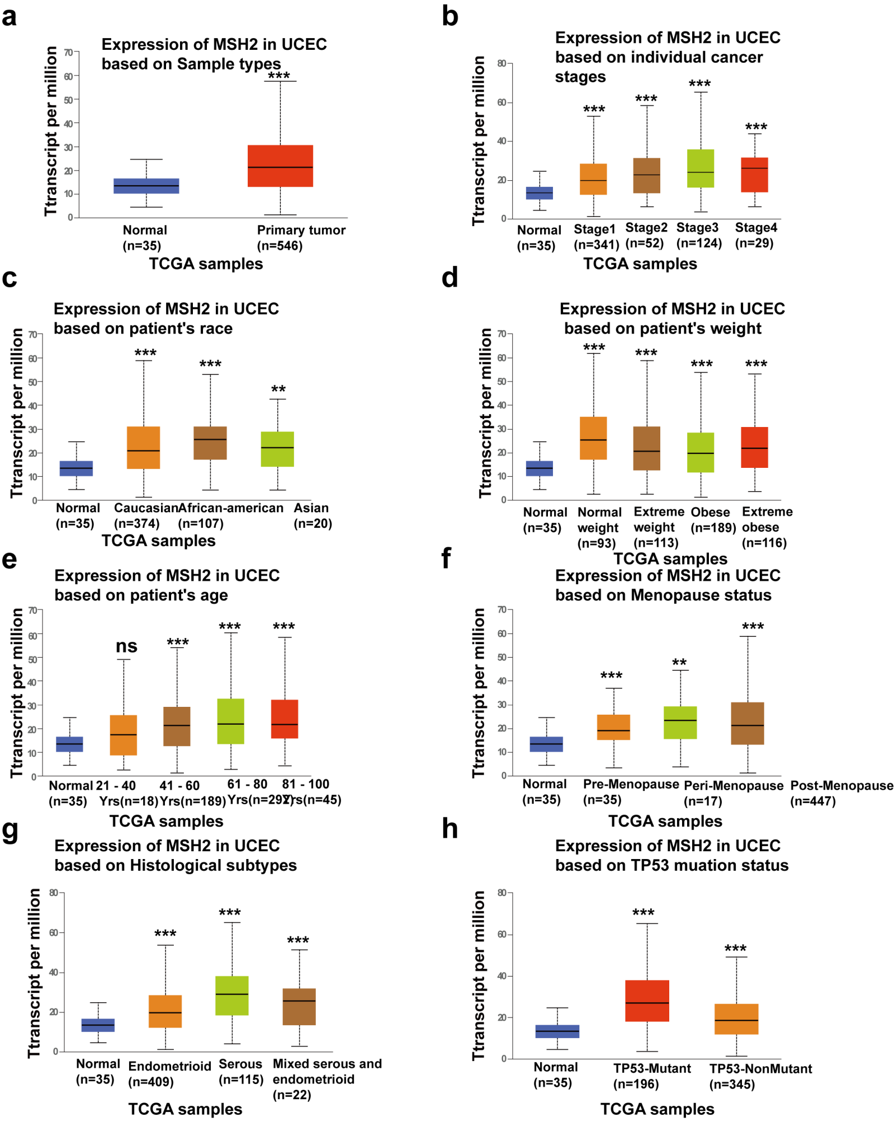
Supplementary Fig. 1. Box plots assessing MSH2 expression among different subgroups via the UALCAN database based on clinical parameters of patients. Sample types (a), individual cancer stages (b), race (c), weight (d) age (e), menopause status (f), historical subtypes (g), and TP53 mutation (h). respectively. *p < 0.05, **p < 0.01, ***p < 0.001. ns p > 0.05.

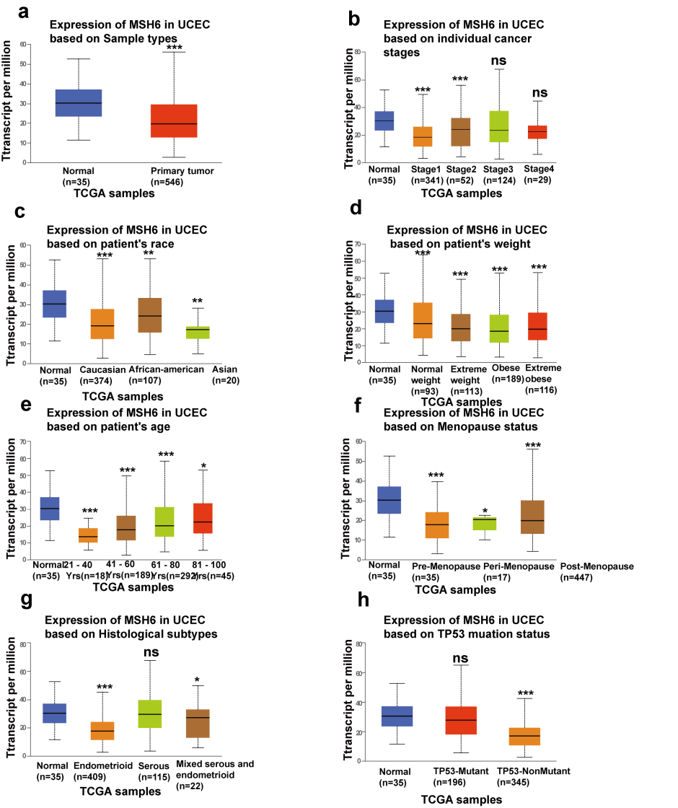

Supplementary Fig. 2. Box plots assessing MSH6 expression among different subgroups via the UALCAN database on the basis of clinical parameters of patients. Sample types (a), individual cancer stages (b), race (c), weight (d), age (e), menopause status (f), historical subtypes (g), and TP53 mutation (h). respectively. *p < 0.05, **p < 0.01, ***p < 0.001. ns, non sense p > 0.05.

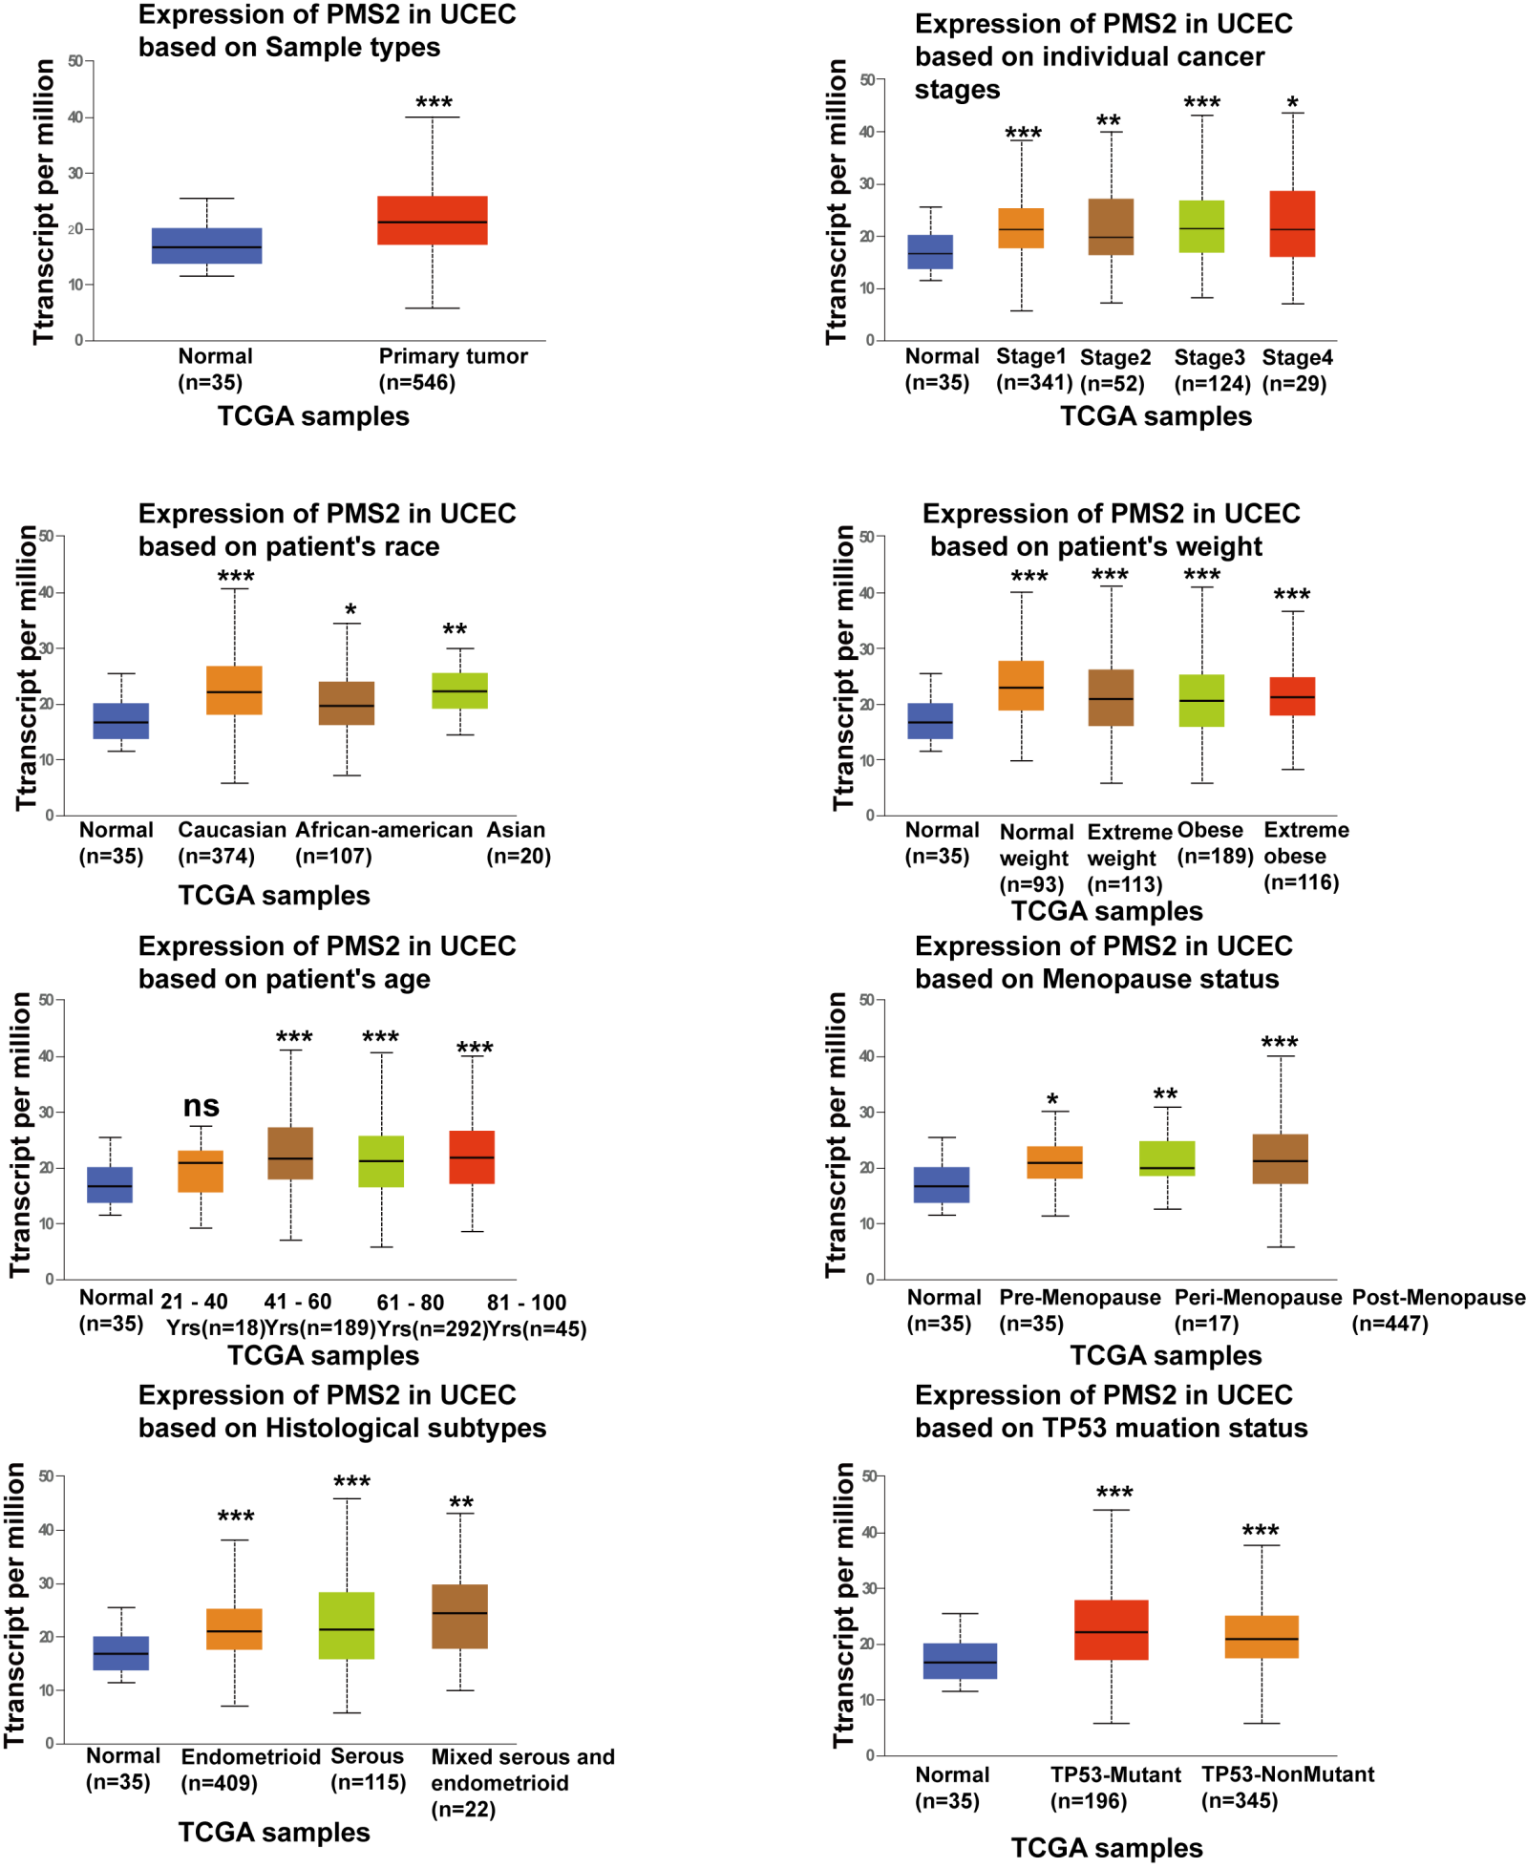

Supplementary Fig. 3. Box plots assessing PMS2 expression among different subgroups via the UALCAN database on the basis of clinical parameters of patients. Sample types (a), individual cancer stages (b), race (c), weight (d), age (e), menopause status (f), historical subtypes (g) TP53 and mutation (h). respectively. *p < 0.05, **p < 0.01, ***p < 0.001. ns p > 0.05.

