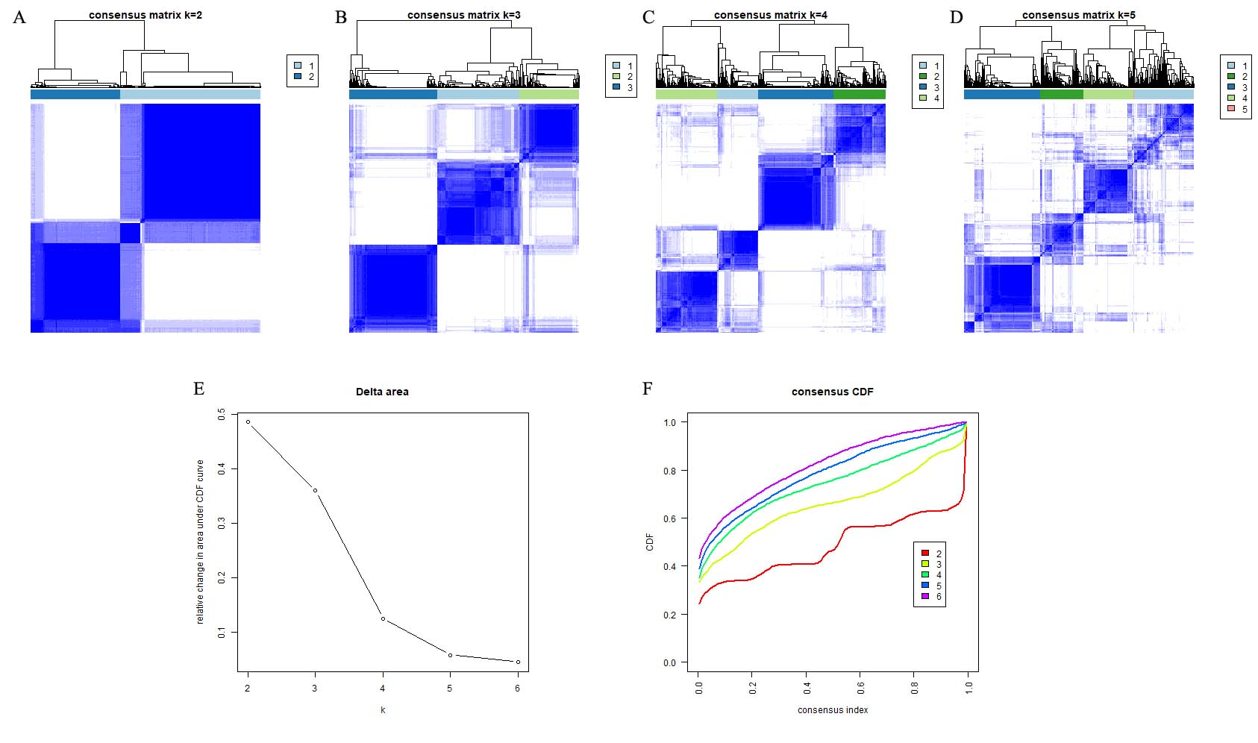
Fig. S1. Consensus clustering based on the ICI patterns. (A-D) Consensus matrixes of UCEC samples for each k (k = 2–5), displaying the clustering stability using 1000 iterations of hierarchical clustering. (E) The relative change in area under the CDF curve for k = 2–6. (F) Area under cumulative distribution function (CDF) curve when index k ranges from 2 to 6.

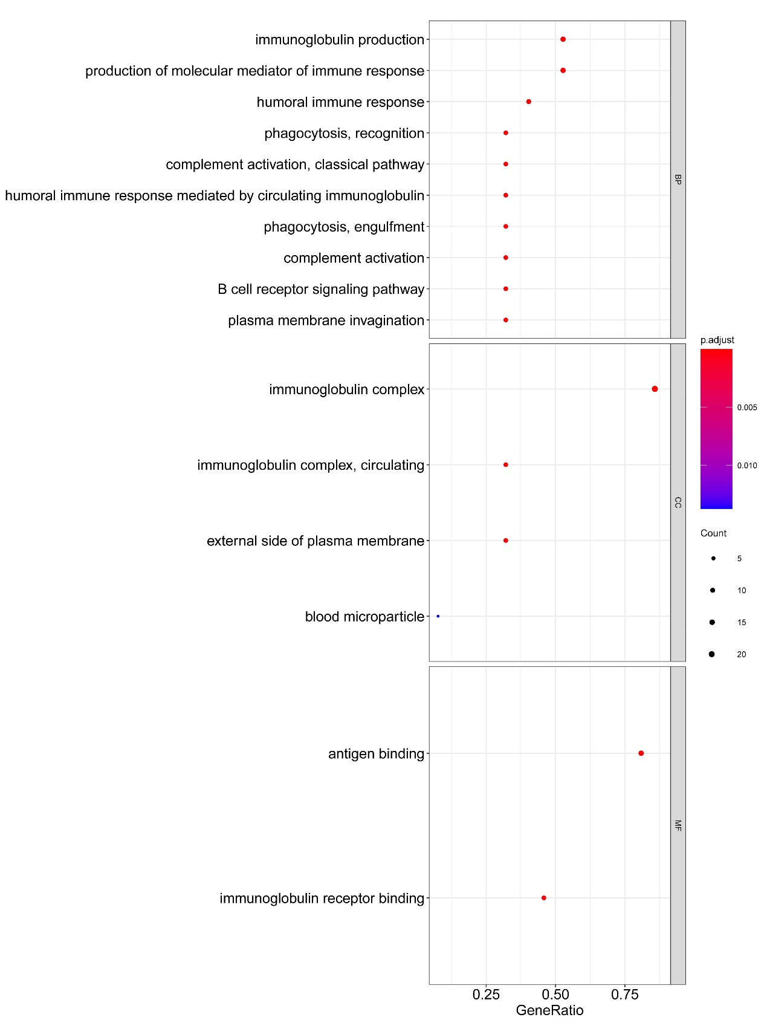
Fig. S2. GO enrichment analysis.

