Supplementary Figures.
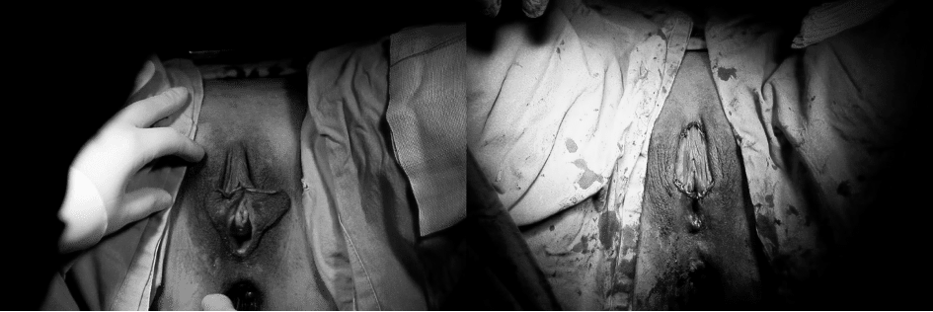
Supplementary Fig. 1. Preoperative and postoperative view (Freya approach), case 1.
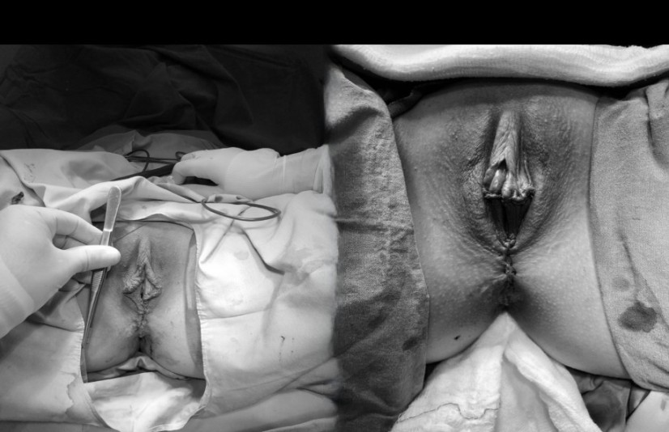
Supplementary Fig. 2. Preoperative and postoperative view (Freya approach), case 2.
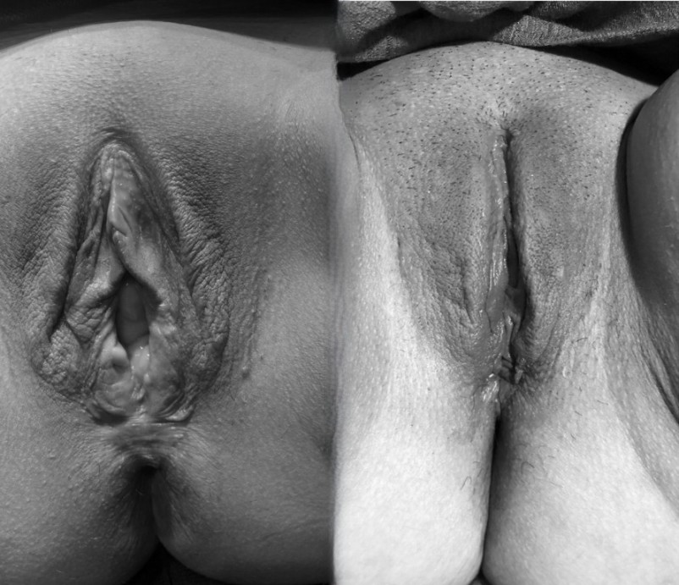
Supplementary Fig. 3. Preoperative and postoperative view (Freya approach), case 3.
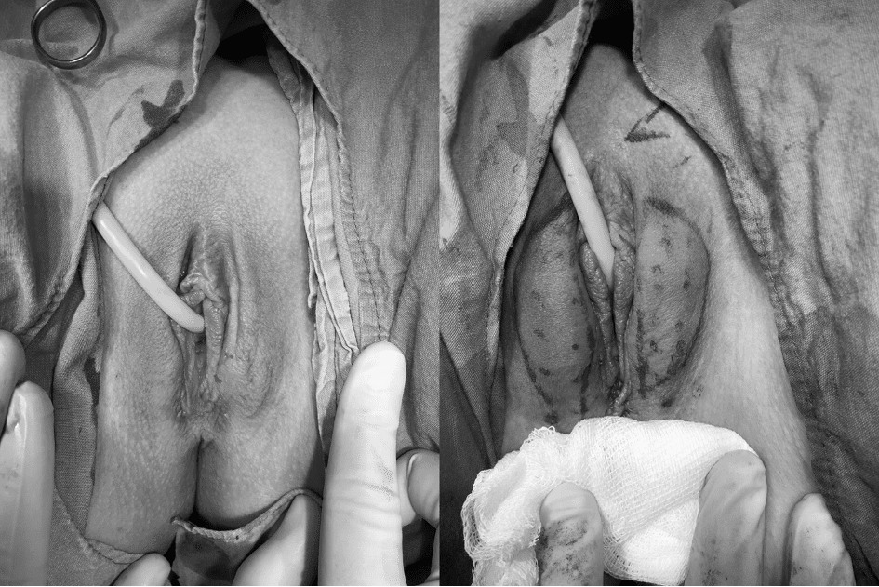
Supplementary Fig. 4. Preoperative and postoperative view (Freya approach), case 4.

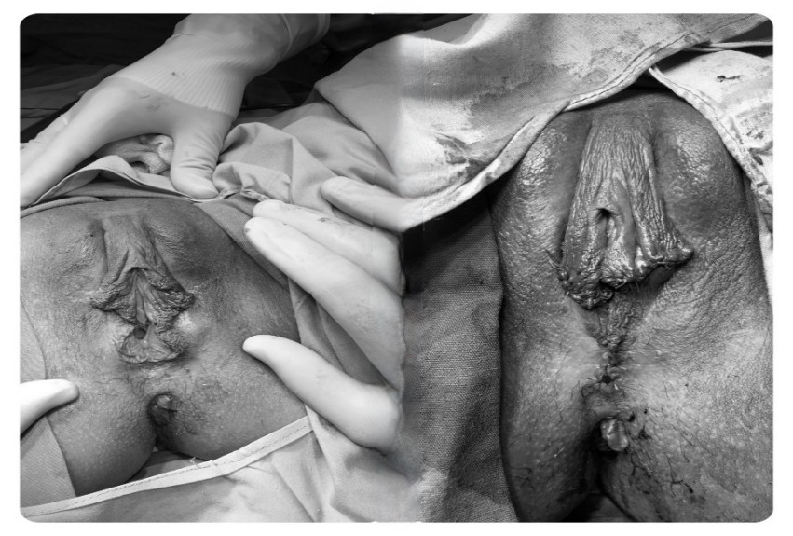
Supplementary Fig. 5. Preoperative and postoperative view (Freya approach), case 5.

