Supplementary Material

Significance of Abiotrophia spp. and Granulicatella spp. bacteraemia:
In the study period, 20 Abiotrophia spp. or Granulicatella spp. bacteraemias were detected in our microbiology department (13 by Abiotrophia spp. and 7 by Granulicatella spp.). IE was diagnosed in eight of these bacteraemias (6 by Abiotrophia spp. (46.2%) and 2 by Granulicatella spp. (28.6%)). The other 12 bacteraemias (5 of them concomitantly with other microorganisms in the context of polymicrobial bacteraemias) correspond to patients without IE (6 by Abiotrophia spp. and 6 by Granulicatella spp.). These bacteraemias in patients without IE were related to miscellaneous infections (1 ascending cholangitis after endoscopic retrograde cholangiopancreatography, 3 primary bacteraemia of uncertain origin in patients without proven endocarditis, 1 primary bacteraemia in patient with spontaneous cerebral hemorrhage due to familial cerebral cavernomatosis, 2 catheter colonization, 3 primary intra-abdominal infections, 1 contaminant and 1 polymicrobial right arm wound infection with associated necrotizing fasciitis). The exclusion of endocarditis was not performed in all patients with Abiotrophia spp. or Granulicatella spp. bacteraemia. The exclusion of endocarditis (by transesophageal echocardiogram and control blood cultures) was performed in the 3 patients with bacteraemia of uncertain origin and in the 2 patients with catheter colonization.

Description of non-surgical patients:
Patient #3 did not undergo surgery due to death the day after hospital admission because of septic shock and severe mitral insufficiency. Patient #7 was a 20-year-old male with complex congenital cardiopathy (pulmonary branch hypoplasia, (MAPCAs), pulmonary atresia and ventricular septal defect), who presented IE on a prosthetic pulmonary conduit Contegra by A.defectiva. Due to the large number of cardiac surgeries he had undergone since childhood, the multidisciplinary team decided that the surgical risk was high and opted for conservative antibiotic treatment with intravenous ceftriaxone for 6 weeks (the first week in combination with gentamicin) and after completing the IV treatment, oral levofloxacin was started as a suppressive therapy, which continues at the time of the present study. His clinical evolution has been favorable and to date there is no fever or evidence of active infection. Patient #8 was an 86-year-old patient with multiple comorbidities, in whom it was decided not to perform surgery and to undertake conservative treatment with intravenous antibiotics for several weeks, followed by oral antibiotherapy with levofloxacin for 3 months.

Description of patients who died:
Patient #3 died the day after hospital admission due to septic shock with multiorgan failure and ruptured chordae with severe mitral insufficiency due to IE. Patient #10 was an 18-year-old male with congenital aortic stenosis, with IE on native aortic valve due to G.elegans in 2016, treated with intravenous antibiotherapy with ceftriaxone and gentamicin, and surgical valve replacement. During surgery, he presented an intraoperative cardiac arrest, with postcardiotomy cardiogenic shock. Extracorporeal membrane oxygenation was implanted and a heart transplant was performed 14 days after the valve surgery, presenting post-transplant severe biventricular dysfunction, leading to the patient's death. The third patient, #8, died 5 months after the IE episode, due to Enterococcus faecium bacteraemia related to a hemodialysis catheter, and a transesophageal echocardiogram ruled-out endocarditis.

Temporal distribution of IE cases by Abiotrophia spp. or Granulicatella spp.:
We did not observe any cluster of cases in the study period. The patients were unrelated to each other, and occurred in a heterogeneous temporal distribution. Although there are two cases of IE in each of 2011 and 2019, these are caused by different species, excluding their involvement in clusters.

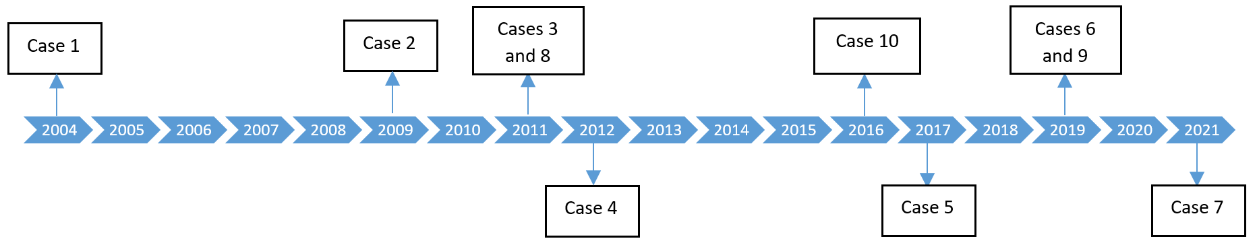Supplementary Fig. 2. Temporal distribution of Abiotrophia spp. and Granulicatella spp. IE cases.

