Supplemental Materials

Determination of vitamin B₁₂ and folate compounds in commercially available edible seaweed products
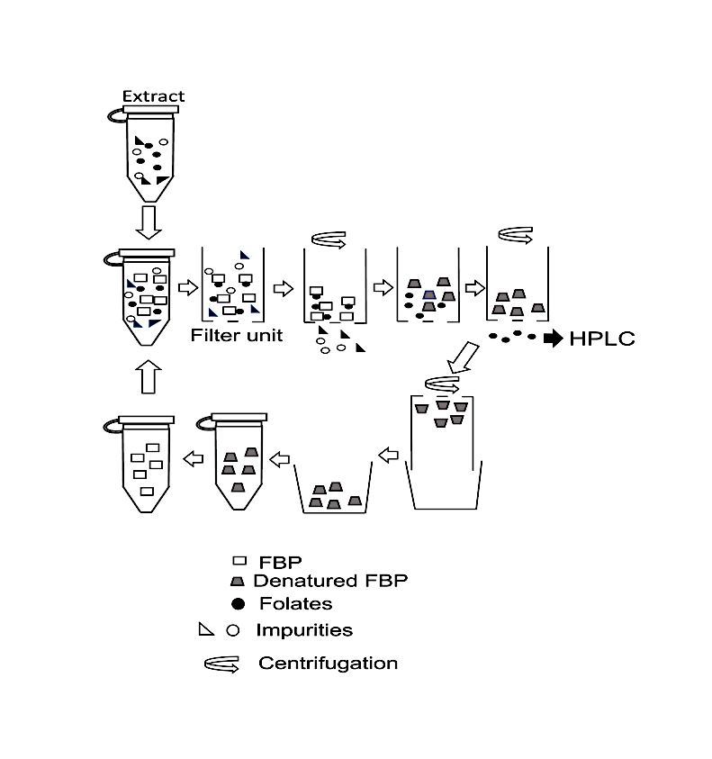

Fig. S1 Outline of the purification of folate compounds using FBP and the Ultracel®-10K filter unit
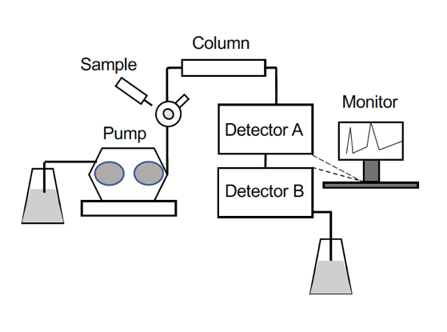

Fig. S2. High-performance liquid chromatography system for food folate analysis
Detector A, Fluorescence detector; and detector B, electrochemical detector.
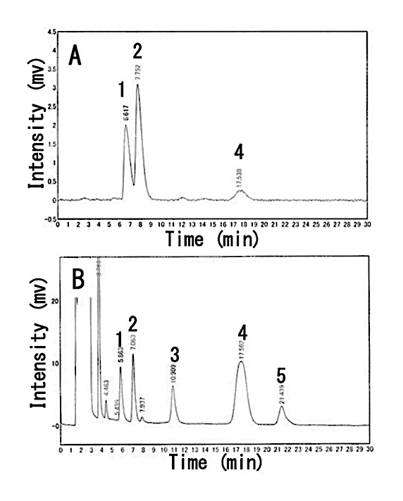
Fig. S3 High-performance liquid chromatography chromatograms of authentic folate compounds. Panel A, fluorescence detector; panel B, electrochemical detector.
Peak 1, THF; peak 2, 5-CH₃-THF; peak 3, 5,10-CH=THF or 10-CHO-THF;
peak 4, 5-CHO-THF; and peak 5, FA.

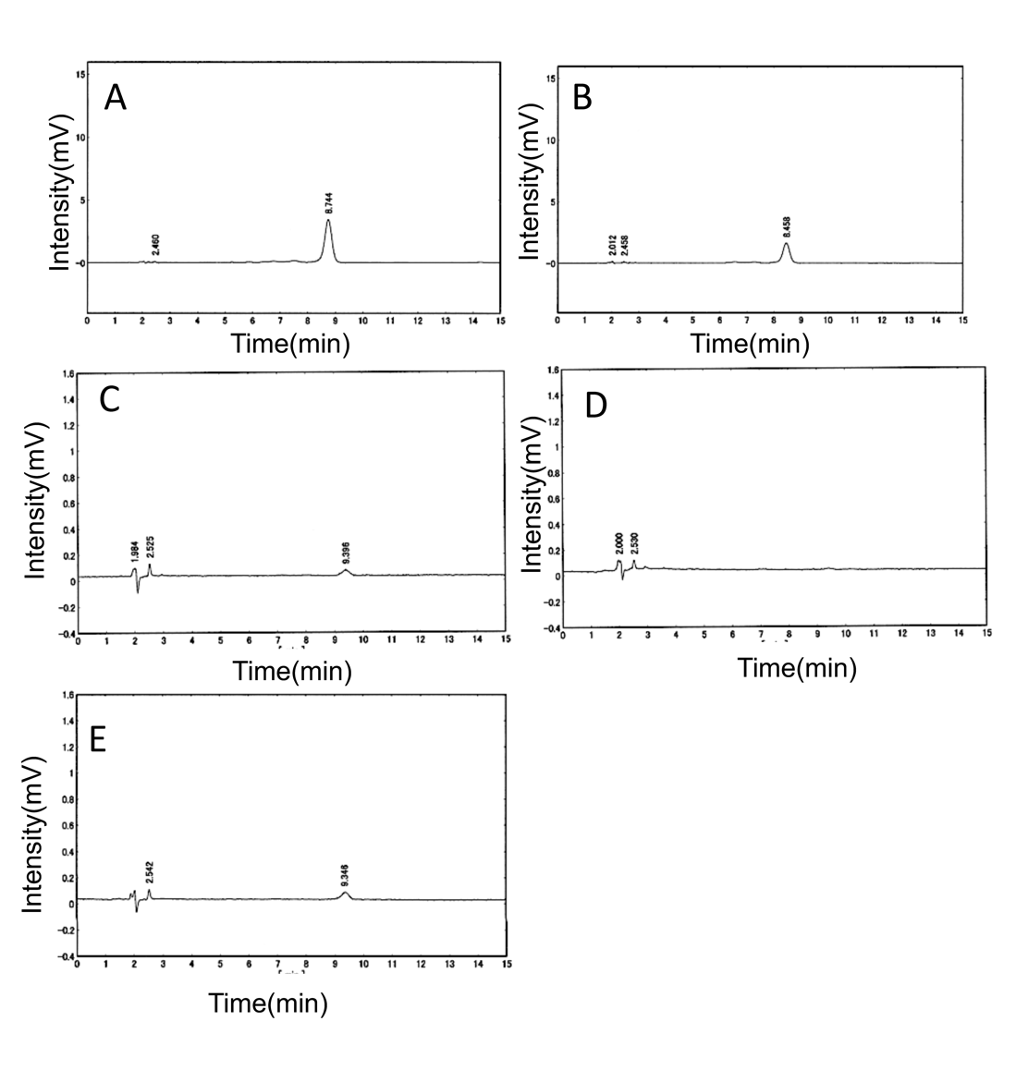
Fig. S4 High-performance liquid chromatography patterns of B₁₂ compounds from various dried seaweed products A, toasted purple laver products; B, seasoned and toasted purple laver products; C, dried kombu products; D, boiled and dried hijiki products, and E, dried wakame products.
Table S1. Recovery of authentic folate compounds during FBP purification and Ultracel®-10K filter unit.
Aliquots (100 µg) of lyophilized FBP was dissolved in 0.5 mL of 50 mmol/L potassium phosphate buffer containing 2% (v/v) ascorbic acid and 0.2% (v/v) 2-mercaptoethanol. Each solution (0.5 mL) of authentic folate compounds (100 ng/mL) listed in the table was treated with FBP-Ultracel®-10K filter unit purification as described in the text. The filtrate fractions were combined and used as HPLC samples. Recovery (%) was calculated from the values determined from the samples with or without FBP purification. The experiments were repeated three times. Data are represented as mean ± SEM. FBP, folate-binding protein.

Authentic folate compounds Recovery (%)

THF 86.8 ± 2.0
5CH₃-THF 84.6 ± 4.0
5,10-CH=THF 87.5 ± 7.2
5-CHO-THF 110.3 ± 15.7
FA 85.4 ± 4.3

Table S2. Folate contents of the certified reference material BCR-485 (from mixed vegetables) using various methods.
Folate compounds were extracted from the certified reference material BCR-485 (from mixed vegetables, 0.2 g), treated with tri-enzymes, purified with FBP, and determined using HPLC as described in the text. The experiments were repeated three times. Data are represented as mean values. HPLC, High-performance liquid chromatography; ND, not detected.

Folate Content (µg/100 g)
compounds Labeled Report 1* Report 2** This study

THF − 8 (3%) 29 (9%) 14.5 ± 5.0 (4.6% ± 1.6%)
5-CH₃-THF 214 (68%) 247 (78%) 249 (79%). 229.0 ± 2.5 (72.7% ± 0.8%)
5-CHO-THF − ND 23 (7%) ND
Total folates 315 (100%) 255 (81%) 289 (92%). 243.5 ± 7.6 (77.3 %± 2.4%)
*Shohag et al., Journal of Chromatography B, 1040, 169–179 (2017)
**Jastrebova et al., Food Chemistry, 80, 579–588 (2003)

