Recovery of phenolic compounds from orange peel waste by conventional and assisted extraction techniques using sustain-able solvents
Blanca Sáenz de Miera¹, Raquel Cañadas², María González-Miquel¹, Emilio J. González^{1,}*

¹ Dpto. Ingeniería Química Industrial y del Medio Ambiente, ETSI Industriales, Universidad Politécnica de Madrid, Madrid, 28006, Spain
²Advanced Biofuels and Bioproducts Unit, Department of Energy, CIEMAT, 28040 Madrid, Spain
*Correspondence: ej.gonzalez@upm.es (Emilio J. González)

Supplementary information
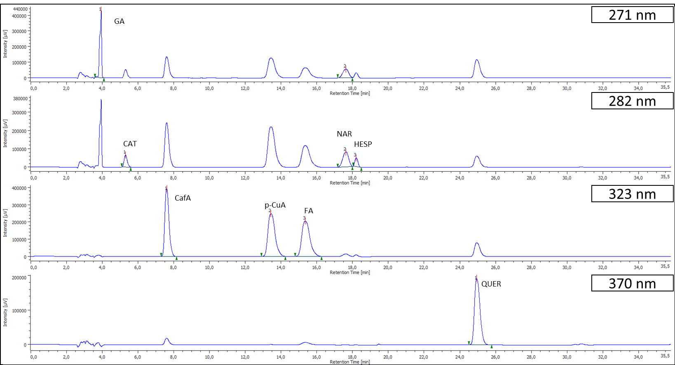
Supplementary Fig. 1. Chromatogram profile of HPLC-DAD at 270 nm (for determination and quantification of gallic acid), at 282 nm (for determination and quantification of catechin, naringin and hesperidin), at 323 nm (for determination and quantification of caffeic acid, p-coumaric acid and ferulic acid) and 370 nm (for determination and quantification of quercetin)
Supplementary Table 1. Results after orbital shaker extraction (OSE) from orange peel waste (OPW). Total phenolic content (TPC), total flavonoid content (TFC) and HPLC quantification of the flavonoids and phenolic acids. Extraction conditions: biomass:solvent ratio =1:10; T= 303 and 333 K; t_{extraction}= 30, 60 and 90 min; stirring rate: 900 rpm.
 |  |  |  |  |  |  | HPLC (µg/g OPW ± RDS, %)
Solvent | T (K) | t (min) |  | TPC (mg GAE/g OPW) | TFC  (mg QE/g OPW) |  | HESP | NAR | CAT | RUT | GA | CafA | p-CuA | FA
H₂0 | 303 | 60 |  | 5.4 ± 0.1 | 5.7 ± 0.1 |  | 7570.4 ± 0.2 | 53.9 ± 5 | 252.8 ± 17.7 | 32.8 ± 3.8 | 683.7 ± 0.8 | 18.3 ± 0.7 | 81.8 ± 3.7 | 95.3 ± 4.7
H₂0 | 333 | 30 |  | 7.8 ± 0.2 | 5.3 ± 0.1 |  | 7813.1 ± 0.9 | 69.5 ± 3.3 | 266.5 ± 1.8 | 35.9 ± 2.3 | 826.1 ± 1.6 | 20.4 ± 5.2 | 96.9 ± 1.3 | 131 ± 0.5
H₂0 | 333 | 60 |  | 7.8 ± 0.1 | 5.5 ± 0.1 |  | 7966.8 ± 0.3 | 52.8 ± 3.9 | 243.7 ± 1.6 | 31.3 ± 5 | 925.7 ± 0.2 | 11.9 ± 3.9 | 109.8 ± 3.1 | 111.2 ± 0.5
H₂0 | 333 | 90 |  | 8.1 ± 0.1 | 5.6 ± 0.2 |  | 7309.8 ± 0.7 | 82.7 ± 3.2 | 249.4 ± 1.5 | 35.7 ± 3.4 | 920.2 ± 0.4 | 23.4 ± 0.8 | 107.2 ± 1.7 | 146 ± 1.8
80 % EtOH | 303 | 60 |  | 3.9 ± 0.1 | 8.8 ± 0.1 |  | 5136.8 ± 0.3 | nf | 15.7 ± 7.8 | 27.1 ± 1.1 | 76.5 ± 5.3 | 6.7 ± 1.9 | 24 ± 0.6 | 43.3 ± 4.2
80 % EtOH | 333 | 30 |  | 8.2 ± 0.1 | 12.8 ± 0.3 |  | 34939.2 ± 0.1 | nf | 56.0 ± 7.1 | 41.8 ± 3.6 | 19.5 ± 1.9 | 11.3 ± 4.8 | 26.7 ± 5.6 | 154.5 ± 0.8
80 % EtOH | 333 | 60 |  | 6.8 ± 0.5 | 12.5 ± 0.4 |  | 27367.2 ± 0.2 | nf | 28.8 ± 1.2 | 36.6 ± 3.3 | 28.2 ± 16.1 | 8.7 ± 3.9 | 45.3 ± 4.1 | 74 ± 1.3
80 % EtOH | 333 | 90 |  | 8.1 ± 0.1 | 12.4 ± 0.1 |  | 29530.3 ± 0.1 | nf | 52.8 ± 8.2 | 39.4 ± 1.3 | 22.9 ± 8.4 | 12 ± 3.5 | 22.3 ± 2.3 | 73.9 ± 2.7
EA | 303 | 60 |  | 0.4 ± 0.2 | 2.5 ± 0.1 |  | 126.1 ± 4.1 | nf | nf | nf | nf | nf | nf | nf
EA | 333 | 30 |  | 0.8 ± 0.9 | 4.4 ± 0.9 |  | 299.2 ± 4.3 | nf | nf | nf | nf | nf | nf | nf
EA | 333 | 60 |  | 1.1 ± 0.5 | 4.1 ± 0.4 |  | 279.2 ± 3.5 | nf | nf | nf | nf | nf | nf | nf
EA | 333 | 90 |  | 1.2 ± 1.3 | 3.7 ± 0.9 |  | 440.3 ± 1.8 | nf | nf | nf | nf | nf | nf | nf
*nf, not found

Supplementary Table 2. Results after ultrasound bath assisted extraction (USBE) from orange peel waste (OPW). Total phenolic content (TPC), total flavonoid content (TFC) and HPLC quantification of the flavonoids and phenolic acids. Extraction conditions: biomass:solvent ratio =1:10; T= 333 K; and t_{extraction}= 30 min.
 |  |  |  | HPLC (µg/g OPW ± RDS. %)
Solvent | TPC (mg GAE/g OPW) | TFC (mg QE/g OPW) |  | HESP | NAR | CAT | RUT | GA | CafA | p-CuA | FA
H₂O | 4.2 ± 0.2 | 2.6 ± 0.4 |  | 9713.4 ± 0.9 | 46.9 ± 0.1 | 205.3 ± 9.3 | 26.4 ± 3.9 | 540 ± 3.5 | 13.8 ± 2 | 55.9 ± 7.8 | 88.9 ± 2.4
80% EtOH | 4.1 ± 0 | 6.1 ± 0.5 |  | 17247.7 ± 0.1 | nf | 15.7 ± 3.4 | 25.8 ± 1.3 | 3.4 ± 16.8 | 6.5 ± 0.2 | 13.2 ± 6.1 | 45.1 ± 1
EA | 1.1 ± 0.9 | 3.9 ± 0.2 |  | 415.2 ± 3 | nf | nf | nf | nf | nf | nf | nf
*nf, not found

Supplementary Table 3. Results after ultrasound probe assisted extraction (USPE) from orange peel waste (OPW). Total phenolic content (TPC), total flavonoid content (TFC) and HPLC quantification of the flavonoids and phenolic acids. Extraction conditions: biomass:solvent ratio =1:10; t _{extraction}= 1.5, 3 and 6 min; P=10 W; T_{max} =333 K.
 |  |  |  |  |  |  |  |  |  | HPLC (µg/g OPW ± RDS. %)
Solvent | P (W) |  | t (min) |  |  |  | TPC (mg GAE/g OPW) | TFC (mg QE/g OPW) |  | HESP | NAR |  | CAT | RUT | GA | CafA | p-CuA | FA
H₂O | 10 | 1.5 |  |  |  | 7.6 ± 0.0 |  | 5.2 ± 0.1 |  | 12262.9 ± 1.5 | 27.8 ± 15.5 | 286.3 ± 2 |  | 32.8 ± 8.9 | 874.4 ± 0.1 | 7.3 ± 4 | 102 ± 3.8 | 118.8 ± 0.9
H₂O | 10 | 3 |  |  |  | 8.1 ± 0.1 |  | 5.2 ± 0.1 |  | 8832.3 ± 0.3 | 36.1 ± 12.2 | 2639.6 ± 0.5 |  | 31.2 ± 7.8 | 650.5 ± 12.2 | 7.1 ± 2.8 | 85.4 ± 0.7 | 109.6 ± 0.6
H₂O | 10 | 6 |  |  |  | 7.4 ± 0.1 |  | 5.8 ± 0.0 |  | 8089.1 ± 3.1 | 50.4 ± 4.4 | 198.7 ± 1.7 |  | 32.4 ± 1.2 | 669.2 ± 0.4 | 7.5 ± 4.6 | 80.4 ± 1.1 | 101.1 ± 4.2
80% EtOH | 10 | 1.5 |  |  |  | 8.8 ± 0.0 |  | 17.1 ± 0.2 |  | 40047.7 ± 0.2 | nf | 131.8 ± 9.6 |  | 43.5 ± 2.2 | 292.4 ± 1.9 | 10.7 ± 6.1 | 70.3 ± 1.1 | 168.5 ± 0.8
80% EtOH | 10 | 3 |  |  |  | 8.4 ± 0.1 |  | 12.6 ± 0.1 |  | 34362.7 ± 0.1 | nf | 60.6 ± 1.8 |  | 34.5 ± 5.1 | 34.9 ± 36.9 | 8.3 ± 5.9 | 43.6 ± 2.5 | 117 ± 1.4
80% EtOH | 10 | 6 |  |  |  | 9.1 ± 0.0 |  | 21.4 ± 0.1 |  | 31999.6 ± 0.2 | nf | 111.0 ± 2.6 |  | 36.9 ± 4.1 | 261.1 ± 0.1 | 9.4 ± 2.1 | 53.9 ± 10.8 | 137.2 ± 1.6
EA | 10 | 1.5 |  |  |  | 0.8 ± 0.8 |  | 4.6 ± 0.4 |  | 253.4 ± 0.3 | nf | nf |  | nf | nf | nf | nf | nf
EA | 10 | 3 |  |  |  | 1 ± 1.6 |  | 3.9 ± 2.7 |  | 402.1 ± 1.8 | nf | nf |  | nf | nf | nf | nf | nf
EA | 10 | 6 |  |  |  | 0.9 ± 0.3 |  | 3.9 ± 1.7 |  | 428.6 ± 0.3 | nf | nf |  | nf | nf | nf | nf | nf
*nf, not found

Supplementary Table 4. Results after microwave assisted extraction (MAE) from orange peel waste (OPW). Total phenolic content (TPC), total flavonoid content (TFC) and HPLC quantification of the flavonoids and phenolic acids. Extraction conditions: biomass:solvent ratio =1:10; T= 333 and 373 K; t_{extraction}= 1.5, 3 and 6 min; stirring rate: 1000 rpm.
 |  |  |  |  |  |  | HPLC (µg/g OPW± RDS. %)
Solvent | T (K) | t (min) |  | TPC (mg GAE/g OPW) | TFC (mg QE/g OPW) |  | HESP | NAR | CAT | RUT | GA | CafA | p-CuA | FA
H₂O | 333 | 1.5 |  | 5.6 ± 0.1 | 2.9 ± 0.2 |  | 9861.7 ± 0.3 | 62.4 ± 10 | 356.7 ± 4.1 | 25.9 ± 2.1 | 847.6 ± 0.4 | 8 ± 3.7 | 103.4 ± 0.6 | 114.3 ± 1.4
H₂O | 373 | 1.5 |  | 5.1 ± 0.3 | 3.1 ± 0.1 |  | 21979.2 ± 0 | 36.3 ± 2.3 | 201.4 ± 2.5 | 22.1 ± 1.8 | 363.2 ± 5.1 | 5.3 ± 2.4 | 48.6 ± 3 | 103.5 ± 1.5
H₂O | 373 | 3 |  | 4.9 ± 0.2 | 3.1 ± 0.1 |  | 16300.9 ± 0 | 28.8 ± 3.1 | 149 ± 1.7 | 22.2 ± 1.4 | 314.4 ± 4.3 | 12.8 ± 2.1 | 39.6 ± 0.6 | 89.6 ± 0.8
H₂O | 373 | 6 |  | 5.4 ± 0.2 | 3.0 ± 0.4 |  | 27165.5 ± 0.3 | 33.8 ± 2.5 | 133.3 ± 10.8 | 25 ± 1.4 | 393.8 ± 2.3 | 14.2 ± 2.6 | 40.1 ± 2.3 | 116.3 ± 0.7
80% EtOH | 333 | 1.5 |  | 3.4 ± 0.1 | 4.7 ± 0.2 |  | 22095.7 ± 0 | nf | 47.9 ± 1.7 | 30.1 ± 1.1 | 1.8 ± 29.8 | 7.5 ± 4.3 | 14.7 ± 2.3 | 70.7 ± 2.4
80% EtOH | 373 | 1.5 |  | 5.7 ± 0.0 | 11.5 ± 0 |  | 42693.0 ± 0.5 | nf | 68 ± 18.2 | nf | 83 ± 0.8 | 9.6 ± 3.3 | 22.2 ± 9.2 | 83.4 ± 5
80% EtOH | 373 | 3 |  | 5.2 ± 0.1 | 10.8 ± 0 |  | 47320.1 ± 0.2 | nf | 25.3 ± 4.7 | 25.2 ± 2 | 106.5 ± 0.5 | 13.3 ± 0.6 | 22.3 ± 2.3 | 91.5 ± 2.3
80% EtOH | 373 | 6 |  | 7.2 ± 0.1 | 13.3 ±0.1 |  | 58207.5 ± 0.1 | nf | 149.6 ± 1.8 | 26.7 ± 1.2 | 32.2 ± 12.9 | 13.8 ± 4.6 | 27.9 ± 4.1 | 125.1 ± 8.2
EA | 333 | 1.5 |  | 0.5 ± 0.2 | 3.0 ± 0.0 |  | 131.2 ± 0.5 | nf | nf | nf | nf | nf | nf | nf
EA | 373 | 1.5 |  | 1.4 ± 0.1 | 4.1 ± 0.1 |  | 451.9 ± 1.6 | nf | nf | nf | nf | nf | nf | nf
EA | 373 | 3 |  | 1.8 ± 1.7 | 5.1 ± 0.2 |  | 700.3 ± 3.5 | nf | nf | nf | nf | nf | nf | nf
EA | 373 | 6 |  | 1.9 ± 0 | 4.9 ± 0.1 |  | 606.6 ± 4.3 | nf | nf | nf | nf | nf | nf | nf
*nf, not found

