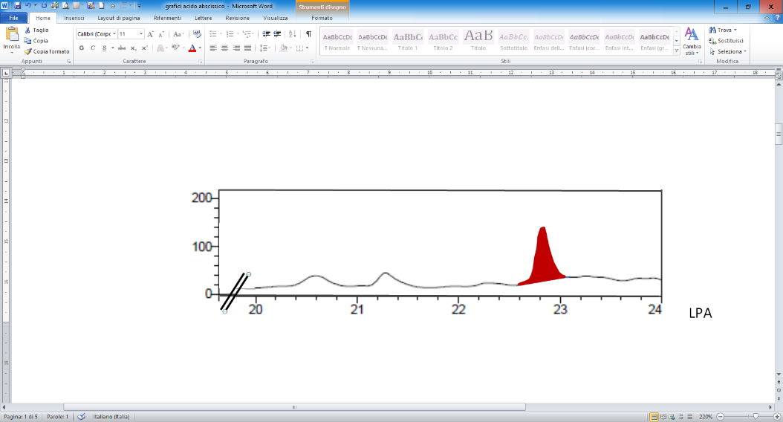
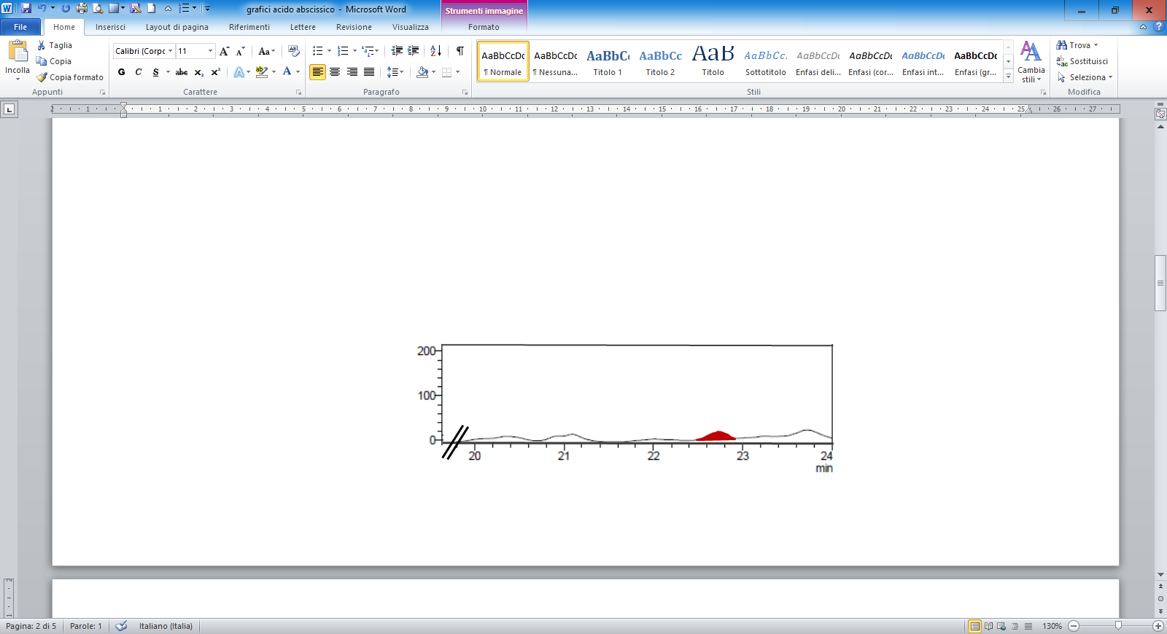
Supplementary Fig. 1. HPLC-DAD trace for detection of absiscic acid in samples lpa1-1 and wild-type. The concentration of ABA in the extracts produced with the method described in the text are 5.1 μg mL⁻¹ and 1.2 μg mL⁻¹ respectively.
LPA

WT

