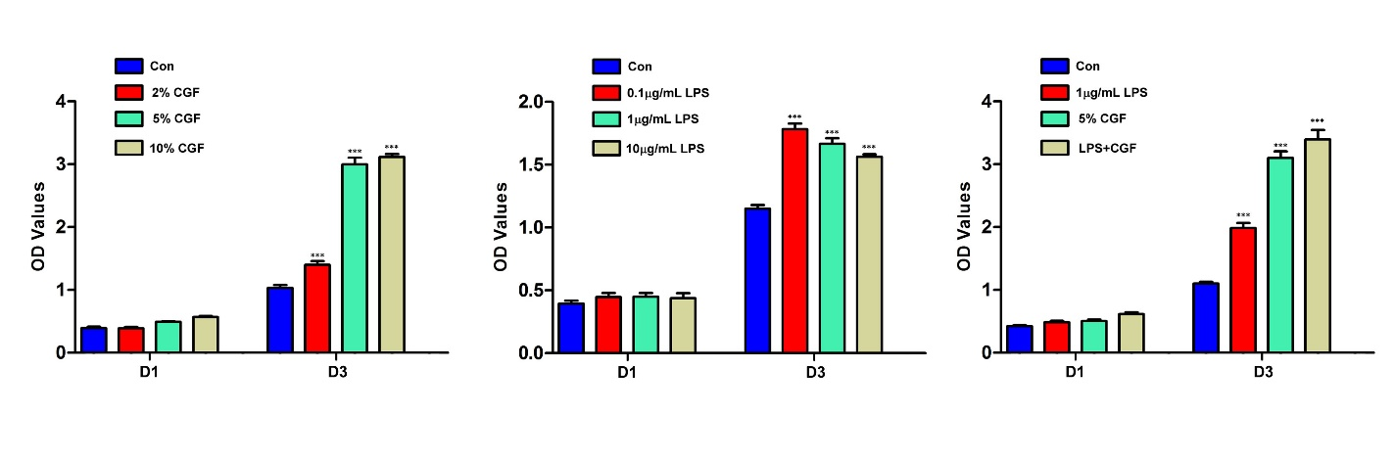
Supplementary Fig. 1. The effects of LPS and CGF on the proliferation of HaCaT cells. (a) CCK-8 assay was used to test the proliferation of HaCaT cells in different concentrations of CGF (0, 2%, 5%, and 10%) for 1 day and 3 days. (b) CCK-8 assay was used to test the proliferation of HaCaT cells in different concentration of LPS (0, 0.1, 1, and 10 μg/mL) for 1 day and 3 days. (c) CCK-8 assay was used to test the proliferation of HaCaT cells treated with a combination of CGF (5%) and LPS (1 μg/mL) for 1 and 3 days. All values are displayed as the mean ± S.D. from three independent experiments. *p < 0.05, **p < 0.01, ***p < 0.001, as evaluated by Student’s T test compared with the control group.

