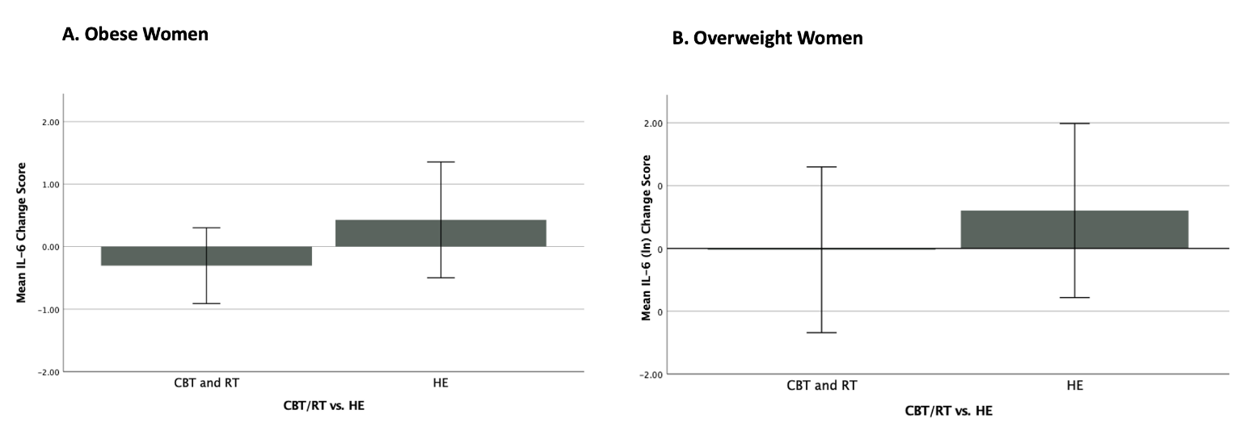
Supplementary Fig. 1. Change in IL-6 Pre- to 6-months Post-Intervention by Study Condition (CBR/RT vs HE) among obese (A) and overweight (B) women with breast cancer. Cytokine levels are log-transformed to achieve normality. Error bars represent 95% confidence intervals. Among both overweight and obese women assignment to CBT/RT was associated with a decrease or no increase in IL-6 versus a rise in IL-6 in the HE condition.

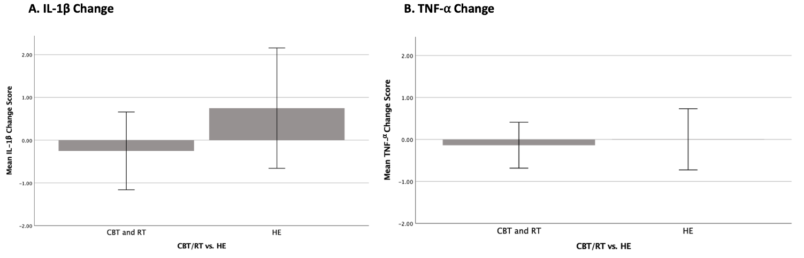
Supplementary Fig. 2. Change in IL-1β and TNF-α Pre- to 6-months Post-Intervention by Study Condition (CBT/RT vs HE) among Overweight and Obese Women with Breast Cancer Combined. Prior to calculating six-month change scores, cytokine levels were log-transformed to achieve normality. Error bars represent 95% confidence intervals. CBT, Cognitive Behavioral Therapy; RT, Relaxation Training; HE, Health Education. RMANOVA subgroup analyses indicated that there was no effect of CBT/RT versus HE on IL-1β (F (1,47) = 2.44, p = 0.125) or on TNF-α (F (1,47) = 0.21, p = 0.647) among OW/OB women.

