Supplementary Information
Unconventional T cell immunity in the lungs of young children with cystic fibrosis
Rebecca McElroy, Ghazal Alipour Talesh, Christopher M Harpur, Rosemary Carzino, Alexandra J Corbett, Daniel G Pellicci, Sarath Ranganathan and Philip Sutton on behalf of the Australian Respiratory Early Surveillance Team for Cystic Fibrosis (AREST CF)
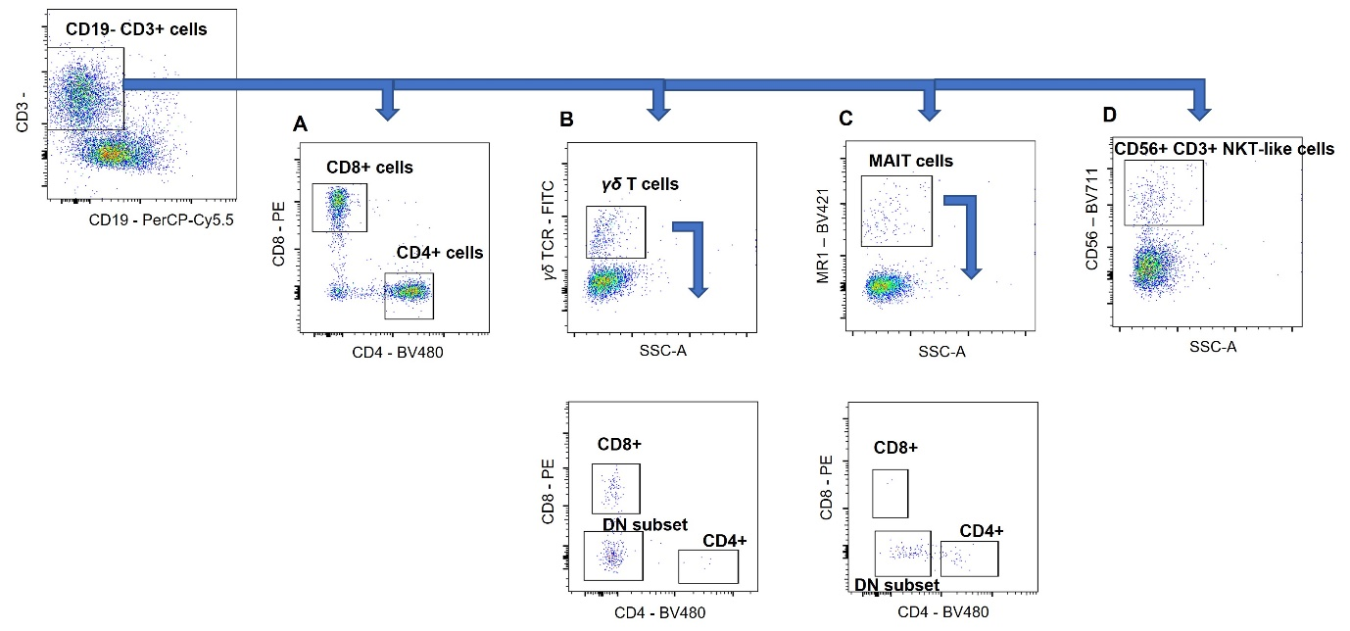
Supplementary Fig. 1. Gating strategy for flow cytometric phenotyping. Representative plots are shown as used to identify and analyse different subtypes of CD19- CD3+ T cells, gated on live CD45+ leukocytes, in BAL samples. T cells were further interrogated for (A) CD8+ and CD4+ T cells; (B) γδ T cells; (C) MAIT cells and (D) NKT-like cells. which were further analysed for the expression of CD4 vs CD8 to investigate CD4+, CD8+ and DN sub-populations. (D) Selection of CD56+ cells on gated CD3+ CD19- as NKT-like cells and further identification of CD8+ and DN subsets.

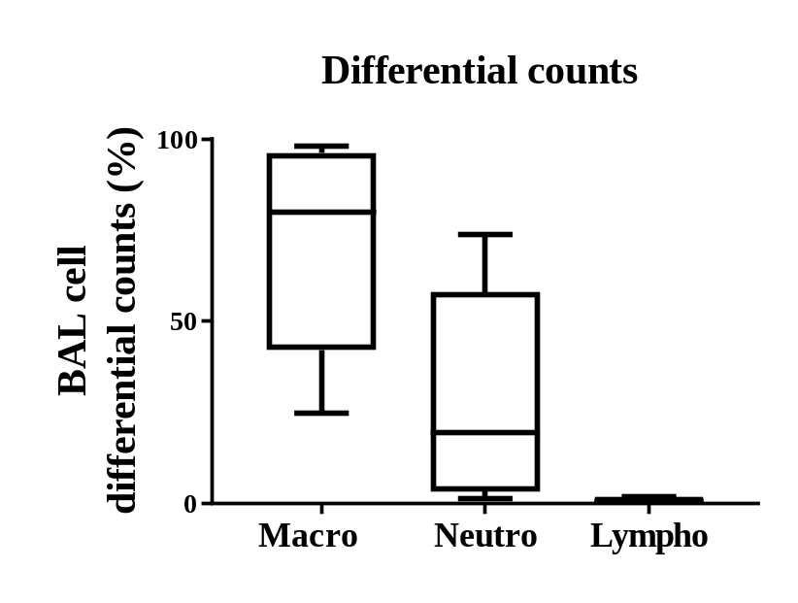
Supplementary Fig. 2. Differential counts of immune cells within BAL cells from children with CF aged 2-6 years of age (n=17). Data are single values pooled from children analyzed individually over an 18-month period. Boxplots present the middle 50% of values (box), the median (line) and range (error bars).

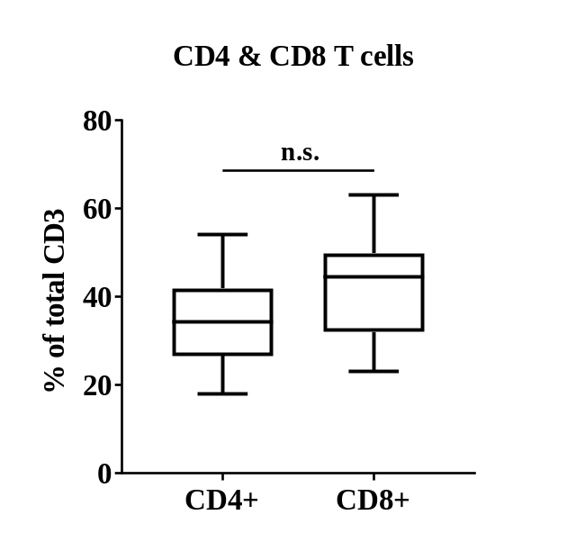
Supplementary Fig. 3. Proportion of CD4 or CD8 expressing T cells within BAL of children with CF. Proportion of T cells within BAL of children with CF (n=17) that expressed CD4 or CD8, as measured by flow cytometric immune analysis. Data are values pooled from children analyzed individually over an 18-month period, expressed as a boxplot. Boxplots present the middle 50% of values (box), the median (line) and range (error bars). n.s. not significant p>0.05 (unpaired t-test).

