Supplementary materials

Mitochondrial DNA in visceral adipose tissue in severe obesity: from copy number to D-Loop methylation

Supplemetary Table 1. TaqMan probes used for gene expression analysis are shown (A). Primers used for methylation analysis through pyrosequencing assays are displayed (B).
A
Target gene | Assay ID
β-Actin | HS01060665_g1
MTHFR | Hs01114487_m1
ND6 | Hs02596879_g1
NRF1 | Hs01073349_g1
PGC1α | Hs01016719_m1
PPARG | Hs01115513_m1
PHGDH | Hs01106329_m1
TFAM | HS01073349_g1
TBP | Hs00427620_m1

B
 | Forward (5'-3') | BIO-Reverse (5'-3') | Sequencing (5'-3') | Chromosomal location of the amplicon (hg19)
HDLR (heavy strand) | TGGAAAGTGGTTGTGTAGATATTTAA | CTTTAATTCCTACCTCATCCTATTATTT | AATTAATTAATATATTTTAGTAAG | chrM:82-320
LDLR (light strand) | TTTTTAGTGTATTGTTTTGAGGAGGTAAGT | CACTCCCATACTACTAATCTCATCA | TTTTTGGGGTTTGGT | chrM:265-513
MTHFR | TTTTAATTTTTGTTTGGAGGGTAGT | AAAAAAACCACTTATCACCAAATTC | TGAGAGTTTTAAAGATAGTT | chr1:11,862,940-11,863,194
PHGDH | GGTTGTTGTTGTTGTTTTAGTTGTGTTATA | TCCCTAACCAACTTACAAACTTCT | GTGGTTTTGGAAATTGT | chr1:120,255,943-120,256,092
PPARG | TAGTTAGGTATGGTGGTGTGTATT | CTTATTAATTCCAAAATTCCAATCTACTT | GGGAGGATTTTTTGAG | chr3:12,327,987-12,328,136
LINE-1 | TTTTGAGTTAGGTGTGGGATATA | AAAATCAAAAAATTCCCTTTC | AGTTAGGTGTGGATATAGT | (Tabish et al., 2015)

Supplementary Table 2. Correlation matrix between BMI, expression of genes regulating mitochondrial functions or the one carbon cycle and mtDNAcn (A). Association (adjusted for sex, age, diabetes and BMI) between mtDNAcn and genes associated to mitochondrial functions or the one carbon cycle (B).
A
 |  | mtDNAcn | BMI | MTHFR (dCt) | PPARG (dCt) | PHGDH (dCt) | TFAM (dCt) | PGC1α (dCt) | NRF1 (dCt) | ND6 (dCt)
mtDNAcn | Spearman’s Rho | 1
 | p | .
BMI | Spearman’s Rho | -0.293 | 1
 | p | 0.033 | .
MTHFR (dCt) | Spearman’s Rho | 0.177 | 0.267 | 1
 | p | 0.239 | 0.073 | .
PPARG (dCt) | Spearman’s Rho | -0.184 | 0.395 | 0.285 | 1
 | p | 0.211 | 0.005 | 0.055 | .
PHGDH (dCt) | Spearman’s Rho | -0.008 | 0.044 | 0.550 | 0.514 | 1
 | p | 0.959 | 0.772 | 7.4*10⁻⁵ | 2.5*10⁻⁴ | .
TFAM (dCt) | Spearman’s Rho | 0.261 | 0.176 | 0.306 | 0.043 | 0.023 | 1
 | p | 0.086 | 0.252 | 0.043 | 0.78 | 0.884 | .
PGC1α (dCt) | Spearman’s Rho | 0.186 | 0.084 | 0.541 | 0.657 | 0.722 | 0.027 | 1
 | p | 0.215 | 0.578 | 1.02*10⁻⁴ | 7.1*10⁻⁷ | 1.5*10⁻⁸ | 0.861 | .
NRF1 (dCt) | Spearman’s Rho | -0.119 | 0.513 | 0.437 | 0.558 | 0.177 | 0.222 | 0.304 | 1
 | p | 0.420 | 1.9*10⁻⁴ | 0.002 | 3.7*10⁻⁵ | 0.239 | 0.148 | 0.04 | .
ND6 (dCt) | Spearman’s Rho | -0.123 | -0.183 | -0.053 | 0.262 | 0.317 | -0.456 | 0.17 | -0.125 | 1
 | p | 0.422 | 0.247 | 0.746 | 0.093 | 0.046 | 0.004 | 0.294 | 0.429 | .
 | Bonferroni Adj p. | 0.006

B
 |  | mtDNAcn (dCt)
MTHFR (dCt) | β | 0.180
MTHFR (dCt) | P | 0.228
PPARG (dCt) | β | -0.193
PPARG (dCt) | P | 0.255
PHGDH (dCt) | β | -0.033
PHGDH (dCt) | P | 0.823
TFAM (dCt) | β | 0.354
TFAM (dCt) | P | 0.025
PGC1α (dCt) | β | 0.084
 | P | 0.571
NRF1 (dCt) | β | -0.013
 | P | 0.940
ND6 (dCt) | β | -0.161
ND6 (dCt) | P | 0.341
Bonferroni Adj p. = 0.007

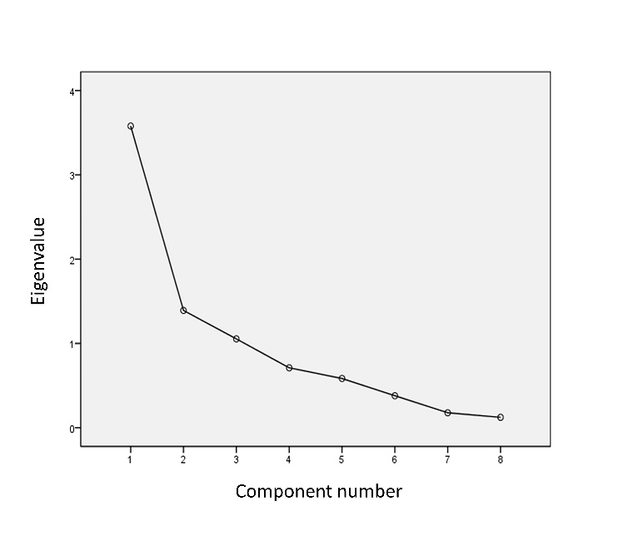
Supplementary Fig. 1. Scree plot for number of PCs selection.

Supplementary Table 3. Rotated Matrix of Components. Loadings of the 3 selected Principal Components are shown.
 | Rotated Matrix of Components
 | PC1 | PC2 | PC3
mtDNAcn | 0,023 | 0,257 | -0,879
MTHFR | 0,741 | 0,43 | 0,03
PPARG | 0,837 | -0,061 | 0,198
PHGDH | 0,911 | -0,077 | 0,075
ND6 | 0,101 | -0,86 | 0,118
TFAM | 0,489 | 0,497 | 0,02
PGC1A | 0,935 | 0,136 | 0,002
NRF1 | 0,312 | 0,46 | 0,643
Extraction method: principal component analysis
Rotation method: Varimax with Kaiser normalization.

Supplementary Table 4. Linear regression between LINE-1 methylation, methylation in PPARG, PHGDH, MTHFR and mitochondrial areas adjusting for age and sex.
 |  | LINE-1 methylation (%)
PHGDH methylation (%) | β | 0.229
PHGDH methylation (%) | P | 0.199
MTHFR methylation (%) | β | 0.427
MTHFR methylation (%) | P | 0.008
PPARG methylation (%) | β | -0.04
PPARG methylation (%) | P | 0.788
LDLR methylation (%) | β | 0.112
LDLR methylation (%) | P | 0.444
HDLR methylation (%) | β | 0.537
HDLR methylation (%) | P | 5.5*10⁻⁵
Bonferroni Adj p =0.01

Supplementary Table 5. Linear regression between LINE-1 methylation, methylation in PPARG, PHGDH, MTHFR and mitochondrial areas adjusting for age and sex.
 |  | LINE-1 methylation (%)
TFAM (dCt) | β | -0.430
TFAM (dCt) | P | 0.006
MTHFR (dCt) | β | -0.315
MTHFR (dCt) | P | 0.031
PPARG (dCt) | β | -0.053
PPARG (dCt) | P | 0.724
PHGDH (dCt) | β | -0.167
PHGDH (dCt) | P | 0.263
NRF1 (dCt) | β | 0.007
 | P | 0.964
ND6 (dCt) | β | -0.049
ND6 (dCt) | P | 0.754
Bonferroni Adj p =0.008

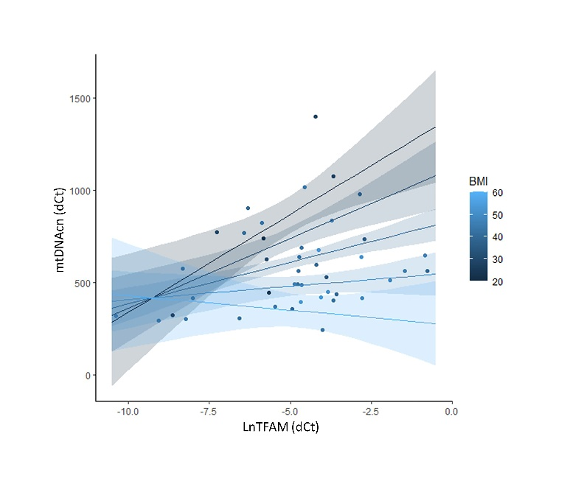
Supplementary Fig. 2. Correlation between TFAM expression and mtDNAcn stratified for BMI. TFAM expression correlates with mtDNAcn only in lean individuals (dark blue). The correlation is lost in severe obesity (light blue), showing that BMI is a confounder in this association (β =-0.474; p=0.009). BMI is considered as a continuous variable in this plot; the gradient of BMI values is shown in the legend.

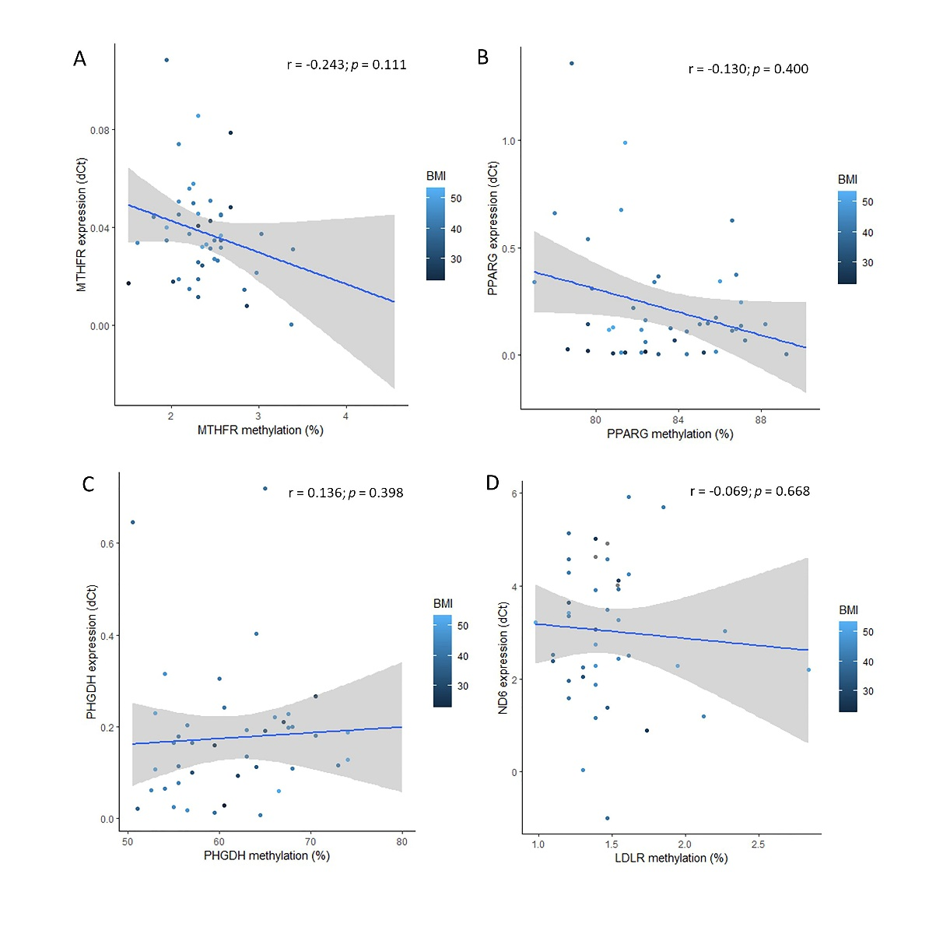
Supplementary Fig. 3. Correlation between gene expression and their promoter’s methylation. Correlation plot between methylation and gene expression levels for MTHFR (A), PPARG (B), PHGDH (C) and ND6 (D).

References
Tabish AM, Baccarelli AA, Godderis L, Barrow TM, Hoet P, Byun H-M. 2015. Assessment of Changes in Global DNA Methylation Levels by Pyrosequencing® of Repetitive Elements. Methods Mol Biol 1315:201–207. doi:10.1007/978-1-4939-2715-9_15
Vos S, Nawrot TS, Martens DS, Byun H-M, Janssen BG. 2021. Mitochondrial DNA methylation in placental tissue: a proof of concept study by means of prenatal environmental stressors. Epigenetics 16:121–131. doi:10.1080/15592294.2020.1790923

