SUPPLEMENTARY TABLE
Supplementary Table 1. The list of primers used for qPCR.
Accession No. | Gene | Primer sequence | Product length (bp)
NM_001206359 | GAPDH | Forward: 5′-GCTTGTCATCAATGGAAAGG-3′  Reverse: 5′-CATACGTAGCACCAGCATCA-3′ | 86
NM_213867 | IL-8 | Forward: 5′-CCGTGTCAACATGACTTCCAA-3′  Reverse: 5′-GCCTCACAGAGAGCTGCAGAA-3′ | 75
NM_214399 | IL-6 | Forward: 5′-AATGTCGAGGCTGTGCAGATT-3′  Reverse: 5′-TGGTGGCTTTGTCTGGATTCT-3′ | 82
NM_214022 | TNF-α | Forward: 5′-TGGCCCCTTGAGCATCA-3′  Reverse: 5′-CGGGCTTATCTGAGGTTTGAGA-3′ | 68
NM_214055.1 | IL-1β | Forward:5′-GTGGACTGCAAACTCCAGGACAAA-3′  Reverse: 5′-GCTCATGCAGAACACCACTTCTCT-3′ | 120

Supplementary Table 2. The list of antibodies used in western blotting.
Antibody | Dilution | Company | Cat#
Rabbit polyclonal anti-Phospho-FAK (Tyr 397) | 1:1000 | CST* | 3283
Rabbit polyclonal anti-FAK | 1:1000 | CST | 3285
Rabbit polyclonal anti-Phospho-p44/42 MAPK (P-ERK1/2) (Thr202/Tyr204) | 1:1000 | CST | 9101
Rabbit polyclonal anti-p44/42 MAPK (ERK1/2) | 1:1000 | CST | 9102
Mouse monoclonal anti- NF-κB P65 | 1:1000 | CST | 6956
Rabbit polyclonal anti-Phospho- NF-κB P65 (Ser536) | 1:1000 | CST | 3033
Rabbit monoclonal anti-GAPDH | 1:1000 | CST | 2118
HRP-linked anti-rabbit IgG | 1:2000 | CST | 7074
HRP-linked anti-mouse IgG | 1:2000 | CST | 7076
Rabbit polyclonal anti-α-Tubulin | 1:2000 | CST | 2125
Note: *CST, Cell Signaling Technology (MA, USA).

Supplementary Table 3. The concentrations of polyamines in culture medium and cells treated with DEGBG (or/and) spermidine.
Item | Ctrl | DEGBG | Spd | DEGBG+Spd | SEM | P-value
Medium polyamines, nmol/mL
Putrescine | 10.13 | 11.02 | 11.17 | 9.72 | 2.03 | 0.949
Spermidine | 106.67 | 107.50 | 111.50 | 119.83 | 5.58 | 0.394
Spermine | 37.17 | 45.85 | 48.33 | 44.50 | 6.09ª | 0.645
Cell lysates polyamines, nmol/mL
Putrescine | 6.98^{c} | 41.17ª | 5.12^{c} | 24.50^{b} | 2.75 | < 0.01
Spermidine | 54.80ª | 31.00^{b} | 55.17ª | 54.00ª | 5.67 | 0.033
Spermine | 11.80ª | 15.60ª | 13.33ª | 17.00ª | 1.92 | 0.450
Note: n = 4. Ctrl control, DEGBG 1 mmol/L diethylglyoxal bis (guanylhydrazone), Spd 8 μmol/L spermidine; ^{a,b,c} Within a row, means a significant difference (P ≤ 0.05).

SUPPLEMENTARY FIGURE
Supplementary Fig. 1. Inhibition of DEGBG at different concentrations on cell growth. IPEC-J2 cells were incubated with different concentration of DEGBG (0.25 mmol/L, 0.5 mmol/L, 1 mmol/L, 2 mmol/L) for 24 h. Then the cell numbers were determined by the CCK-8 kit. The data are expressed as the mean ± SE, n=6. Different letters indicate a significant difference (P ≤ 0.05).

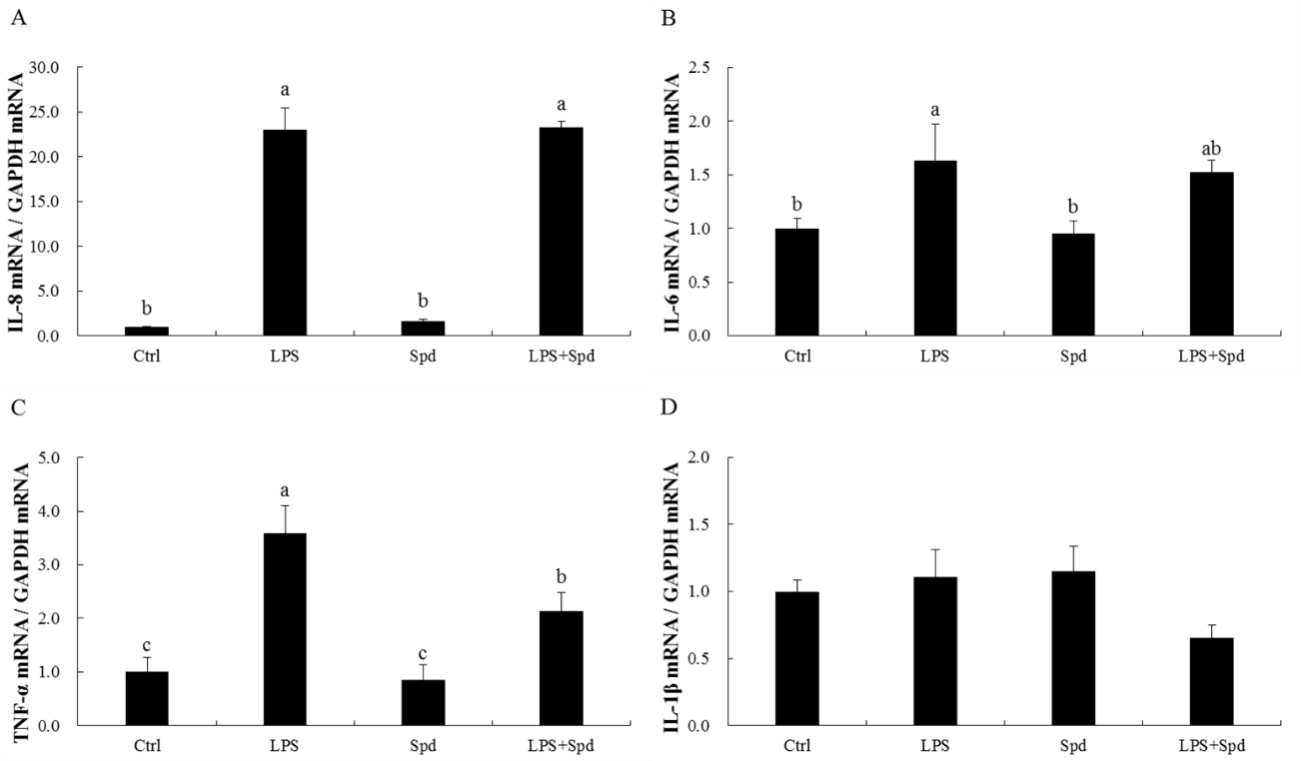
Supplementary Fig. 2. Effect of spermidine on expression of inflammatory genes in LPS-stimulated IPEC-J2 cells. IPEC-J2 cells were incubated with spermidine (8 μmol/L) for 24 h, then the cells were challenged with LPS (100 μg/mL) in the presence or absence of spermidine, and the expression level of IL-8 (A), IL-6 (B), TNF-α (C) and IL-1β (D) were quantified by qPCR. The data are presented as the mean ± SE, n=6. Different letters represent a significant difference (P ≤ 0.05).

