Supplementary Information

Biological Evaluation of Maytansinoid-Based Site-Specific Antibody-Drug Conjugate Produced by Fully Chemical Conjugation Approach: AJICAP®

Takuya Seki¹, Kei Yamada¹, Yuri Ooba¹, Tomohiro Fujii¹, Takahiro Narita¹, Akira Nakayama¹, Yoshiro Kitahara¹, Brian A. Mendelsohn^{2,§}, Yutaka Matsuda^{1,2,}*, Tatsuya Okuzumi^{1,}*

¹Ajinomoto Co., Inc., 1-1, Suzuki-Cho, Kawasaki-Ku, Kawasaki-Shi, 210-8681 Kanagawa, Japan
²Ajinomoto Bio-Pharma Services, 11040 Roselle Street, San Diego, CA 92121, USA

*Correspondence:
Yutaka.Matsuda@US.AjiBio-Pharma.com (Yutaka Matsuda);
tatsuya.okuzumi.e2m@asv.ajinomoto.com. (Tatsuya Okuzumi)
§Present addresses: Exelixis Inc., 1851 Harbor Bay Pkwy, Alameda, CA 94502, USA

1. Analytical results
1-1 Q-TOF MS analysis
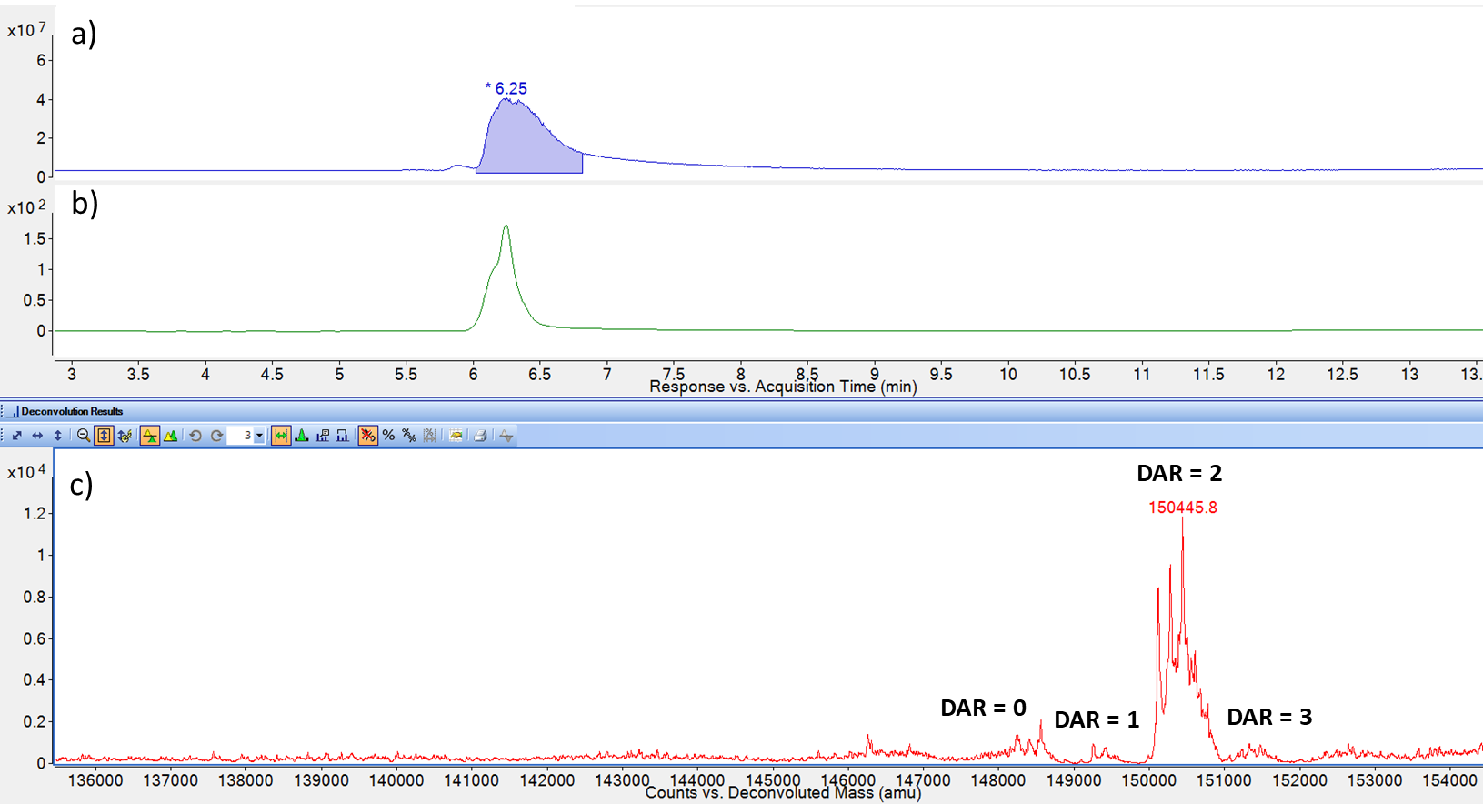
Supplementary Fig.1. Q-TOF analytical results of trastuzumab-AJICAP-maytansinoid. (a) TIC results, (b) UV results (280 nm), Deconvoluted spectra.

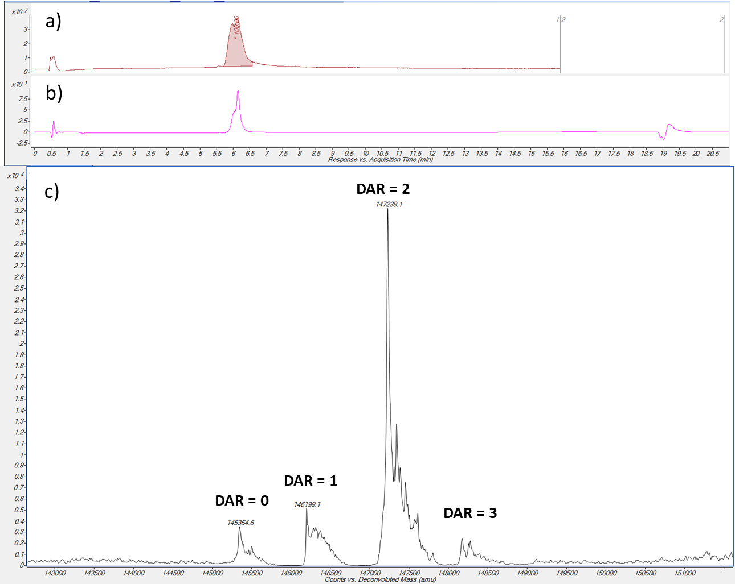
Supplementary Fig.2. Q-TOF analytical results of deglycosilated trastuzumab-AJICAP-maytansinoid. (a) TIC results, (b) UV results (280 nm), Deconvoluted spectra.

1-2 HPLC analysis
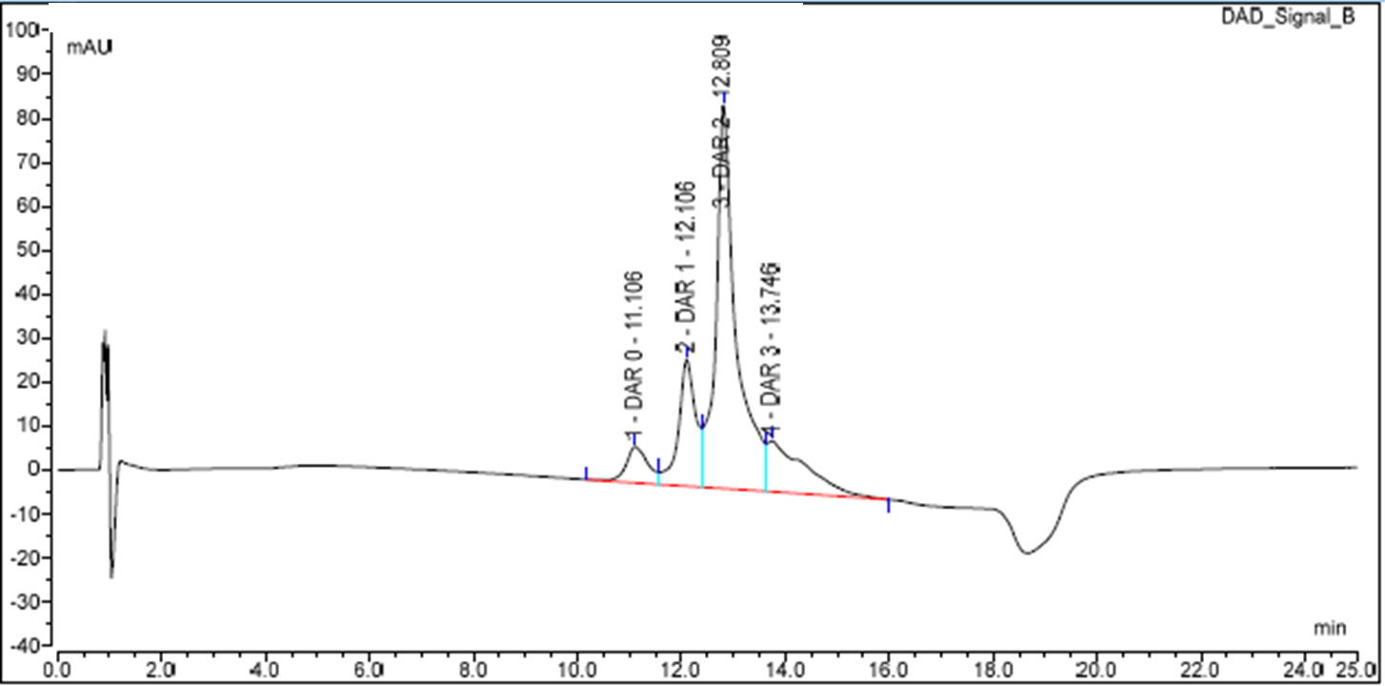
Supplementary Fig.3. HIC HPLC results of trastuzumab-AJICAP-maytansinoid.
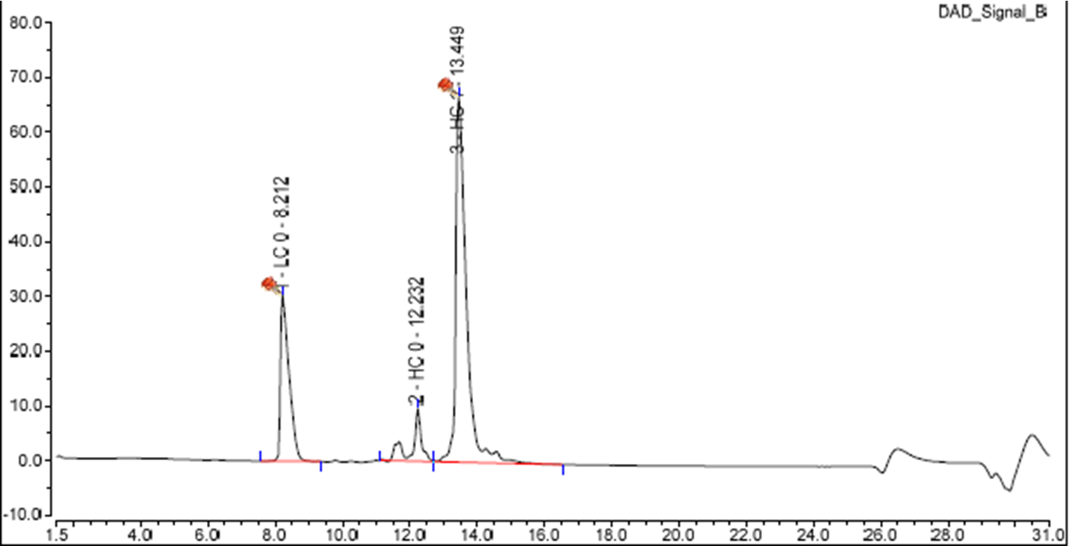
Supplementary Fig.4. RP-HPLC results of trastuzumab-AJICAP-maytansinoid.
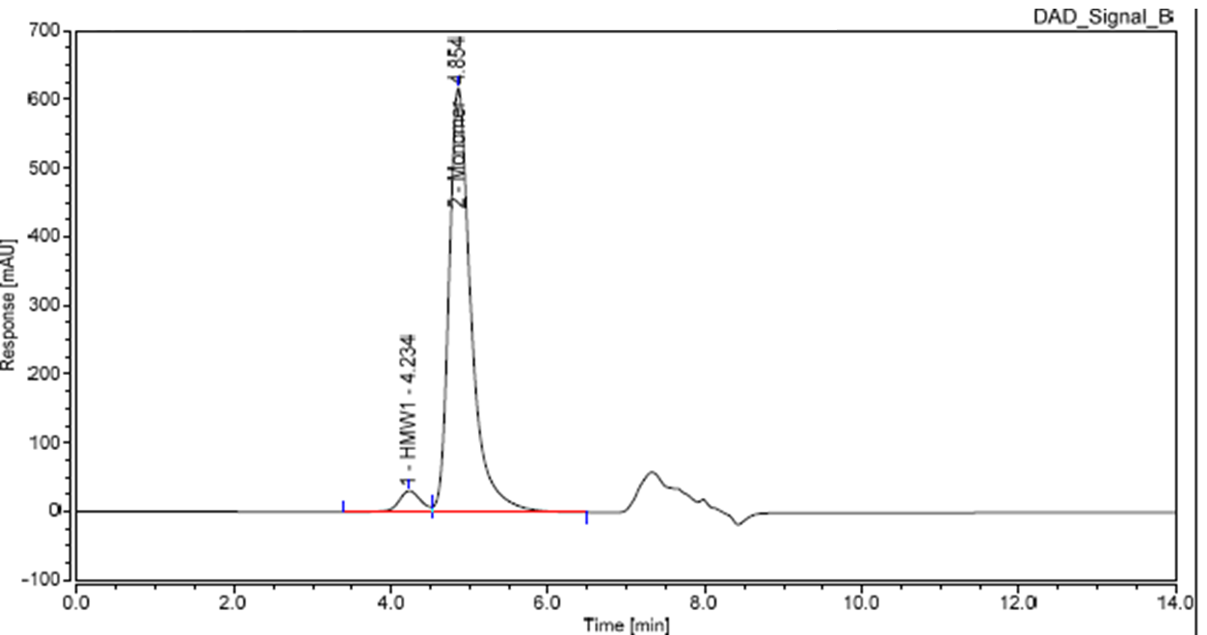
Supplementary Fig.5. SEC-HPLC results of trastuzumab-AJICAP-maytansinoid.

2. Rat acute toxicity study results
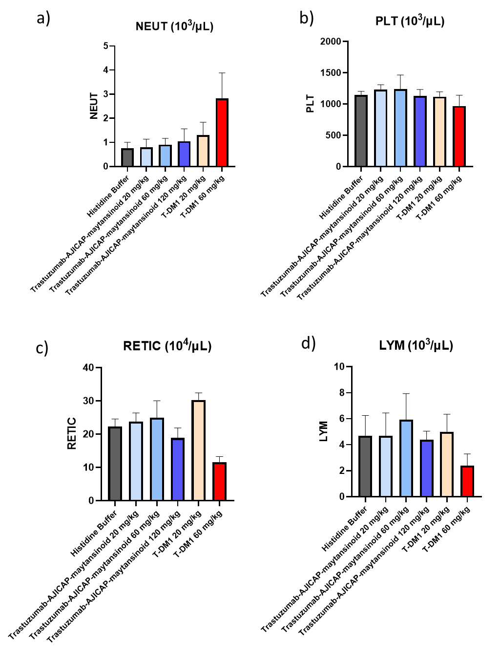
Supplementary Fig.6. Rat acute toxicity study to determine the MTD of ADCs. (a) Neutrophil (NEUT) in rat serum at 2 days after administration. (N = 5 female SD rats). (b) Platelet count (PLT) in rat serum at 2 days after administration. (N = 5 female SD rats). (c) Reticulocytes (RETIC) in rat serum at 2 days after administration. (N = 5 female SD rats). (d) Lymphocytes (LYM) in rat serum at 2 days after administration. (N = 5 female SD rats).

