Supplementary Fig. 1. Expression of stem cell specific genes in hiPSCs. A. Immunocytochemistry for NANOG (red), OCT4, SSEA4 and TRA-1-60 (green). Nuclei were stained with DAPI (blue). Bar=100um.

Supplementary Fig. 2. Expression of neural stem cell specific genes in hiPSCs derived iNSC. A. Immunocytochemistry for NESTIN and SOX2 (green). Nuclei were stained with DAPI (blue). Bar=100um.
Supplementary Fig. 3. Expression of specific genes in hiPSCs derived hepatocytes-like cells. A. Immunocytochemistry for AFP and ALB (green). Nuclei were stained with DAPI (blue). Bar=100um.

Supplementary Fig. 4. Expression of specific genes in hiPSCs derived cardiomyocytes. A. Immunocytochemistry for cTnT (green). Nuclei were stained with DAPI (blue). Bar=20um.

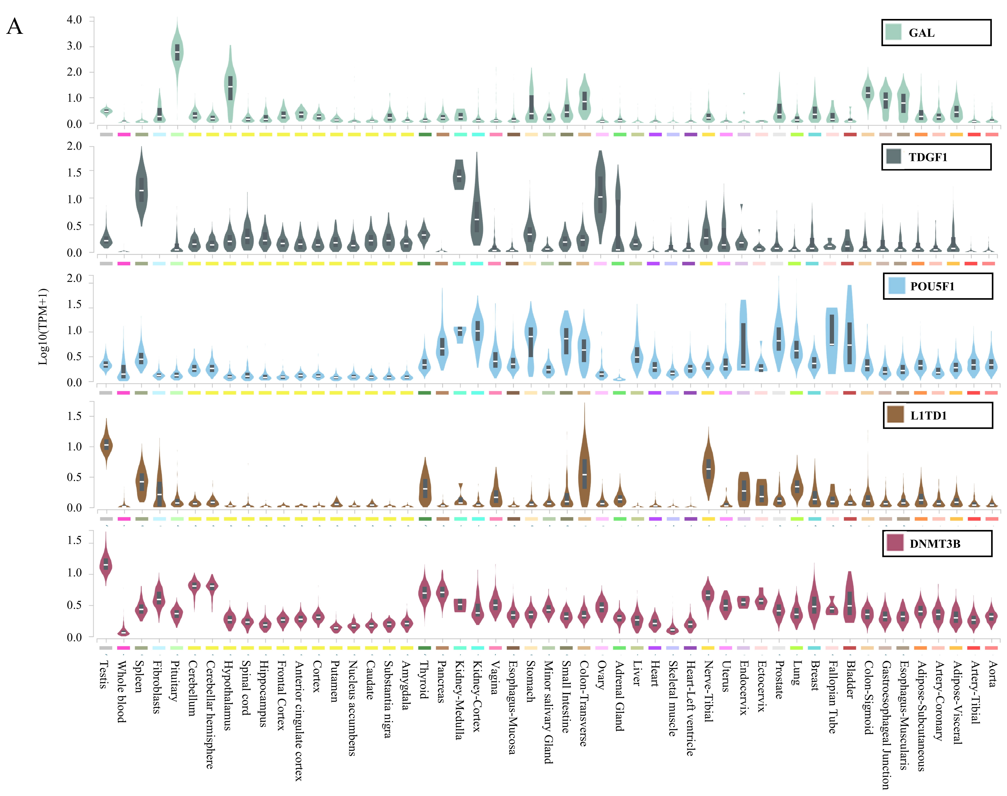
Supplementary Fig. 5. Gene expression levels in various tissues. A. Gene expression level in various tissues. Data were from the Multi-Gene Query through The Genotype-Tissue Expression (GTEx) project database.

