Supplementary Table 1. Dinucleotide property values used correlated factor features
 | AA | AC | AG | AU | CA | CC | CG | CU | GA | GC | GG | GU | UA | UC | UG | UU
rise | 3.18 | 3.24 | 3.3 | 3.24 | 3.09 | 3.32 | 3.3 | 3.3 | 3.38 | 3.22 | 3.32 | 3.24 | 3.26 | 3.38 | 3.09 | 3.18
roll | 7 | 4.8 | 8.5 | 7.1 | 9.9 | 8.7 | 12.1 | 8.5 | 9.4 | 6.1 | 12.1 | 4.8 | 10.7 | 9.4 | 9.9 | 7
shift | -0.08 | 0.23 | -0.04 | -0.06 | 0.11 | -0.01 | 0.3 | -0.04 | 0.07 | 0.07 | -0.01 | 0.23 | -0.02 | 0.07 | 0.11 | -0.08
slide | -1.27 | -1.43 | -1.5 | -1.36 | -1.46 | -1.78 | -1.89 | -1.5 | -1.7 | -1.39 | -1.78 | -1.43 | -1.45 | -1.7 | -1.46 | -1.27
tilt | -0.8 | 0.8 | 0.5 | 1.1 | 1 | 0.3 | -0.1 | 0.5 | 1.3 | 0 | 0.3 | 0.8 | -0.2 | 1.3 | 1 | -0.8
twist | 31 | 32 | 30 | 33 | 31 | 32 | 27 | 30 | 32 | 35 | 32 | 32 | 32 | 32 | 31 | 31
enthalpy | -6.6 | -10.2 | -7.6 | -5.7 | -10.5 | -12.2 | -8 | -7.6 | -13.3 | -14.2 | -12.2 | -10.2 | -8.1 | -10.2 | -7.6 | -6.6
entropy | -18.4 | -26.2 | -19.2 | -15.5 | -27.8 | -29.7 | -19.4 | -19.2 | -35.5 | -34.9 | -29.7 | -26.2 | -22.6 | -26.2 | -19.2 | -18.4
free_energy | -0.9 | -2.1 | -1.7 | -0.9 | -1.8 | -2.9 | -2 | -1.7 | -2.3 | -3.4 | -2.9 | -2.1 | -1.1 | -2.1 | -1.7 | -0.9

Supplementary Table 2. Genomic features used in the m1ARegpred
ID | Name | Description | Note
1 | UTR5 | 5' UTR | Dummy variables indicating whether the site is overlapped to the topological region on the major RNA transcript.
2 | UTR3 | 3' UTR
3 | cds | CDS
4 | Stop_codons | stop codons flanked by 100bp
5 | Start_codons | start codons flanked by 100bp
6 | TSS | downstream 100bp of TSS
7 | TSS_A | downstream 100bp of TSS on A
8 | exon_stop | exons containing stop codons
9 | alternative_exon | alternative exons
10 | constitutive_exon | constitutive exons
11 | internal_exon | Internal exons
12 | long_exon | long exons (exon length >= 400bp)
13 | last_exon | last exons
14 | last_exon_400bp | 5’ 400bp of the last exons
15 | last_exon_sc400 | 5’ 400bp of the last exons containing stop codons
16 | intron | introns
17 | pos_UTR5 | relative position on 5'UTR | Relative position on the region
18 | pos_UTR3 | relative position on 3'UTR | Relative position on the region
19 | pos_cds | relative position on CDS | Relative position on the region
20 | pos_exons | relative position on exon | Relative position on the region
21 | dist_sj_5_p2000 | distance to the upstream (5' end) splicing junction | The region length in bp.
22 | dist_sj_3_p2000 | distance to the downstream (3' end) splicing junction | The region length in bp.
23 | length_UTR5 | 5'UTR length | The region length in bp.
24 | length_UTR3 | 3'UTR length | The region length in bp.
25 | length_cds | CDS length | The region length in bp.
26 | length_gene_ex | standardized gene length of exonic regions | The region length in bp.
27 | length_gene_full | standardized gene length of all regions | The region length in bp.
28 | length_tx_exon | transcript exonic length | The region length in bp.
29 | length_tx_full | transcript full length | The region length in bp.
30 | "AAACA" | AAACA motif | Dummy variables indicating whether the site shows certain motif
31 | "GAACA" | GAACA motif
32 | "AGACA" | AGACA motif
33 | "GGACA" | GGACA motif
34 | "AAACT" | AAACT motif
35 | "GAACT" | GAACT motif
36 | "AGACT" | AGACT motif
37 | "GGACT" | GGACT motif
38 | "AAACC" | AAACC motif
39 | "GAACC" | GAACC motif
40 | "AGACC" | AGACC motif
41 | "GGACC" | GGACC motif
42 | PC_1bp | phastCons scores of the nucleotide | Scores related to evolutionary conservation
43 | PC_101bp | average phastCons scores within the flanking 50bp region | Scores related to evolutionary conservation
44 | FC_1bp | fitCons scores of the nucleotide | Scores related to evolutionary conservation
45 | FC_101bp | average fitCons scores within the flanking 50bp region | Scores related to evolutionary conservation
46 | struct_hybridize | Predicted RNA hybridized region | RNA secondary structure
47 | struct_loop | Predicted RNA loop region | RNA secondary structure
48 | miR_targeted_genes | miRNA targeted genes | Gene characteristic
49 | sncRNA | sncRNA | Gene characteristic
50 | lncRNA | lncRNA | Gene characteristic
51 | isoform_num | isoform number | Gene characteristic
52 | exon_num | exon number | Gene characteristic
53 | HK_genes | housekeeping genes | Gene characteristic
54 | GC_cont_genes | gene level GC content z score | Gene characteristic
55 | GC_cont_101bp | 101bp GC content z score | Gene characteristic
56 | GC_cont_101bp_abs | 101bp GC content z score | Gene characteristic

Supplementary Fig. 1. Feature selection and F score.s
DF1 full transcrpt model
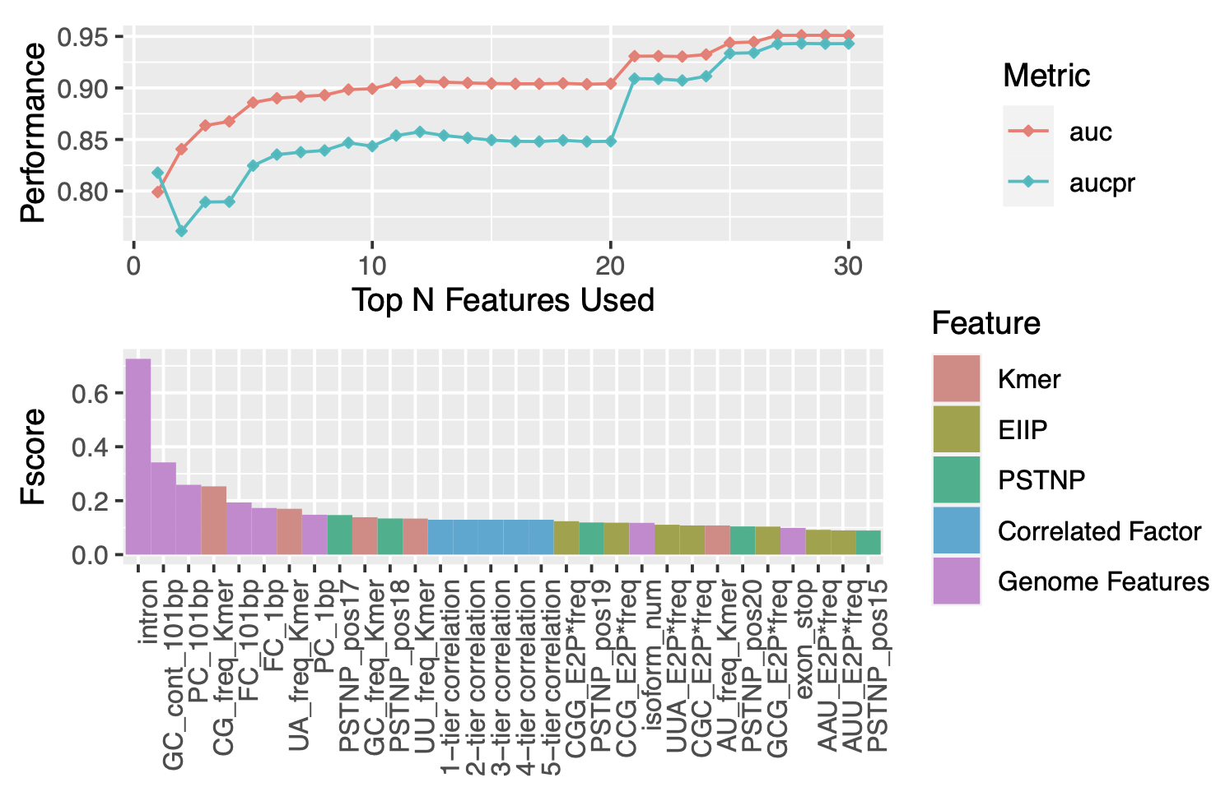
DF1 Mature mRNA model
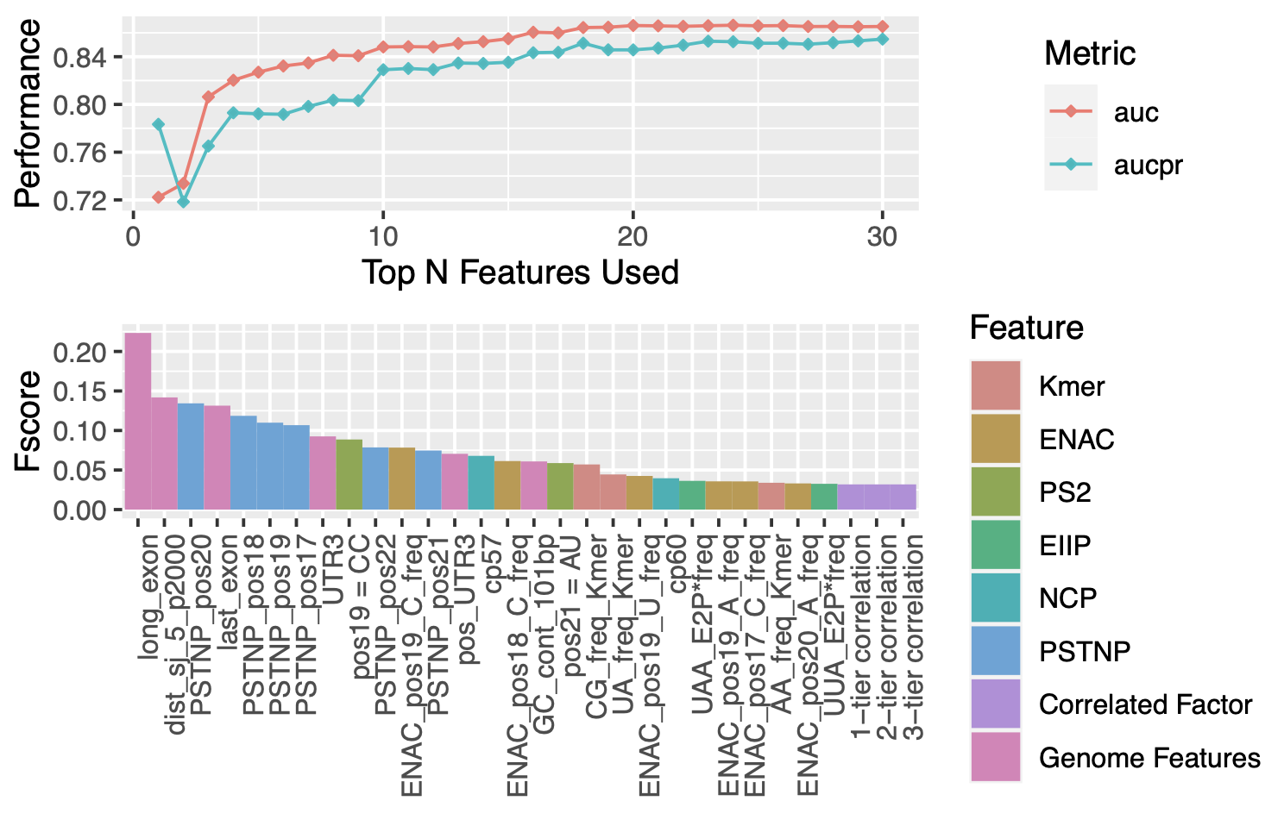
DF2 full transcrpt model
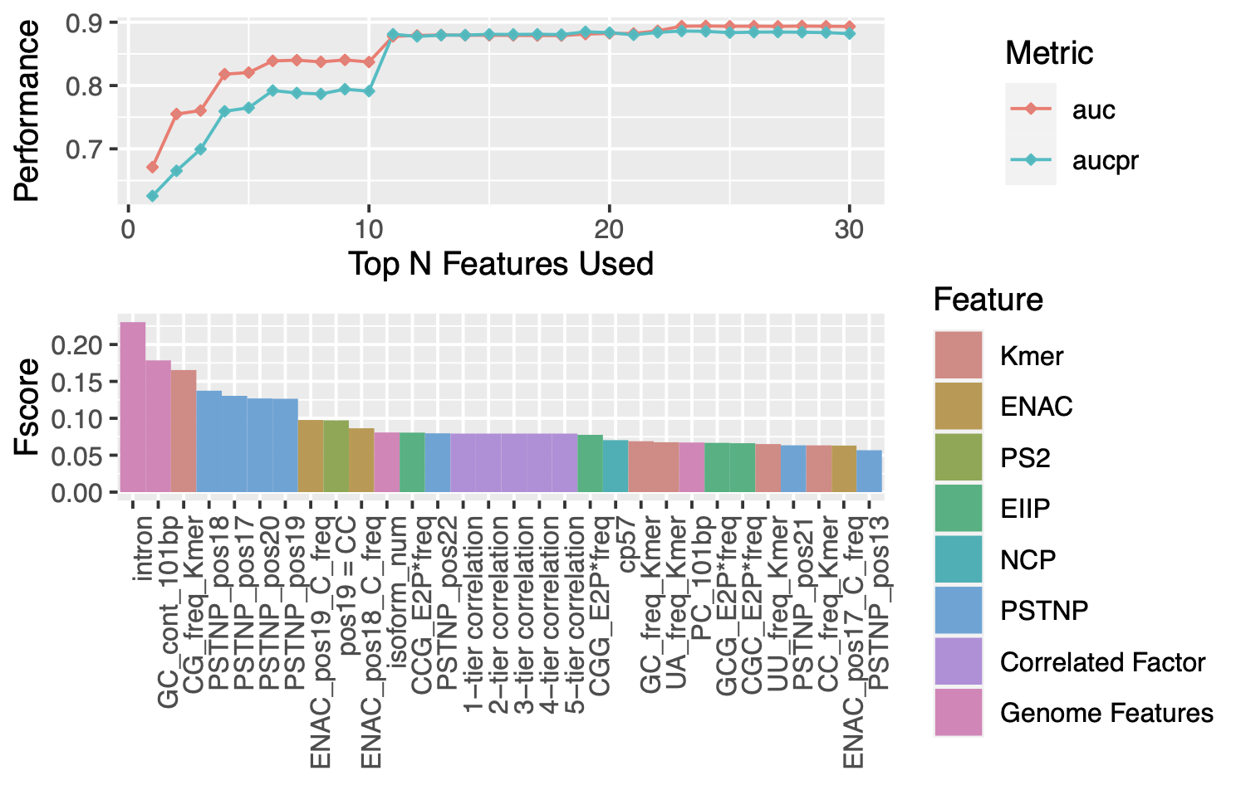
DF2 Mature mRNA model
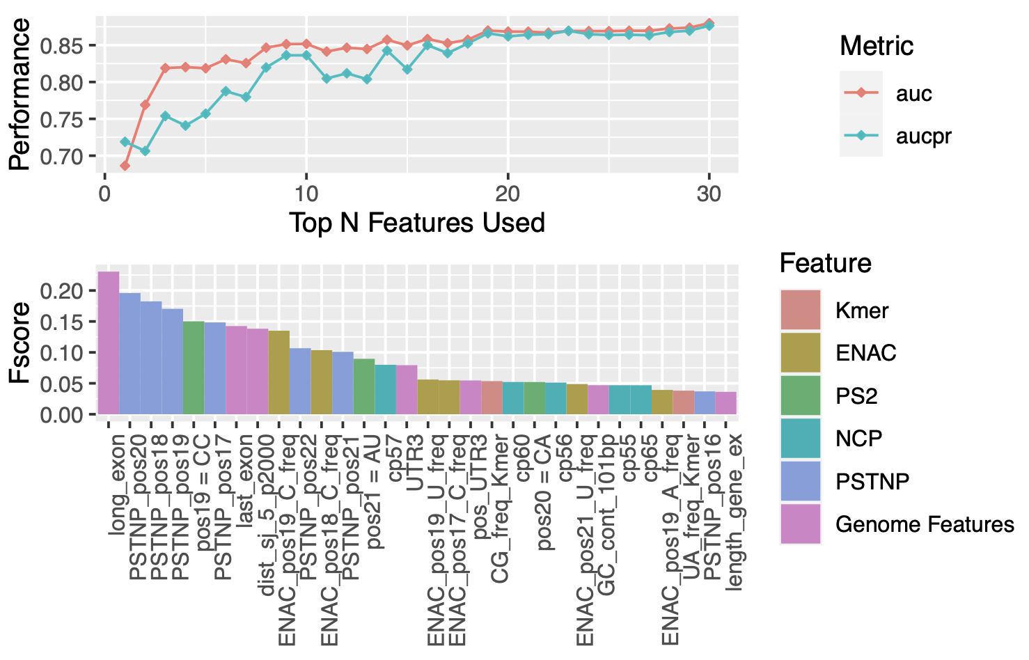
DF3 full transcrpt model
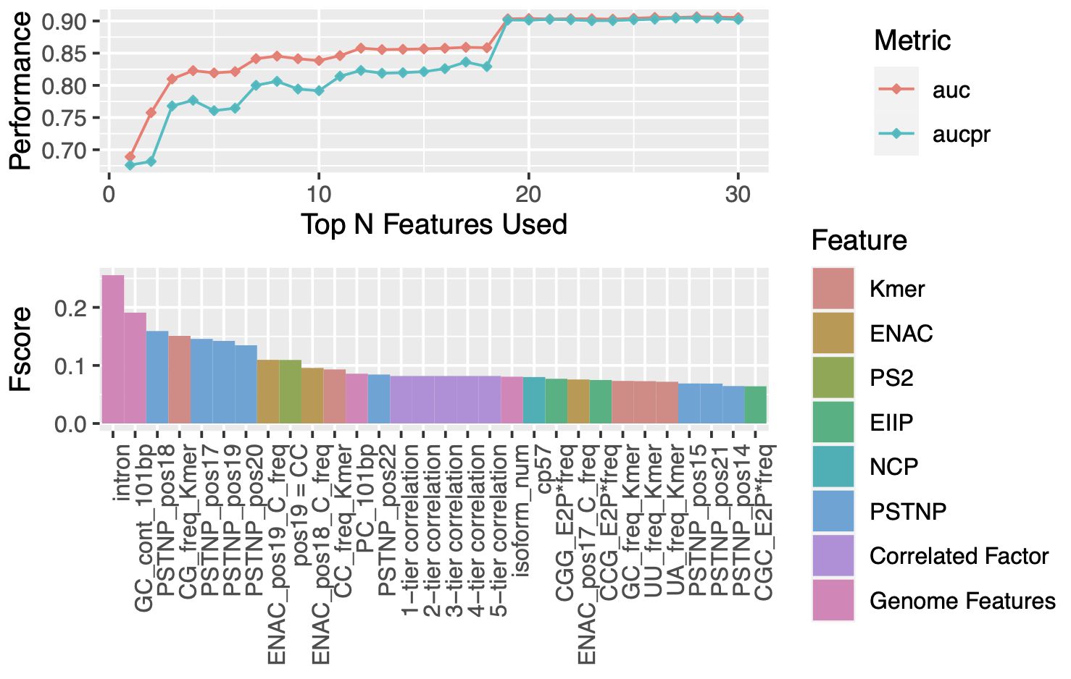
DF3 Mature mRNA model
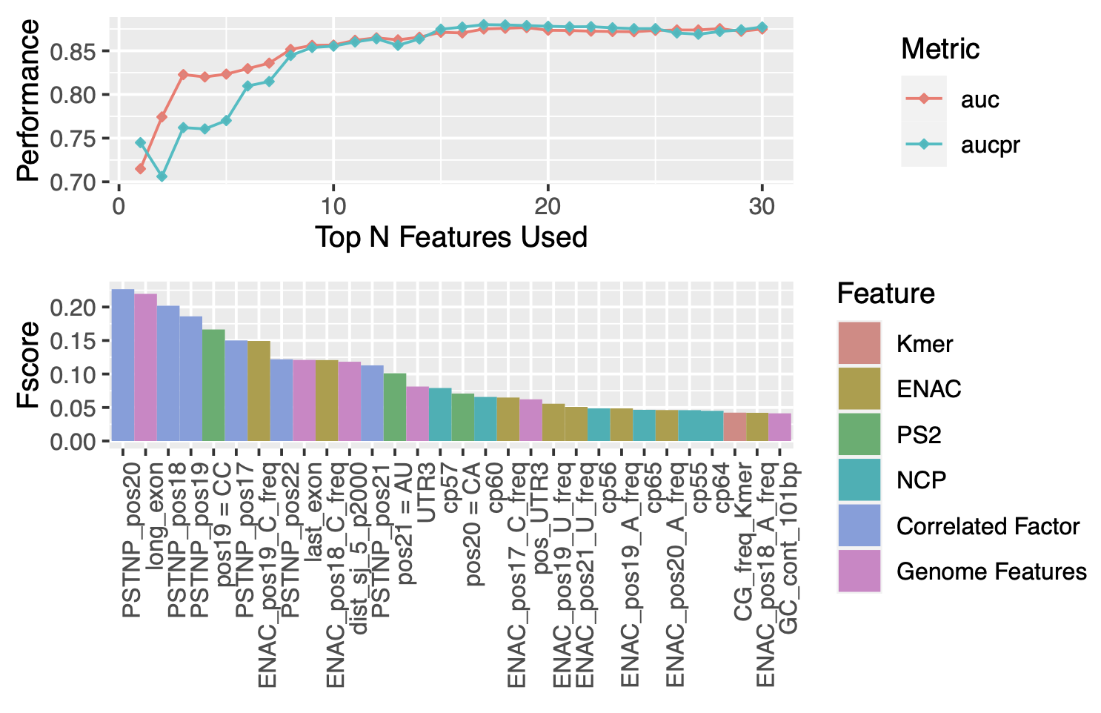
DC1 full transcrpt model
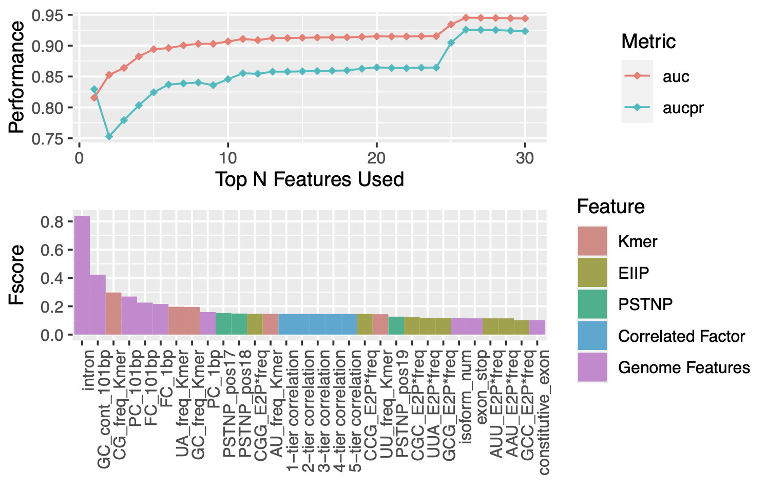
DC1 Mature mRNA model
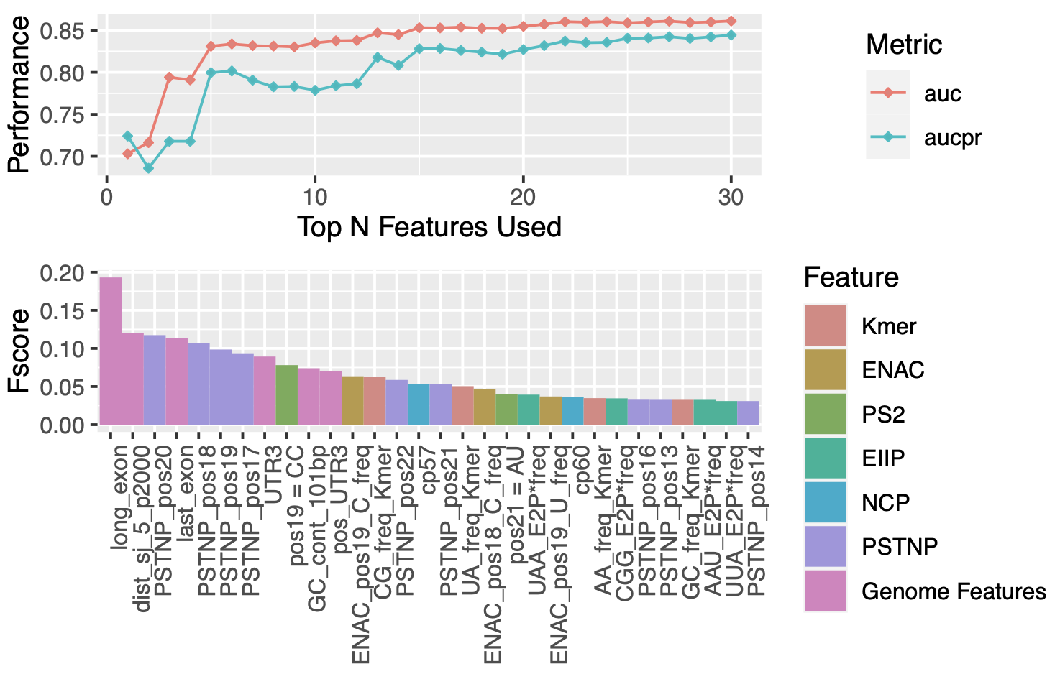

Supplementary Table 3. Performance on the independent testing test (All metrics)
DF1 Full model
 | AUC | PRC | Accuracy | Sensitivity | Specificity
m1ARegpred | 0.934 | 0.913 | 0.866 | 0.923 | 0.811
Kmer | 0.819 | 0.783 | 0.749 | 0.746 | 0.752
E2P | 0.843 | 0.817 | 0.767 | 0.760 | 0.775
ANP | 0.670 | 0.668 | 0.622 | 0.532 | 0.708
PSTNP | 0.829 | 0.813 | 0.755 | 0.726 | 0.782

DF1 Mature model
 | AUC | PRC | Accuracy | Sensitivity | Specificity
m1ARegpred | 0.863 | 0.843 | 0.802 | 0.803 | 0.801
Kmer | 0.699 | 0.654 | 0.652 | 0.628 | 0.674
E2P | 0.728 | 0.685 | 0.664 | 0.642 | 0.685
ANP | 0.604 | 0.599 | 0.584 | 0.499 | 0.664
PSTNP | 0.769 | 0.769 | 0.701 | 0.596 | 0.800
one hot | 0.756 | 0.754 | 0.691 | 0.632 | 0.747

DF2 Full model
 | AUC | PRC | Accuracy | Sensitivity | Specificity
m1ARegpred | 0.891 | 0.887 | 0.819 | 0.806 | 0.831
Kmer | 0.757 | 0.713 | 0.694 | 0.636 | 0.745
E2P | 0.830 | 0.813 | 0.736 | 0.655 | 0.819
ANP | 0.661 | 0.662 | 0.615 | 0.456 | 0.777
PSTNP | 0.800 | 0.801 | 0.701 | 0.534 | 0.871

DF2 Mature model
 | AUC | PRC | Accuracy | Sensitivity | Specificity
m1ARegpred | 0.860 | 0.847 | 0.810 | 0.790 | 0.827
Kmer | 0.679 | 0.629 | 0.635 | 0.566 | 0.695
E2P | 0.709 | 0.664 | 0.649 | 0.596 | 0.695
ANP | 0.624 | 0.586 | 0.601 | 0.434 | 0.747
PSTNP | 0.786 | 0.798 | 0.728 | 0.569 | 0.867

DF3 Full model
 | AUC | PRC | Accuracy | Sensitivity | Specificity
m1ARegpred | 0.900 | 0.905 | 0.820 | 0.825 | 0.815
Kmer | 0.771 | 0.742 | 0.705 | 0.705 | 0.705
E2P | 0.802 | 0.775 | 0.732 | 0.741 | 0.724
ANP | 0.649 | 0.646 | 0.610 | 0.586 | 0.634
PSTNP | 0.808 | 0.803 | 0.730 | 0.715 | 0.745
one hot | 0.789 | 0.785 | 0.704 | 0.712 | 0.696

DF3 Mature model
 | AUC | PRC | Accuracy | Sensitivity | Specificity
m1ARegpred | 0.862 | 0.865 | 0.796 | 0.826 | 0.766
Kmer | 0.697 | 0.679 | 0.650 | 0.680 | 0.620
E2P | 0.719 | 0.692 | 0.660 | 0.702 | 0.616
ANP | 0.640 | 0.633 | 0.604 | 0.611 | 0.597
PSTNP | 0.802 | 0.818 | 0.733 | 0.646 | 0.820

DC1 Full model
 | AUC | PRC | Accuracy | Sensitivity | Specificity
m1ARegpred | 0.952 | 0.935 | 0.884 | 0.906 | 0.864
Kmer | 0.834 | 0.803 | 0.762 | 0.718 | 0.800
E2P | 0.859 | 0.832 | 0.778 | 0.746 | 0.806
ANP | 0.678 | 0.654 | 0.641 | 0.493 | 0.769
PSTNP | 0.842 | 0.826 | 0.774 | 0.714 | 0.827

DC1 Mature model
 | AUC | PRC | Accuracy | Sensitivity | Specificity
m1ARegpred | 0.843 | 0.813 | 0.782 | 0.783 | 0.781
Kmer | 0.707 | 0.662 | 0.658 | 0.568 | 0.736
E2P | 0.727 | 0.674 | 0.666 | 0.598 | 0.724
ANP | 0.623 | 0.583 | 0.596 | 0.409 | 0.758
PSTNP | 0.769 | 0.756 | 0.715 | 0.585 | 0.828

Supplementary Table 4. Performance on the unbalanced testing test
DF1 Full model
 | AUC | AUPRC | Accuracy | Sensitivity | Specificity
m1ARegpred | 0.931 | 0.554 | 0.822 | 0.9375 | 0.811
Kmer | 0.812 | 0.281 | 0.749 | 0.726 | 0.752
E2P | 0.833 | 0.332 | 0.772 | 0.738 | 0.775
ANP | 0.644 | 0.178 | 0.693 | 0.507 | 0.711
PSTNP | 0.809 | 0.325 | 0.774 | 0.679 | 0.782

DF1 Mature model
 | AUC | AUPRC | Accuracy | Sensitivity | Specificity
m1ARegpred | 0.879 | 0.510 | 0.804 | 0.828 | 0.801
Kmer | 0.737 | 0.260 | 0.676 | 0.691 | 0.674
E2P | 0.751 | 0.283 | 0.684 | 0.679 | 0.685
ANP | 0.611 | 0.199 | 0.649 | 0.539 | 0.664
PSTNP | 0.768 | 0.404 | 0.776 | 0.605 | 0.800

DF2 Full model
 | AUC | AUPRC | Accuracy | Sensitivity | Specificity
m1ARegpred | 0.899 | 0.683 | 0.830 | 0.824 | 0.831
Kmer | 0.766 | 0.340 | 0.731 | 0.648 | 0.745
E2P | 0.783 | 0.363 | 0.742 | 0.691 | 0.750
ANP | 0.626 | 0.250 | 0.706 | 0.449 | 0.746
PSTNP | 0.787 | 0.430 | 0.785 | 0.628 | 0.810

DF2 Mature model
 | AUC | AUPRC | Accuracy | Sensitivity | Specificity
m1ARegpred | 0.860 | 0.632 | 0.816 | 0.765 | 0.827
Kmer | 0.685 | 0.326 | 0.681 | 0.589 | 0.702
E2P | 0.725 | 0.376 | 0.678 | 0.605 | 0.695
ANP | 0.633 | 0.273 | 0.692 | 0.445 | 0.747
PSTNP | 0.781 | 0.569 | 0.816 | 0.585 | 0.867

DF3 Full model
 | AUC | AUPRC | Accuracy | Sensitivity | Specificity
m1ARegpred | 0.893 | 0.691 | 0.815 | 0.816 | 0.815
Kmer | 0.787 | 0.374 | 0.710 | 0.738 | 0.705
E2P | 0.816 | 0.415 | 0.731 | 0.769 | 0.724
ANP | 0.628 | 0.266 | 0.622 | 0.5625 | 0.634
PSTNP | 0.818 | 0.478 | 0.742 | 0.726 | 0.745

DF3 Mature model
 | AUC | AUPRC | Accuracy | Sensitivity | Specificity
m1ARegpred | 0.861 | 0.690 | 0.775 | 0.808 | 0.766
Kmer | 0.711 | 0.383 | 0.639 | 0.710 | 0.620
E2P | 0.742 | 0.404 | 0.639 | 0.722 | 0.616
ANP | 0.629 | 0.319 | 0.595 | 0.589 | 0.597
PSTNP | 0.807 | 0.621 | 0.781 | 0.636 | 0.820

DC1 Full model
 | AUC | AUPRC | Accuracy | Sensitivity | Specificity
m1ARegpred | 0.949 | 0.610 | 0.868 | 0.917 | 0.864
Kmer | 0.843 | 0.315 | 0.793 | 0.695 | 0.800
E2P | 0.867 | 0.371 | 0.804 | 0.769 | 0.806
ANP | 0.664 | 0.148 | 0.748 | 0.484 | 0.769
PSTNP | 0.839 | 0.333 | 0.817 | 0.699 | 0.827

DC1 Mature model
 | AUC | AUPRC | Accuracy | Sensitivity | Specificity
m1ARegpred | 0.832 | 0.409 | 0.778 | 0.746 | 0.781
Kmer | 0.720 | 0.230 | 0.720 | 0.589 | 0.736
E2P | 0.733 | 0.237 | 0.713 | 0.617 | 0.724
ANP | 0.630 | 0.189 | 0.722 | 0.414 | 0.758
PSTNP | 0.774 | 0.357 | 0.800 | 0.570 | 0.828

Supplementary Table 5. Performance in independent sample testingset (AUROC)
YTHDF1 (Dataset 1 - 2)
Independent Testing set | Dataset 1 | Dataset 2 | Average
Full Transcript Model
m1ARegpred | 0.762 | 0.718 | 0.740
Kmer | 0.589 | 0.553 | 0.571
EIIP | 0.661 | 0.616 | 0.639
ANP | 0.591 | 0.552 | 0.572
PSTNP | 0.716 | 0.598 | 0.657
Mature mRNA Model
m1ARegpred | 0.903 | 0.832 | 0.868
Kmer | 0.629 | 0.549 | 0.589
EIIP | 0.715 | 0.559 | 0.637
ANP | 0.616 | 0.554 | 0.585
PSTNP | 0.786 | 0.711 | 0.749

YTHDF2 (Dataset 3 - 5)
Independent Testing set | Dataset 3 | Dataset 4 | Dataset 5 | Average
Full Transcript Model
m1ARegpred | 0.775 | 0.873 | 0.928 | 0.859
Kmer | 0.637 | 0.741 | 0.761 | 0.713
EIIP | 0.707 | 0.761 | 0.819 | 0.762
ANP | 0.620 | 0.588 | 0.643 | 0.617
PSTNP | 0.751 | 0.768 | 0.801 | 0.773
Mature mRNA Model
m1ARegpred | 0.860 | 0.875 | 0.908 | 0.881
Kmer | 0.637 | 0.670 | 0.802 | 0.703
EIIP | 0.705 | 0.706 | 0.860 | 0.757
ANP | 0.687 | 0.623 | 0.670 | 0.660
PSTNP | 0.793 | 0.782 | 0.877 | 0.817

YTHDF3 (Dataset 6 - 7)
Independent Testing set | Dataset 6 | Dataset 7 | Average
Full Transcript Model
m1ARegpred | 0.956 | 0.723 | 0.840
Kmer | 0.560 | 0.589 | 0.575
EIIP | 0.561 | 0.586 | 0.574
ANP | 0.596 | 0.530 | 0.563
PSTNP | 0.648 | 0.695 | 0.672
Mature mRNA Model
m1ARegpred | 0.841 | 0.791 | 0.819
Kmer | 0.639 | 0.549 | 0.593
EIIP | 0.787 | 0.545 | 0.666
ANP | 0.681 | 0.523 | 0.602
PSTNP | 0.765 | 0.633 | 0.699

YTHDC1 (Dataset 8 - 11)
Independent Testing set | Dataset 8 | Dataset 9 | Dataset 10 | Dataset 11 | Average
Full Transcript Model
m1ARegpred | 0.804 | 0.779 | 0.850 | 0.878 | 0.828
Kmer | 0.574 | 0.608 | 0.690 | 0.688 | 0.640
EIIP | 0.635 | 0.675 | 0.758 | 0.726 | 0.698
ANP | 0.587 | 0.663 | 0.618 | 0.583 | 0.613
PSTNP | 0.624 | 0.717 | 0.692 | 0.773 | 0.702
Mature mRNA Model
m1ARegpred | 0.843 | 0.857 | 0.805 | 0.817 | 0.831
Kmer | 0.649 | 0.629 | 0.646 | 0.649 | 0.643
EIIP | 0.714 | 0.702 | 0.684 | 0.685 | 0.696
ANP | 0.675 | 0.732 | 0.621 | 0.578 | 0.652
PSTNP | 0.747 | 0.792 | 0.743 | 0.759 | 0.760

Supplementary Table 6. Performance of different machine learning algorithms
DF1 Full model
 | AUC | AUPRC | Accuracy | Sensitivity | Specificity
SVM | 0.934 | 0.913 | 0.866 | 0.923 | 0.811
GBM | 0.954 | 0.949 | 0.881 | 0.897 | 0.865
bayes | 0.905 | 0.873 | 0.816 | 0.794 | 0.837
RF | 0.956 | 0.954 | 0.884 | 0.911 | 0.858
KNN | 0.921 | 0.890 | 0.855 | 0.880 | 0.831

DF1 Mature model
 | AUC | AUPRC | Accuracy | Sensitivity | Specificity
SVM | 0.863 | 0.843 | 0.802 | 0.803 | 0.801
GBM | 0.878 | 0.868 | 0.813 | 0.817 | 0.808
bayes | 0.804 | 0.796 | 0.714 | 0.660 | 0.766
RF | 0.875 | 0.866 | 0.809 | 0.828 | 0.790
KNN | 0.834 | 0.820 | 0.760 | 0.755 | 0.765

DF2 Full model
 | AUC | AUPRC | Accuracy | Sensitivity | Specificity
SVM | 0.891 | 0.887 | 0.819 | 0.806 | 0.831
GBM | 0.913 | 0.915 | 0.825 | 0.785 | 0.860
bayes | 0.832 | 0.807 | 0.737 | 0.644 | 0.819
RF | 0.916 | 0.917 | 0.834 | 0.780 | 0.882
KNN | 0.869 | 0.857 | 0.782 | 0.749 | 0.811

DF2 Mature model
 | AUC | AUPRC | Accuracy | Sensitivity | Specificity
SVM | 0.860 | 0.847 | 0.810 | 0.790 | 0.827
GBM | 0.887 | 0.879 | 0.814 | 0.803 | 0.824
bayes | 0.815 | 0.804 | 0.711 | 0.609 | 0.800
RF | 0.884 | 0.887 | 0.814 | 0.794 | 0.832
KNN | 0.862 | 0.860 | 0.790 | 0.753 | 0.823

DF3 Full model
 | AUC | AUPRC | Accuracy | Sensitivity | Specificity
SVM | 0.900 | 0.905 | 0.820 | 0.825 | 0.815
GBM | 0.924 | 0.933 | 0.834 | 0.816 | 0.851
bayes | 0.851 | 0.840 | 0.744 | 0.653 | 0.834
RF | 0.924 | 0.926 | 0.838 | 0.813 | 0.862
KNN | 0.885 | 0.882 | 0.795 | 0.796 | 0.794

DF3 mature model
 | AUC | AUPRC | Accuracy | Sensitivity | Specificity
SVM | 0.862 | 0.865 | 0.796 | 0.826 | 0.766
GBM | 0.876 | 0.882 | 0.800 | 0.820 | 0.780
bayes | 0.796 | 0.803 | 0.681 | 0.544 | 0.819
RF | 0.875 | 0.876 | 0.8 | 0.809 | 0.790
KNN | 0.852 | 0.873 | 0.778 | 0.778 | 0.778

DC1 Full model
 | AUC | AUPRC | Accuracy | Sensitivity | Specificity
SVM | 0.952 | 0.935 | 0.884 | 0.906 | 0.864
GBM | 0.959 | 0.951 | 0.879 | 0.883 | 0.876
bayes | 0.908 | 0.870 | 0.817 | 0.767 | 0.861
RF | 0.963 | 0.961 | 0.890 | 0.902 | 0.879
KNN | 0.945 | 0.927 | 0.874 | 0.875 | 0.874

DC1 Mature model
 | AUC | AUPRC | Accuracy | Sensitivity | Specificity
SVM | 0.843 | 0.813 | 0.782 | 0.783 | 0.781
GBM | 0.859 | 0.837 | 0.790 | 0.782 | 0.797
bayes | 0.791 | 0.766 | 0.710 | 0.662 | 0.751
RF | 0.858 | 0.835 | 0.786 | 0.794 | 0.779
KNN | 0.824 | 0.798 | 0.748 | 0.729 | 0.764

Supplementary Table 7. Performance of different algorithms after redundancy reduction
DF1 Full model
 | AUC | AUPRC | Accuracy | Sensitivity | Specificity
SVM | 0.933 | 0.917 | 0.867 | 0.916 | 0.818
GBM | 0.949 | 0.947 | 0.868 | 0.878 | 0.858
bayes | 0.908 | 0.877 | 0.819 | 0.792 | 0.847
RF | 0.948 | 0.948 | 0.874 | 0.891 | 0.857
KNN | 0.918 | 0.899 | 0.841 | 0.848 | 0.833

DF1 Mature model
 | AUC | AUPRC | Accuracy | Sensitivity | Specificity
SVM | 0.823 | 0.804 | 0.756 | 0.740 | 0.773
GBM | 0.836 | 0.820 | 0.774 | 0.753 | 0.795
bayes | 0.799 | 0.767 | 0.729 | 0.667 | 0.790
RF | 0.838 | 0.818 | 0.775 | 0.764 | 0.786
KNN | 0.782 | 0.771 | 0.715 | 0.691 | 0.740

DF2 Full model
 | AUC | AUPRC | Accuracy | Sensitivity | Specificity
SVM | 0.850 | 0.855 | 0.780 | 0.719 | 0.841
GBM | 0.873 | 0.887 | 0.789 | 0.741 | 0.837
bayes | 0.833 | 0.837 | 0.747 | 0.681 | 0.814
RF | 0.868 | 0.881 | 0.801 | 0.751 | 0.850
KNN | 0.820 | 0.843 | 0.752 | 0.702 | 0.802

DF2 Mature model
 | AUC | AUPRC | Accuracy | Sensitivity | Specificity
SVM | 0.827 | 0.811 | 0.757 | 0.743 | 0.772
GBM | 0.847 | 0.843 | 0.764 | 0.762 | 0.765
bayes | 0.806 | 0.789 | 0.726 | 0.669 | 0.782
RF | 0.831 | 0.809 | 0.745 | 0.748 | 0.743
KNN | 0.797 | 0.790 | 0.728 | 0.701 | 0.755

DF3 Full model
 | AUC | AUPRC | Accuracy | Sensitivity | Specificity
SVM | 0.912 | 0.905 | 0.847 | 0.847 | 0.847
GBM | 0.931 | 0.932 | 0.844 | 0.832 | 0.856
bayes | 0.864 | 0.855 | 0.759 | 0.681 | 0.837
RF | 0.924 | 0.919 | 0.847 | 0.834 | 0.860
KNN | 0.888 | 0.883 | 0.810 | 0.794 | 0.825

DF3 Mature model
 | AUC | AUPRC | Accuracy | Sensitivity | Specificity
SVM | 0.838 | 0.833 | 0.773 | 0.709 | 0.838
GBM | 0.857 | 0.871 | 0.769 | 0.709 | 0.829
bayes | 0.811 | 0.819 | 0.735 | 0.636 | 0.833
RF | 0.854 | 0.875 | 0.767 | 0.704 | 0.830
KNN | 0.803 | 0.839 | 0.724 | 0.685 | 0.763

DC1 Full model
 | AUC | AUPRC | Accuracy | Sensitivity | Specificity
SVM | 0.954 | 0.944 | 0.896 | 0.944 | 0.849
GBM | 0.963 | 0.960 | 0.895 | 0.923 | 0.868
bayes | 0.922 | 0.892 | 0.837 | 0.805 | 0.868
RF | 0.964 | 0.960 | 0.900 | 0.935 | 0.865
KNN | 0.943 | 0.959 | 0.877 | 0.898 | 0.856

DC1 Mature model
 | AUC | AUPRC | Accuracy | Sensitivity | Specificity
SVM | 0.793 | 0.769 | 0.730 | 0.709 | 0.752
GBM | 0.803 | 0.796 | 0.737 | 0.743 | 0.732
bayes | 0.767 | 0.770 | 0.694 | 0.627 | 0.762
RF | 0.801 | 0.803 | 0.727 | 0.724 | 0.729
KNN | 0.745 | 0.748 | 0.681 | 0.679 | 0.683

