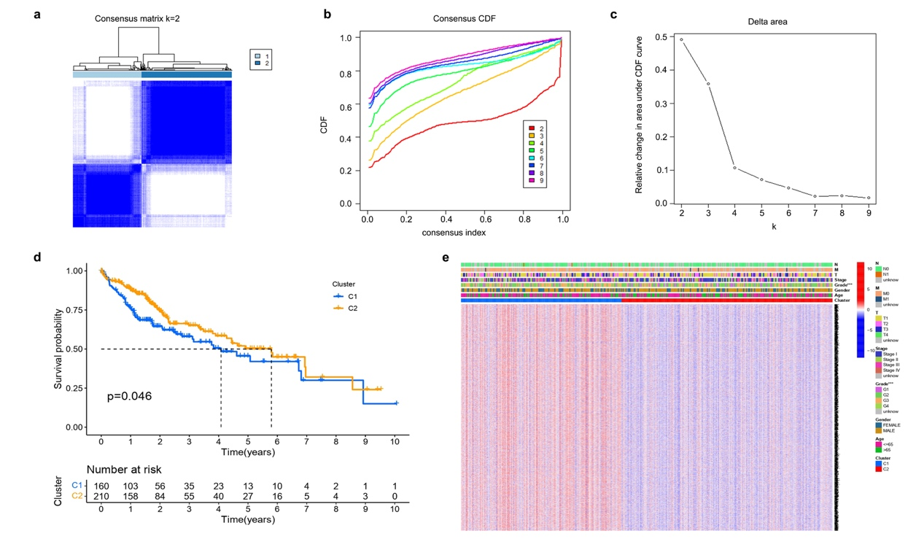
Supplement Fig. 1. Consensus clustering to DEGs associated with pyroptosis. (a) 370 HCC patients were classified into two subgroups based on k=2,. (b-c) Consensus clustering model with CDF by k from 2 to 9. (d) The cluster 1 prognosis was better than that of cluster 2. (e) The clinicopathological parameters of the two patients' clusters were shown in heatmap.

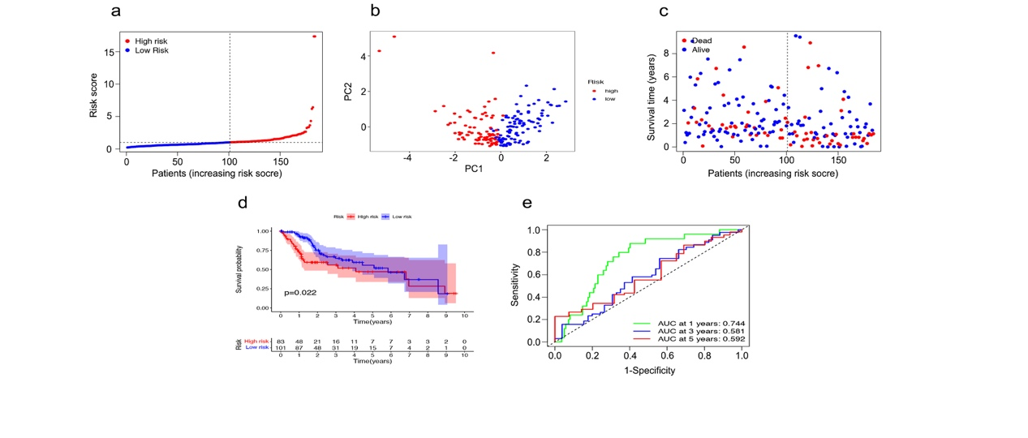
Supplement Fig. 2. Validation in TCGA test cohort. (a-c) Patients distribution in the test cohort. (d) The KM analysis of the test cohort’s OS in the two risk groups. (e) Time-dependent ROC scores analysis.
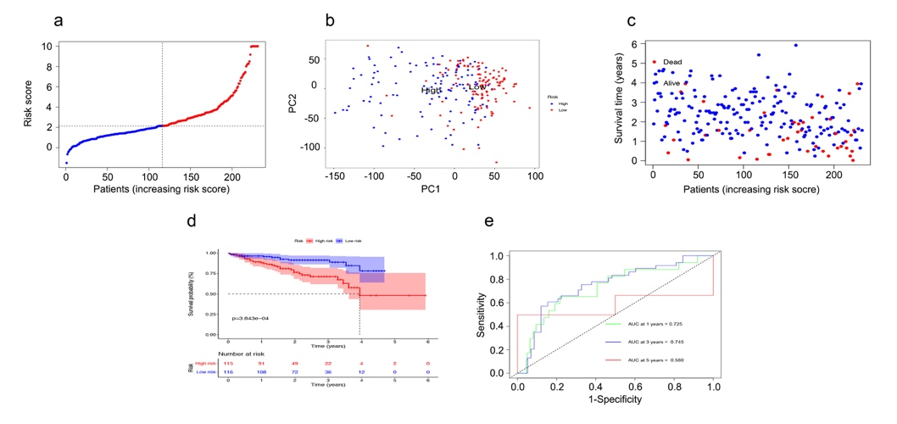
Supplement Fig. 3. Validation in the ICGC cohort. (a-c) Patients distribution in the ICGC cohort. (d) The KM analysis of the OS in the two risk groups in the validation cohort. (e) Time-dependent ROC scores analysis.

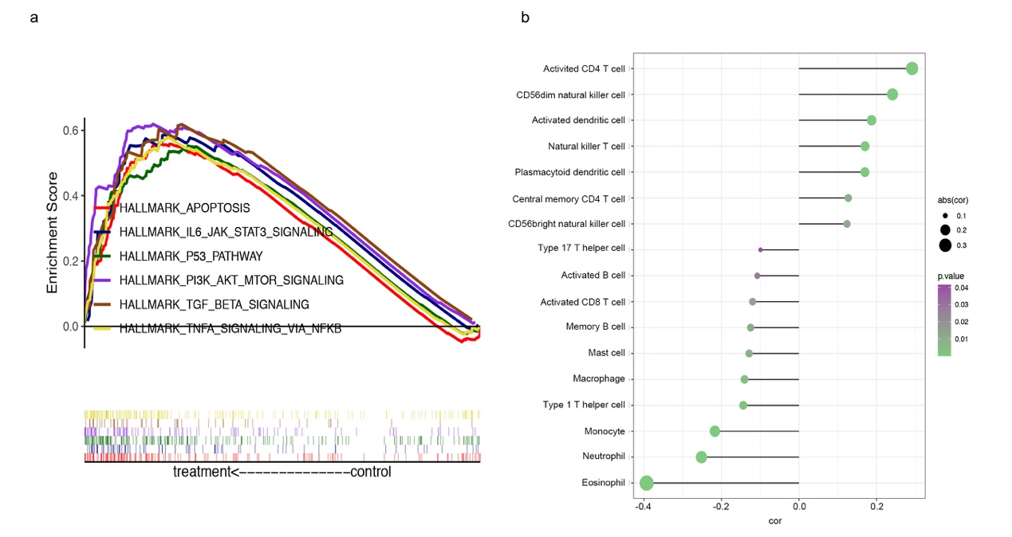
Supplement Fig. 4. The DEGs functional analysis of the two-risk groups in TGCA cohort. (a) GSEA of the significantly enriched pathway in the TCGA cohort. (b) The association of immune cells and risk model.

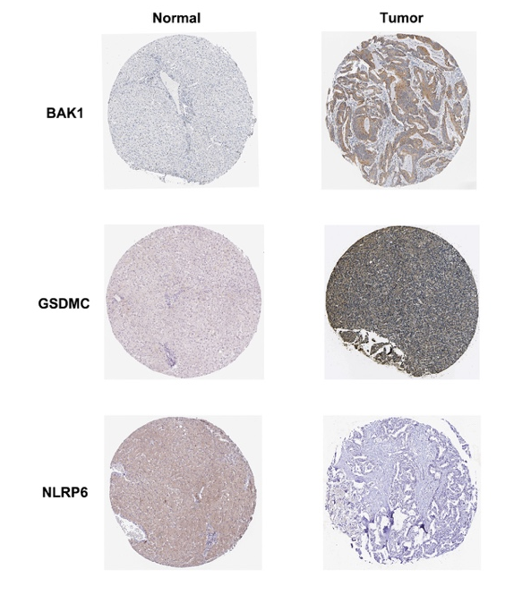

Supplement Fig. 5. Expression of the prognostic genes. Immunohistochemistry of the 3 pyroptosis-related prognosis genes in the tumor or normal groups from the HPA database.

