1. Establishment of animal model of DCD liver transplantation
SPF-grade SD rats weighing 150-180g and aged 5-6 weeks were randomly selected. Adeno-associated viruses were injected into donor SD rats through the tail vein, based on group conditions, and were then kept in the SPF animal house for 21 days to wait for the stable expression of adeno-associated viruses. During this period, a 12-hour light and 12-hour darkness light/shade ratio was alternated, while the temperature was maintained at a constant 22℃ and relative humidity at 60%. Before surgery, the rats were fasted for 12 hours but had unrestricted access to water. The donor and acceptant rats were anesthetized with isoflurane using a MATRX animal anesthesia machine in the USA. The rat was then fixed in the rat fixator, and its tail was placed in warm water for 3-5 minutes. Each group was injected with 200μl of adeno-associated virus via caudal vein, with each dose being 2.5*10^9vg/μl. After the injection, the rats were kept in the SPF-grade animal house for 21 days until the adeno-associated virus was stably expressed. The rat tail was disinfected with a 75% alcohol cotton ball two to three times. In this study, the "two-cuff" method established by Kamada et al. was adopted to establish the liver transplantation model of SD rats. The model was considered successful if the survival time was more than 24 hours, and a postoperative survival curve was created.
1.1 Donor surgery
Figure 1 demonstrates the process of inducing anesthesia in SD rats by inhalation of 5% isoflurane, followed by fixation on the operating tray and maintenance of anesthesia by inhalation of 2-3% isoflurane. A median abdominal incision was made, and the inferior vena cava was dissected, followed by injection of a 2 IU/g body weight dose of heparin sodium solution into the inferior vena cava to induce systemic heparinization. Excessive isoflurane inhalation was then administered to euthanize the SD rats, and the criteria for successful establishment of the DCD model were observed by peritoneal macroscopic observation of diaphragm beat to determine cardiac arrest. After 10 minutes, a cross incision was made in the abdomen and UW solution was injected into the proximal end of the abdominal aorta to begin cold ischemia. The liver was carefully dissected, and the falciform ligament, left triangular ligament, posterior hepatic ligament, and hepatogastric ligament were severed. The inferior hepatic vena cava, right renal vein, and right adrenal vein were dissociated and ligated, while the inferior vena cava was cut open to ensure effective liver perfusion. The portal vein was severed at the confluence of the upper and lower mesenteric veins to form a trumpet shape, and the common bile duct was dissociated and a bile duct stent was inserted into the distal end for fixation. The liver was then removed and stored in UW solution at 4℃ for future use.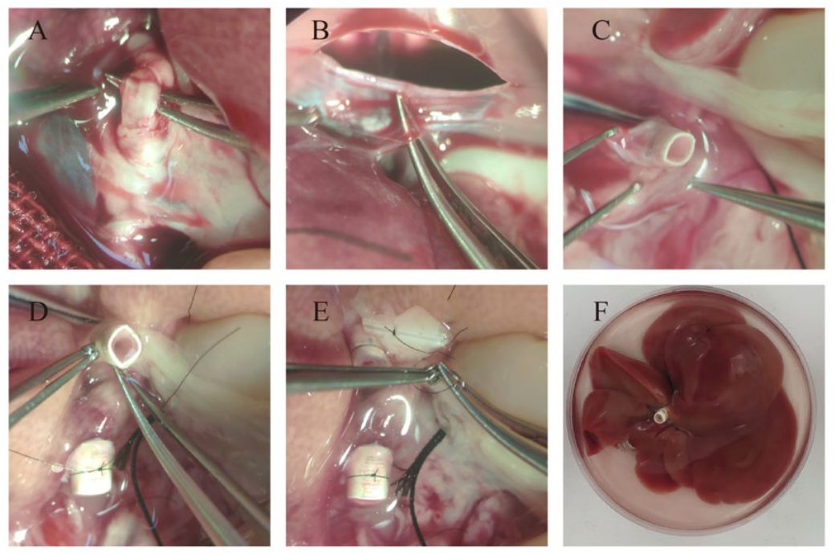
Supplement Figure 1. Donor surgery and major surgical procedures for donor liver acquisition
A: Block the proximal peritoneal trunk of the common hepatic artery; B: Dissociate and ligate the left inferior phrenic vein; C: The inferior vena cava of the liver was severed and inserted into the "cuff"; D: The portal vein was severed and put into the "cuff"; E: Implantation of bile duct stent; F: The donor liver was stored in UW solution at 4℃ in vitro.

1.2 Acceptor operation
As shown in Figure 2, anesthesia was induced by inhalation of 5% isoflurane. After the anesthesia took effect, the rats were fixed on the operating tray and anesthesia was maintained by inhalation of 2-3% isoflurane. Median abdominal incision, xiphoid process was exposed and fixed, falciform ligament was severed, left inferior phrenic vein was dissected and exposed, and left inferior phrenic vein was ligated near liver and diaphragm respectively, and severed. Free the superior and inferior hepatic vena cava, free and disconnected the hepatic and gastric veins; Turn the liver to the right side, ligation and cut off the hepatic esophageal venous plexus; The choledochus was dissociated, and the bile duct was ligated near the hilus hepatis. The hepatic artery was ligated and severed, and the splenic vein was dissociated and ligated. The right adrenal vein was dissected, and the right adrenal vein was ligated away from the liver. The portal vein and inferior inferior vena cava were blocked with non-damaging vessel clamp successively, and 2ml normal saline was injected into the portal vein bifurcation, and the liver immediately turned earthen yellow. The non-damaging vessel clamp and part of the diaphragm were immediately used to block the superior and inferior hepatic vena cava, and the liver was removed completely. The donor liver was carefully transplanted into the abdominal cavity of the recipient, and the superior and inferior vena cava of the liver was reconstructed using the 8-0 polypropylene non-absorbable suture line from the left end -- posterior wall -- right end -- anterior wall. The donor portal vein cuff was inserted into the portal stump of the recipient portal vein, ligated and fixed, the portal vein was reconstructed, the vascular clamp was removed to open the portal vein, and then the vascular clamp was removed immediately to open the superior and inferior hepatic vena cava, and the hepatitis-free period was ended (the interval from the beginning of cold ischemia to the end of the hepatitis-free period was 4h). The subhepatic inferior vena cava cuff of the donor liver was inserted into the recipient subhepatic inferior vena cava stump, ligated and fixed, and the subhepatic inferior vena cava was reconstructed. A small opening was made in the anterior wall of the recipient choledochus, and the donor choledochus was directly inserted into the recipient choledochus, ligated and fixed, and the choledochus was reconstructed. Finally, the abdominal cavity was rinsed with warm saline to check whether there was bleeding or oozing blood. The abdominal incision was sutured continuously with 2-0 silk thread, and the incision was disinfected and placed at 37℃ resuscitation in thermostat.
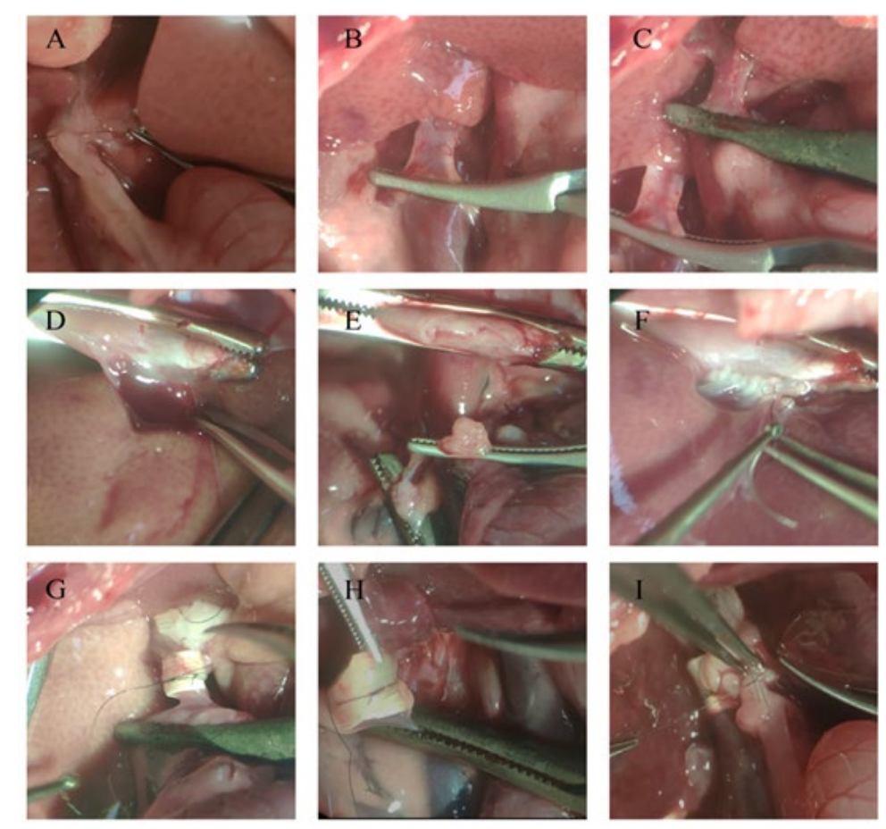
Supplement Figure 2. Main procedures of recipient surgery and donor liver implantation
A: Ligation of the common bile duct; B: Block the portal vein; C: Block the inferior hepatic vena cava; D: blocking and severing the superior and inferior hepatic vena cava; E: The portal vein and the severed end of the upper and lower hepatic vena cava of the recipient after liver removal; F: Anastomotic reconstruction of superior and inferior hepatic vena cava; G: Reconstruction of portal vein; H: Reconstruction of inferior hepatic vena cava; I: Reconstruction of the common bile duct.
1.3 Postoperative care
The activity state of SD rats was observed 2 hours after operation. After waking up, the rats could move freely. They were transferred to the SPF feeding house and kept in cages. After that, ensure that the water and food fully meet the needs of SD rats.
1.4 Harvested liver tissue
After obtaining fresh liver tissue samples from animal anesthesia machine, the rats died due to excessive inhalation anesthesia. The liver tissues were frozen with liquid nitrogen and fixed with 4% paraformaldehyde.
1.5 Serum acquisition
The whole blood of rats was collected and placed in a coagulant tube for 2h, then centrifuged at a high speed (3000rpm, 15min), and the upper serum was collected and divided into 200μl pieces and stored in a -80℃ refrigerator for detection.

