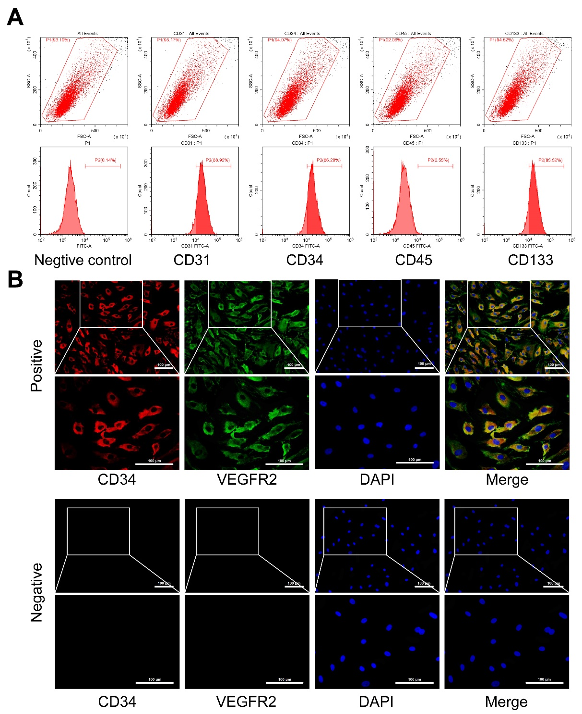

Supplementary Fig. 1. EPCs were identified by flow cytometry and IF staining (A) Representative images of flow cytometry in EPCs. (B) Representative micrographs of IF staining to identify EPCs. Magnification = 200× or 400×, scale bar = 100 μm.

