Supplementary Fig. 1. (A) ROC curves of TMB predicting survival, and the TCGA-CESC cohort was divided into low- and high-TMB subgroups based on the threshold of ROC curve. (B) KM curves of OS between two TMB risk groups in the TCGA-CESC cohort.
Supplementary Fig. 2. The expression of 7 DEARGs, including CXCL8, SLPI, CDH3, MMP13, SPP1, ITGA8, and KLF4, in the GEPIA public database with 306 CC and 13 normal samples.
Supplementary Fig. 3. The scatter diagram of the relationship between TMB calculated by DEARGs and the risk scores calculated by the gene signature and clinicopathological factors.
Supplementary Fig. 4. Bar diagram showed KEGG analysis of differentially expressed genes between high-risk and low-risk group.
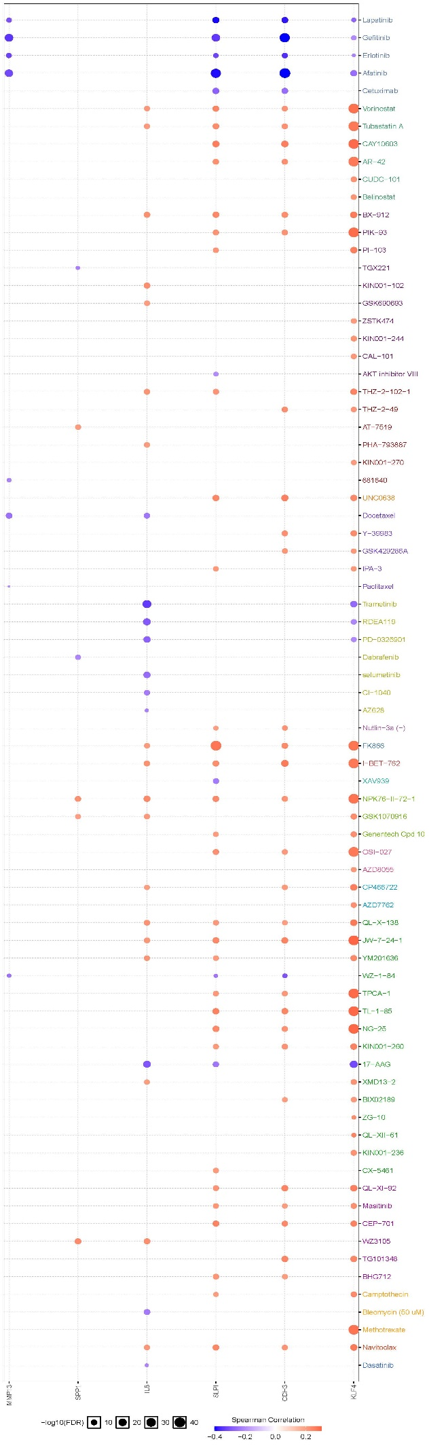
Supplementary Fig. 5. Bubble diagram showed the Spearman correlation analysis between the expression of selected DEARGs and the sensitivities of cervical cancer cells to several different chemotherapy or targeting drugs. The positive correlation demonstrates that the gene high expression is resistant to the drug, and vice versa.

