Supplementary Table 1. Properties and descriptors of identified hit compounds from QikProp module for G12C K-Ras protein
S.No | Drugbank ID | Hit Molecules | XP GScore | Stars | CNSª | MW (Da)^{b} | SASA^{c} | FOSA^{d} | FISA^{e} | PISA^{f} | donorHB^{g} | accptHB^{h} | QPlogPoct^{i} | QPlogPw^{j} | QPlogPo/w^{k} | QPlogS^{l} | QPPCaco^{m} | QPlogBB^{n} | QPlogKhsa-1º | HOA^{p} | HOA (%)^{q}
1 | DB08916 | Afatinib | -7.375 | 0 | 1 | 485.945 | 795.193 | 379.494 | 93.837 | 221.546 | 2 | 9.45 | 24.448 | 14.286 | 3.697 | -5.13 | 318.378 | -0.314 | 0.289 | 3 | 93.39
2 | DB09101 | Elvitegravir | -6.755 | 0 | -2 | 447.89 | 720.702 | 299.539 | 178.137 | 156.365 | 1 | 5.95 | 19.477 | 9.32 | 4.808 | -6.258 | 51.313 | -1.546 | 0.502 | 1 | 85.708
3 | DB08976 | Floctafenine | -6.635 | 0 | -2 | 406.361 | 678.556 | 98.68 | 141.093 | 327.306 | 2 | 5.9 | 20.49 | 11.553 | 3.926 | -5.596 | 454.899 | -1.123 | 0.302 | 3 | 100
4 | DB12301 | Doravirine | -6.136 | 0 | -2 | 425.754 | 625.634 | 99.649 | 198.793 | 165.435 | 1 | 8 | 20.337 | 12 | 2.441 | -5.652 | 129.046 | -1.236 | -0.098 | 3 | 79.017
5 | DB11967 | Binimetinib | -5.983 | 0 | -2 | 441.231 | 660.516 | 175.656 | 150.23 | 206.253 | 2 | 6.9 | 20.706 | 11.96 | 3.134 | -5.215 | 372.619 | -1.108 | 0.062 | 3 | 91.317
6 | DB08916 | Afatinib | -5.954 | 0 | 1 | 485.945 | 828.733 | 372.019 | 95.579 | 251.342 | 2 | 9.45 | 25.508 | 14.584 | 3.914 | -5.739 | 306.493 | -0.372 | 0.343 | 3 | 94.363
7 | DB00266 | Dicoumarol | -5.683 | 0 | -1 | 336.3 | 546.241 | 32.101 | 146.268 | 367.872 | 2 | 6.5 | 17.59 | 12.98 | 1.955 | -3.393 | 406.298 | -0.992 | -0.145 | 3 | 85.086
8 | DB01129 | Rabeprazole | -5.492 | 0 | -1 | 359.442 | 668.003 | 285.462 | 87.548 | 278.26 | 1 | 8.95 | 19.379 | 14.836 | 2.63 | -2.598 | 58.301 | -0.784 | -0.331 | 3 | 73.949
9 | DB09074 | Olaparib | -5.459 | 0 | -2 | 434.469 | 720.901 | 289.149 | 178.366 | 215.62 | 1 | 8 | 21.678 | 14.703 | 2.74 | -4.974 | 120.012 | -1.41 | 0.115 | 3 | 80.203
10 | DB09219 | Bisoxatin | -5.282 | 0 | -2 | 333.343 | 570.043 | 0 | 164.015 | 406.028 | 3 | 4.75 | 19.84 | 13.6 | 2.591 | -4.214 | 275.77 | -1.061 | 0.26 | 3 | 85.796
11 | DB00682 | Warfarin | -5.253 | 0 | 0 | 308.333 | 549.263 | 97.354 | 101.201 | 350.708 | 1 | 5.25 | 15.951 | 9.648 | 2.703 | -3.871 | 1086.954 | -0.639 | 0.059 | 3 | 100
12 | DB09292 | Sacubitril | -5.235 | 0 | -2 | 411.497 | 756.001 | 285.129 | 166.839 | 304.032 | 2 | 6.5 | 21.706 | 12.747 | 4.169 | -5.269 | 49.997 | -1.867 | 0.096 | 3 | 81.763
13 | DB08893 | Mirabegron | -5.119 | 0 | -2 | 396.506 | 771.484 | 156.235 | 178.821 | 382.61 | 5 | 7.7 | 26.018 | 17.895 | 2.526 | -4.252 | 49.778 | -1.667 | -0.038 | 2 | 72.108
14 | DB05039 | Indacaterol | -5.098 | 0 | -2 | 392.497 | 723.82 | 350.607 | 175.078 | 198.136 | 4 | 6.45 | 23.73 | 14.447 | 2.704 | -4.21 | 54.018 | -1.367 | 0.354 | 2 | 73.787
15 | DB00530 | Erlotinib | -4.992 | 0 | 0 | 393.441 | 765.634 | 396.785 | 35.994 | 332.855 | 1.5 | 7.4 | 19.736 | 11.13 | 4.459 | -5.641 | 4514.07 | -0.519 | 0.213 | 3 | 100
16 | DB05039 | Indacaterol | -4.934 | 0 | -2 | 392.497 | 721.767 | 350.779 | 175.357 | 195.63 | 4 | 6.45 | 23.488 | 14.427 | 2.698 | -4.176 | 53.689 | -1.361 | 0.354 | 2 | 73.702
17 | DB01129 | Rabeprazole | -4.89 | 0 | -1 | 359.442 | 664.077 | 287.506 | 82.077 | 276.422 | 1 | 8.95 | 18.463 | 14.778 | 2.632 | -2.537 | 65.699 | -0.72 | -0.346 | 3 | 74.889
18 | DB01611 | Hydroxychloroquine | -4.834 | 0 | 1 | 335.876 | 644.022 | 312.637 | 80.714 | 179.07 | 2 | 5.7 | 17.688 | 9.399 | 3.321 | -3.349 | 424.024 | -0.265 | 0.157 | 3 | 93.416
19 | DB06237 | Avanafil | -4.755 | 0 | -2 | 483.956 | 764.689 | 345.868 | 134.013 | 244.337 | 2 | 8.95 | 23.805 | 13.907 | 3.922 | -5.584 | 530.95 | -1.264 | 0.345 | 3 | 100
20 | DB01611 | Hydroxychloroquine | -4.676 | 0 | 1 | 335.876 | 667.096 | 333.697 | 68.269 | 193.521 | 2 | 5.7 | 17.817 | 9.468 | 3.535 | -3.743 | 556.417 | -0.174 | 0.196 | 3 | 96.78
21 | DB13874 | Enasidenib | -5.938 | 1 | -1 | 473.38 | 698.956 | 174.373 | 94.072 | 244.92 | 3 | 6.75 | 24.383 | 13.27 | 4.531 | -6.065 | 1270.04 | -0.348 | 0.396 | 3 | 100
22 | DB09330 | Osimertinib | -5.884 | 1 | 1 | 499.614 | 836.883 | 450.985 | 69.724 | 316.175 | 2 | 8.75 | 25.996 | 13.921 | 4.807 | -5.485 | 539.027 | -0.332 | 0.775 | 3 | 100
23 | DB01136 | Carvedilol | -5.471 | 1 | 0 | 406.48 | 774.757 | 248.652 | 73.355 | 452.75 | 3 | 5.45 | 22.035 | 12.498 | 4.211 | -5.048 | 497.94 | -0.541 | 0.589 | 3 | 100
24 | DB12941 | Darolutamide | -5.224 | 1 | -2 | 398.851 | 725.947 | 213.584 | 216.52 | 231.259 | 3 | 8.2 | 24.67 | 15.461 | 2.477 | -6.573 | 87.628 | -2.102 | 0.065 | 1 | 76.218
25 | DB01418 | Acenocoumarol | -5.191 | 1 | -2 | 353.331 | 599.654 | 110.774 | 205.741 | 283.139 | 1 | 6.25 | 19.373 | 10.785 | 2.226 | -3.968 | 110.881 | -1.754 | 0.031 | 3 | 76.576
26 | DB08881 | Vemurafenib | -5.009 | 1 | -2 | 489.923 | 773.419 | 159.41 | 164.633 | 315.951 | 1 | 6.5 | 22.136 | 11.219 | 4.907 | -7.351 | 272.075 | -1.368 | 0.751 | 1 | 100
27 | DB11632 | Opicapone | -4.904 | 1 | -2 | 413.173 | 627.107 | 139.272 | 271.131 | 112.629 | 2 | 6.5 | 20.378 | 12.545 | 1.896 | -5.325 | 26.593 | -2.096 | 0.161 | 2 | 63.545
28 | DB12941 | Darolutamide | -4.671 | 2 | -2 | 398.851 | 724.473 | 214.681 | 212.804 | 232.397 | 2 | 7.2 | 23.686 | 12.991 | 3.057 | -6.92 | 95.034 | -2.047 | 0.283 | 1 | 80.248
29 | DB01204 | Mitoxantrone | -8.442 | 3 | -2 | 444.486 | 740.151 | 304.411 | 286.745 | 148.995 | 4 | 9.9 | 24.761 | 16.545 | 0.344 | -1.083 | 1.176 | -2.632 | -0.396 | 1 | 17.264
ªPredicted central nervous system activity on a –2 (inactive) to +2 (active) scale; ^{b}Molecular Weight; ^{c}Total solvent accessible surface area; ^{d}Hydrophobic component of the SASA; ^{e}Hydrophilic component of the SASA; ^{f}π (carbon and attached hydrogen) component of the SASA; ^{g}Number of donor hydrogen bonds; ^{h}Number of acceptor hydrogen bonds; ^{i}Predicted octanol/gas partition coefficient; ^{j}Predicted water/gas partition coefficient; ^{k}Predicted octanol/water partition coefficient; ^{l}Predicted aqueous solubility; ^{m}Predicted apparent Caco-2 cell permeability in nm/sec; ^{n}Predicted brain/blood partition coefficient; ºPrediction of binding to human serum albumin; ^{p}Predicted qualitative human oral absorption; ^{q}Predicted human oral absorption on 0 to 100% scale.

Supplementary Table 2. Properties and descriptors of identified hit compounds from QikProp module for G12D K-Ras protein
S.No | Drugbank ID | Hit Molecules | XP GScore | Stars | CNS | MW (Da) | SASA | FOSA | FISA | PISA | donorHB | accptHB | QPlogPoct | QPlogPw | QPlogPo/w | QPlogS | QPPCaco | QPlogBB | QPlogKhsa-1 | HOA | HOA (%)
1 | DB00557 | Hydroxyzine | -5.772 | 0 | 2 | 374.909 | 678.051 | 272.227 | 48.222 | 285.953 | 1 | 7.4 | 18.59 | 10.417 | 3.043 | -2.289 | 214.987 | 0.508 | 0.081 | 3 | 86.51
2 | DB01624 | Zuclopenthixol | -4.789 | 0 | 2 | 400.965 | 709.126 | 275.596 | 52.801 | 272.366 | 1 | 5.7 | 18.59 | 9.21 | 4.132 | -4.055 | 194.532 | 0.646 | 0.608 | 3 | 92.11
3 | DB00623 | Fluphenazine | -4.508 | 0 | 2 | 437.522 | 721.765 | 271.696 | 64.259 | 235.536 | 1 | 6.2 | 19.72 | 9.575 | 4.358 | -4.151 | 151.473 | 0.637 | 0.634 | 3 | 91.48
4 | DB00623 | Fluphenazine | -4.212 | 0 | 2 | 437.522 | 701.298 | 270.077 | 58.439 | 237.296 | 1 | 6.2 | 19.4 | 9.493 | 4.345 | -4.117 | 171.996 | 0.684 | 0.59 | 3 | 92.4
5 | DB01624 | Zuclopenthixol | -4.142 | 0 | 2 | 400.965 | 688.932 | 259.794 | 60.338 | 272.83 | 1 | 5.7 | 18.48 | 9.212 | 4.058 | -3.812 | 165.011 | 0.567 | 0.595 | 3 | 90.39
6 | DB00561 | Doxapram | -3.826 | 0 | 2 | 378.513 | 678.183 | 355.696 | 24.932 | 297.555 | 0 | 6.7 | 18.02 | 10.694 | 3.22 | -3.049 | 1005.39 | 0.479 | -0.033 | 3 | 100
7 | DB01611 | Hydroxychloroquine | -6.329 | 0 | 1 | 335.876 | 666.974 | 334.407 | 66.348 | 194.62 | 2 | 5.7 | 18.08 | 9.462 | 3.555 | -3.741 | 580.259 | -0.153 | 0.198 | 3 | 100
8 | DB12492 | Piritramide | -5.633 | 0 | 1 | 430.592 | 759.969 | 310.982 | 127.436 | 321.551 | 2 | 7 | 23.15 | 14.909 | 2.877 | -3.967 | 23.077 | -0.388 | 0.415 | 2 | 68.19
9 | DB00557 | Hydroxyzine | -5.631 | 0 | 1 | 374.909 | 698.276 | 283.045 | 57.248 | 286.335 | 1 | 7.4 | 18.62 | 10.53 | 3.098 | -2.641 | 176.53 | 0.396 | 0.126 | 3 | 85.3
10 | DB01611 | Hydroxychloroquine | -5.251 | 0 | 1 | 335.876 | 644.022 | 312.637 | 80.714 | 179.07 | 2 | 5.7 | 17.69 | 9.399 | 3.321 | -3.349 | 424.024 | -0.265 | 0.157 | 3 | 93.42
11 | DB00246 | Ziprasidone | -5.148 | 0 | 1 | 412.936 | 675.149 | 229.666 | 110.411 | 237.373 | 1 | 6 | 19.77 | 10.457 | 3.745 | -5.074 | 221.704 | -0.087 | 0.61 | 3 | 90.86
12 | DB00246 | Ziprasidone | -5.086 | 0 | 1 | 412.936 | 691.034 | 230.627 | 107.341 | 249.04 | 1 | 6 | 19.82 | 10.556 | 3.91 | -5.383 | 237.075 | -0.071 | 0.652 | 3 | 92.34
13 | DB00496 | Darifenacin | -4.787 | 0 | 1 | 426.557 | 741.184 | 245.978 | 76.546 | 418.66 | 2 | 5.25 | 21.95 | 13.645 | 4.313 | -4.361 | 268.134 | -0.25 | 0.63 | 3 | 95.66
14 | DB01611 | Hydroxychloroquine | -4.636 | 0 | 1 | 335.876 | 607.959 | 287.062 | 86.013 | 166.252 | 2 | 5.7 | 16.9 | 9.26 | 3.045 | -2.732 | 377.695 | -0.266 | 0.079 | 3 | 90.9
15 | DB01608 | Periciazine | -4.353 | 0 | 1 | 365.492 | 662.098 | 239.33 | 120.802 | 265.872 | 1 | 5.7 | 18.21 | 9.711 | 3.517 | -4.027 | 176.699 | -0.52 | 0.455 | 3 | 87.76
16 | DB08916 | Afatinib | -3.843 | 0 | 1 | 485.945 | 828.733 | 372.019 | 95.579 | 251.342 | 2 | 9.45 | 25.51 | 14.584 | 3.914 | -5.739 | 306.493 | -0.372 | 0.343 | 3 | 94.36
17 | DB06654 | Safinamide | -6.507 | 0 | 0 | 302.348 | 617.725 | 142.091 | 114.526 | 314.109 | 3 | 4.75 | 18.5 | 14.613 | 2.067 | -2.09 | 97.662 | -0.525 | -0.226 | 3 | 74.66
18 | DB01039 | Fenofibrate | -5.192 | 0 | 0 | 360.836 | 680.809 | 288.128 | 77.346 | 243.677 | 0 | 4.75 | 15.86 | 6.921 | 4.771 | -5.967 | 1829.91 | -0.432 | 0.548 | 3 | 100
19 | DB06654 | Safinamide | -4.74 | 0 | 0 | 302.348 | 614.529 | 154.263 | 104.542 | 308.731 | 3 | 4.75 | 18.35 | 14.311 | 2.106 | -2.121 | 127.307 | -0.417 | -0.235 | 3 | 76.95
20 | DB11952 | Duvelisib | -4.241 | 0 | 0 | 416.869 | 632.733 | 72.03 | 114.092 | 387.003 | 2 | 7 | 21.6 | 13.834 | 3.486 | -5.074 | 820.29 | -0.531 | 0.315 | 3 | 100
21 | DB00530 | Erlotinib | -4.11 | 0 | 0 | 393.441 | 765.634 | 396.785 | 35.994 | 332.855 | 1.5 | 7.4 | 19.74 | 11.13 | 4.459 | -5.641 | 4514.07 | -0.519 | 0.213 | 3 | 100
22 | DB09280 | Lumacaftor | -5.112 | 0 | -1 | 452.413 | 711.411 | 173.978 | 136.393 | 305.99 | 2 | 7.5 | 23.38 | 13.908 | 4.387 | -6.222 | 127.67 | -0.851 | 0.291 | 1 | 90.33
23 | DB06626 | Axitinib | -4.783 | 0 | -1 | 386.47 | 690.377 | 105.64 | 112.877 | 441.571 | 2 | 4.5 | 20.1 | 11.201 | 4.738 | -6.217 | 842.338 | -0.897 | 0.738 | 1 | 100
24 | DB00412 | Rosiglitazone | -4.615 | 0 | -1 | 357.426 | 625.145 | 188.594 | 117.064 | 285.552 | 1 | 5.25 | 16.24 | 9.066 | 3.647 | -4.761 | 768.742 | -0.922 | 0.292 | 3 | 100
25 | DB00412 | Rosiglitazone | -4.447 | 0 | -1 | 357.426 | 600.128 | 201.793 | 118.301 | 245.858 | 1 | 5.25 | 15.98 | 8.744 | 3.505 | -4.323 | 748.254 | -0.864 | 0.261 | 3 | 100
26 | DB01129 | Rabeprazole | -4.432 | 0 | -1 | 359.442 | 668.003 | 285.462 | 87.548 | 278.26 | 1 | 8.95 | 19.38 | 14.836 | 2.63 | -2.598 | 58.301 | -0.784 | -0.331 | 3 | 73.95
27 | DB01129 | Rabeprazole | -4.427 | 0 | -1 | 359.442 | 655.077 | 281.349 | 76.754 | 270.274 | 1 | 8.95 | 18.32 | 14.681 | 2.626 | -2.423 | 73.797 | -0.633 | -0.372 | 3 | 75.76
28 | DB12015 | Alpelisib | -4.345 | 0 | -1 | 441.47 | 723.482 | 353.269 | 141.691 | 96.792 | 3 | 7 | 24.27 | 18.558 | 2.474 | -4.67 | 136.665 | -0.813 | -0.133 | 3 | 79.66
29 | DB01129 | Rabeprazole | -4.107 | 0 | -1 | 359.442 | 664.077 | 287.506 | 82.077 | 276.422 | 1 | 8.95 | 18.46 | 14.778 | 2.632 | -2.537 | 65.699 | -0.72 | -0.346 | 3 | 74.89
30 | DB09054 | Idelalisib | -3.888 | 0 | -1 | 415.429 | 648.329 | 108.336 | 129.53 | 374.285 | 2 | 8 | 22.79 | 14.646 | 3.137 | -4.762 | 585.549 | -0.795 | 0.203 | 3 | 94.85
31 | DB13258 | Etofamide | -3.887 | 0 | -1 | 427.283 | 715.309 | 221.058 | 122.848 | 244.729 | 0 | 6.2 | 17.59 | 9.784 | 3.783 | -4.863 | 447.269 | -0.986 | -0.09 | 3 | 96.54
32 | DB09054 | Idelalisib | -3.78 | 0 | -1 | 415.429 | 649.808 | 107.964 | 124.826 | 380.847 | 2 | 8 | 22.16 | 14.662 | 3.122 | -4.786 | 648.894 | -0.767 | 0.178 | 3 | 95.56
33 | DB11827 | Ertugliflozin | -7.397 | 0 | -2 | 436.888 | 702.976 | 297.535 | 157.088 | 198.129 | 4 | 9.05 | 24.62 | 16.632 | 2.469 | -4.521 | 320.799 | -1.46 | -0.113 | 3 | 86.26
34 | DB01132 | Pioglitazone | -7.058 | 0 | -2 | 356.439 | 657.33 | 248.13 | 139.895 | 237.722 | 1 | 4.75 | 16.4 | 8.48 | 3.912 | -5.505 | 466.954 | -1.217 | 0.507 | 3 | 100
35 | DB08860 | Pitavastatin | -6.425 | 0 | -2 | 421.467 | 670.338 | 199.941 | 170.482 | 258.275 | 2 | 5.4 | 19.89 | 10.526 | 4.596 | -5.145 | 60.648 | -1.479 | 0.416 | 3 | 85.76
36 | DB06292 | Dapagliflozin | -6.397 | 0 | -2 | 408.878 | 711.922 | 282.58 | 173.883 | 205.543 | 4 | 9.25 | 24.29 | 17.015 | 2.165 | -4.608 | 222.314 | -1.71 | -0.205 | 2 | 81.63
37 | DB09292 | Sacubitril | -6.009 | 0 | -2 | 411.497 | 756.001 | 285.129 | 166.839 | 304.032 | 2 | 6.5 | 21.71 | 12.747 | 4.169 | -5.269 | 49.997 | -1.867 | 0.096 | 3 | 81.76
38 | DB06603 | Panobinostat | -5.881 | 0 | -2 | 349.432 | 689.471 | 200.09 | 161.43 | 327.952 | 4 | 5.7 | 22.25 | 14.195 | 2.59 | -3.66 | 72.772 | -1.305 | 0.158 | 3 | 75.44
39 | DB01132 | Pioglitazone | -5.717 | 0 | -2 | 356.439 | 688.443 | 263.857 | 139.135 | 253.152 | 1 | 4.75 | 16.84 | 8.655 | 4.106 | -6.065 | 474.773 | -1.296 | 0.573 | 3 | 100
40 | DB09101 | Elvitegravir | -5.668 | 0 | -2 | 447.89 | 720.702 | 299.539 | 178.137 | 156.365 | 1 | 5.95 | 19.48 | 9.32 | 4.808 | -6.258 | 51.313 | -1.546 | 0.502 | 1 | 85.71
41 | DB01132 | Pioglitazone | -5.575 | 0 | -2 | 356.439 | 658.324 | 247.433 | 140.56 | 238.362 | 1 | 4.75 | 16.65 | 8.491 | 3.909 | -5.525 | 460.225 | -1.227 | 0.506 | 3 | 100
42 | DB08976 | Floctafenine | -5.571 | 0 | -2 | 406.361 | 680.463 | 99.284 | 143.269 | 326.687 | 2 | 5.9 | 20.63 | 11.568 | 3.904 | -5.628 | 433.788 | -1.156 | 0.299 | 3 | 100
43 | DB09292 | Sacubitril | -5.443 | 0 | -2 | 411.497 | 780.27 | 339.627 | 136.74 | 303.903 | 2 | 6.5 | 22 | 12.577 | 4.498 | -5.702 | 97.031 | -1.612 | 0.141 | 3 | 88.85
44 | DB06603 | Panobinostat | -5.336 | 0 | -2 | 349.432 | 705.32 | 190.735 | 171.69 | 342.895 | 4 | 5.7 | 22.81 | 14.404 | 2.602 | -3.923 | 58.166 | -1.473 | 0.179 | 3 | 73.77
45 | DB11689 | Selumetinib | -5.278 | 0 | -2 | 457.686 | 695.544 | 190.346 | 146.389 | 193.697 | 2 | 6.9 | 21.6 | 11.946 | 3.551 | -5.964 | 405.219 | -1.058 | 0.163 | 3 | 94.41
46 | DB08976 | Floctafenine | -5.06 | 0 | -2 | 406.361 | 677.086 | 98.612 | 142.308 | 324.954 | 2 | 5.9 | 20.49 | 11.542 | 3.904 | -5.57 | 442.989 | -1.133 | 0.298 | 3 | 100
47 | DB08976 | Floctafenine | -4.873 | 0 | -2 | 406.361 | 678.556 | 98.68 | 141.093 | 327.306 | 2 | 5.9 | 20.49 | 11.553 | 3.926 | -5.596 | 454.899 | -1.123 | 0.302 | 3 | 100
48 | DB12941 | Darolutamide | -4.809 | 0 | -2 | 398.851 | 642.48 | 211.866 | 192.733 | 209.187 | 2 | 7.2 | 21.17 | 12.486 | 2.618 | -5.389 | 147.304 | -1.604 | 0.141 | 3 | 81.08
49 | DB01132 | Pioglitazone | -4.774 | 0 | -2 | 356.439 | 657.212 | 247.197 | 140.742 | 237.505 | 1 | 4.75 | 16.5 | 8.484 | 3.9 | -5.504 | 458.395 | -1.226 | 0.504 | 3 | 100
50 | DB05015 | Belinostat | -4.754 | 0 | -2 | 318.347 | 590.957 | 22.65 | 210.941 | 356.287 | 3 | 8.7 | 21.83 | 16.419 | 0.707 | -3.07 | 98.98 | -1.985 | -0.582 | 3 | 66.8
51 | DB08976 | Floctafenine | -4.642 | 0 | -2 | 406.361 | 681.701 | 99.461 | 141.971 | 328.794 | 2 | 5.9 | 20.61 | 11.577 | 3.926 | -5.65 | 446.257 | -1.144 | 0.302 | 3 | 100
52 | DB00412 | Rosiglitazone | -4.6 | 0 | -2 | 357.426 | 635.88 | 173.669 | 136.496 | 294.142 | 1 | 5.25 | 16.54 | 9.281 | 3.601 | -4.94 | 502.934 | -1.141 | 0.327 | 3 | 96.38
53 | DB09074 | Olaparib | -4.576 | 0 | -2 | 434.469 | 720.901 | 289.149 | 178.366 | 215.62 | 1 | 8 | 21.68 | 14.703 | 2.74 | -4.974 | 120.012 | -1.41 | 0.115 | 3 | 80.2
54 | DB11817 | Baricitinib | -4.569 | 0 | -2 | 371.416 | 630.038 | 204.195 | 218.221 | 207.142 | 1 | 8.5 | 19.17 | 13.084 | 1.416 | -5.004 | 84.432 | -1.83 | -0.209 | 3 | 69.72
55 | DB01132 | Pioglitazone | -4.562 | 0 | -2 | 356.439 | 645.341 | 253.096 | 139.463 | 221.214 | 1 | 4.75 | 16.33 | 8.336 | 3.885 | -5.291 | 471.379 | -1.165 | 0.505 | 3 | 100
56 | DB00275 | Olmesartan | -4.557 | 0 | -2 | 446.508 | 731.181 | 289 | 204.42 | 237.761 | 3 | 7.25 | 24.95 | 14.036 | 3.985 | -5.324 | 28.906 | -2.014 | 0.321 | 2 | 76.43
57 | DB01132 | Pioglitazone | -4.527 | 0 | -2 | 356.439 | 643.985 | 253.225 | 130.214 | 228.233 | 1 | 4.75 | 16.58 | 8.318 | 3.952 | -5.271 | 576.873 | -1.068 | 0.502 | 3 | 100
58 | DB01132 | Pioglitazone | -4.508 | 0 | -2 | 356.439 | 647.498 | 264.907 | 122.301 | 226.279 | 1 | 4.75 | 16.24 | 8.26 | 3.952 | -5.341 | 685.673 | -1.011 | 0.475 | 3 | 100
59 | DB08877 | Ruxolitinib | -4.491 | 0 | -2 | 306.369 | 577.636 | 223.167 | 150.756 | 203.713 | 1 | 5 | 15.84 | 9.028 | 2.776 | -5.358 | 368.366 | -1.079 | 0.255 | 3 | 89.13
60 | DB00412 | Rosiglitazone | -4.372 | 0 | -2 | 357.426 | 635.324 | 173.495 | 132.095 | 297.753 | 1 | 5.25 | 16.54 | 9.275 | 3.626 | -4.932 | 553.665 | -1.097 | 0.322 | 3 | 100
61 | DB09078 | Lenvatinib | -4.365 | 0 | -2 | 426.858 | 739.826 | 261.145 | 190.091 | 222.935 | 4 | 6.75 | 24.29 | 17.398 | 2.527 | -5.388 | 97.894 | -1.775 | -0.001 | 3 | 77.37
62 | DB00275 | Olmesartan | -4.205 | 0 | -2 | 446.508 | 747.1 | 302.504 | 198.626 | 245.969 | 3 | 7.25 | 25.29 | 14.091 | 4.137 | -5.589 | 32.804 | -2.007 | 0.358 | 2 | 78.3
63 | DB01132 | Pioglitazone | -4.201 | 0 | -2 | 356.439 | 657.817 | 249.127 | 137.852 | 238.565 | 1 | 4.75 | 16.57 | 8.473 | 3.93 | -5.517 | 488.256 | -1.196 | 0.507 | 3 | 100
64 | DB00412 | Rosiglitazone | -4.018 | 0 | -2 | 357.426 | 638.986 | 179.567 | 137.615 | 290.231 | 1 | 5.25 | 16.5 | 9.27 | 3.601 | -4.995 | 490.789 | -1.162 | 0.332 | 3 | 96.19
65 | DB01382 | Glymidine | -4.01 | 0 | -2 | 309.339 | 567.086 | 183.917 | 122.024 | 260.883 | 1 | 8.95 | 16.71 | 12.425 | 1.053 | -2.315 | 689.837 | -1.041 | -0.79 | 3 | 83.92
66 | DB08439 | Parecoxib | -3.959 | 0 | -2 | 370.422 | 646.81 | 206.448 | 170.538 | 268.286 | 1 | 6.5 | 19.02 | 11.467 | 2.88 | -4.998 | 239.162 | -1.313 | 0.324 | 3 | 86.38
67 | DB05015 | Belinostat | -3.843 | 0 | -2 | 318.347 | 586.917 | 22.541 | 209.4 | 354.814 | 3 | 8.7 | 21.64 | 16.389 | 0.678 | -3.007 | 102.366 | -1.961 | -0.593 | 3 | 66.89
68 | DB09101 | Elvitegravir | -3.834 | 0 | -2 | 447.89 | 704.44 | 287.621 | 176.251 | 153.956 | 1 | 5.95 | 19.86 | 9.251 | 4.79 | -5.969 | 53.47 | -1.455 | 0.494 | 3 | 85.92
69 | DB06589 | Pazopanib | -3.793 | 0 | -2 | 437.518 | 749.53 | 284.56 | 193.318 | 269.876 | 3 | 8.5 | 25.19 | 16.117 | 2.795 | -5.76 | 145.433 | -1.908 | 0.251 | 3 | 82.02
70 | DB00412 | Rosiglitazone | -3.783 | 0 | -2 | 357.426 | 615.406 | 184.93 | 134.957 | 263.22 | 1 | 5.25 | 16.35 | 9.012 | 3.504 | -4.583 | 520.125 | -1.059 | 0.301 | 3 | 96.08
71 | DB00875 | Flupentixol | -6.535 | 1 | 2 | 434.519 | 716.281 | 266.42 | 54.105 | 250.296 | 1 | 5.7 | 19.24 | 9.099 | 4.416 | -4.205 | 189.071 | 0.737 | 0.725 | 3 | 93.55
72 | DB00623 | Fluphenazine | -4.847 | 1 | 2 | 437.522 | 769.502 | 268.305 | 51.972 | 316.156 | 1 | 6.2 | 20.57 | 10.149 | 4.393 | -4.219 | 198.083 | 0.681 | 0.765 | 3 | 93.78
73 | DB00850 | Perphenazine | -4.685 | 1 | 2 | 403.969 | 687.646 | 281.722 | 52.284 | 246.126 | 1 | 6.2 | 18.59 | 9.469 | 4.197 | -4.052 | 196.741 | 0.673 | 0.468 | 3 | 92.57
74 | DB01063 | Acetophenazine | -4.721 | 1 | 1 | 411.561 | 742.954 | 356.801 | 112.225 | 237.687 | 1 | 8.2 | 20.44 | 11.677 | 2.757 | -3.121 | 53.146 | -0.239 | 0.241 | 2 | 73.97
75 | DB01063 | Acetophenazine | -4.694 | 1 | 1 | 411.561 | 723.874 | 355.187 | 94.516 | 237.884 | 1 | 8.2 | 20.19 | 11.512 | 2.789 | -2.789 | 78.236 | -0.013 | 0.207 | 2 | 77.16
76 | DB01063 | Acetophenazine | -4.121 | 1 | 1 | 411.561 | 734.281 | 344.334 | 109.268 | 244.577 | 1 | 8.2 | 20.74 | 11.683 | 2.783 | -2.969 | 56.691 | -0.182 | 0.243 | 2 | 74.63
77 | DB14723 | Larotrectinib | -5.685 | 1 | 0 | 428.441 | 722.743 | 294.499 | 114.363 | 247.097 | 2 | 6.2 | 22.04 | 13.699 | 3.739 | -6.522 | 611.356 | -0.609 | 0.447 | 1 | 100
78 | DB01136 | Carvedilol | -4.61 | 1 | 0 | 406.48 | 775.971 | 248.899 | 74.36 | 452.711 | 3 | 5.45 | 21.95 | 12.507 | 4.21 | -5.069 | 487.124 | -0.555 | 0.589 | 3 | 100
79 | DB04794 | Bifonazole | -3.98 | 1 | 0 | 310.398 | 616.144 | 6 | 33.306 | 576.838 | 0 | 2 | 14.65 | 6.44 | 4.778 | -6.024 | 4786.92 | -0.005 | 1.033 | 3 | 100
80 | DB11942 | Selinexor | -4.425 | 1 | -1 | 443.311 | 696.272 | 45.3 | 129.591 | 291.198 | 2 | 9 | 23.85 | 15.249 | 3.28 | -6.075 | 584.776 | -0.516 | -0.05 | 3 | 95.68
81 | DB00276 | Amsacrine | -4.081 | 1 | -1 | 393.459 | 684.666 | 179.628 | 106.842 | 397.464 | 2 | 6.75 | 20.96 | 13.272 | 3.596 | -5.437 | 960.995 | -0.853 | 0.324 | 3 | 100
82 | DB00276 | Amsacrine | -3.971 | 1 | -1 | 393.459 | 684.506 | 179.554 | 107.915 | 396.307 | 2 | 6.75 | 20.97 | 13.271 | 3.584 | -5.434 | 938.73 | -0.865 | 0.323 | 3 | 100
83 | DB13874 | Enasidenib | -3.917 | 1 | -1 | 473.38 | 698.956 | 174.373 | 94.072 | 244.92 | 3 | 6.75 | 24.38 | 13.27 | 4.531 | -6.065 | 1270.04 | -0.348 | 0.396 | 3 | 100
84 | DB11632 | Opicapone | -8.205 | 1 | -2 | 413.173 | 627.107 | 139.272 | 271.131 | 112.629 | 2 | 6.5 | 20.38 | 12.545 | 1.896 | -5.325 | 26.593 | -2.096 | 0.161 | 2 | 63.55
85 | DB11632 | Opicapone | -5.952 | 1 | -2 | 413.173 | 628.126 | 139.973 | 272.123 | 111.228 | 2 | 6.5 | 20.41 | 12.545 | 1.898 | -5.345 | 26.023 | -2.109 | 0.164 | 2 | 63.39
86 | DB00197 | Troglitazone | -5.784 | 1 | -2 | 441.541 | 734.378 | 392.291 | 159.616 | 150.307 | 2 | 5.25 | 20.97 | 10.383 | 4.581 | -6.756 | 303.574 | -1.366 | 0.943 | 1 | 100
87 | DB12941 | Darolutamide | -5.383 | 1 | -2 | 398.851 | 725.947 | 213.584 | 216.52 | 231.259 | 3 | 8.2 | 24.67 | 15.461 | 2.477 | -6.573 | 87.628 | -2.102 | 0.065 | 1 | 76.22
88 | DB12941 | Darolutamide | -5.305 | 1 | -2 | 398.851 | 722.858 | 210.12 | 214.617 | 233.536 | 3 | 8.2 | 24.6 | 15.456 | 2.504 | -6.523 | 91.346 | -2.058 | 0.072 | 1 | 76.7
89 | DB01219 | Dantrolene | -4.913 | 1 | -2 | 314.257 | 544.747 | 53.339 | 241.184 | 250.224 | 1 | 5 | 14.9 | 9.88 | 1.685 | -3.851 | 51.139 | -1.951 | 0.001 | 3 | 67.4
90 | DB08864 | Rilpivirine | -4.823 | 1 | -2 | 366.424 | 671.052 | 166.269 | 188.35 | 316.433 | 2 | 6 | 21.53 | 11.842 | 3.236 | -5.95 | 162.096 | -1.798 | 0.359 | 3 | 85.44
91 | DB00197 | Troglitazone | -4.793 | 1 | -2 | 441.541 | 732.265 | 391.747 | 160.855 | 148.158 | 2 | 5.25 | 20.94 | 10.371 | 4.561 | -6.716 | 295.471 | -1.373 | 0.941 | 1 | 100
92 | DB01219 | Dantrolene | -4.791 | 1 | -2 | 314.257 | 545.371 | 54.378 | 241.466 | 249.527 | 1 | 5 | 14.85 | 9.879 | 1.685 | -3.86 | 50.825 | -1.957 | 0.002 | 3 | 67.35
93 | DB00197 | Troglitazone | -4.781 | 1 | -2 | 441.541 | 733.954 | 391.962 | 160.863 | 149.653 | 2 | 5.25 | 20.97 | 10.386 | 4.567 | -6.745 | 295.42 | -1.379 | 0.943 | 1 | 100
94 | DB14083 | Bisphenol A diglycidyl ether | -4.749 | 1 | -2 | 340.418 | 615.368 | 395.828 | 0 | 219.54 | 0 | 5.5 | 14.15 | 6.346 | 3.234 | -4.704 | 9906.04 | -1.53 | 0.046 | 3 | 100
95 | DB00197 | Troglitazone | -4.735 | 1 | -2 | 441.541 | 734.889 | 393.425 | 159.626 | 149.879 | 2 | 5.25 | 20.99 | 10.381 | 4.579 | -6.764 | 303.503 | -1.369 | 0.943 | 1 | 100
96 | DB00346 | Alfuzosin | -4.618 | 1 | -2 | 389.453 | 713.648 | 531.455 | 103.178 | 79.015 | 3 | 8.7 | 21.62 | 15.285 | 2.044 | -3.897 | 694.984 | -1.084 | -0.404 | 3 | 89.78
97 | DB00678 | Losartan | -4.606 | 1 | -2 | 422.916 | 713.562 | 221.625 | 170.993 | 252.839 | 2 | 6.2 | 22.62 | 11.394 | 4.141 | -5.75 | 236.797 | -1.543 | 0.544 | 3 | 93.69
98 | DB11632 | Opicapone | -4.504 | 1 | -2 | 413.173 | 626.272 | 139.743 | 269.729 | 112.419 | 2 | 6.5 | 20.37 | 12.532 | 1.903 | -5.312 | 27.419 | -2.076 | 0.16 | 2 | 63.83
99 | DB00197 | Troglitazone | -4.432 | 1 | -2 | 441.541 | 736.961 | 390.59 | 161.171 | 153.217 | 2 | 5.25 | 20.97 | 10.419 | 4.59 | -6.8 | 293.44 | -1.389 | 0.95 | 1 | 100
100 | DB06414 | Etravirine | -4.338 | 1 | -2 | 435.282 | 641.375 | 135.352 | 224.643 | 215.387 | 3 | 6.5 | 23.52 | 13.531 | 2.589 | -5.666 | 73.386 | -1.834 | 0.185 | 3 | 75.49
101 | DB11791 | Capmatinib | -4.321 | 1 | -2 | 412.425 | 676.84 | 138.57 | 140.858 | 376.247 | 1 | 7 | 20.66 | 12.35 | 3.61 | -5.451 | 457.235 | -1.023 | 0.408 | 3 | 95.7
102 | DB08881 | Vemurafenib | -4.259 | 1 | -2 | 489.923 | 773.419 | 159.41 | 164.633 | 315.951 | 1 | 6.5 | 22.14 | 11.219 | 4.907 | -7.351 | 272.075 | -1.368 | 0.751 | 1 | 100
103 | DB00197 | Troglitazone | -4.256 | 1 | -2 | 441.541 | 749.34 | 407.323 | 160.863 | 149.676 | 2 | 5.25 | 21.13 | 10.423 | 4.652 | -7.016 | 295.42 | -1.425 | 0.975 | 1 | 100
104 | DB11652 | Tucatinib | -4.2 | 1 | -2 | 480.528 | 832.763 | 268.42 | 134.149 | 430.194 | 2 | 8.5 | 25.57 | 15.54 | 4.451 | -7.21 | 529.373 | -1.365 | 0.653 | 1 | 100
105 | DB00795 | Sulfasalazine | -4.173 | 1 | -2 | 398.392 | 689.303 | 0 | 245.652 | 442.551 | 2 | 9.25 | 22.49 | 16.556 | 2.044 | -4.395 | 11.748 | -2.535 | -0.447 | 2 | 58.06
106 | DB00643 | Mebendazole | -4.172 | 1 | -2 | 295.297 | 576.743 | 98.081 | 171.096 | 307.565 | 1 | 5 | 16.35 | 10.091 | 2.393 | -4.505 | 236.261 | -1.327 | 0.136 | 3 | 83.44
107 | DB00346 | Alfuzosin | -4.153 | 1 | -2 | 389.453 | 707.884 | 521.887 | 109.151 | 76.847 | 3 | 8.7 | 21.62 | 15.589 | 1.986 | -3.674 | 567.495 | -1.133 | -0.407 | 3 | 87.87
108 | DB14083 | Bisphenol A diglycidyl ether | -4.037 | 1 | -2 | 340.418 | 615.343 | 395.887 | 0 | 219.456 | 0 | 5.5 | 14.04 | 6.345 | 3.233 | -4.703 | 9906.04 | -1.53 | 0.045 | 3 | 100
109 | DB14203 | Disperse Blue 106 | -3.976 | 1 | -2 | 335.38 | 626.961 | 257.292 | 190.692 | 135.251 | 1 | 7.2 | 17.51 | 10.252 | 1.975 | -3.963 | 154.018 | -1.767 | -0.232 | 3 | 77.66
110 | DB00643 | Mebendazole | -3.86 | 1 | -2 | 295.297 | 576.784 | 98.082 | 171.174 | 307.528 | 1 | 5 | 17.02 | 10.091 | 2.393 | -4.506 | 235.861 | -1.328 | 0.136 | 3 | 83.43
111 | DB00643 | Mebendazole | -3.823 | 1 | -2 | 295.297 | 576.867 | 97.87 | 168.997 | 310 | 0 | 3 | 12.71 | 6.438 | 3.295 | -4.927 | 247.342 | -1.369 | 0.434 | 3 | 89.07
112 | DB12941 | Darolutamide | -4.791 | 2 | -2 | 398.851 | 724.473 | 214.681 | 212.804 | 232.397 | 2 | 7.2 | 23.69 | 12.991 | 3.057 | -6.92 | 95.034 | -2.047 | 0.283 | 1 | 80.25
113 | DB11652 | Tucatinib | -4.603 | 2 | -2 | 480.528 | 831.91 | 269.985 | 137.124 | 424.801 | 2 | 8 | 26.8 | 15.029 | 4.635 | -7.373 | 496.085 | -1.396 | 0.752 | 1 | 100
114 | DB01204 | Mitoxantrone | -8.242 | 3 | -2 | 444.486 | 740.151 | 304.411 | 286.745 | 148.995 | 4 | 9.9 | 24.76 | 16.545 | 0.344 | -1.083 | 1.176 | -2.632 | -0.396 | 1 | 17.26
ªPredicted central nervous system activity on a –2 (inactive) to +2 (active) scale; ^{b}Molecular Weight; ^{c}Total solvent accessible surface area; ^{d}Hydrophobic component of the SASA; ^{e}Hydrophilic component of the SASA; ^{f}π (carbon and attached hydrogen) component of the SASA; ^{g}Number of donor hydrogen bonds; ^{h}Number of acceptor hydrogen bonds; ^{i}Predicted octanol/gas partition coefficient; ^{j}Predicted water/gas partition coefficient; ^{k}Predicted octanol/water partition coefficient; ^{l}Predicted aqueous solubility; ^{m}Predicted apparent Caco-2 cell permeability in nm/sec; ^{n}Predicted brain/blood partition coefficient; ºPrediction of binding to human serum albumin; ^{p}Predicted qualitative human oral absorption; ^{q}Predicted human oral absorption on 0 to 100% scale.

Supplementary Figures

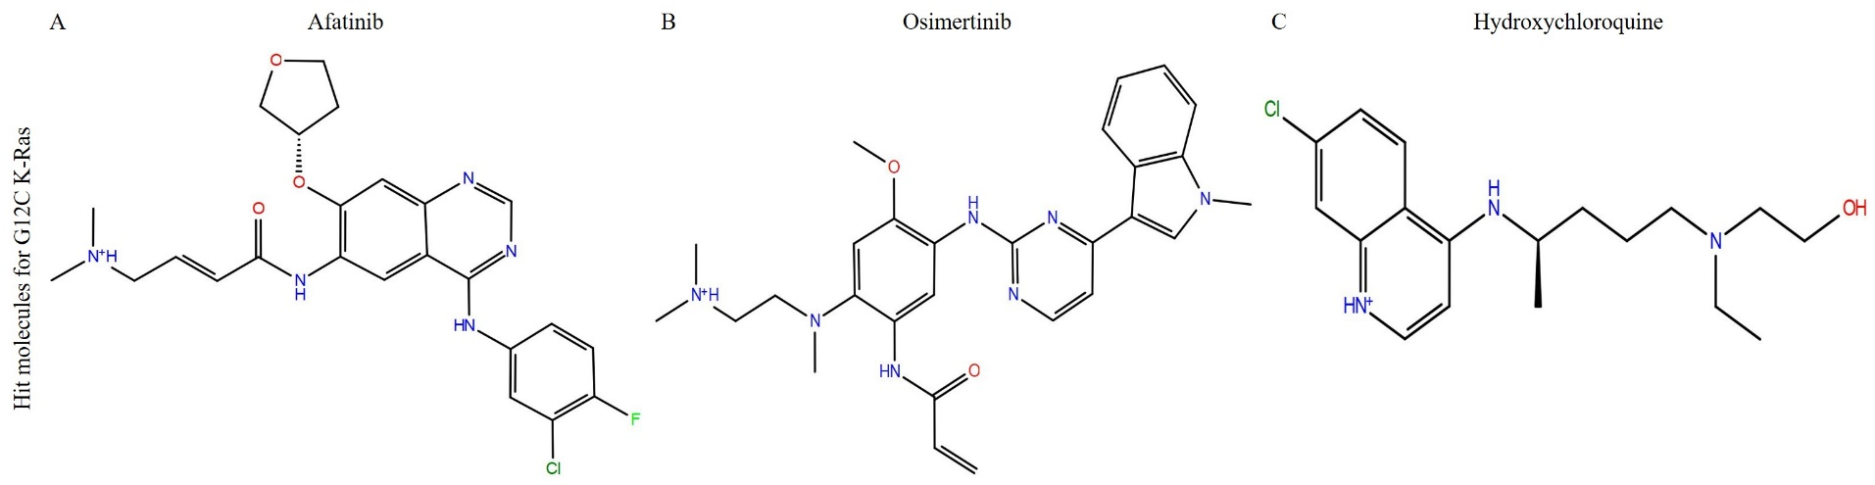
Supplementary Fig. 1. The 2D chemical representation of top hit molecules was obtained through a virtual screening process for the G12C mutant model. (A) Afatinib (B) Osimertinib (C) Hydroxychloroquine.

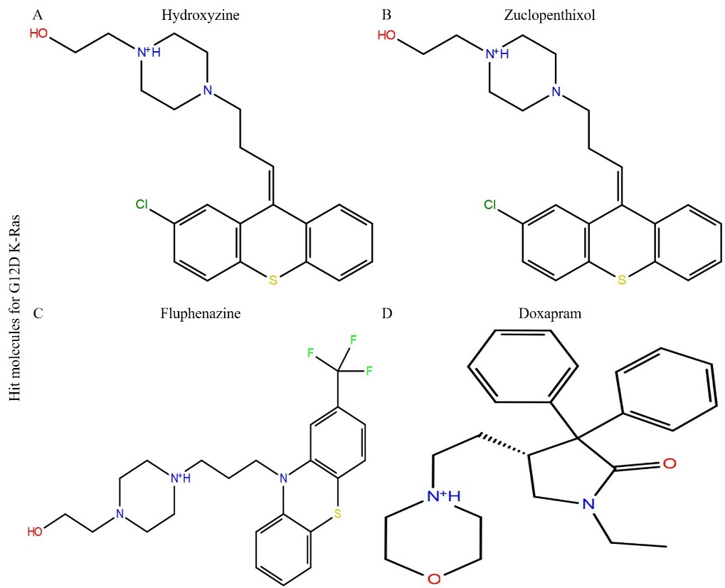
Supplementary Fig. 2. The 2D chemical representation of top hit molecules was obtained through a virtual screening process for the G12D mutant model. (A) Hydroxyzine; (B) Zuclopenthixol; (C) Fluphenazine; (D) Doxapram.

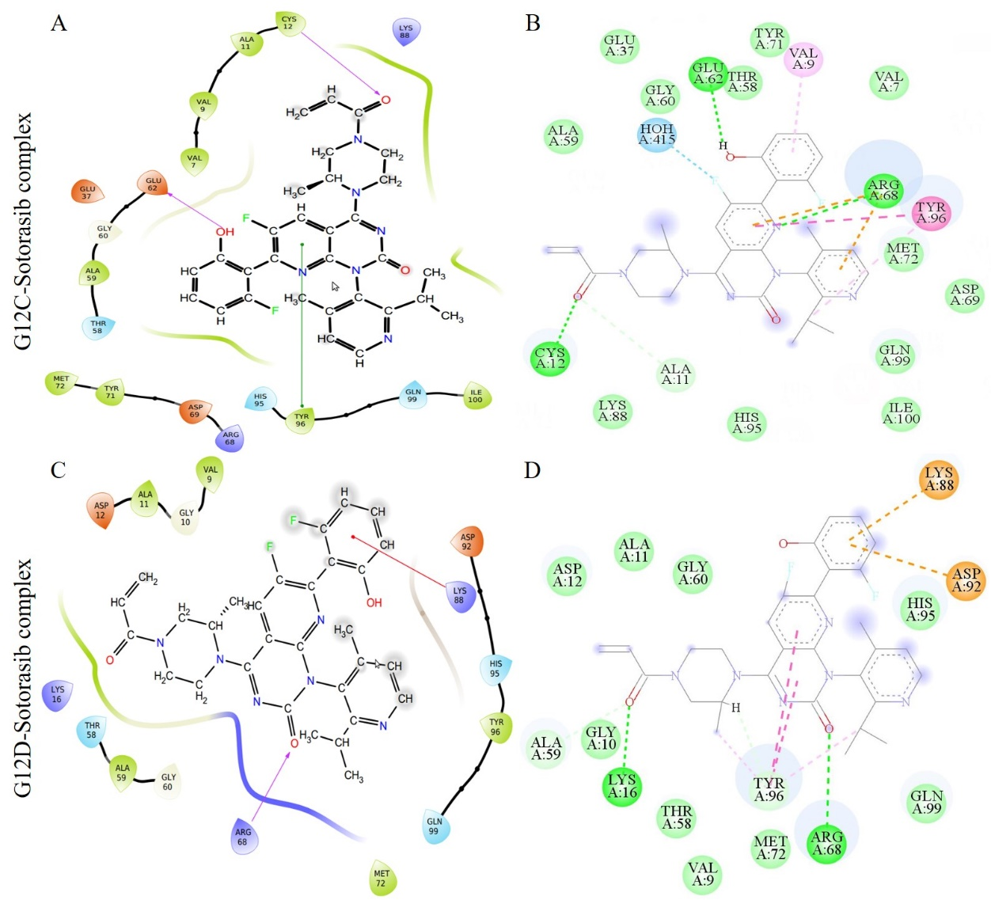
Supplementary Fig. 3. The representation of multiple interactions between the ligand and G12C and G12D models. The ligand interaction diagrams (A) and (C) are from the Maestro suite, whilst (B) and (D) represent the 2D ligand interactions from Discovery Studio. (A) and (B) represent G12C-Sotorasib complexes, (C) and (D) represent G12D-Sotorasib complexes.

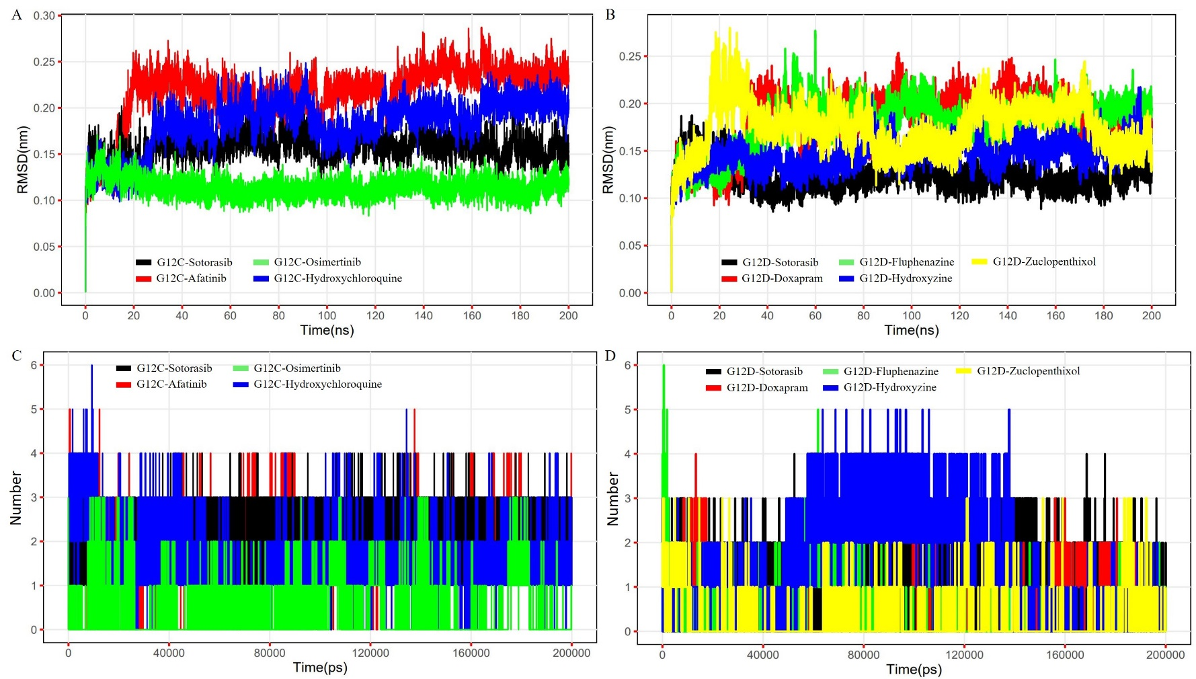
Supplementary Fig. 4. (A) Plot representing the RMSD of the G12C model complexed with reference (Sotorasib) and shortlisted inhibitor compounds (Afatinib, Osimertinib, and Hydroxychloroquine). (B) Plot representing the RMSD of G12D model complexed with reference (Sotorasib) and shortlisted inhibitor compounds (Doxapram, Fluphenazine, Hydroxyzine, and Zuclopenthixol). (C) Plot representing H-bonds of G12C model complexed with reference (Sotorasib) and inhibitor compounds (Afatinib, Osimertinib Hydroxychloroquine). (D) Plot representing H-bonds of G12D model complexed with reference (Sotorasib) and inhibitor compounds (Doxapram, Fluphenazine, Hydroxyzine, and Zuclopenthixol).

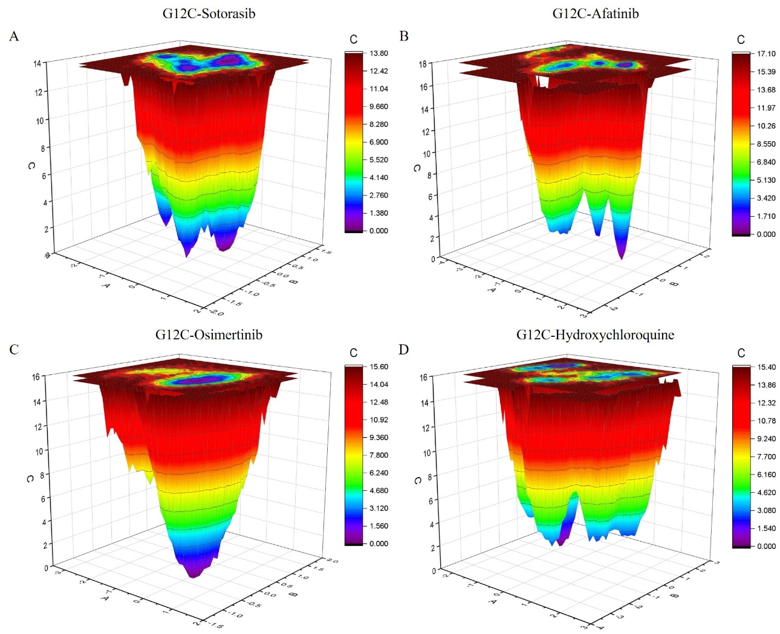
Supplementary Fig. 5. Plots representing the projections of Gibbs free energy landscape (FEL) of G12C model with the top hit molecules onto PC1 and PC2 for (A) G12C-Sotorasib complex; (B) G12C-Afatinib complex; (C) G12C-Osimertinib complex; (D) G12D-Hydroxychloroquine complex where the dark blue color indicates the lowest energy configuration and red color indicates the highest energy conformation.

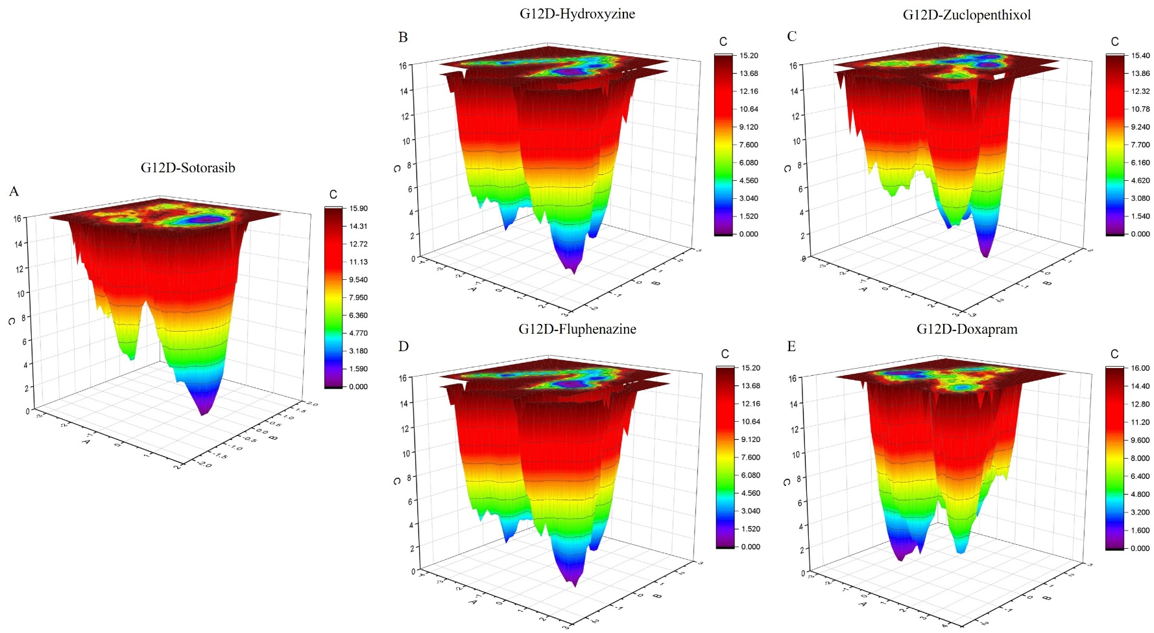
Supplementary Fig. 6. Plots representing the projections of Gibbs free energy landscape (FEL) of G12D model with the top hit molecules onto PC1 and PC2 for (A) G12D-Sotorasib complex; (B) G12D-Hydroxyzine complex; (C) G12D-Zuclopenthixol complex; (D) G12D-Fluphenazine complex; (E) G12D-Doxapram complex where the dark blue color indicates the lowest energy configuration and red color indicates the highest energy conformation.

