Supplementary Material

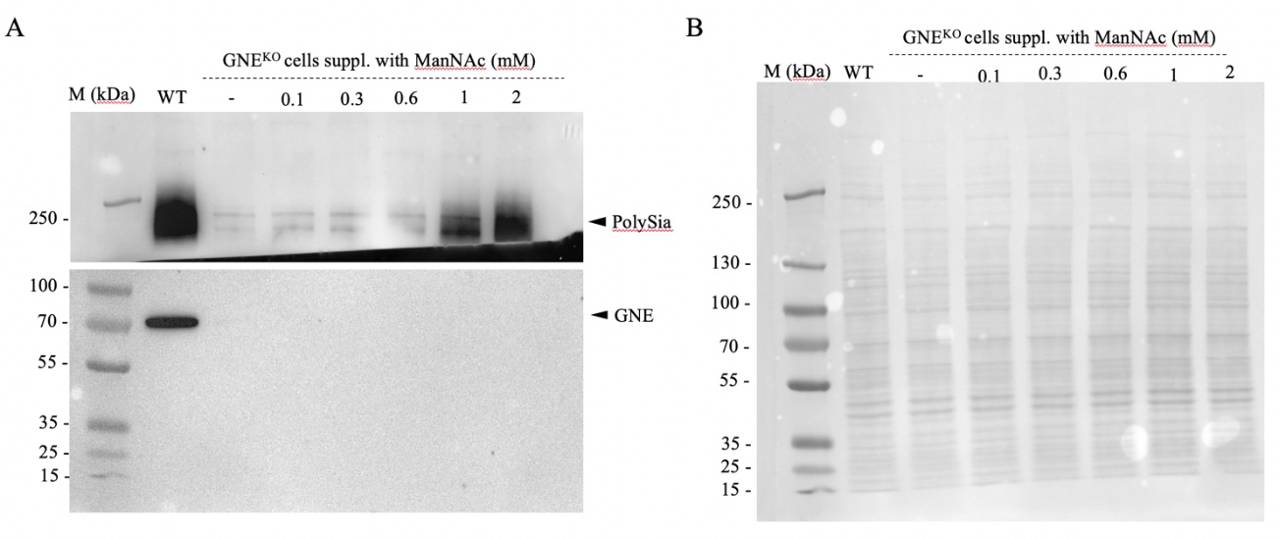
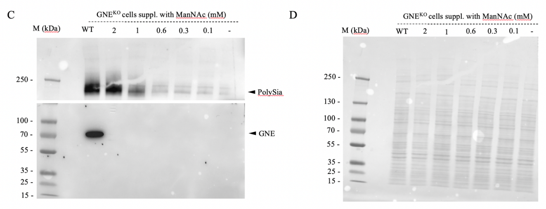
Supplementary Fig. 1. Additional immunoblots of HEK-293 WT and HEK-293 GNE^{KO} cells supplemented with ManNAc. (A,C) Immunoblots of HEK-293 WT and HEK-293 GNE^{KO} cells supplemented with varying amounts of ManNAc, stained for GNE and PolySia. (B,D) Whole Ponceau stains for the respective immunoblots.

