Supplementary Fig. 1. Overexpression efficiency of CEP135 plasmid transfection in human umbilical vein endothelial cells was confirmed by western blotting. Data were analyzed using unpaired Student’s t-test. Error bars indicate SEM. **P<0.01 vs. Control. CEP135, centrosomal protein 135.

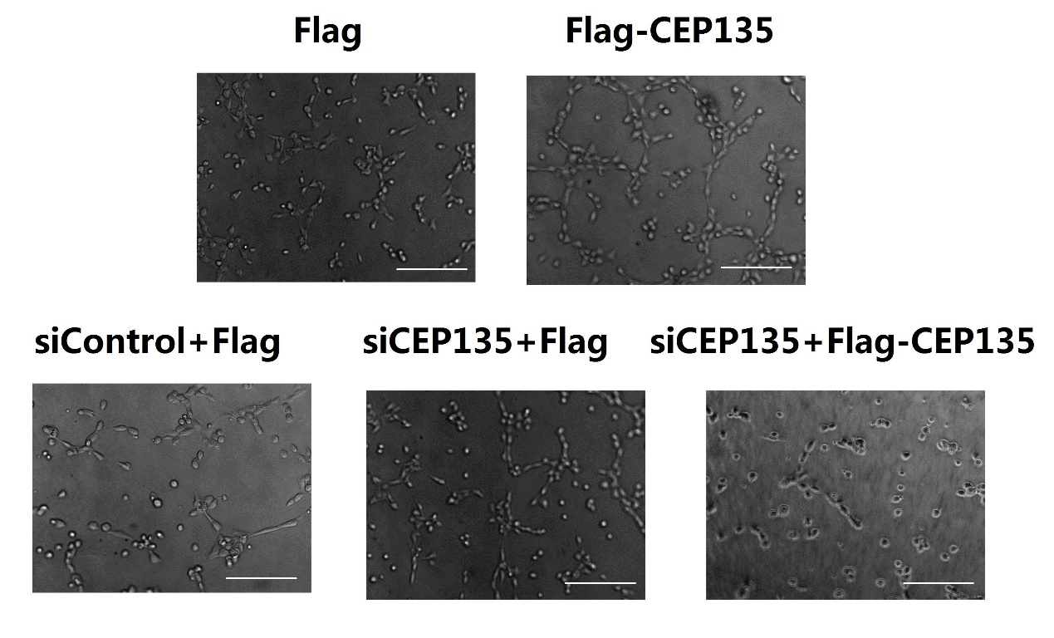
Supplementary Fig. 2. CEP135 depletion leads to defects in HUVEC angiogenesis. Representative images of HUVECs transfected with the indicated plasmids and siRNAs, and plated onto Matrigel are shown. CEP135, centrosomal protein 135; HUVECs, human umbilical vein endothelial cells; si/siRNA, small interfering RNA. Scale bar, 300 µm.

Supplementary Fig. 3. CEP135 depletion induces cell cycle arrest of HUVECs. Flow cytometry showed the percentage of HUVECs at G₁, S and G₂ phases. CEP135, centrosomal protein 135; HUVECs, human umbilical vein endothelial cells; si/siRNA, small interfering RNA.

