Supplemental Information
Title: Genotypic characterization of a Chinese family with osteogenesis imperfecta and generation of disease-specific induced pluripotent stem cells
Author Data: Dandan Li^{1,2,3†}, Minglin Ou^{1,4†}, Guandong Dai^{5†}, Peng Zhu⁵, Qi Luo¹, Jieping Chen¹, Zahir Shah ⁶, Igor M. Samokhvalov^{6,7}, Lianghong Yin², Guoping Sun⁵*, Donge Tang¹*, Yong Dai^{1,8}*
† These authors contributed equally to this study.
- Clinical Medical Research Center, The Second Clinical Medical College of Jinan University (Shenzhen People's Hospital), Shenzhen, Guangdong 518020, China.
- Institute of Nephrology and Blood Purification, The First Affiliated Hospital, Jinan University, Guangzhou, Guangdong 510632, China.
- Experimental Center, Shenzhen Pingle Orthopedic Hospital (Shenzhen Pingshan Traditional Chinese Medicine Hospital), Shenzhen, Guangdong 518118, China.
- Central Laboratory, Guangxi Health Commission Key Laboratory of Glucose and Lipid Metabolism Disorders, The Second Affiliated Hospital of Guilin Medical University, Guilin, Guangxi 541199, China.
- Department of Orthopedics, Department of Radiology, Shenzhen Pingshan District People’s Hospital (Pingshan General Hospital, Southern Medical University), Shenzhen 518110, Guangdong, China.
- CAS Key Laboratory of Regenerative Biology, Guangdong Provincial Key Laboratory of Stem Cells and Regenerative Medicine, Guangzhou Institutes of Biomedicine and Health, Chinese Academy of Sciences, Guangzhou, Guangdong 510530, China.
- Engineering Center for Genetic and Cellular Biotechnology, V. I. Vernadsky Crimean Federal University, 295007 Simferopol, Republic of Crimea
- The First Affiliated Hospital, School of Medicine, Anhui University of Science and Technology, Huainan, Anhui 232001, China.
*Correspondence: daiyong22@aliyun.com (Yong Dai); donge66@126.com (Donge Tang); 15816883398@163.com (Guoping Sun).

Methods
Separation of PBMCs
Blood was collected in heparin-coated tubes, diluted with phosphate-buffered saline (PBS), and centrifuged through a Ficoll gradient (Cat# 17-1440-03, GE Healthcare, Little Chalfont, Buckinghamshire, UK) for 20 min at 2000 rpm. PBMCs were collected, transferred to a new tube, washed, resuspended in PBS and stored at -80 ºC. Genomic DNA was extracted with a HiPure Blood DNA Mini Kit according to the manufacturer’s instructions (Magen, Guangzhou, China).
Genotyping by WGS
The raw data were produced and stored in the FASTQ format. The raw data were filtered and the clean data were aligned to the reference human genome (GRCh37/HG19) using Burrows-Wheeler Aligner software (BWA V0.7.15). Genome Analysis Toolkit (https://www.broadinstituteorg/gatk/guide/best-practices, GATK v3.3.0) was utilized for variant analysis and local realignment including base quality score recalibration and InDels. The duplicate reads were excluded by Picard Tools (http://broadinstitute. github.io/picard/). The coverage and depth of sequencing of each sample were calculated based on the data from the alignments. Variants were annotated using SnpEff tool (http://snpeff.sourceforge.net/SnpEff\cr_manual.html). Discovered SNPs were compared to those in the public databases including NCBI dbSNP (v141), 1000 Genomes Project, and NHLBI Grand Opportunity Exome Sequencing Project 6500 (ESP6500) databases and were further filtered by minor allele frequency (MAF). Then, the common mutations which were present in the OI patients but absent in the healthy individual of the OI family were identified. The candidate variants were screened using a list of OI genes (based on the known OI genes listed in the Osteogenesis Imperfecta Variant Database, https://databases.lovd.nl/shared/diseases/05296, Table S1).
COL1A1 mutation confirmation
Sanger sequencing were performed to confirm the candidate mutation of OI patients. PCR amplification was performed by GeneAmp PCR System 9700 Thermal Cycler (Applied Biosystems, Waltham, MA, USA). The DNA was mixed with buffer, a dNTP mixture, KOD-Plus (TOYOBO, Osaka, Japan), primers and MgSO₄. using the following conditions: initial denaturation at 94 ºC for 2 min, followed by 40 cycles of 94 ºC for 15 s, 55 ºC for 30 s and 68 ºC for 50 s. After purified by agarose gel electrophoresis, the PCR products were analyzed on ABI 3730 DNA genetic analyzer (Applied Biosystems, Foster City, CA, USA). The results were compared with COL1A1 gene sequence by Chromas software.
PBMC cell culture and generation of iPSCs
PBMCs were plated onto Fibronectin-coated 6 well culture-plates (Corning, 354,277, USA) and grown in StemSpan SFEM medium (STEMCELL Technologies) containing EX-CYTE growth enhancement media supplement (1:1000, Millipore, Billerica, MA), GlutaMAX (2 mM), SCF (250 ng/ml), FLT3L (250 ng/ml), TPO (100 ng/ml), IL-3 (20 ng/ml), IL-6 (50 ng/ml) and sIL6-R (10 ng/ml, all from eprotech, Rocky Hill, NJ) for 7 days. 1×10⁶ of PBMCs were electroporated with Episomal iPSC Reprogramming Vectors (pEP4EO2SEN2K, pEP4EO2SET2K, pCEP4-M2L) to deliver reprogramming genes (OCT4, SOX2, NANOG, LIN28, cMYC, KLF4 and SV40LT) by using the Amaxa Nucleofector II device (Amaxa, Germany) with the program T-16 (Figure S1).
After transfected, PBMCs were plated onto Fibronectin/Matrigel®-coated 6 well culture-plates (Corning, 354,277, USA) and incubated overnight in StemSpan SFEM medium supplemented with cytokines. Next day, the medium was changed into DMEM/F12 supplemented with N-2 (1x, ThermoFisher Scientific), B-27 (1x, ThermoFisher Scientific), 100 ng/ml of bFGF (Peprotech), 0.5 μM of PD0325901 (Stemgent), 3 μM of CHIR99021 (Stemgent), 0.5 μM of A-83-01 (Stemgent), 1000 U/ml of hLIF (Millipore), 10 μM of HA-100 (Santa Cruz Biotechnology) and the medium was changed every day. Eleven days later, the medium was changed to NuwaCell hPSC Medium (NuwaCell Biotechnologies, USA) and the medium was replaced every day. Embryonic stem cell-like colonies were manually picked at 11-15 days after transfection, and the picked colonies were transferred onto fresh Matrigel®-coated 6 well culture-plates. Incubation of iPSCs was finished in 0.5 mM of EDTA (NuwaCell Biotechnologies) for 8 min at 37 ºC, and then the medium was changed to Nuwacell hPSC medium (NuwaCell Biotechnologies, USA) for expansion. Cell split was performed at 1:10 twice a week.
Short tandem repeat profiling
To confirm the origin of the new iPSC lines, the extracted DNAs from two iPSC lines and their parental cells were used to perform short tandem repeat (STR) profiling. In brief, genomic DNAs were extracted by Chelex 100 and amplified. The PCR products were electrophoresed and tested on an ABI 3500XL genetic analyzer (Applied Biosystems, Foster City, CA, USA). The genetic signatures were analyzed using the PowerPlex® 21 PCR Amplification System (Promega) based on the 21 loci markers (3S1358, D13S317, D7S820, D16S539, D8S1179, Penta D, D19S433, D5S818, D21S11, TPOX, D1S1656, D6S1043, D2S441, D12S391, D2S1338, vWA, Penta E, H01, D18S51, CSF1PO, FGA) according to the manufacturer’s instructions.
mRNA isolation and quantitative real-time PCR
Total RNA was isolated using an RNAprep Pure Cell/Bacteria Kit (TIANGEN, China) according to the manufacturer's protocol. Then 1 μg of mRNA was subjected to cDNA synthesis using PrimeScriptTM RT reagent Kit with gDNA Eraser (Takara, Cat# RR047Q). Amplification conditions included an activation step at 95 ºC for 30 seconds, followed by 95 ºC for 5 s then 40 cycles of 60 ºC for 30 s. PCR reactions were done in a LightCycler 96 (Roche, Switzerland), and the results were analyzed using LightCycler software version 1.1.0.1320. The expression of pluripotent stem cell markers (POUSF1, NANOG) was analyzed using primers listed in Table S2. Mesenchymal stem cell (MSC) line P3 and hESC line H1 were used as negative control and positive control respectively.
Determination of karyotype
G-banding karyotype analysis was performed for karyotyping iPSC lines. The iPSCs were harvested at 60% confluency and treated with 50 ng/mL colchicine for 2 h at 37 ºC. Then iPSC colonies were dissociated by AccutaseTM Cell Dissociation Reagent (Thermo, A1110501, USA) for 10 min at 37 ºC until a single-cell suspension was obtained. Cells were collected and centrifuged at 1200 rpm for 5 min at RT and washed with PBS. Before fixation, the cells were resuspended in a hypotonic solution (0.6% sodium citrate and 0.13% potassium chloride) for 20 min at 37 ºC for hypotonic treatment and were fixed in 3:1 methanol to acetic acid at room temperature (10 min). The fixing step was repeated twice. After three washes with the fixative, the cells were dropped on an ice-cold slide, dried on a hotplate at 75 ºC (2 h), and stained by Giemsa using a standard G-banding technique. The samples were examined and photographed using a Leica GSL-120 DM6000B Microsystems (Leica Microsystems GmbH, Wetzlar, Germany). Chromosome GTG band analysis was performed according to the International System for Human Cytogenetic Nomenclature (ISCN).
Pluripotency validation in vivo
Teratoma assay was performed to analyze the pluripotency of iPSCs in vivo. The iPSCs that were maintained in the culture medium were evaluated at passage 10 and harvested at 80% confluence and were resuspended in 0.5 mM of EDTA (Nuwacell, RP01007, China), and centrifugated at 1000 rpm for 5 min. The supernatant was then discarded and the cells were resuspended in 50% Matrigel® (Corning, 354,277, USA) with PBS. Then, the cells were injected into the posterior thigh muscles of 4 weeks-old SCID Beige mice. At 8 weeks post-injection, the mice were sacrificed and the tumors were harvested. The tumor tissues were fixed in formalin (10%), embedded, sectioned, and stained by hematoxylin and eosin.

Supplementary Fig. 1. Episomal reprogramming vector maps. This vectors combination contains three vectors (pEP4EO2SEN2K, pEP4EO2SET2K and pCEP4-M2L) and expresses all seven transgenes (OCT4, SOX2, NANOG, LIN28, c-MYC, KLF4 and SV40LT).
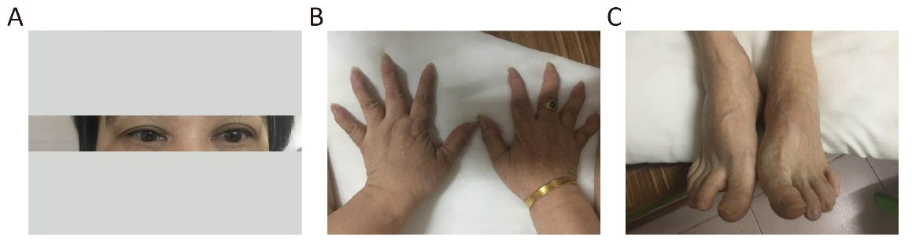
Supplementary Fig. 2. Photographs of the proband (I-1). A. The photograph of the proband’s eyes showed blue sclera. B. The photograph of the proband’s hands showed deformation of the joint. C. The photograph of the proband’s feet showed deformation the ankle.

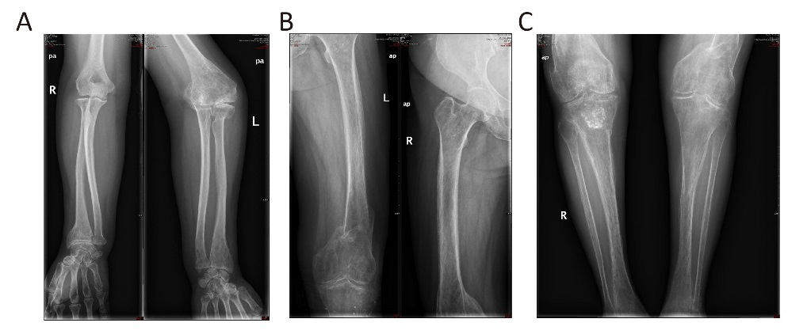
Supplementary Fig. 3. Radiographs of the proband (I-1). A. Radiographs of the proband showed deformation of radius of the fight arm and left forearm joint deformation. (B) Radiographs of the proband showed old fracture and right femur osteoporosis. (C) Radiographs of the proband showed osteoporosis of knee joint and lower leg.
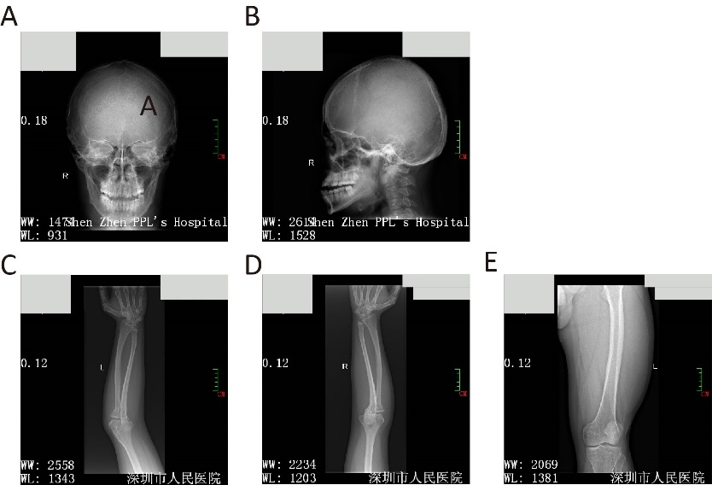
Supplementary Fig. 4. Radiographs of the proband’s affected son (II-4). A and B. Radiographs of the proband’s affected son showed small skull base and facial bone and relatively large skull cap bone. C, D and E. Radiographs of the proband’s affected son showed bending of long tubular bones and widening of distal radius.

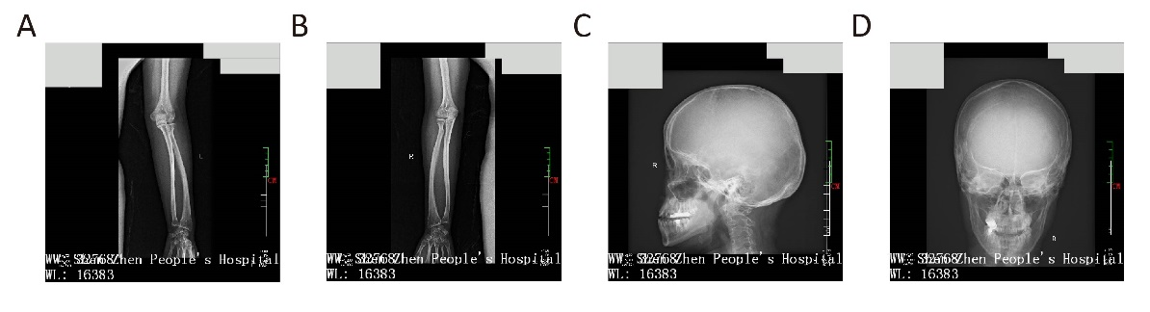
Supplementary Fig. 5. Radiographs of the proband’s unaffected daughter (II-5). A and B. Radiographs of the proband’s affected daughter showed bending of long tubular bones. C and D. Radiographs of the proband’s affected daughter showed small skull base and facial bone and relatively large skull cap bone.
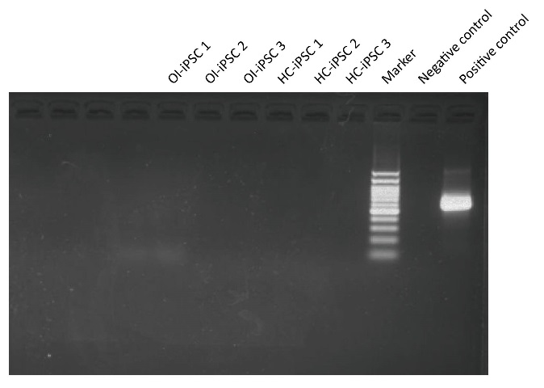
Supplementary Fig. 6. Mycoplasma detection of OI-iPSC and HC-iPSC.

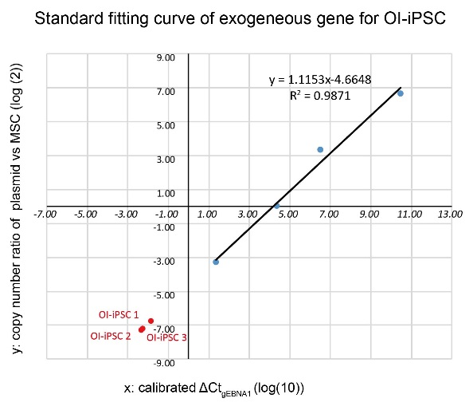
Supplementary Fig. 7. Standard fitting curve of exogeneous gene for OI-iPSC.

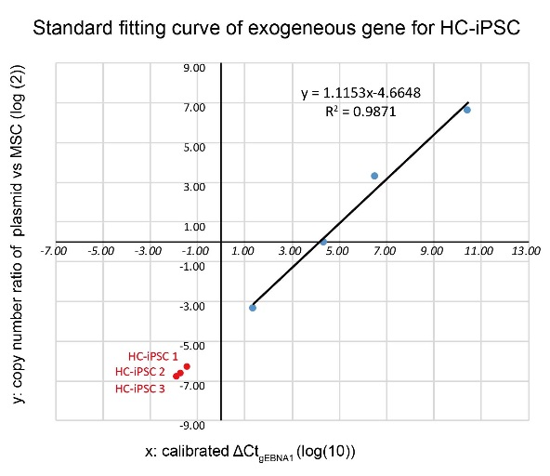
Supplementary Fig. 8. Standard fitting curve of exogeneous gene for HC-iPSC.

Supplementary Table 1. Genes listed in the osteogenesis imperfecta variant database
Gene symbol | Gene name
BMP1 | bone morphogenetic protein 1
CCDC134 | coiled-coil domain containing 134
COL1A1 | collagen type I alpha 1 chain
COL1A2 | collagen type I alpha 2 chain
CREB3L1 | cAMP responsive element binding protein 3 like 1
CRTAP | cartilage associated protein
FAM46A | family with sequence similarity 46 member A
FKBP10 | FKBP prolyl isomerase 10
IFITM5 | interferon induced transmembrane protein 5
P3H1 | prolyl 3-hydroxylase 1
P4HB | prolyl 4-hydroxylase subunit beta
PLOD2 | procollagen-lysine, 2-oxoglutarate 5-dioxygenase 2
PLS3 | plastin 3
PPIB | peptidylprolyl isomerase B
SEC24D | SEC24 homolog D, COPII coat complex component
SERPINF1 | serpin family F member 1
SERPINH1 | serpin family H member 1
SP7 | Sp7 transcription factor
SPARC | secreted protein acidic and cysteine rich
TMEM38B | transmembrane protein 38B
WNT1 | Wnt family member 1

Supplementary Table 2. Primers for pluripotency markers (qRT-PCR)
Target | Forward/Reverse primer (5′-3′)
POU5F1 | CAGTGCCCGAAACCCACAC/ GGAGACCCAGCAGCCTCAAA
NANOG | CAGAAGGCCTCAGCACCTAC/ ATTGTTCCAGGTCTGGTTGC

Supplementary Table 3. Anti-bodies for pluripotency markers (FACS)
Target | Antibody | Brand and Cat #
SSEA 4 | PE Mouse anti-SSEA-4 | BD PharmingenTM, Cat# 560128
Tra-1-81 | PE Mouse anti-TRA-1-81 Antigen | BD PharmingenTM, Cat# 560161

Supplementary Table 4. Primers for exogenous genes (PCR)
Target | Forward/Reverse primer (5′-3′)
OCT4 | AGTTTGTGCCAGGGTTTTTG/ ACTTCACCTTCCCTCCAACC
EBNA1 | CAGTTCCTCGCCTTAGGTTGTA/ GGCTAGGAGTCACGTAGAAAGG

Supplementary Table 5. Results of data processing for whole gene sequencing
Sample | Participant
Sample | I-1 | II-1 | II-4 | II-5
Total reads | 794,417,528 | 755,952,232 | 786,288,160 | 798,595,370
Read length, bp | 150 | 150 | 150 | 150
Total yield, Mbp | 119,162 | 113,392 | 117,943 | 119,789
Reference size, Mbp | 2,858 | 2,858 | 2,858 | 2,858
Throughput mean depth (X) | 41.7 | 39.7 | 41.3 | 41.9

Supplementary Table 6. Overall conditions for statistics output and contrast result
Variable | Participant
Variable | I-1 | II-1 | II-4 | II-5
Output, gigabyte | 119.162 | 113.392 | 117.943 | 119.789
Sequencing depth of raw data | 41.7 | 39.7 | 41.3 | 41.9
Valid sequencing depths | 35.3 | 31.6 | 33.6 | 35.1
Genome coverage rate | 98.8 | 98.9 | 99.4 | 98.8
Single nucleotide polymorphisms | 3,454,919 | 3,360,523 | 3,401,260 | 3,456,607
Insertions and deletions | 461,477 | 437,584 | 449,863 | 461,701
Copy number variations | 90 | 103 | 83 | 113
Structural variations | 6,839 | 6,195 | 6,497 | 6,598

Supplementary Table 7. 25 candidate mutations
Gene symbol | Mutation | Type
SPEN | chr1: g.16261732 C>G, p.N2999K | NON_SYNONYMOUS_CODING
EIF4G3 | chr1: g.21226371 C>G, p.Q549H | NON_SYNONYMOUS_CODING
MACF1 | chr1: g.39924826 C>T, p.R5030W | NON_SYNONYMOUS_CODING
DPYD | chr1: g.98187065 C>A, p. | SPLICE_SITE_DONOR
CDON | chr11: g.125853857 C>T, p.V969I | NON_SYNONYMOUS_CODING
ZBTB44 | chr11: g.130131108 G>A, p.P221S | NON_SYNONYMOUS_CODING
IGSF9B | chr11: g.133790274 G>A, p.P1116S | NON_SYNONYMOUS_CODING
RIMBP2 | chr12: g.130912743 G>A, p.T781M | NON_SYNONYMOUS_CODING
PDX1 | chr13: g.28494372 C>G, p.P33A | NON_SYNONYMOUS_CODING
KRT14 | chr17: g.39741266 A>G, p.I190T | NON_SYNONYMOUS_CODING
COL1A1 | chr17: g.48274566 C>A, p.G242V | NON_SYNONYMOUS_CODING
LRRC37A3 | chr17: g.62892031 C>T, p.V449I | NON_SYNONYMOUS_CODING
MRPL12 | chr17: g.79670575 G>A, p.G15E | NON_SYNONYMOUS_CODING
PSG6 | chr19: g.43420328 G>A, p.R126* | STOP_GAINED
LILRA2 | chr19: g.55086404 C>G, p.P187A | NON_SYNONYMOUS_CODING
USP29 | chr19: g.57640326 T>A, p.L95M | NON_SYNONYMOUS_CODING
SFT2D3 | chr2: g.128459374 T>G, p.F91C | NON_SYNONYMOUS_CODING
HIC2 | chr22: g.21800238 C>T, p.R352W | NON_SYNONYMOUS_CODING
XRN1 | chr3: g.142122584 A>G, p.F679L | NON_SYNONYMOUS_CODING
WDR36 | chr5: g.110462465 C>T, p.L914F | NON_SYNONYMOUS_CODING
SGCD | chr5: g.156186360 G>A, p.A277T | NON_SYNONYMOUS_CODING
HLA-DRB1 | chr6: g.32557506 T>C, p.K5R | NON_SYNONYMOUS_CODING
TTBK1 | chr6: g.43227381 T>C, p.V454A | NON_SYNONYMOUS_CODING
TJAP1 | chr6: g.43470053 C>T, p.T108I | NON_SYNONYMOUS_CODING
SAPCD2 | chr9: g.139959561 C>T, p.G303E | NON_SYNONYMOUS_CODING

Supplementary Table 8. STR profiles of OI-iPSC vs its parental PBMCs
21 STR loci | OI-iPSC | PBMCs from II-4
AMEL | X/Y | X/Y
Yindel | 2 | 2
D3S1358 | 15 | 15
D13S317 | 10/12 | 10/12
D7S820 | 11/12 | 11/12
D16S539 | 9/10 | 9/10
D8S1179 | 14/15 | 14/15
Penta D | 12/13 | 12/13
D19S433 | 13/16 | 13/16
D5S818 | 12/13 | 12/13
D21S11 | 28/30 | 28/30
TPOX | 8 | 8
D1S1656 | 13/17.3 | 13/17.3
D6S1043 | 13/19 | 13/19
D2S441 | 10/12 | 10/12
D12S391 | 15/22 | 15/22
D2S1338 | 18/25 | 18/25
vWA | 18 | 18
Penta E | 11/12 | 11/12
TH01 | 6/7 | 6/7
D18S51 | 13/16 | 13/16
CSF1P0 | 11/12 | 11/12
FGA | 19/22 | 19/22

Supplementary Table 9. STR profiles of HC-iPSC vs its parental PBMCs
21 STR loci | HC-iPSC | PBMCs from II-1
AMEL | X | X
Yindel | - | -
D3S1358 | 15/16 | 15/16
D13S317 | 8/9 | 8/9
D7S820 | 11/12 | 11/12
D16S539 | 11/13 | 11/13
D8S1179 | 13/14 | 13/14
Penta D | 9/12 | 9/12
D19S433 | 12/13 | 12/13
D5S818 | 12/13 | 12/13
D21S11 | 29/30 | 29/30
TPOX | 8 | 8
D1S1656 | 11/16 | 11/16
D6S1043 | 17/19 | 17/19
D2S441 | 10/12 | 10/12
D12S391 | 17/18 | 17/18
D2S1338 | 17/20 | 17/20
vWA | 14/19 | 14/19
Penta E | 18 | 18
TH01 | 9/9.3 | 9/9.3
D18S51 | 15/17 | 15/17
CSF1P0 | 10 | 10
FGA | 22/24 | 22/24

Supplementary Table 10. Donor screening for OI-iPSC
Test | Detection method | Results | Reference value
Anti-HIV | ELISA | Negative | Negative | Human immunodeficiency virus
HBsAg | ELISA | Negative | Negative | Hepatitis B virus
HBsAb | ELISA | Negative | Negative | Hepatitis B virus
HBeAg | ELISA | Negative | Negative | Hepatitis B virus
HBeAb | ELISA | Negative | Negative | Hepatitis B virus
HBcAb | ELISA | Negative | Negative | Hepatitis B virus
TPPA | Agglutination reaction | Negative | Negative | Treponema pallidum
HCV-IgM | ELISA | Negative | Negative | Hepatitis C virus
HCV-IgG | ELISA | Negative | Negative | Hepatitis C virus

Supplementary Table 11. Donor screening for HC-iPSC
Test | Detection method | Results | Reference value
Anti-HIV | ELISA | Negative | Negative | Human immunodeficiency virus
HBsAg | ELISA | Negative | Negative | Hepatitis B virus
HBsAb | ELISA | Negative | Negative | Hepatitis B virus
HBeAg | ELISA | Negative | Negative | Hepatitis B virus
HBeAb | ELISA | Negative | Negative | Hepatitis B virus
HBcAb | ELISA | Negative | Negative | Hepatitis B virus
TPPA | Agglutination reaction | Negative | Negative | Treponema pallidum
HCV-IgM | ELISA | Negative | Negative | Hepatitis C virus
HCV-IgG | ELISA | Negative | Negative | Hepatitis C virus

